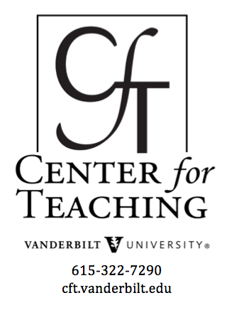
Podcasting

General Resources
- 7 things you should know about ... Podcasting
A two-page document from the Educause Learning Initiative (ELI) answers key questions about podcasting, including what is it? who is doing it? And what are the implications for teaching and learning? (Available to ELI members only, including Vanderbilt).
- 7 things you should know about ... RSS
RSS, or "really simple syndication" is one of the technologies that makes podcasts work. This two-page document from the Educause Learning Initiative (ELI) answers 7 questions about why RSS is significant. (Available to ELI members only, including Vanderbilt).
- ELI Discovery Tool: Guide to Podcasting
Elisa Coghlan, David Futey, Julie Little, Cyprien Lomas, Diana Oblinger and Carie Windham
This 51-page guide from the Educause Learning Initiative (ELI) provides a quick recap of what podcasting is, provides case studies of how podcasting is being used on campuses, explores benefits and limitations to using podcasts to support teaching and learning, discusses important steps in planning for implementation and assessment, and provides valuable podcasting resources. (Available to ELI members only, including Vanderbilt).
- Confessions of a Podcast Junkie - A Student Perspective
Carie Windham, EDUCAUSE Review, May/June 2007
This look at podcasting in higher education offers tips for faculty on offering lectures and course notes via podcasting, as well as assignments of student-created podcasts and non-academic podcasts on campus.
- Podcasting and Education - A conversation with Rice University's Jeffrey Daniel Frey
Campus Technology, January 16, 2008
Campus Technology spoke with Jeffrey Daniel Frey, the Web services manager for enterprise applications in the Information Technology Department at Rice University. Jeff writes, speaks and consults on podcasting, as well as teaching a podcasting course to the community through Rice's School of Continuing Studies. He talked about some of the misconceptions about podcasting, as well as how he sees podcasting as a way to boost recruiting efforts.
- Podcasting: A Teaching with Technology White Paper
Ashley Deal, Carnegie Mellon University
This 15-page guide to podcasting in higher education features information both technical and pedagogical and focuses on three typical uses of podcasting: distribution of lecture archives for review, delivery of supplemental educational materials and content, and assignments of student-created podcasts.
- Podcasting Lectures
Brittain, Glowacki, Van Ittersum, & Johnson, EDUCAUSE Quarterly, Fall 2006
This is a case study describing the process by which information technology staff members at the University of Michigan School of Dentistry determined that podcasting would be an appropriate response to student interest in having class lectures videotaped and made available online.
- Podcasting at University of Wisconsin - Madison
Associate professor of media and cultural studies Jeremy Morris teaches the course Sound Cultures: Podcasting and Music. The University also has an article on Learning beyond the classroom with iTunes U.
- There's Something in the Air: Podcasting in Education
Gardner Campbell, EDUCAUSE Review, November/December 2005
An article describing some of the exciting implications and exploring some of the ways in which podcasting is already being used to change teaching and learning in higher education.

Podcasting at Vanderbilt
- Leading Lines is a podcast on educational technology in higher education. It is produced out of Vanderbilt University by the Office of the Associate Provost for Digital Learning, the Vanderbilt Center for Teaching, the Vanderbilt Institute for Digital Learning, and Office of Scholarly Communications at the Vanderbilt University Library.
- Podcasting your own course or event - Vanderbilt is part of iTunes U, an Apple iTunes service which helps colleges and universities distribute audio and video content. For more information on podcasting at Vanderbilt via iTunes U, see the Vanderbilt iTunes U home page. This website includes information on how to get started with iTunesU, information for contributors, and a list of frequently asked questions.
- Creating a Podcast Episode Using Audacity - A PDF file describing the steps involved in creating a simple podcast using Audacity, a free piece of software that runs on both PC and Mac platforms.
- Audio/Video Recording Release - Vanderbilt has prepared a release form for speakers to sign if they agree to have their lecture, performance or presentation made available on the Web. See the Creative Commons website for additional ways to think about protecting intellectual property in an educational context.

