Diversity for Visiting Students Application 2019
Please ensure you have completed the VSLO application process before submitting this application. Deadline to apply is 5/15/19.
Please note that we are only granting the Diversity for Visiting Students Stipend award for two rotation periods.
First Rotation: Jul. 22, 2019 – Aug. 16, 2019 AND Second Rotation: Aug. 19, 2019 – Sept. 13, 2019

Last Name: First Name:

Primary Phone #: Primary Email Address:

Mailing Address: USMLE Step 1 or COMLEX score:

Name of Medical School: Anticipated date of graduation:

Program: Year and Rotation Date:

Gender
Female Male
Prefer not to say Other (please specify)
Ethnicity: Are you Hispanic or Latino?
No Yes

Race: Choose all that apply (regardless of ethnicity) American Indian or Alaska Native
Asian
Black or African American
Native Hawaiian or Pacific Islander White
Other (please specify)

Are you a first generation college student (i.e. first person in your family to attend college)?
No Yes

Parent/Guardian 1 Education: High School
GED or less
Some College College Graduate
Parent/Guardian 2 Education: High School
GED or less
Some College College Graduate

Was the principal city or town you spent the majority of your childhood (age <18) a town of less than or equal to 40,000 population and at least 10 miles from a community of that size or larger?
No
If "Yes", please specify

While you were growing up, did you experience any of the following types of adversity?

None
Mild
Moderate
Severe
Economic
Educational
Ethnic/Cultural
Family

If you indicated "Severe" in any of the categories above, please use a few sentences to elaborate (200 words max):

Please briefly describe your career goals (200 words max):

Please respond to the OHSU Diversity & Inclusion statement. Share how you will embody OHSU’s commitment to diversity and inclusion (250 words max):
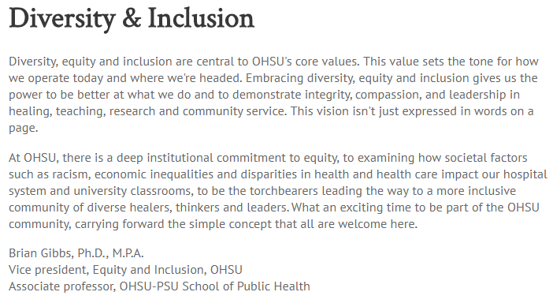

Required Documents:
Upload a letter of endorsement from the related core clerkship director at your home institution to VSLO. This letter should include details about your qualifications and should be sent directly to us.
Upload transcripts (from medical school) to VSLO.

Terms & Condition for All Participants (your signature below indicates your acceptance):
I agree to participate in the longitudinal research study being conducted as part of the OHSU Diversity program for visiting students.
I agree to all the terms and conditions to the OHSU Code of Conduct (please read link below)
I agree to participate in the rotation to which I have been accepted and the diversity program activities.
I agree to participate in a cohort based model during my rotation periods. This involves sharing your contact information with other visiting students that have also been selected as recipients for the diversity stipend award.

OHSU Code of Conduct Student Signature & Date

