TBFA Data Sheet
Previously, we told you that if a trial was conducted with errors, you should mark “no” on the TBFA data sheet and re-conduct the trial was conducted with errors. Now, we will also have you scratch out data from trials that are not conducted to fidelity so that you do not accidentally enter them into the excel file. To do so, simply draw a line across the trial that was NOT conducted to fidelity. See the below data sheet for an example:
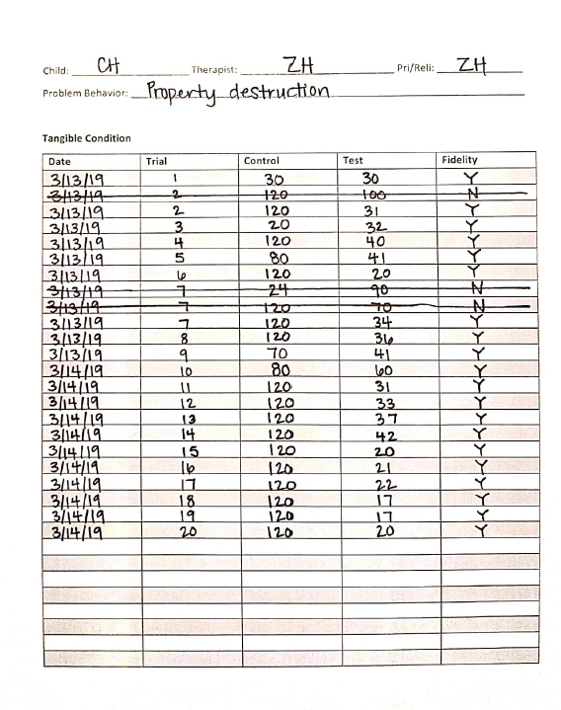

Excel Template
Below you will find a blank excel template. In the first 7 columns, you will simply enter the data directly from your TBFA data sheet into the corresponding columns. Be sure to hit the right arrow on your keyboard after entering the correct information into each cell. You will notice, however, that the last two columns do not exist on your TBFA data sheet. That is because this is where you will make decisions about the TBFA.
In the column that says “functional relation?” you will type “yes” if there is a functional relation based off the data you’ve entered thus far. If you are unable to determine if there is a functional relation, you will type “no.” Remember, the rules for identifying a function are:
- There must be at least 3 valid demonstrations of effect AND
- At least 50% of all trials must be valid demonstrations of effect.
In the column that says “stop,” you will write “go” if you are unable to stop the TBFA condition. If you should stop the TBFA condition, you will write “stop.” Remember, the rules for terminating the TBFA condition are:
- The completion of 20 trials OR
- A function being identified, whichever comes first

