Learning and Course
Management Systems
by Richard Coble

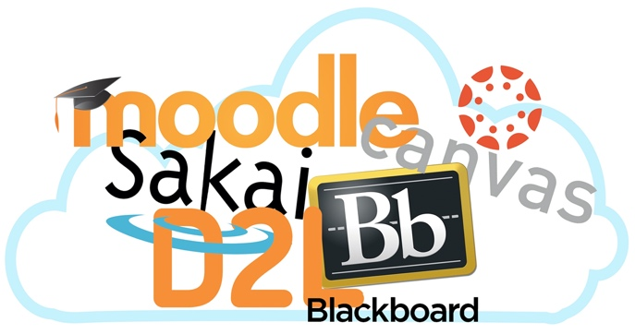
Systems such as Blackboard, Canvas, and Desire2Learn are becoming a vital part of university classrooms in the 21st Century. This guide seeks to bring clarity about the definitions, use, and possibilities of such systems for both instructors and students. After differentiating the definitions and scope of Learning and Course Management Systems (LMS/CMS), the guide explores how users on Vanderbilt’s campus were employing the current system during the 2015-2016 school year based on the results of a campus-wide survey held in the spring of that year. The guide then ends with a list of best practices for classroom technology integration and shows how better integration with an LMS can further learning goals.

Definitions
Learning and course management systems are online learning platforms used either to provide a digital supplement for a traditional classroom that meets regularly in person or to host an online course that does not hold regular in-person meetings. There is some controversy and confusion over the difference and overlap of the terms learning management system or LMS and course management system or CMS.
In a helpful article, William Watson and Sunnie Lee Watson (2007) define an LMS as a
Framework that handles all aspects of the learning process. An LMS is the infrastructure that delivers and manages instructional content, identifies and assesses individual and organizational learning or training goals, tracks the progress towards meeting those goals, and collects and presents data for supervising the learning process of an organization as a whole (p. 28).
Noting that the two are often confused with one another, they then differentiate the holistic framework of an LMS from a Course Management System,
Used primarily for online or blended learning, supporting the placement of course materials online, associating students with courses, tracking student performance, storing student submissions and mediating communication between the students and well as their instructor (p. 29).
So the difference is one of scope. The LMS seeks to “encompass the entire organization” of the learning while a CMS provides a set of tools to aid and expand the learning process (p. 30).
However, since Watson and Watson’s article a decade ago, the two terms have continued to be used interchangeably, with a noticeable preference for LMS over CMS. For example, Watson and Watson state definitively that Blackboard “does not meet the functionality necessary to be identified as an LMS” (p. 30), but, in the decade since their writing, Blackboard Learn has adapted the term LMS, as have its major competitors, including Canvas, Desire2Learn, Moodle, and Sakai.

How do Teachers and Learners Use an LMS?
In the spring of 2016, the Center for Teaching, as the administrative home of Blackboard at Vanderbilt, created a campus-wide LMS needs assessment survey inviting faculty, staff, and students to comment on the kinds of tools and features they value in an LMS. The survey received over a thousand responses regarding campus wide use, and those responses can help us understand how teachers and students use Vanderbilt’s LMS. Of those who responded, 48% were instructors or teaching assistants, 52% were students, 7% provided course support, and 8% coordinated organizations for Vanderbilt. 91% had used Blackboard in the last year. The following graph represents where the respondents are affiliated with Vanderbilt:
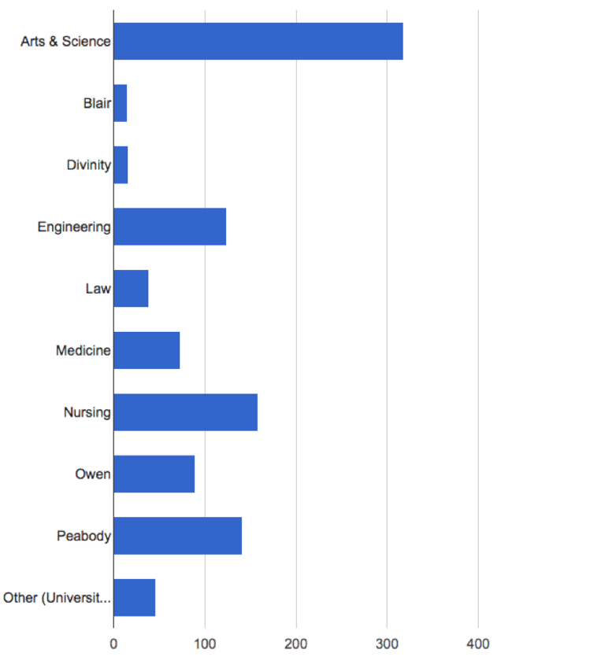
In what follows, I will go through some of the results of the survey. In addition to noting how specific LMS items scored, I will also provide a few links to user guides and videos produced by the Center for Teaching for Blackboard, so that you can see what the terms mean for the LMS.
The following LMS features were “very important” to 50% or more of the respondents with instructional roles:
- Posting Content or Uploading Files
- The Grade Center
- Email, Messaging, or Announcements
The only item to receive a greater percentage of being “Important” or “Very Important” over “I am not familiar with this feature” or it is “Not at all important” was:
- Assignments
The following items received a greater percentage of “I am not familiar with this feature” or it is “Not at all important”:
- Groups (i.e. subsets of students within a course)
- Quizzes/testing or surveys
- Discussion Board
- Blog, journal, or wiki
- Media integration or streaming video (e.g. Kaltura)
- Library integration or reserves
- Textbook/publisher integration
In addition, over 50% of student respondents stated they “often” or “very often” use the LMS for:
- Checking my grades in a course
- Downloading readings
- Turning in assignments
- Retrieving course information such as syllabi or deadlines
- Receiving communications about the course
These responses indicate that the majority of users utilize Blackboard as a communications tool and repository for classroom files and information, while more integrated features such as performing assessments, creating groups, and holding discussions online are less widely used.

Levels of Use
William Dutton, Pauline Hope Cheong, and Namkee Park (2004) delineate a typology of “Six patterns of use” for learning management systems based on a university-wide study. They range from the least to the most integrated use of the LMS with the classroom (p. 75-76):
Level 1:
eCopier: Substitute for the copy machine: Using LMS to give students access to documents online rather than handing out hard copies in class
Level 2:
ePublisher: Electronic distribution of enhanced course content: Enhancing classroom content by including multi-media items such as movie clips and cartoons
Level 3:
eProjector: Substituting for the 35mm slide projector: Giving access to high-quality images that could once only have been seen in a museum or in poor-quality copies
Level 4:
eProject: Promoting group work: LMS functions as an electronic gathering place for students to read and offer feedback on one another’s work and contributions
Level 5:
eTeam: Grassroots innovation in student groups: Students chat, post relevant materials, and write up literature reviews, creating a virtual study group around a developing group reading list
Level 6:
eClassroom: Substituting the virtual for the real: Students meet on campus only a few times, spending most of the semester using the LMS to coordinate individual and group work, developing online portfolios that students then share together in person
From the results of the LMS needs assessment survey reviewed above, it is clear that the majority of users employ the LMS at Levels 1-3. This is in keeping with Vanderbilt’s commitment to residential over online education. Further, this level of use seems to be all many users expect from the platform. When asked if the LMS was meeting their needs, users responded:
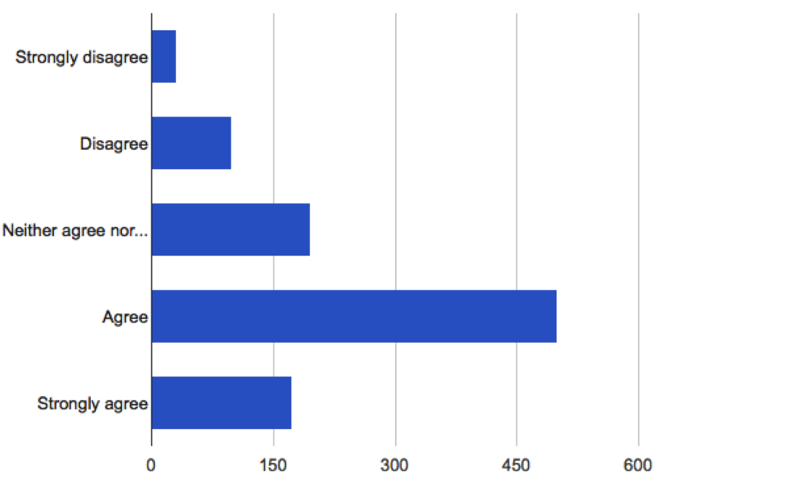
In spite of these satisfaction scores, the low level of course integration represented by the survey may span from past limitations in the platform itself. (Blackboard has been in use at Vanderbilt for more than a decade, although it was known as “OAK,” or Online Access to Knowledge, for most of that time.) In general, learning management systems come under critique for their lack of speed, intuitiveness, and efficiency (Ioannou and Hannafin, 2008). As Lisa Lane (2008) points out in her article, “‘Toolbox or Trap?’ Course Management Systems and Pedagogy,” high satisfaction scores may simply reflect resignation with the limitations of a platform:
But what about statistics showing high levels of satisfaction with CMS use? Colleges that survey their faculty to see how satisfied they are with the current CMS can use high marks to avoid making changes. Faculty satisfaction rates with integrated systems can be deceptive, however. An instructor seeking an easy way to post word-processed documents, enter grades, receive papers and assignments through a digital dropbox, and run a traditional threaded discussion board will tend to show great satisfaction with using a CMS. Those who tax the system more, and use the most complex features, show lower levels of satisfaction. In addition, after spending months crafting material and quizzes in a proprietary system, faculty rightly panic at the idea of ‘moving everything’ to another system. The big systems simply do not allow for easy export, and no one wants to do all that work over again. It is much easier to simply declare satisfaction with things the way they are (p. 6).
In other words, high satisfaction scores may represent the fact that users simply have not tried to integrate an LMS more fully into the classroom. But with the overall trend toward LMS over CMS, these systems are gaining higher levels of functionality and usability. As LMS platforms correct or evolve from past limitations in speed and efficiency, instructors may find that greater classroom integration with the LMS could help accomplish course goals. The next section offers ways to increase integration while keeping learning goals in mind.

How to Integrate an LMS Further into the Classroom
Chickering and Ehrmann (1996), adapting an earlier list by Chickering and Gamson (1987) outline seven principles of good practice for implementing technology in the classroom. Though their work is now several decades old, their principles serve as a reminder that classroom technology must undergo the same critical evaluation of its pedagogical use as all other classroom components. When integrating an LMS, an instructor must ask how it will further her teaching goals. Following these principles will help answer this question.
After each principle, I will outline how an LMS may aid instructors in satisfying it.
- Good Practice Encourages Contacts Between Students and Faculty
The LMS can be more than simply a repository for classroom materials. While having a common place for the course syllabus, readings, and assignment instructions is a useful part of the LMS, it can also become a place for continued interaction outside of the class. Discussion boards, blogs, and wikis enable asynchronous communication where students can continue classroom discussions on their own outside of the class meeting time. As Harrington, Staffo, and Wright (2006) explain from their survey of campus-wide LMS use, “Several [faculty] noted that in traditional formats, it always seemed that the students regarded the class as over as soon as they walked out the door. However, the online component meant that this perception changed. The class became an ongoing phenomenon, which engaged the students with the subject on a prolonged and deeper level than before” (p. 184). Utilizing these integrated features allows students to participate on their own time outside of the class in ways that go beyond reading for the next class period.
- Good Practice Develops Reciprocity and Cooperation Among Students
Chickering and Ehrmann (1996) state, “Learning is enhanced when it is more like a team effort than a solo race. Good learning, like good work, is collaborative and social, not competitive and isolated. Working with others often increases involvement in learning.” In addition to the collaborative and social learning that takes place on a discussion board, an LMS offers easy ways to put students into groups for a specific project or for an entire semester. These groups can then have their own reading lists, discussion boards, and assignments.
Navaporn Snodin (2013) found that use of groups via a CMS platform encouraged greater student investment and autonomy through collaborative learning:
The most outstanding advantage of the blended learning was that it helped to facilitate collaborative learning. The students participated more in group-related activities and worked easily with others. This was as a result of having the CMS as another channel through which to share their thoughts with each other outside of the class, and this led to better participation in class as well. The blended learning encouraged students to form groups and networks and benefit from peer support. They often discussed things with each other quite happily (even without the teacher) and they wrote to and for each other in the learning journals. It has been found that group cohesiveness reinforces the desire and need of group members to perform well (Levine & Moreland, 1990). This was also shown in this study. For example, when some members did extra homework which was not required, this applied some positive pressure on other group members. This positive pressure had the effect of enhancing individual learners’ autonomy and motivation. By contrast, when some members did not follow the group norm, e.g., to update a weekly learning journal, they received negative comments from their peers. Several learners commented on the fact that seeing their classmates engage in English learning activities after class was a positive inspiration for them; their classmates’ behaviour motivated them to follow suit (p. 214).
See also the CFT guide on effective use of cooperative learning groups.
- Good Practice Uses Active Learning Techniques
The CFT guide on active learning explains,
In their seminal work Active Learning: Creating Excitement in the Classroom, compiled in 1991 for the Association for the Study of Higher Education and the ERIC Clearinghouse on Higher Education, Bonwell and Eison defined strategies that promote active learning as ‘instructional activities involving students in doing things and thinking about what they are doing’ (Bonwell and Eison, 1991). Approaches that promote active learning focus more on developing students’ skills than on transmitting information and require that students do something—read, discuss, write—that requires higher-order thinking. They also tend to place some emphasis on students’ explorations of their own attitudes and values.
Active learning thus focuses on skill development through activity rather than simply transmitting knowledge. An LMS can provide the means for skill-acquisition, for example, by asking students to provide feedback on one another’s work through peer review or allowing students to submit multi-media presentations rather than written assignments. Again, the emphasis here is not just on using the LMS as a digital repository for course documents, but engaging the LMS so that students can interact with each other and with the course actively through the digital platform.
- Good Practice Gives Prompt Feedback
Automation is a key component of an LMS, because it allows instructors to offer students frequent and pointed feedback on their progress through the course. As Rubin et al. (2010) report, “Some LMSs can automate notifications of due dates on a readily visible calendar, and some can automate direct email communication if students are not participating as required…An LMS that enables easy automation of such communication may increase its reliability and frequency, thus also increasing teaching presence and student engagement” (p. 83). Thus, an instructor who employs the automated feedback mechanisms in the LMS, for example, giving direct feedback on quiz answers and setting up automatic emails for student progress, will ensure that students know where they stand in the course, even in large, survey level courses with many students.
- Good Practice Emphasizes Time on Task
Chickering and Ehrmann (1996) state, “Time plus energy equals learning. Learning to use one’s time well is critical for students and professionals alike. Allocating realistic amounts of time means effective learning for students and effective teaching for faculty. Technology also can increase time on task by making studying more efficient.” An LMS platform can utilize student time efficiently by matching course content and assignments directly to the overall learning goals of the class. That way, students will know exactly what they are meant to gain or accomplish with each course item.
Further, the LMS can neatly divide course content up by modules. As Rubin et al. (2010) found, “An LMS that allows all the materials needed in one week to be visually grouped on a single page by means of contiguous placement makes it easier for students to consider all the elements as
part of the week’s tasks, and therefore more likely for them to access all the materials” (p. 82). In other words, dividing the course and tasks up by modules helps students understand the goals underlying each task. Students can then know where and how to concentrate their efforts to ensure they meet the goals of the module. The following is a screenshot of the first module on Blackboard for the Center for Teaching’s Certificate in College Teaching Practicum. Note that all materials appear on the left, while an excerpt from the syllabus explains the goals of the module:
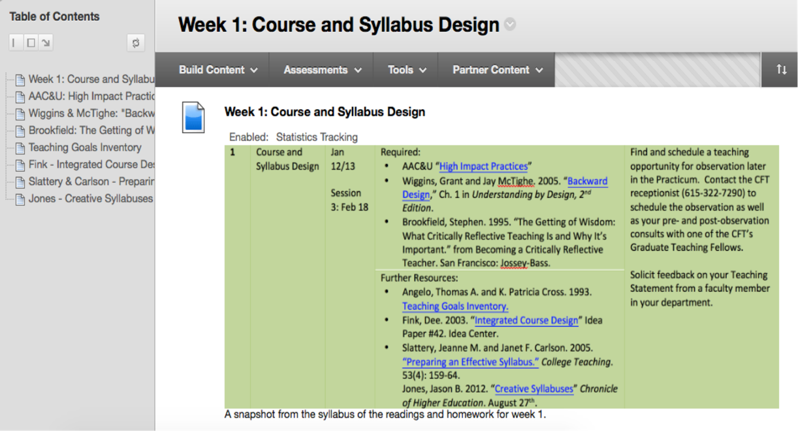

- Good Practice Communicates High Expectations
The following video illustrates how an LMS (Canvas) encouraged classroom communication and preparation to the extent that students could see how well others were performing, cumulatively raising the expectations for the class:
- Good Practice Respects Diverse Talents and Ways of Learning
This is where higher integration of an LMS into the classroom can aid instructors and students the most. If we return to the original definition of the LMS offered by Watson and Watson (2007) above, we see that the LMS emphasizes individual and organizational learning goals, along with measurement of progress and satisfaction of these goals. With that definition, the authors go on at the end of their essay to critique the “industrial model of learning” currently taking place in much of residential education:
Today’s educational system remains mired in the Industrial Age, putting the onus for learning on teachers, encouraging students to remain passive, and treating all students as if they are the same and forcing them to do the same things in the same amount of time (p. 31).
This is a model based on standardized tests taken at the same time by all students, some of whom pass while others may fail. Watson and Watson then contrast this model with what they call “an Information Age-appropriate paradigm of education,” in which:
Students will be allowed as much time as they need to achieve mastery and move on immediately upon demonstrating that mastery, requiring a customized pace and sequencing of instruction…Instruction will move to a more learner-centered approach as teachers cease acting primarily as knowledge sources and instead become facilitators of the knowledge acquisition process by acting as guides, coaches, and motivators as students become more active in their learning process (p. 31).
This is the promise of the LMS. If instructors can utilize it to facilitate student instruction, with students working together and singularly towards their own goals, then the LMS can help the classroom recognize diverse talents and ways of knowing.

References
Bonwell, C. C., & Eison, J. A. (1991). Active learning: Creating excitement in the classroom. ASH#-ERIC Higher Education Report No. 1, Washington, D.C.: George Washington University, School of Education and Human Development.
Chickering, A. & Ehrmann, S. C. (1996). Implementing the seven principles: Technology as lever. AAHE Bulletin Oct.: 3-6.
Chickering, A. & Gamson, Z. F. (1987). Seven principles for good practice in undergraduate education. AAHE Bulletin March: 3-7.
Dutton, W. H., Cheong, P. H., & Park, N. (2004). The social shaping of a virtual learning environment: The case of a university-wide Course Management System. Electronic Journal of e-Learning 2(1): 69-80.
Harrington, T., Staffo, M., & Wright, V. H. (2006). Faculty uses of and attitudes toward a Course Management System in improving instruction. Journal of Interactive Online Learning 5(2): 178-90.
Ioannou, A. & Hannafin, R. D. (2008). Course Management Systems: Time for users to get what they need. TechTrends 52(1). 46-50.
Lane, L. M. (2008). Toolbox or trap?: Course Management Systems and pedagogy. Educause Quarterly 2: 4-6.
Levine, J. M., & Moreland, R. L. (1990). Progress in small group research. Annual Review of Psychology 41: 585–634.
Navaporn, S. S. (2013). The effects of blended learning with a CMS on the development of autonomous learning: A case study of different degrees of autonomy achieved by individual learners. Computers & Education: An International Journal 61: 209-16.
Rubin, B., Fernandes, R., Avgerinou, M. D., & Moore, J. (2010). The effect of learning management systems on student and faculty outcomes. Internet and Higher Education 13: 82-3.
Watson, W. R. & Watson, S. L. (2007). What are Learning Management Systems, what are they not, and what should they become? TechTrends 51(2): 28-34.

This teaching guide is licensed under a Creative Commons Attribution-NonCommercial 4.0 International License.

