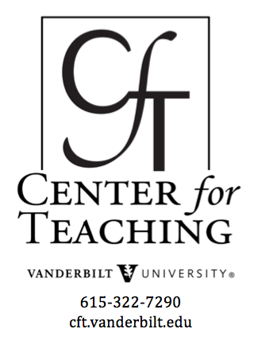
Beyond the Essay: Making Student Thinking Visible in the Humanities
by Nancy Chick
“We asked faculty to ask themselves the most important questions they could about student learning in their courses. How did they know that their students were learning? Did the students’ learning promise to last? What did teachers really know about the processes of their students’ learning, especially what we call the ‘intermediate processes,’ or the processes that experienced or expert learners employ habitually in their work but that are often tacit or absent in instruction. By asking these questions, faculty members discovered early on that what most interested–or eluded–them about their students’ learning could not be answered simply by looking at regularly assigned course work.” (Bernstein & Bass, 2005, p. 39)

In the quote above, Randy Bass reflects on The Visible Knowledge Project, a five-year, multi-campus program that sought ways of making student and faculty knowledge more visible to each other. Authentic student thinking is rarely surfaced through traditional assignments, and faculty thinking most often occurs at a distance from students’ learning experiences–in research activities, in class preparation, at conferences, in specialized journals.
Subsequent research on teaching and learning has picked up where The Visible Knowledge Project left off. Some scholars have worked on assignments that encourage students to create “external and thus concretized representations of personal understanding,” thus sharing their “process of mental construction” with faculty (Kandiko, Hay, & Weller, 2012, p. 71-72). Others have called for faculty to render explicit in the classroom the typically hidden ways of thinking and doing by disciplinary experts–not simply to model expertise but to shift students from recipients of others’ meaning-making to agents of their own meaning-making. The notion of “signature pedagogies”–ways of teaching that are “signature” or authentic to the discipline–calls for learning activities that “invoke the core characteristics of a discipline to help students think like a biologist, a creative writer, or a sociologist, rather than simply expecting them to passive accept analysis or findings of an expert who already thinks like a biologist, a creative writer, or a sociologist” (Chick, Haynie, & Gurung, 2009, p. 4).
These three ways of talking about teaching and learning—making faculty and student knowledge visible, externalizing representations of personal understanding, and having students create, produce, or perform their own interpretations or conclusions—shift students away from the role of passive recipients or consumers to creators, producers, or performers of knowledge, understanding, interpretations, and conclusions. The next two pages offer examples of humanities-based activities and assignments designed to fulfill these goals.

Introduction | Formative Activities:  Snapshots of Learning  in Progress | Summative Assignments:  Authentic Alternatives  to the Essay
 | - Concept Maps  - Word Clouds  - Word Webs | - Metaphor Maps  - Student Anthologies  - Poster Presentations

References
Bernstein, Dan, & Bass, Randy. (July/August 2005). The Scholarship of teaching and learning . Academe, 91(4). 37-43.
Chick, Nancy L, Haynie, Aeron, & Gurung, Regan A.R. (2009). From generic to signature pedagogies: teaching disciplinary understandings. Exploring Signature Pedagogies: Approaching Disciplinary Habits of Mind. Eds. Gurung, Chick, & Haynie. Sterling, WV: Stylus. 1-16.
Kandiko, Camille, Hay, David, & Weller, Saranne. (2012). Concept mapping in the humanities to facilitate reflection: externalizing the relationship between public and personal learning. Arts & Humanities in Higher Education, 12.1. 70-87.
Content is licensed under a Creative Commons Attribution-NonCommercial 4.0 International License.

