Bloom’s Taxonomy
by Patricia Armstrong
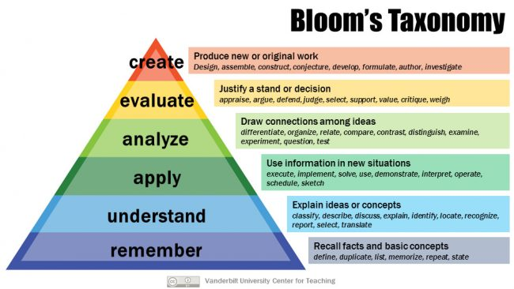

The above graphic is released under a Creative Commons Attribution license. You’re free to share, reproduce, or otherwise use it, as long as you attribute it to the Vanderbilt University Center for Teaching. For a higher resolution version, visit our Flickr account and look for the “Download this photo” icon.

Background Information
In 1956, Benjamin Bloom with collaborators Max Englehart, Edward Furst, Walter Hill, and David Krathwohl published a framework for categorizing educational goals: Taxonomy of Educational Objectives. Familiarly known as Bloom’s Taxonomy, this framework has been applied by generations of K-12 teachers and college instructors in their teaching.
The framework elaborated by Bloom and his collaborators consisted of six major categories: Knowledge, Comprehension, Application, Analysis, Synthesis, and Evaluation. The categories after Knowledge were presented as “skills and abilities,” with the understanding that knowledge was the necessary precondition for putting these skills and abilities into practice.
While each category contained subcategories, all lying along a continuum from simple to complex and concrete to abstract, the taxonomy is popularly remembered according to the six main categories.

The Original Taxonomy (1956)
Here are the authors’ brief explanations of these main categories in from the appendix of Taxonomy of Educational Objectives (Handbook One, pp. 201-207):
- Knowledge “involves the recall of specifics and universals, the recall of methods and processes, or the recall of a pattern, structure, or setting.”
- Comprehension “refers to a type of understanding or apprehension such that the individual knows what is being communicated and can make use of the material or idea being communicated without necessarily relating it to other material or seeing its fullest implications.”
- Application refers to the “use of abstractions in particular and concrete situations.”
- Analysis represents the “breakdown of a communication into its constituent elements or parts such that the relative hierarchy of ideas is made clear and/or the relations between ideas expressed are made explicit.”
- Synthesis involves the “putting together of elements and parts so as to form a whole.”
- Evaluation engenders “judgments about the value of material and methods for given purposes.”
The 1984 edition of Handbook One is available in the CFT Library in Calhoun 116. See itsACORN record for call number and availability.
While many explanations of Bloom’s Taxonomy and examples of its applications are readily available on the Internet, this guide to Bloom’s Taxonomy is particularly useful because it contains links to dozens of other web sites.
Barbara Gross Davis, in the “Asking Questions” chapter of Tools for Teaching, also provides examples of questions corresponding to the six categories. This chapter is not available in the online version of the book, but Tools for Teaching is available in the CFT Library. See itsACORN record for call number and availability.

The Revised Taxonomy (2001)
A group of cognitive psychologists, curriculum theorists and instructional researchers, and testing and assessment specialists published in 2001 a revision of Bloom’s Taxonomy with the title A Taxonomy for Teaching, Learning, and Assessment. This title draws attention away from the somewhat static notion of “educational objectives” (in Bloom’s original title) and points to a more dynamic conception of classification.
The authors of the revised taxonomy underscore this dynamism, using verbs and gerunds to label their categories and subcategories (rather than the nouns of the original taxonomy). These “action words” describe the cognitive processes by which thinkers encounter and work with knowledge:
- Remember
  - Recognizing
  - Recalling
- Understand
  - Interpreting
  - Exemplifying
  - Classifying
  - Summarizing
  - Inferring
  - Comparing
  - Explaining
- Apply
  - Executing
  - Implementing
- Analyze
  - Differentiating
  - Organizing
  - Attributing
- Evaluate
  - Checking
  - Critiquing
- Create
  - Generating
  - Planning
  - Producing
In the revised taxonomy, knowledge is at the basis of these six cognitive processes, but its authors created a separate taxonomy of the types of knowledge used in cognition:
- Factual Knowledge
  - Knowledge of terminology
  - Knowledge of specific details and elements
- Conceptual Knowledge
  - Knowledge of classifications and categories
  - Knowledge of principles and generalizations
  - Knowledge of theories, models, and structures
- Procedural Knowledge
  - Knowledge of subject-specific skills and algorithms
  - Knowledge of subject-specific techniques and methods
  - Knowledge of criteria for determining when to use appropriate procedures
- Metacognitive Knowledge
  - Strategic Knowledge
  - Knowledge about cognitive tasks, including appropriate contextual and conditional knowledge
  - Self-knowledge
Mary Forehand from the University of Georgia provides a guide to the revised version giving a brief summary of the revised taxonomy and a helpful table of the six cognitive processes and four types of knowledge.

Why Use Bloom’s Taxonomy?
The authors of the revised taxonomy suggest a multi-layered answer to this question, to which the author of this teaching guide has added some clarifying points:
- Objectives (learning goals) are important to establish in a pedagogical interchange so that teachers and students alike understand the purpose of that interchange.
- Teachers can benefit from using frameworks to organize objectives because
- Organizing objectives helps to clarify objectives for themselves and for students.
- Having an organized set of objectives helps teachers to:
  - “plan and deliver appropriate instruction”;
  - “design valid assessment tasks and strategies”;and
  - “ensure that instruction and assessment are aligned with the objectives.”
Citations are from A Taxonomy for Learning, Teaching, and Assessing: A Revision of Bloom’s Taxonomy of Educational Objectives.

Further Information
Section III of A Taxonomy for Learning, Teaching, and Assessing: A Revision of Bloom’s Taxonomy of Educational Objectives, entitled “The Taxonomy in Use,” provides over 150 pages of examples of applications of the taxonomy. Although these examples are from the K-12 setting, they are easily adaptable to the university setting.
Section IV, “The Taxonomy in Perspective,” provides information about 19 alternative frameworks to Bloom’s Taxonomy, and discusses the relationship of these alternative frameworks to the revised Bloom’s Taxonomy.
This teaching guide is licensed under a Creative Commons Attribution-NonCommercial 4.0 International License.

