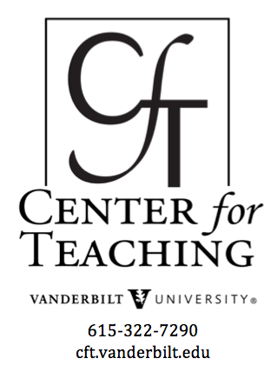
Teaching Assistants

- Questions TAs Might Ask Their Supervisors: One of the most important elements in a relationship between a TA and the TA's supervisor is open communication. The questions listed here will help a TA clarify his or her responsibilities and resources.
- The Graduate Student Experience: This interview with Ann Austin, originally published in the Spring 2002 issue of the CFT's newsletter, Teaching Forum, addresses a variety of issues relevant to graduate students -- their roles as teaching assistants, their relationships with their research advisors, and their preparation for future faculty roles.
- The TA Experience: Two Vanderbilt professors -- Ken Frampton (Engineering) and Jo-Anne Bachorowski (Psychology) -- reflect on their faculty experiences in light of their experience as TAs in this interview, originally published in the Spring 2002 issue of the CFT's newsletter, Teaching Forum.
- Learning by Doing: Four teaching assistants discuss how their teaching assistantships are preparing them for future academic positions. The TAs describe those experiences that they have found to be most enjoyable and challenging in this panel interview, originally published in the Spring 2002 issue of the CFT's newsletter, Teaching Forum.
- Innovations by TAs: Three TAs describe ways in which they have effectively expanded the borders of their classrooms through various creative strategies in this article, originally published in the Spring 1999 issue of the CFT's newsletter, Teaching Forum.
- Learning from Teaching Assistants: Four undergraduates discuss how teaching assistants have contributed to their learning in this article, originally published in the Spring 2002 issue of the CFT's newsletter, Teaching Forum.
- Advice for TAs from Undergraduates: Undergraduate students offer advice to Teaching Assistants in this article, originally published in the Fall 1998 issue of the CFT's newsletter, Teaching Forum.
- Tips from CFT Fellows: Several graduate students working at the CFT offer tips for TAs in this article originally published in the Fall 1998 issue of the CFT's newsletter,Teaching Forum.
- First Day to Final Grade (Book Review): This book was written to prepare TAs for their teaching duties. The link above leads to a review of this book originally published in the Spring 2002 issue of the CFT's newsletter, Teaching Forum.
- Graduate Development Network: Many Vanderbilt organizations have joined together to support the professional and personal development of graduate students. This website lists current activities and services.

Content on this site is licensed under a Creative Commons Attribution-NonCommercial 4.0 International License.

