Running Head: Adding patterns to the equation

Beyond Numeracy in Preschool: Adding Patterns to the Equation

Bethany Rittle-Johnson
Emily R. Fyfe
Abbey M. Loehr
Michael R. Miller
Vanderbilt University

Author Note
Bethany Rittle-Johnson, Emily R. Fyfe, Abbey M. Loehr, and Michael R. Miller, Department of Psychology and Human Development, Vanderbilt University. Michael R. Miller now at Department of Pediatrics, Children’s Health Research Institute, Western University, London, Ontario, Canada.

Research supported by National Science Foundation grant DRL-0746565 to Bethany Rittle-Johnson and Institute of Education Sciences post-doctoral training grant R305B080008 to Vanderbilt University. Fyfe was supported by a Graduate Research Fellowship from the National Science Foundation. The authors thank Laura McLean, Heather Dunham, Katharine Miller, Maddy Feldman, Emily Esposito, and Cristina Zeppos for their assistance with data collection and coding as well as the staff, teachers, and children at Blakemore Children’s Center, Bellevue Active Learning Center, Centennial Child Development Center, Children’s Christian Center, The Gardner School, Glen Leven Presbyterian Church Dayschool, Gordon Jewish Community Center Preschool, Holly Street Daycare, Fannie Battle Day Home for Children, St. Mary Villa Child Development Center, Temple Preschool, and West End Weekday Preschool for participating in this research.

Address correspondence to Bethany Rittle-Johnson, Department of Psychology and Human Development, 230 Appleton Place, Peabody #552, Vanderbilt University, Nashville TN 37203, USA. Email: bethany.rittle-johnson@vanderbilt.edu,

Abstract
Patterns are a pervasive and important, but understudied, component of early mathematics knowledge. In a series of three studies, we explored (a) growth in children’s pattern knowledge over the pre-K year (N = 65), (b) the frequency of pattern activities reported by parents (n = 20) and teachers (n = 5) relative to other mathematical activities, and (c) changes in 4-year-old children’s pattern knowledge after brief experience generating or receiving explanations on patterns (N = 124). Together, these studies illustrate the types of experiences preschool children are receiving with patterns and how their pattern knowledge changes over time and in response to explanation. Young children are able to succeed on a more sophisticated pattern activity than they are frequently encouraged to do at home or at school.

Keywords: Mathematics development; mathematics standards; patterns; knowledge sources; self-explanation; instructional-explanations

Beyond Numeracy in Preschool: Adding Patterns to the Equation
“It’s a pattern!” Young children, parents, teachers, and educational TV and games all emphasize patterns in the world. Patterns are a predictable sequence, and the first patterns young children usually interact with are repeating patterns (i.e., linear patterns that have a unit that repeats, such as the colors blue-blue-red-blue-blue-red). Exploring pattern and shape was the most common mathematical activity observed during the play of 4- and 5-year-olds, accounting for 20–40% of the observed time in U.S. preschools (Ginsburg, Inoue, & Seo, 1999; Ginsburg, Lin, Ness, & Seo, 2003). Preschool teachers also view pattern activities as important (Clarke, Clarke, & Cheeseman, 2006; Economopoulos, 1998), and educational games and TV shows often incorporate them.
In addition to being a common topic for young children, patterns are considered a central idea in mathematics (Charles, 2005; Sarama & Clements, 2004; Steen, 1988). Identifying, extending, and describing predictable sequences in objects or numbers are core to mathematical thinking. For example, counting and arithmetic principles describe generalizations of predictable sequences, such as the next number name in the count sequence represents a magnitude that is exactly one more than the previous number name (the successor function). Similarly, functional relationships capture predictable input-output relations between two variables (e.g., y = 2x + 5). Working with repeating patterns provides early opportunities to identify and describe predictable sequences, and many early mathematics education researchers consider patterns to be central to early mathematics thinking, particularly algebraic thinking (Burton, 1982; Fox, 2005; Lee & Freiman, 2006; Mulligan & Mitchelmore, 2009; Papic, 2007; Papic, Mulligan, & Mitchelmore, 2011; Sarama & Clements, 2004; Warren & Cooper, 2006).
New research on patterns provides strong evidence that pattern knowledge is central to mathematics achievement. In a six-month intervention, struggling first-grade students were randomly assigned to learn about patterns, numeracy, reading, or social studies. Across two studies, children who received pattern instruction performed as well or better on several standardized mathematics assessments relative to children who received numeracy instruction, and systematically better than children who received reading or social studies instruction (Kidd et al., 2013; Kidd et al., 2014). A specialized preschool pattern intervention that focused on the unit of repeat in repeating patterns supported greater knowledge of both repeating and growing patterns in Kindergarten (Papic et al., 2011) and knowledge of repeating patterns has been used to support thinking about ratios (Warren & Cooper, 2007). Further, pattern knowledge in elementary school is predictive of algebraic proficiency a year later (Lee, Ng, Bull, Pe, & Ho, 2011). Thus, multiple studies indicate that understanding patterns is important for mathematics achievement.
Despite the importance of patterns, a vast majority of research on early mathematics focuses exclusively on numeracy (Sarama & Clements, 2004). To help address our limited knowledge of early development of pattern knowledge, the goals of the current paper were to explore growth in repeating pattern knowledge over the pre-K year (Study 1), describe exposure to pattern activities reported by parents and teachers (Study 2), and explore the impact of explanations in learning to abstract patterns (Study 3). In the next section, we review what is known about early development of pattern knowledge

From Duplicating and Extending to More Sophisticated Pattern Tasks
The most common and popular pattern tasks for preschoolers are creating, duplicating, and extending repeating patterns (Economopoulos, 1998). For example, children are shown an ABBABB pattern and asked to make an exact replica of the pattern (duplicate) or to continue the pattern (extend, see top row of Figure 1). This is in line with the NAEYC Standard 2.F.08: “Children are provided varied opportunities and materials that help them recognize and name repeating patterns” (NAEYC, 2014, p. 17). Many 4-year-old children can duplicate repeating patterns and some can extend patterns (Clements, Sarama, & Liu, 2008; Papic et al., 2011; Starkey, Klein, & Wakeley, 2004).
However, duplicating and extending patterns can be completed using object-matching strategies and may not stand up to mathematical considerations (Threlfall, 1999). Mathematical patterns rest on generalizing and abstracting relationships that go beyond object matching. As Economopoulos (1998) noted, “To generalize and predict, children must move from looking at a pattern as a sequence of ‘what comes next’ to analyzing the structure of the pattern, that is, seeing that it is made of repeating units” (p. 230). Thus, children must learn to identify the pattern unit: the part of the pattern that repeats (Clements & Sarama, 2009; Papic et al., 2011).
We propose that pattern abstraction helps young children learn to focus on the pattern unit, making it a more mathematically relevant task than duplicating and extending patterns. Pattern abstraction requires making the same kind of pattern using new objects. For example, children might be shown a blue-yellow-yellow-blue-yellow-yellow pattern and be asked to create the same kind of pattern using orange squares and circles (see Figure 1). This abstraction requires children to pay attention to the overall structure of the pattern rather than its surface features. Pattern abstraction cannot be executed using an object-matching strategy, and it emphasizes the need to abstract the relationships beyond specific objects. This task has been recommended by some educators, but without empirical evidence on the difficulty, validity, or value of the task (Clements & Sarama, 2009; Mulligan & Mitchelmore, 2009; Warren & Cooper, 2006).
Children also learn to explicitly recognize the pattern unit (pattern unit recognition), such as identifying the set of elements that repeat. For example, children have been asked to say or to circle the part of the pattern that is repeating (Papic et al., 2011; Warren & Cooper, 2006) or to use the smallest number of objects to make their own pattern while keeping the pattern the same as in the model pattern (Sarama & Clements, 2010). A less explicit measure is to ask children to reproduce a pattern from memory with the same number of units as the model pattern (Papic et al., 2011). Children who are successful on this task typically verbalized the pattern unit and noted how many times it repeated.
In a recent study, we found that a substantial minority of 4-year-old children was able to abstract patterns (Rittle-Johnson, Fyfe, McLean, & McEldoon, 2013). Children participated in the Fall of their pre-K year (the year before starting Kindergarten), and most children could duplicate patterns and about half could extend patterns. Pattern abstraction was more difficult than duplicating and extending patterns, but was achievable by some preschool children. Very few 4-year-old children were successful with explicit pattern unit recognition. This study led to a four-level construct map for repeating pattern knowledge, which was an extension of the learning trajectory for patterns and structure proposed by Clements and Sarama (2009). A construct map represents the continuum of knowledge through which people are thought to progress, but it is not comprised of distinct stages as knowledge progression is continuous and probabilistic (Wilson, 2005). At Level 1, children can duplicate patterns, and at Level 2, they can extend patterns. At Level 3, children can abstract the underlying pattern well enough to generate a pattern using different materials. At this level, children must be able to represent the pattern at a non-perceptual level to recreate the pattern with new materials. Finally, at Level 4, children can explicitly recognize the smallest unit of a pattern. Thus, Levels 3 and 4 of our construct map go beyond basic skills with repeating patterns and assess children’s understanding of pattern units. See Figure 1 for sample items from each level.
Current Study
In the current study, we extend this prior research by evaluating growth in repeating pattern knowledge over the pre-K year (Study 1) and describing exposure to pattern activities reported by parents and teachers (Study 2). This is meant to provide background information on knowledge change and potential sources of this change. The final study explores the impact of explanations in learning to abstract patterns (Study 3).
Study 1
In the Fall of their pre-K year, we found large individual differences among 4-year-old children in their repeating pattern knowledge, spanning across the four knowledge levels hypothesized in our construct map (Rittle-Johnson et al., 2013). We reassessed the same children near the end of their pre-K year to evaluate growth in their pattern knowledge.
Method
Participants. Sixty-five of the 66 children from the initial study participated at follow-up (36 females). One child had moved away. Children attended one of six pre-K classes at four preschools. Three of the preschools served primarily Caucasian, middle- and upper-middle-class children (n = 47), and the other preschool had a publicly funded pre-K program serving primarily African American, low-income children (i.e., all children qualified for free- or reduced-lunch; n = 18). Approximately 35% of the participants were racial or ethnic minorities (26% African American), and their average age was 5.2 years (range = 4.7 – 5.9 years).
Materials. We used the same 10-item assessment administered in our previous study, which had been adapted from previous assessments (Papic et al., 2011; Sarama & Clements, 2010; Starkey et al., 2004). As shown in Table 1, there was one Level-1 item (duplicate a pattern), two Level-2 items (extend a pattern), four Level-3 items (abstract a pattern) and three Level-4 items (pattern unit recognition). The distribution of items across levels reflects our primary interest in Levels 3 and 4. Figure 1 shows example items at each level, including a picture of the pattern task, instructions, and a correct solution.
The model pattern for most items was constructed with colored shapes from a tangram puzzle set that had been glued to a strip of cardstock, with two instances of the pattern unit (e.g., AABAAB). To respond, children were given enough materials to complete two full units and one partial unit of the model pattern on most items. For the duplicate, extend, and memory items, children’s materials were identical to the materials in the model pattern. For the abstract-to-color items, children’s materials were a uniform three-dimensional shape in two colors that differed from the model pattern. For the abstract-to-shape items, the model pattern consisted of painted wooden cubes, and children’s materials were small flat shapes of unpainted wood. For the unit tower item, the model pattern was made of two different colors of Unifix cubes, and children’s materials were Unifix cubes in the same colors.
Procedure. The items were administered in one of two fixed orders to each child individually in a quiet room at his or her preschool in May, very near the end of the school year. Instructions for most of the items are included in Figure 1. Two of the Level-4 items merit additional information on how they were administered. For the unit memory item, children were shown a pattern for 5 seconds and then prompted to “Make the same kind of pattern as mine with the same number of blocks in the same places as mine,” after it was hidden (Papic et al., 2011). They practiced the task with an AB pattern. For the unit identification item, children were asked: “Can you move the stick to show where the pattern starts over again?” after a demonstration on an AB pattern.
Item screening. Because the assessment was administered in one of two orders, we first evaluated whether order affected accuracy on any of the items using between-subjects t tests on accuracy on each item. Accuracy on each item was comparable across the two orders, ts < 0.91, ps > .05. Similar to the item-by-item analyses, children’s overall accuracy did not differ for the two orders, F = .082, p > .05.
We also screened the 10 items for sound psychometric properties. Only one item was approaching a ceiling effect (the duplicate item). Items at Levels 1–3 had acceptable to good item-total correlations ranging from 0.25–0.87 (see Table 1). The Level-4 items on pattern unit recognition were much more difficult, and some were only weakly related to performance on the other items (item-total correlations ranging from 0.14 – 0.39). Because one of the Level-4 items (i.e., unit identification) had to be dropped from the assessment in the Fall due to an extremely low item-total correlation, this item was also dropped from the current analyses to allow for direct comparison between Fall and Spring.
Item difficulty was estimated using a Rasch model, which is a one-parameter member of the item response theory family of models (Bond & Fox, 2007). Traditional estimation procedures for Rasch models, such as conditional and marginal maximum likelihood estimation, require moderate to large sample sizes to be reliable. Because of this, we used a newer estimation procedure called Laplace approximation and empirical Bayesian prediction that has been shown to be stable for sample sizes around 50 (Cho & Rabe-Hesketh, 2011; Hofman & De Boeck, 2011). Our estimation procedure treated both items and respondents as random effects, whereas traditional estimation methods treat respondents as a random effect and items as a fixed effect, assuming a normal distribution and variance for the items (Bock & Aitkin, 1981). Laplace approximation was implemented in R (http://www.r-project.org/), using the lmer function of the lme4 package (Bates, Maechler, & Dai, 2008).
Results
Evidence for reliability and validity of the assessment. Two sources of evidence affirm the reliability of the assessment. The assessment was internally consistent as assessed by Cronbach’s alpha (α = 0.84). Relative performance on the assessment was stable from Fall to Spring, with a fairly high test-retest correlation, r(63) = .58, p < .01.
The validity of the assessment, particularly the internal structure of the measure, was evaluated by inspecting whether our construct map correctly predicted relative item difficulties. Item difficulty scores and standard errors are listed in Table 1. As with the Fall data, in the Spring, the duplicate item was the easiest, the extend items were relatively easy (with difficulty estimates < 0), the abstract items were of moderate difficulty, and the unit recognition items were most difficult (with difficulty estimates > 1). A Spearman’s rank order correlation between hypothesized difficulty level and empirically derived item difficulty in the Spring was very high, ρ(7) = .97, p < .001. Across Fall and Spring, the item difficulties remained fairly stable when accounting for standard error. We used standard errors to construct 95% confidence intervals around item difficulty estimates, and the confidence intervals overlapped for all items.
Growth in knowledge. Total scores improved from the Fall to the Spring, with children successful on two additional items on average (M_{Fall} = 3.23 out of 9, SD = 2.55 vs. M_{Spring} = 5.12, SD = 2.59, t(64) = -6.47, p < .001). Inspection of Table 1 indicates that the proportion correct for each item at Levels 1–3 improved by at least 0.2. Substantial improvements were made on pattern duplication (M_{Fall} = 0.78, SD = 0.41 vs. M_{Spring} = 0.95, SD = 0.21, McNemar test p = .007), pattern extension (M_{Fall} = 0.48, SD = 0.42 vs. M_{Spring} = 0.71, SD = 0.38, t(64) = -4.05, p < .001), and pattern abstraction (M_{Fall} = 0.31, SD = 0.39 vs. M_{Spring} = 0.60, SD = 0.44, t(64) = -5.28, p < .001). Children did not improve in pattern unit recognition (M_{Fall} = 0.13, SD = 0.25 vs. M_{Spring} = 0.19, SD = 0.30, t(64) = -1.26, p = .21).
To gain further insight into children’s pattern knowledge, we examined children’s errors and compared them to errors made in the Fall. We coded children’s errors based on the system used in our previous study (Rittle-Johnson et al., 2013). In the Fall, error classifications emerged from a detailed analysis of children’s incorrect responses and discussion with five mathematics education researchers with previous experience in the area. In the Spring, we used the existing coding scheme to classify error types. Excluding the unit tower item, all errors for the remaining items could be classified into one of six categories. Two coders independently classified all of children’s errors, with a Kappa of .85. Three error types reflected at least some pattern knowledge: (1) partially correct, which contained at least one full unit of the pattern but with errors before or after, and (2) wrong pattern AB, in which children created an AB pattern, or (3) wrong pattern other, in which they created some other pattern. These three error types occurred on 31% of all trials in both the Fall and Spring. Three other error types were less sophisticated and did not involve patterns: sorting the objects, placing the objects in random sequences, or using the objects in an off-task manner. It was these less sophisticated errors that decreased between the Fall and Spring, They occurred on 26% of all trials in the Fall, but only on 8% of all trials in the Spring. See Table S1 in the online supplementary materials for descriptions, examples, and frequency data for each error type. Thus, the types of errors children made also became more sophisticated over the pre-K year.
Discussion
Children showed growth in pattern knowledge between the Fall and Spring, both in accuracy and in error quality. Findings supported our four-level construct map for repeating pattern knowledge. Items were at the expected level of difficulty and children showed growth at Levels 1 – 3, which involved duplicating, extending and abstracting patterns (see Figure 1). Growth in abstracting patterns indicates that even young children are able to move beyond object-matching strategies that can be used to duplicate and extend patterns and pay attention to the overall structure of the pattern. Pattern abstraction has been recommended by some educators, but without empirical evidence on the difficulty, validity, or value of the task (Clements & Sarama, 2009; Mulligan & Mitchelmore, 2009; Warren & Cooper, 2006). The current findings confirm that pattern abstraction is an accessible task for preK children. Because pattern abstraction requires the mathematically important skills of generalizing and abstracting relationships that go beyond object matching (Economopoulos (1998), we believe preschool teachers should encourage pattern abstraction. At the same time, children did not improve in more explicit pattern unit recognition (e.g,, their ability to explicitly recognize the smallest unit of a pattern), supporting our claim that explicit pattern unit recognition is more difficult than pattern abstraction. This may reflect minimal attention to explicit pattern unit recognition by parents and teachers. It may also reflect children’s difficulty understanding task directions and demands for these items, rather than in their underlying knowledge. Further, knowledge changes may reflect the particular experiences of the participating children and may not generalize to children who do not attend preschool or who have different home or preschool experiences with patterns.

Study 2
What was the source of growth in pattern knowledge? Research on numeracy indicates that home and school numeracy experiences help predict young children’s numeracy knowledge and development (Anders et al., 2012; Kleemans, Peeters, Segers, & Verhoeven, 2012; LeFevre et al., 2009; Manolitsis, Georgiou, & Tziraki, 2013). The same is likely true for patterns. In our past pattern study, teachers reported doing pattern activities an average of 10 times per week (Rittle-Johnson et al., 2013). Parents may also engage their children in pattern activities. Furthermore, we wanted to learn more about the nature of pattern activities that teachers use. Thus, in Study 2, we surveyed parents and preschool teachers about pattern activities in the context of other mathematical activities.
Method
Participants. Parents or guardians of participants in Study 1 were invited to complete a survey near the end of the pre-K year on math-related activities they did with their child. Parents could complete a paper survey and return it to their child’s teacher or complete the survey online. Twenty parents or guardians completed the survey (31% response rate). This fairly low response rate limits the generalizability of the findings, but the diversity of the respondents suggests that the findings were not limited to a particular demographic group. Nineteen respondents reported demographic information. Thirteen mothers, four fathers, and two grandparents or other guardians responded. Ten children were female, and there was good racial diversity (10 Caucasian, non-Hispanic; five African American; two Hispanic or Latino; two other race). Respondents’ highest education was diverse (one with some high school, three completed high school or GED, five had some college or a two-year degree, four had a bachelor’s degree, and six had a master’s or professional degree). Occupations also varied (e.g., social worker, hair stylist, event manager, graduate student, physician).
Five of the six teachers of children from Study 1 volunteered to complete a survey near the end of the pre-K year. All five teachers were female, had taught preschool for at least five years, and had either a certificate or B.A. in Early Education. Researchers met with the teachers and administered the survey verbally so that they could answer teacher’s questions and clarify responses.
Materials. The parent survey was based on surveys used by LeFevre and colleagues to gather parent reports on the home numeracy environment, academic expectations, and academic attitudes (LeFevre, Polyzoi, Skwarchuk, Fast, & Sowinski, 2010; LeFevre et al., 2009; Skwarchuk, Sowinski, & LeFevre, 2014). The first section was a 20-item parent questionnaire on potential pattern, numeracy, and other mathematical activities, using the same format as past surveys, but with new items focused on patterns and related activities. Parents were asked to rate how often they engaged in certain activities with their child, such as making or duplicating patterns, on a 5-point scale ranging from rarely or never to almost daily. Table S2 in the online supplementary materials contains a list of all 20 items and the rating scale. Parents also reported what they would tell their child the word “pattern” meant. Next, parents were asked to report their academic expectations for their child in mathematics; parents reported how important mastering certain skills (e.g., knowing all 26 alphabet letters, counting to 100) were before Grade 1 on a scale from one (not important) to five (very important). An item, Make and talk about patterns, was added to the scale used previously. The third section of the questionnaire requested information regarding whether math and reading activities were taught in the home, confidence in the activities, and attitudes about math and reading. Parents were asked to agree or disagree on a scale from one (strongly disagree) to four (strongly agree). The final section requested demographic information.
The teacher survey was similar in content to the first section of the parent survey. The bulk of the survey was a 13-item questionnaire on potential pattern activities. Teachers were asked how many times per week they modeled the activities and how many times per week their students did the activities in the past three months. Table S3 in the online supplementary material contains a list of all 13 items and the frequency and range of reported responses. Teachers also reported what they would tell their child the word “pattern” meant and how important they thought patterning skills were. Given the small number of open-ended items, we report on each response in the results.
Results
Parent survey. Parents reported doing a range of pattern activities at least once a week. Parents reported that their child noticed patterns in the world almost daily and that they read books and watched TV shows that included patterns about two to four times a week. Parents reported doing a number of pattern activities about once per week. These included making or duplicating patterns, figuring out what comes next in a pattern, asking their child to say in words what the pattern is, playing computer games that included patterns, and discussing patterns in days of the week, months, or year. Other pattern activities were rare, such as playing hand or motion games with patterns (e.g., hokey-pokey) and naming patterns using letters of the alphabet (e.g., that’s an ABB pattern). Across all activities, children seemed to be doing about 9–10 pattern activities at home each week. The reported frequency of pattern activities was similar to the frequency of other mathematical activities, such as identifying shapes and colors, counting, and discussing number facts (such as 2 + 2 = 4). See Table S2 in the supplemental materials for the median reported frequency for each survey item.
To gather evidence for the validity of these parent reports, we explored whether the frequency of reported pattern activities was related to children’s total pattern scores in the Spring. We created a composite pattern activity score for each parent by averaging across pattern items, assigning a score of 1 (rarely or never) up to a score of 5 (almost daily). Controlling for children’s age and total pattern score in the Fall, the frequency of pattern activities reported by parents was moderately correlated with their child’s total pattern score, r(16) = .43, p = .07, but was only marginally significant, likely due to the small sample size.
Most parents (62% that responded to the question, or eight out of 13 parents) reported that if their child asked what a pattern is, they would respond by either explaining a pattern as something that repeats or by giving an example using colors or shapes in which the order repeats (e.g., circle, square, circle) in a way that you can predict what comes next. Two parents reported that they would explain a pattern by using an example or by making a pattern together without specifying what the example or pattern would be. Three parents vaguely described a pattern as a group of things or as a design.
Parents also reported information about academic expectations for their children by the end of the first grade. A majority of parents (63%) agreed making and talking about patterns was a very important skill, and the remaining 37% rated this skill as important. Almost all parents (90%) agreed being able to count up to 10 objects and knowing all 26 alphabet letters were very important skills. A majority also thought printing the alphabet (74%) and counting to 100 (58%) were very important.
All but two parents reported that math and reading skills were taught in their home. However, 53% of parents reported being unsure of what math activities to do with their child, whereas only 21% were unsure of what reading activities to do. Finally, 63% of parents agreed and 11% strongly agreed that they liked math, whereas 32% agreed and 68% strongly agreed that they liked reading. Overall, parents were more comfortable with reading and felt more confident in how to help their children learn to read compared to math.
Teacher survey. None of the teachers reported using a specialized curriculum focused on patterns. All five teachers reported that patterns were important relative to other math skills. Two teachers specifically used the term “pretty important,” two others used the term “very important,” and the fifth teacher simply said “important.” One teacher also noted that the school district’s report card for pre-K included patterns as one of the first math skills. When asked what they would tell their students the word pattern meant, all five teachers descriptively defined a pattern as something that repeats. Specifically, they defined patterns as: “shapes that repeat,” “something about it repeats,” “repeats itself,” and “picture or action that repeats itself.” The fifth teacher said she would give an example of red-blue-red-blue.
Teachers varied in what kinds of pattern activities they did in their classrooms, as well as how frequently they did these activities. Table S3 in the online supplemental materials includes the reported frequency of each activity on the questionnaire. All five teachers reported modeling or having their students make or duplicate patterns with objects or sounds, think about what comes next in a pattern (i.e., extend a pattern), and say in words what the pattern is. All but one teacher reported playing hand movement games involving patterns (e.g., Miss Mary Mack) often. Most teachers also reported talking about patterns in the days of the week, months of the year, or seasons several times a week. Overall, teachers reported engaging their children in frequent pattern activities focused on creating, duplicating, extending, and naming patterns.
Three of the five teachers reported sometimes engaging in activities that went beyond creating, duplicating, and extending patterns. These three teachers reported identifying the unit of repeat and either naming patterns with letters (e.g., This is an ABB pattern) or using abstract language by referring to elements of the pattern as same or different. Two of the teachers reported abstracting patterns once or twice a week. One of the teachers asked her students to do most of these activities (rather than her doing it). Informal analyses indicated that abstract pattern scores were not systematically better for children in classrooms engaging in pattern abstraction relative to classrooms that were not.
Discussion
Overall, this select group of parents and teachers reported that they frequently engaged their children in pattern activities. At home, activities ranged from reading books and watching television shows that included patterns to creating, duplicating, extending, and naming patterns at least once a week. Pattern activities seemed almost as common as other mathematical activities at home. Preschool teachers reported frequently engaging children in similar pattern activities at school. Children also spontaneously noticed patterns in the world around them (Ginsburg et al., 1999; Ginsburg et al., 2003). Clearly, preschool children are exposed to and spontaneously engage in many pattern activities. The activities at home likely did not focus attention on the unit of repeat, although it was difficult to gather this information. Three of the five preschool teachers reported some attention to this more sophisticated skill, and two reported occasionally abstracting patterns. As with numeracy, pattern activities were relatively common at home and at school, and engagement in these activities may support children’s pattern knowledge.
Although informative, these results should be interpreted with the study’s limitations in mind. For example, there are a number of issues with the sample that limit the generalizability of the findings. First, the number of parents and teachers interviewed was small and they were from a convenience sample. Second, parent response rate was low, which may limit the representativeness of the responses. It is possible that the frequency of pattern activities differs between parents who did and did not respond. Further, the parents who did respond may have been influenced by social desirability, thus reporting engaging in more pattern activities than actually occurs. Finally, the current study provides no evidence for a causal relation between engaging in pattern activities and children’s pattern knowledge. Although the frequency of reported pattern activities at home was correlated with children’s pattern scores, the direction of this relationship remains unclear. One possibility is that engaging in more frequent pattern activities and discussion at home leads to higher pattern knowledge. However, it is also plausible that children with higher pattern knowledge elicit more pattern activities and discussion with their parents or that frequency of pattern activities is just a proxy for general intellectual engagement and stimulation by parents. Despite these limitations, the current results provide preliminary insight into the frequency and nature of pattern activities that some preschool children engage in both in the classroom and at home.
Study 3
Parents and teachers encourage children to describe patterns in words, and talking about patterns may play an important role in supporting pattern knowledge. Study 3 focused on the role and source of explanations in particular. People who are provided explanations often learn more than people who are not given explanations (e.g., Tenenbaum, Alfieri, Brooks, & Dunne, 2008; Wittwer & Renkl, 2010). Experts (e.g., teachers or parents) provide these instructional-explanations with the goal of elucidating why or how something works. It is common for parents to provide explanations to their children, and more frequent explanations are associated with greater knowledge in young children (Dunn, Brown, Slomkowski, Tesla, & Youngblade, 1991; Ruffman, Slade, & Crowe, 2002). At the same time, prompting even young children to generate their own explanations (i.e., self-explanations) can improve their learning (Amsterlaw & Wellman, 2006; Brown & Kane, 1988; Pillow, Mash, Aloian, & Hill, 2002; Tenenbaum et al., 2008), including learning about patterns (Rittle-Johnson, Saylor, & Swygert, 2008). Together, this research suggests that explanation, both provided by experts and generated by the learner, support children’s understanding.
In Study 3, we contrasted whether explanations about patterns were generated by the child (self-explanation), were provided by a more knowledgeable other (instructional-explanation), or were used in combination (instructional- and self-explanation). Recent arguments have favored providing instructional-explanations, as teaching children directly reduces demands on cognitive resources, supports accurate knowledge acquisition, and takes advantage of efficient social learning (Csibra & Gergely, 2009; Kirschner, Sweller, & Clark, 2006; Klahr & Nigam, 2004). However, a majority of experimental research on instructional- and self-explanations has been conducted with adolescents and adults and tested the presence versus absence of one type of explanation (rather than contrasting the two types). The three most relevant prior studies with young children used varied conditions and their findings do not converge. In one, 4-year-olds showed better analogical transfer when prompted to self-explain than when given an instructional-explanation (Brown & Kane, 1988). A second study found that 5- to 8-year-olds’ emotion understanding improved equally when asked to provide self-explanations or given instructional-explanations, and both were better than a no-explanation control condition (Tenenbaum et al., 2008). A third study found that 6- to 8-year-olds learned a comparable amount when self-explanation was prompted with or without instructional-explanations (Crowley & Siegler, 1999). Overall, two of the three studies found no differences across explanation conditions, suggesting that the source of the explanation (i.e., the learner or expert) may not matter, at least for young children. Study 3 contrasted the source of the explanation for preschoolers learning about pattern abstraction.
Method
Participants. Participants were 124 children (53 female) in one of 20 classrooms drawn from 10 preschools serving middle- and upper-middle-class families and had not participated in Study 1. Approximately 23% of the participants were racial or ethnic minorities, and the average age was 4.6 years (range = 4.0 – 5.8 years). None of the preschools were using a specialized curriculum focused on patterns, but teachers reported doing pattern activities an average of 10 times per week (range 4 – 22 times per week). The most common activity was to have children create their own pattern (M = 3.2 times per week), but duplicating and extending patterns were also common activities (M = 2.0 and 1.8 times per week, respectively). Most teachers (73%) also reported either identifying the core pattern unit for children or requesting that children do so once or twice a week. Over half of the teachers (60%) also asked children to abstract patterns about twice a week.
Assessment. Pattern knowledge was assessed using most of the assessment items from Study 1, but was shortened to accommodate children’s limited attention span given the addition of tutoring in this study. The pretest pattern assessment (α = .64) consisted of the one duplicate, two extend, and the Abstract-to-Shape AABB and Abstract-to-Color AAB items (see Table 1). The posttest pattern assessment (α = .73) included all five items from the pretest along with an additional abstract item (i.e., Abstract-to-Color AABB) and two pattern unit recognition items (i.e., unit identification and unit tower) for a total of eight items. The items were administered in the same fixed order. Although beyond the scope of the current research question, established assessments of children’s cognitive skills (i.e., working memory, inhibitory control, set shifting and relational knowledge) were also administered (see Miller, Rittle-Johnson, Fyfe, & Loehr, 2013).
Design and procedure. All children participated in two one-on-one sessions on consecutive days. In the first session, children completed the pretest pattern assessment and the first half of the tutoring. In the second session, children completed the second half of the tutoring and the posttest pattern assessment. Each session lasted approximately 30 minutes and included a short break halfway through, including completing the cognitive skills assessments. Children were randomly assigned to one of three conditions: instructional-explanation (n = 41), self-explanation (n = 41), or instructional- and self-explanation (n = 42).
During the tutoring, all children alternated between studying correct examples of pattern abstraction items and solving pattern abstraction items for a total of 10 trials. For the correct example trials, children were shown two pre-made patterns that had the same underlying unit of repeat using different materials. For the solve trials, the items had the same format as on the assessment, but children received accuracy feedback and were shown a correct solution if they solved it incorrectly. See Figure 1 for an example abstract item.
In the instructional-explanation condition, on each item, the pattern was labeled using shared labels that could be used across patterns. Shared verbal label encourages children to look beyond surface features like object properties for underlying similarities (Gentner & Loewenstein, 2002; Graham, Namy, Gentner, & Meagher, 2010). For example, on a pair of AAB patterns, children were told for each pattern “The part that repeats is two that are the same and one that is different,” in addition to an explanation for why two patterns were alike (e.g., “because the part that repeats is the same”). In the self-explanation condition, children were prompted to explain their own pattern and why two patterns were the same (e.g., “What is your pattern? How is my pattern the same kind of pattern as yours?”). In the instructional- and self-explanation condition, children alternated between receiving instructional-explanations and being prompted to self-explain. On solve items, all explanations occurred after children received feedback and were shown a correct solution if necessary.
Results
Table 2 presents mean accuracy scores by condition at pretest, tutoring session, and posttest, broken down by item type. At pretest, most children could duplicate a pattern, many could extend patterns, and some could abstract patterns. At posttest, children had improved on the abstract pattern items (M_{pretest} = 0.38, SD = 0.41 vs. M_{posttest} = 0.67, SD = 0.40, t(123) = -8.63, p < .001). However, they had not improved on the duplicate or extend items, ps > .70. Some children were successful with the unit of repeat items.
At posttest, there were no reliable differences between conditions on total scores or abstract pattern items, controlling for age and pretest score, Fs(2, 119) < 0.20, ps > .05 (see Table 2). Informal analyses indicated that the conditions also did not differ in the quality of errors that children made.
Accuracy scores during the tutoring session suggested an initial benefit of instructional-explanations that faded by the second day. For accuracy on Day 1, there was a main effect of condition after controlling for age and pretest scores, F(2, 119) = 3.07, p = .05. Post-hoc tests indicated that children in the instructional-explanation condition solved more problems correctly than children in the self-explanation condition, but the other conditions did not differ from each other. This difference was no longer present on Day 2 of the tutoring, F(2, 119) = 0.37, p = .69. Thus, children learned just as much if they generated explanations on their own than if they received instructional-explanations or alternated between instructional- and self-explanations. The source of the explanations, including the inclusion of verbal labels, was not important for learning.
Children’s self-explanations during the intervention provided some insights into their thinking about patterns. We coded their explanations to the prompt “How is my pattern the same kind of pattern as yours?” based on the system used in our previous study (Rittle-Johnson et al., 2013). In the previous study, codes emerged from a detailed analysis of children’s responses. We expanded one of the codes into three different types of codes because it occurred frequently enough to allow for more fine-grained distinctions in this study. A trained research assistant coded children’s explanations and a second assistant coded the responses of about 30% of the children (n = 24 out of 83) who provided explanations. Interrater reliability was high (Kappa = .96). Children in the instruction condition could not be considered in this analysis because they did not provide any self-explanations.
Although children were asked to explain how the two patterns were alike, the majority of explanations were in reference to a single pattern (see Table 3). For example, a common explanation was to label the elements from one of the patterns in order (e.g., “mine goes red, red, blue, red, red, blue”). Unfortunately, a large proportion of explanations were vague, highlighting the difficulty of obtaining appropriate explanations from young children. However, a substantial number of explanations was more sophisticated in nature and showed evidence of linking the two patterns. For example, over one third of the children verbally linked the two patterns by matching up corresponding elements (e.g., “red in mine go with green in yours, blue go with yellow”; see links elements code in Table 3). Similarly, a number of children linked the two patterns by using same-different language in reference to the unit of repeat in each pattern (e.g., “both patterns go same, same, different”; see links same-different code in Table 3).
Exposure to instructional-explanations impacted children’s explanations (see Table 3). Children in the instructional-and-self-explanation condition used same-different language more frequently, either in reference to a single pattern or in reference to linking the two patterns. Similarly, more children in this condition used those same-different explanations at least once. Thus, many children in the instructional-and-self-explanation condition adopted the high-quality explanation modeled by the experimenter. Children in the self-explanation condition, however, tended to verbally link the corresponding elements or label the elements in one pattern.
We explored whether children who used the linking same-different explanation differed from children who did not. Fourteen children (17%) used the linking same-different explanation at least once. All of these children were in the instructional-and-self-explanation condition. Children who used this language scored somewhat higher at pretest than children who did not (M_{linking} = 0.66, SE = 0.08 vs. M_{non-linking} = 0.57, SE = 0.03), F(1, 81) = 1.22, p = .27, and were significantly older (M_{linking} = 4.48, SE = 0.12 vs. M_{non-linking} = 4.56, SE = 0.05), F(1, 81) = 5.44, p = .02. After controlling for differences in pretest scores and age, children who used linking same-different language had somewhat higher total posttest scores (M = 0.67, SE = 0.05) than children who did not use it (M = 0.57, SE = 0.02), F(1, 79) = 2.99, p = .09. This difference was particularly robust on the unit recognition items at posttest (M_{linking} = 0.50, SE = 0.08 vs. M_{non-linking} = 0.22, SE = 0.04), F(1, 79) = 9.48, p =.003. Across the two conditions, whether students used other types of identifiable explanations did not predict posttest scores after controlling for pretest scores and age.
Discussion
The source of explanation did not matter. Children who received instructional-explanations, were prompted to self-explain, or had a combination of the two gained similar pattern knowledge. Although recent arguments have favored instructional-explanations (Csibra & Gergely, 2009; Kirschner et al., 2006; Klahr & Nigam, 2004), these results converge with previous evidence that prompting for self-explanations can be as effective as instructional- explanations for young children (Tenenbaum et al., 2008). Instructional-explanations provide information on important concepts in the domain (Wittwer & Renkl, 2010). Self-explanations help learners draw on prior knowledge and use it to understand a new task (Chi, de Leeuw, Chiu, & LaVancher, 1994). In both this study and a previous one, instructional-explanations improved the quality of children’s self-explanations, but did not directly lead to greater learning than self-explanation alone (Crowley & Siegler, 1999). Overall, providing instructional-explanations and prompting for self-explanations both seem to help young children learn about patterns. Future research needs to assess whether these findings would generalize to alternative instructional explanations and to more extensive, classroom-based intervention.
General Discussion
Children’s abilities to duplicate, extend, and abstract patterns improved during their Pre-K year, but their ability to explicitly recognize the unit of repeat did not. Doing and talking about patterns are activities that potentially help support improving pattern knowledge. Surveys with a small number of parents and teachers suggested that pattern activities were pervasive in preschool and home environments, with teachers and parents reporting engaging in multiple pattern activities weekly. Evidence also suggests that children’s pattern knowledge improved both when they generated self-explanations for patterns and when adults provided instructional explanations.

Developing Pattern Knowledge in Preschool
The current study is consistent with previous research demonstrating that young children first learn to duplicate and then to extend repeating patterns (Clements et al., 2008; Papic et al., 2011; Starkey et al., 2004). However, duplicating and extending patterns can be accomplished using object-matching strategies, rather than attending to the underlying unit of repeat. Indeed, both mathematicians and educators have questioned whether these types of activities are mathematical in nature (Economopoulos, 1998; National Mathematics Advisory Panel, 2008; Threlfall, 1999).
In the present studies, we foregrounded a more mathematically relevant task: pattern abstraction. Pattern abstraction cannot be completed successfully using a perceptual object-matching strategy. Rather, it requires attending to the structure of the pattern as opposed to its surface features. It implicitly requires abstraction of the unit of repeat so that it can be translated to new materials or modalities. Across two studies, 4- and 5-year-old children were largely successful on the abstraction task, suggesting that pattern abstraction is accessible to preschool-age children without much explicit instruction. Further, it may be one effective task to help children focus on the underlying structure of patterns. In contrast, children struggled to explicitly recognize the pattern’s unit of repeat, even at the end of the preschool year. This supports the hypothesis that unit recognition is the most difficult repeating pattern task for children and should be distinguished from pattern abstraction on a construct map for pattern knowledge.
Potential Sources of Pattern Knowledge
Children clearly develop pattern knowledge in preschool. However, the sources of this knowledge remain underspecified. The current study suggests potential experiences that may support pattern knowledge, particularly doing and talking about patterns in home and at preschool.
Research on numeracy knowledge indicates that home and school numeracy experiences are prevalent and help predict young children’s numeracy knowledge and development (Anders et al., 2012; Kleemans et al., 2012; LeFevre et al., 2009; Manolitsis et al., 2013). The same may be true for pattern knowledge. In a survey with a small number of parents and teachers, they reported frequent home and school pattern experiences. At home, parents reported doing pattern activities almost as often as numeracy activities. Most often, they reported that children noticed or created their own patterns and that they frequently duplicated, extended, and described patterns as well. Frequency of reported pattern experiences at home was marginally related to children’s pattern knowledge. At school, preschool teachers believed that patterns were very important and reported frequent pattern activities. In general, preschool children appear to have lots of experience creating, duplicating, and extending patterns. Some children were also asked to abstract patterns or identify the unit of repeat, but such experiences were not as common. Nevertheless, children’s ability to abstract patterns improved even though parents and teachers reported limited exposure to the task.
In addition to doing pattern activities, talking about patterns is another potential knowledge source. Language plays a key role in developing many cognitive and academic skills (Duncan et al., 2007). Our results suggest that children have frequent opportunities to talk about patterns and that they often describe patterns by labeling the characteristics of the elements in order (e.g., red, blue, blue, red, blue, blue). Children also gained exposure to pattern-talk from more knowledgeable sources, especially parents and teachers. Both child and adult pattern talk are potential knowledge sources. For example, in our brief intervention, instructional-explanations provided by an adult and self-explanations provided by the child produced similar gains in pattern abstraction. These results converge with previous evidence that providing and prompting for explanations can be equally effective for young children’s learning and development (Tenenbaum et al., 2008).
Although the source of pattern explanations may not be critical, our results suggest that the content of the pattern explanation may impact learning outcomes. As in previous research, instructional-explanations improved the quality of children’s self-explanations (Crowley & Siegler, 1999; Rittle-Johnson et al., 2013). Specifically, instruction led some children to adopt same-different language in reference to the two patterns. Importantly, children who adopted this particular language had higher scores on the posttest relative to children who did not. However, instructional-explanations alone did not lead to greater posttest performance. Rather, only children who adopted the higher quality explanations demonstrated greater posttest knowledge. Many children still provided vague, non-pattern explanations on a large proportion of trials,
Given the importance of explanation content, future research should evaluate different ways of labeling and explaining patterns. Providing a shared label for elements of patterns may allow children to extract important pattern features (e.g., the unit of repeat), because shared verbal label encourages children to look beyond surface features like object properties for underlying similarities (Gentner & Loewenstein, 2002; Graham et al., 2010). In the current study, we labeled patterns using same-different language because this language is familiar to young children. However, instructional-explanations may be enhanced by using shared, abstract labels that can be applied across any pattern. In a recent study with preschool children, describing patterns with letter labels (e.g., ABAB) supported greater pattern knowledge than describing patterns with perceptual labels (e.g., red, blue, red, blue; Fyfe, McNeil, & Rittle-Johnson, in press). Indeed, elementary-school curriculum often use letter labels to refer to repeating patterns (Charles et al., 2012; Macmillan/McGraw-Hill Math, 2005), and some preschool teachers and a few parents reported doing so. Abstract letter labels may be useful in supporting pattern knowledge even in preschool.
Although not addressed in the current research, improvements in children’s general cognitive skills are another potential source of change in pattern knowledge. For example, preschoolers’ pattern knowledge is correlated with individual differences in (a) working memory capacity, which is the amount of information children can hold in mind and manipulate at once (Miller et al., 2013; Rittle-Johnson et al., 2013), (b) cognitive flexibility, which is the ability to switch attention between tasks (Bennett & Müller, 2010; Miller et al., 2013) and (c) analogical thinking, which is drawing comparisons between objects on the basis of relational similarities (White, Alexander, & Daugherty, 1998). This evidence suggests that general cognitive skills impact children’s understanding of patterns. However, further research is needed to determine how multiple cognitive skills contribute to children’s pattern knowledge, and which skills are particularly important.
Implications for Early Mathematics Instruction and Content Standards
The current findings inform efforts to revise curriculum standards for mathematics. The National Mathematics Advisory Panel (2008) concluded: “In the Major Topics of School Algebra set forth in this report, patterns are not a topic of major importance. The prominence given to patterns in PreK–8 is not supported by comparative analyses of curricula or mathematical considerations” (p. 59). This recommendation was based on the paucity of evidence on patterns that existed at the time. The only evidence cited in the report was a curriculum analysis indicating that only one of the six highest performing countries on an international assessment emphasized patterns in the early grades (Schmidt & Houang, 2007). The claim that patterns failed to stand up to mathematical considerations referenced an unpublished paper by a mathematician (Wu, 2007). The Common Core State Standards followed this recommendation, not including patterns as a mathematics content standard at any grade level (National Governors Association Center for Best Practices & Council of Chief State School Officers, 2010).
Contrary to these recommendations, recent evidence suggests that patterns should be kept in mathematics content standards. Pattern knowledge in elementary school is predictive of algebraic proficiency a year later (Lee et al., 2011) and instruction on repeating patterns supports knowledge of growing patterns (Papic et al., 2011), ratios (Warren & Cooper, 2007) and general mathematics achievement (Kidd et al., 2013; Kidd et al., 2014). There is limited evidence that instruction on repeating patterns during first grade can support reading development as well, although the findings are inconsistent (Kidd et al., 2013; Kidd et al., 2014).
A more appropriate criticism of prior content standards may be their focus on basic pattern tasks that do not require generalizing and abstracting relationships that go beyond object matching. For example, Pre-K and Kindergarten standards only include duplicating, extending, and naming patterns (NCTM, 2006; NAEYC, 2014). One solution is to focus content standards on pattern abstraction and unit identification, which highlight the core mathematical idea of identifying underlying structure. Our evidence indicates that children’s knowledge of pattern abstraction grew over the Pre-K year, with success around 60% on abstract pattern items at the end of Pre-K. Success with identifying the unit of repeat was much lower. Our surveys of select preschool teachers indicated that some teachers were already asking their children to abstract patterns and identify the unit of repeat. Convincing more preschool teachers to bring out the mathematical nature of patterns, through pattern abstraction tasks, may be more successful and productive than convincing them to minimize an activity they report doing many times a week and believe is very important. Given recent evidence that pattern knowledge supports mathematics achievement, it may be more appropriate to adjust standards for patterns rather than minimize them. Future research needs to document whether pattern knowledge in preschool, particularly pattern abstraction knowledge, is predictive of mathematics achievement throughout elementary school and beyond, whether patterning instruction leads to long-term improvements in mathematics achievement, and whether patterning instruction focused on pattern abstraction and the unit of repeat is particularly effective in improving mathematics achievement beyond more typical patterning instruction focused on pattern duplication and extension.
Conclusion
Over the pre-K year, abilities to duplicate, extend, and abstract patterns improved. Potential sources of this knowledge included pervasive exposure to pattern tasks in preschool and at home, adult explanations of patterns, and children’s own talk about patterns. Greater attention to pattern abstraction could help more children attend to pattern structure and better highlight the mathematical importance of patterns.

References
Amsterlaw, J., & Wellman, H. M. (2006). Theories of Mind in Transition: A Microgenetic Study of the Development of False Belief Understanding. Journal of Cognition and Development, 7, 139-172.
Anders, Y., Rossbach, H.-G., Weinert, S., Ebert, S., Kuger, S., Lehrl, S., & von Maurice, J. (2012). Home and preschool learning environments and their relations to the development of early numeracy skills. Early Childhood Research Quarterly, 27, 231-244. doi: 10.1016/j.ecresq.2011.08.003
Bates, D., Maechler, M., & Dai, B. (2008). The lme4 Package version 0.999375-26. Retrieved from http://cran.r-project.org/web/packages/lme4/lme4.pdf/
Bennett, J., & Müller, U. (2010). The Development of Flexibility and Abstraction in Preschool Children. Merrill-Palmer Quarterly, 56, 455-473. doi: 10.2307/23097951
Bock, R. D., & Aitkin, M. (1981). Marginal maximum likelihood estimation of item parameters: Application of an EM algorithm. Psychometrika, 46, 443-459. doi: 10.1007/bf02293801
Bond, T. G., & Fox, C. M. (2007). Applying the Rasch model: Fundamental measurement in the human sciences (2nd ed.). Mahwah, NJ: Erlbaum.
Brown, A. L., & Kane, M. J. (1988). Preschool children can learn to transfer: Learning to learn and learning from example. Cognitive Psychology, 20, 493-523. doi: 10.1016/0010-0285(88)90014-x
Burton, G. M. (1982). Patterning: Powerful play. School Science and Mathematics, 82, 39-44. doi: 10.1111/j.1949-8594.1982.tb17161.x
Charles, R. (2005). Big ideas and understandings as the foundation for elementary and middle school mathematics. Journal of Mathematics Educationa Leadership, 73, 9-24.
Charles, R., Caldwell, J. H., Cavanagh, M., Chancellor, D., Copley, J. V., Crown, W., ... Van de Walle, J. A. (2012). enVisionMATH. Glenview, IL: Pearson.
Chi, M. T. H., de Leeuw, N., Chiu, M. H., & LaVancher, C. (1994). Eliciting self-explanations improves understanding. Cognitive Science, 18, 439-477. doi: 10.1207/s15516709cog1803_3
Cho, S.-J., & Rabe-Hesketh, S. (2011). Alternating imputation posterior estimation of models with crossed random effects. Computational Statistics and Data Analysis, 55, 12-25. doi: 10.1016/j.csda.2010.04.015
Clarke, B., Clarke, D., & Cheeseman, J. (2006). The mathematical knowledge and understanding young children bring to school. Mathematics Education Research Journal, 18, 78-102.
Clements, D. H., & Sarama, J. (2009). Other content domains. Learning and Teaching Early Math: The Learning Trajectories Approach, 189-202.
Clements, D. H., Sarama, J. H., & Liu, X. H. (2008). Development of a measure of early mathematics achievement using the rasch model: The research-based early maths assessment. Educational Psychology, 28, 457-482. doi: 10.1080/01443410701777272
Crowley, K., & Siegler, R. S. (1999). Explanation and generalization in young children's strategy learning. Child Development, 70, 304-316. doi: 10.1111/1467-8624.00023
Csibra, G., & Gergely, G. (2009). Natural pedagogy. Trends in Cognitive Sciences, 13, 148-153. doi: 10.1016/j.tics.2009.01.005
Duncan, G. J., Dowsett, C. J., Claessens, A., Magnuson, K., Huston, A. C., Klebanov, P., . . . American Psychological Association Washington DC. (2007). School Readiness and Later Achievement. Developmental Psychology, 43, 1428-1446.
Dunn, J., Brown, J., Slomkowski, C., Tesla, C., & Youngblade, L. (1991). Young children's understanding of other people's feelings and beliefs: Individual differences and their antecedents. Child Development, 62, 1352-1366. doi: 0009-3920/91/6206-0006
Economopoulos, K. (1998). What comes next? The mathematics of pattern in kindergarten. Teaching Children Mathematics, 5, 230-233.
Fox, J. (2005). Child-Initiated Mathematical Patterning in the Pre-Compulsory Years. In H. L. Chick & J. L. Vincent (Eds.), Proceedings of the 29th Conference of the International Group for the Psychology of Mathematics Education (Vol. 2, pp. 313-320). Melbourne, AU: International Group for the Psychology of Mathematics Education.
Fyfe, E. R., McNeil, N. M., & Rittle-Johnson, B. (in press). Easy as ABCABC: Abstract language facilitates performance on a concrete patterning task. Child Development.
Gentner, D., & Loewenstein, J. (2002). Relational language and relational thought. In E. Amsel & J. P. Byrnes (Eds.), Language, literacy, and cognitive development: The development and consequences of symbolic communication (pp. 87-120). Mahwah, NJ: Erlbaum.
Ginsburg, H. P., Inoue, N., & Seo, K.-H. (1999). Young children doing mathematics: Observations of everyday activities. In J. V. Copley (Ed.), Mathematics in the early years (pp. 88-99). Reston, VA: National Council of Teachers.
Ginsburg, H. P., Lin, C.-l., Ness, D., & Seo, K.-H. (2003). Young american and chinese children's everyday mathematical activity. Mathematical Thinking and Learning, 5, 235-258. doi: 10.1207/S15327833MTL0504_01
Graham, S. A., Namy, L. L., Gentner, D., & Meagher, K. (2010). The role of comparison in preschoolers' novel object categorization. Journal of Experimental Child Psychology, 107, 280-290. doi: 10.1016/j.jecp.2010.04.017
Hofman, A., & De Boeck, P. (2011). Distributional assumptions and sample size using crossed random effect models for binary data: A recovery study based on the lmer function.
Kidd, J. K., Carlson, A. G., Gadzichowski, K. M., Boyer, C. E., Gallington, D. A., & Pasnak, R. (2013). Effects of Patterning Instruction on the Academic Achievement of 1st-Grade Children. Journal of Research in Childhood Education, 27, 224-238.
Kidd, J. K., Pasnak, R., Gadzichowski, K. M., Gallington, D. A., McKnight, P., Boyer, C. E., & Carlson, A. (2014). Instructing First-Grade Children on Patterning Improves Reading and Mathematics. Early Education & Development, 25, 134-151. doi: 10.1080/10409289.2013.794448
Kirschner, P. A., Sweller, J., & Clark, R. E. (2006). Why minimal guidance during instruction does not work: An analysis of the failure of constructivist, discovery, problem-based, experiential, and inquiry-based teaching. Educational Psychologist, 41, 75-86. doi: 10.1207/s15326985ep4102_1
Klahr, D., & Nigam, M. (2004). The equivalence of learning paths in early science instruction: Effects of direct instruction and discovery learning. Psychological Science, 15, 661-667. doi: 10.1111/j.0956-7976.2004.00737.x
Kleemans, T., Peeters, M., Segers, E., & Verhoeven, L. (2012). Child and home predictors of early numeracy skills in kindergarten. Early Childhood Research Quarterly, 27, 471-477. doi: 10.1016/j.ecresq.2011.12.004
Lee, K., Ng, S. F., Bull, R., Pe, M. L., & Ho, R. H. M. (2011). Are patterns important? An investigation of the relationships betwen proficiencies in patterns, computation, executive functioning, and algebraic word problems. Journal of Educational Psychology, 103, 269-281. doi: 10.1037/a0023068
Lee, L., & Freiman, V. (2006). Developing algebraic thinking through pattern exploration. Mathematics Teaching in the Middle School, 11, 428-433.
LeFevre, J.-A., Polyzoi, E., Skwarchuk, S. L., Fast, L., & Sowinski, C. (2010). Do home numeracy and literacy practices of Greek and Canadian parents predict the numeracy skills of kindergarten children? International Journal of Early Years Education, 18, 55-70. doi: 10.1080/09669761003693926
LeFevre, J.-A., Skwarchuk, S.-L., Smith-Chant, B. L., Fast, L., Kamawar, D., & Bisanz, J. (2009). Home numeracy experiences and children’s math performance in the early school years. Canadian Journal of Behavioural Science, 41, 55-66. doi: 10.1037/a0014532
Macmillan/McGraw-Hill Math. (2005). Math: Kindergarten Volume 1. New York, NY: Macmillan/McGraw-Hill.
Manolitsis, G., Georgiou, G. K., & Tziraki, N. (2013). Examining the effects of home literacy and numeracy environment on early reading and math acquisition. Early Childhood Research Quarterly, 28, 692-703. doi: 10.1016/j.ecresq.2013.05.004
Miller, M. M., Rittle-Johnson, B., Fyfe, E. R., & Loehr, A. A. (2013). Importance of executive function for learning about patterns. Paper presented at the Cognitive Development Society Conference, Memphis, TN.
Mulligan, J., & Mitchelmore, M. (2009). Awareness of pattern and structure in early mathematical development. Mathematics Education Research Journal, 21, 33-49. doi: 10.1007/BF03217544
National Association for the Education of Young Children. (2014). NAEYC early childhood program standards and accreditation criteria. Washington DC: Authors.
National Governors Association Center for Best Practices & Council of Chief State School Officers. (2010). Common core state standards for mathematics. Washington, DC: Authors.
National Mathematics Advisory Panel. (2008). Foundations of success: The final report of the National Mathematics Advisory Panel. Washington, DC: U.S. Department of Education.
Papic, M. M. (2007). Promoting Repeating Patterns with Young Children--More than Just Alternating Colours! Australian Primary Mathematics Classroom, 12, 8-13.
Papic, M. M., Mulligan, J. T., & Mitchelmore, M. C. (2011). Assessing the development of preschoolers' mathematical patterning. Journal for Research in Mathematics Education, 42, 237-268.
Pillow, B. H., Mash, C., Aloian, S., & Hill, V. (2002). Facilitating children's understanding of misinterpretation: Explanatory efforts and improvements in perspective taking. The Journal of Genetic Psychology, 163, 133-148. doi: 10.1080/00221320209598673
Rittle-Johnson, B., Fyfe, E. R., McLean, L. E., & McEldoon, K. L. (2013). Emerging Understanding of Patterning in 4-Year-Olds. Journal of Cognition and Development, 14, 376-396. doi: 10.1080/15248372.2012.689897
Rittle-Johnson, B., Saylor, M., & Swygert, K. E. (2008). Learning from Explaining: Does It Matter if Mom Is Listening? Journal of Experimental Child Psychology, 100, 215-224.
Ruffman, T., Slade, L., & Crowe, E. (2002). The Relation between Children's and Mothers' Mental State Language and Theory-of-Mind Understanding. Child Development, 73, 734-751.
Sarama, J., & Clements, D. H. (2004). Building Blocks for early childhood mathematics. Early Childhood Research Quarterly, 19, 181-189. doi: 10.1016/j.ecresq.2004.01.014
Sarama, J., & Clements, D. H. (2010). Elementary math assessment. Columbus, OH: SRA/McGraw-Hill.
Schmidt, W. H., & Houang, R. T. (2007). Lack of focus in mathematics: Symptom or cause? Lessons learned. In T. Loveless (Ed.), What international assessments tell us about math achievement (pp. 65-84). Washington, DC: Brookings Institution Press.
Skwarchuk, S. L., Sowinski, C., & LeFevre, J.-A. (2014). Formal and informal home learning activities in relation to children's early numeracy and literacy skills: the development of a home numeracy model. Journal of Experimental Child Psychology, 121, 63-84. doi: 10.1016/j.jecp.2013.11.006
Starkey, P., Klein, A., & Wakeley, A. (2004). Enhancing young children's mathematical knowledge through a pre-kindergarten mathematics intervention. Early Childhood Research Quarterly, 19, 99-120. doi: 10.1016/j.ecresq.2004.01.002
Steen, L. A. (1988). The science of patterns. Science, 240, 611-616.
Tenenbaum, H. R., Alfieri, L., Brooks, P. J., & Dunne, G. (2008). The effects of explanatory conversations on children's emotion understanding. British Journal of Developmental Psychology, 26, 249-263. doi: 10.1348/026151007x231057
Threlfall, J. (1999). Repeating patterns in the early primary years. In A. Orton (Ed.), Pattern in the Teaching and Learning of Mathematics. London, UK: Cassell.
Warren, E., & Cooper, T. (2006). Using Repeating Patterns to Explore Functional Thinking. Australian Primary Mathematics Classroom, 11, 9-14.
Warren, E., & Cooper, T. (2007). Repeating Patterns and Multiplicative Thinking: Analysis of Classroom Interactions with 9-Year-Old Students that Support the Transition from the Known to the Novel. Journal of Classroom Interaction, 41, 7-17.
White, C. S., Alexander, P. A., & Daugherty, M. (1998). The relationship between young children's analogical reasoning and mathematical learning. Mathematical Cognition, 4, 103-123. doi: 10.1080/135467998387352
Wilson, M. (2005). Constructing measures: An item response modeling approach. Mahwah, NJ: Lawrence Erlbaum Associates.
Wittwer, J., & Renkl, A. (2010). How Effective are Instructional Explanations in Example-Based Learning? A Meta-Analytic Review. Educational Psychology Review, 22, 393-409. doi: 10.1007/s10648-010-9136-5
Wu, H.-H. (2007). Fractions, decimals, and rational numbers. University of California, Department of Mathematics.

Table 1
Description of and Summary Statistics for Repeating Pattern Assessment Items (Study 1)
Level | Item Type and Pattern Unit* | Time | Proportion Correct (SD) | Item Total Correlation | Item Difficulty | SE of Difficulty
1 | Duplicate AABB | Fall | .77 (.42) | .47 | -2.89 | 0.41
 |  | Spring | .95 (.21) | .25 | -3.41 | 0.62
2 | Extend ABB | Fall | .52 (.50) | .49 | -1.20 | 0.38
 |  | Spring | .80 (.40) | .53 | -1.54 | 0.45
2 | Extend AABB | Fall | .42 (.50) | .61 | -0.64 | 0.38
 |  | Spring | .62 (.49) | .43 | -0.10 | 0.41
3 | Abstract to Shape AABB | Fall | .32 (.47) | .59 | 0.03 | 0.39
 |  | Spring | .60 (.49) | .64 | 0.01 | 0.41
3 | Abstract to Color ABB | Fall | .30 (.46) | .64 | 0.13 | 0.40
 |  | Spring | .58 (.50) | .87 | 0.12 | 0.41
3 | Abstract to Color AABB | Fall | .30 (.46) | .68 | 0.13 | 0.40
 |  | Spring | .60 (.49) | .76 | 0.01 | 0.41
3 | Abstract to Color AAB | Fall | .30 (.46) | .70 | 0.13 | 0.40
 |  | Spring | .60 (.49) | .81 | 0.01 | 0.41
4 | Unit Memory ABB | Fall | .18 (.39) | .29 | 1.04 | 0.43
 |  | Spring | .20 (.40) | .39 | 2.62 | 0.43
4 | Unit Identification AAB | Fall | .09 (.29) | .02 | NA | NA
 |  | Spring | .12 (.33) | .18 | NA | NA
4 | Unit Tower AAB | Fall | .08 (.27) | .22 | 2.16 | 0.52
 |  | Spring | .17 (.38) | .14 | 2.86 | 0.44
Note: *For example Duplicate AABB indicates that the child was asked to duplicate an AABB pattern. Fall data are also reported in Rittle-Johnson et al. (2013).

Table 2

Proportion Correct by Condition at Pretest, Tutoring and Posttest, by Item Type (Study 3)

Variable | Total | Instructional-Explanation | Self-  Explanation | Instructional- and Self-Explanation
Pretest
Duplicate | 0.91 | 0.90 | 0.90 | 0.93
Extend | 0.62 | 0.60 | 0.69 | 0.57
Abstract | 0.38 | 0.40 | 0.39 | 0.35
Total Score | 0.58 | 0.58 | 0.61 | 0.55
Tutoring
Abstract Day 1 | 0.55 | 0.62 | 0.48 | 0.55
Abstract Day 2 | 0.64 | 0.66 | 0.62 | 0.63
Total Score | 0.58 | 0.63 | 0.54 | 0.58
Posttest
Duplicate | 0.90 | 0.85 | 0.85 | 1.00
Extend | 0.63 | 0.61 | 0.69 | 0.60
Abstract | 0.67 | 0.69 | 0.67 | 0.65
Unit ID | 0.29 | 0.36 | 0.23 | 0.30
Total Score | 0.60 | 0.61 | 0.59 | 0.59

Table 3

Examples of Explanation Types and The Frequency of Their Use, Reported as Percentage of Trials on Which the Explanation was Produced and Percentage of Children Who Produced the Explanation at Least Once (Study 3)

Explanation Code | Example | % Use Across Trials |  | % Children Who Used
 |  | SE | IE+SE | SE | IE+SE
Links Two Patterns
Links Same-Different | “Both patterns go same, same, different” | 0* | 12 | 0* | 33
Links Elements | “Red in mine go with green in yours, blue go with yellow” | 20^ | 10 | 44 | 31
Links by Pointing | Points to first three blocks in each pattern. | 6 | 3 | 22 | 12
Focus on One Pattern
Same-Different | “My pattern has one that’s different and two the same” | 1* | 21 | 7* | 52
Labels Items in Order | “Mine goes red, red, blue, red, red, blue” | 25 | 23 | 71* | 45
Gestures to Pattern | Points to each element in one pattern. | 5 | 2 | 17 | 10
Non-Pattern
Names Characteristics | “Yellow and blue” | 6 | 1 | 17 | 7
Vague | “Long” “Good” | 32 | 23 | 66 | 52
No Response | Silence or “I don’t know” | 5 | 4 | 20 | 10
Note. SE = self-explanation condition; IE+SE = instructional- and self- explanation condition.
^p < .10. *p < .05.

Duplicate AABB  (Level 1)  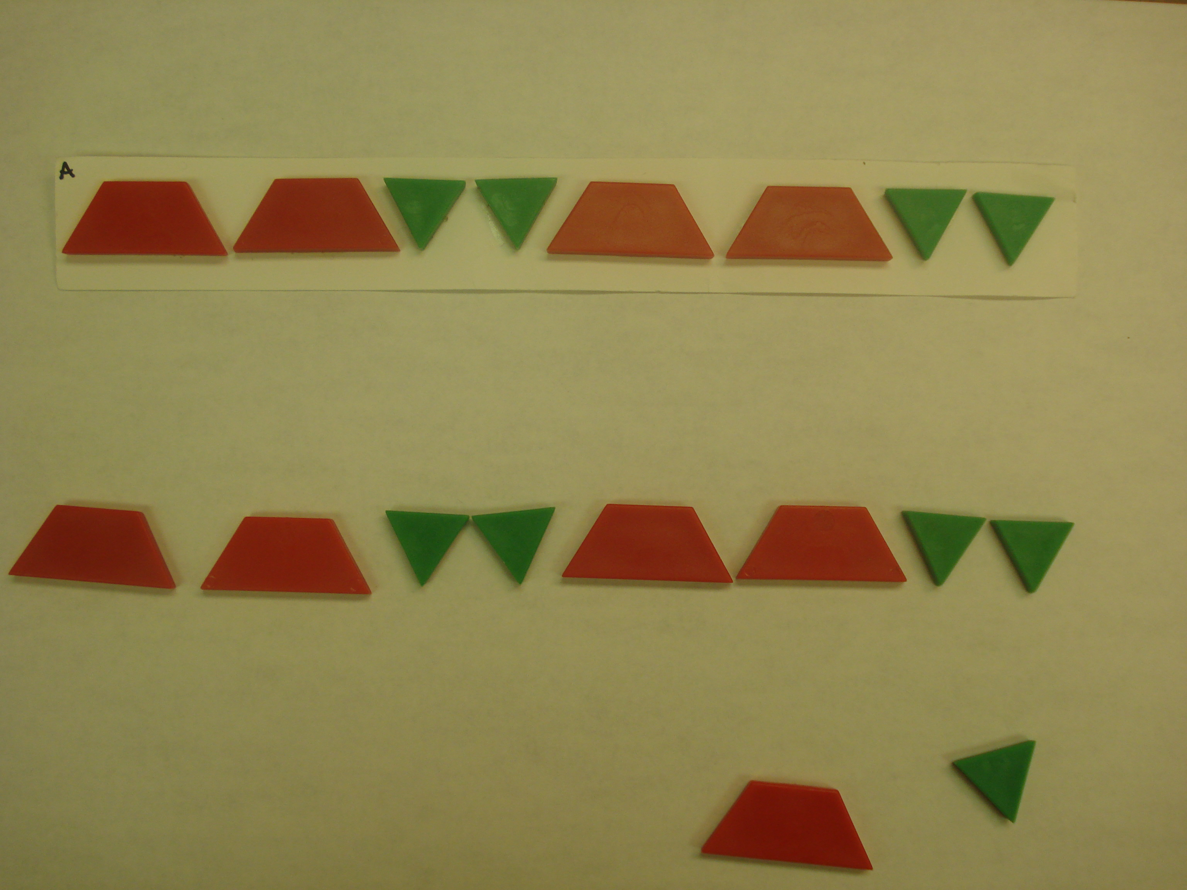  “I made a pattern with these blocks. Please make the same kind of pattern here.” (Trapezoids were red; triangles were green.) | Extend ABB  (Level 2)  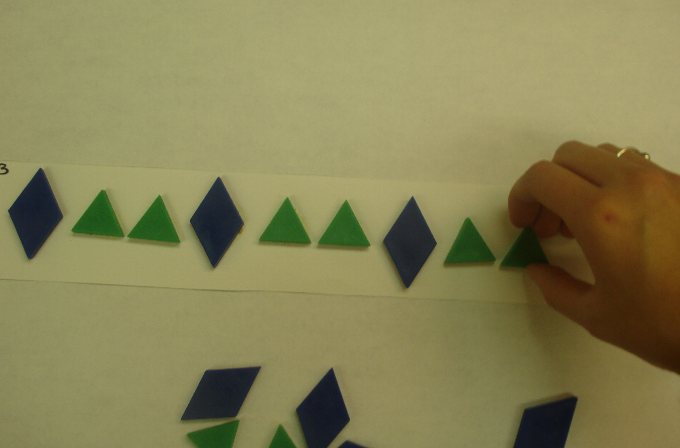  “I made a pattern with these blocks. Finish my pattern here the way I would.” (Diamonds were blue; triangles were green)
Abstract to Color AABB  (Level 3)  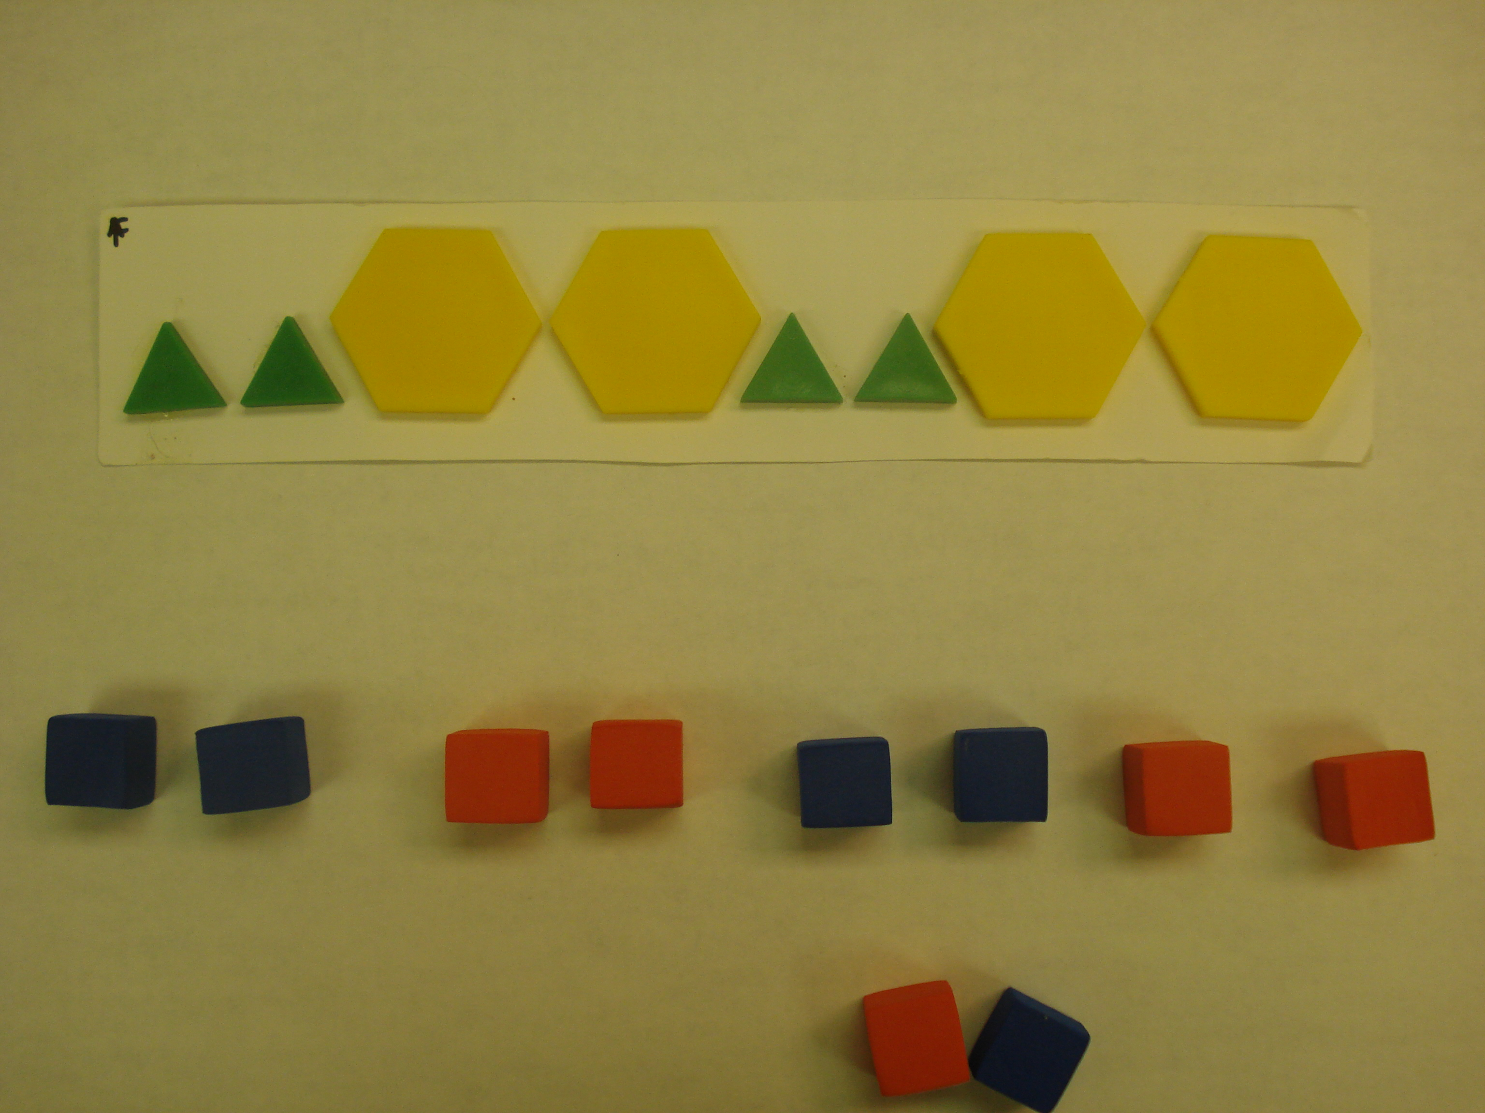  “I made a pattern with these blocks. Please make the same kind of pattern here, using these cubes.” (Triangles were green; hexagons were yellow; blocks were blue and red) | Unit Tower AAB  (Level 4)  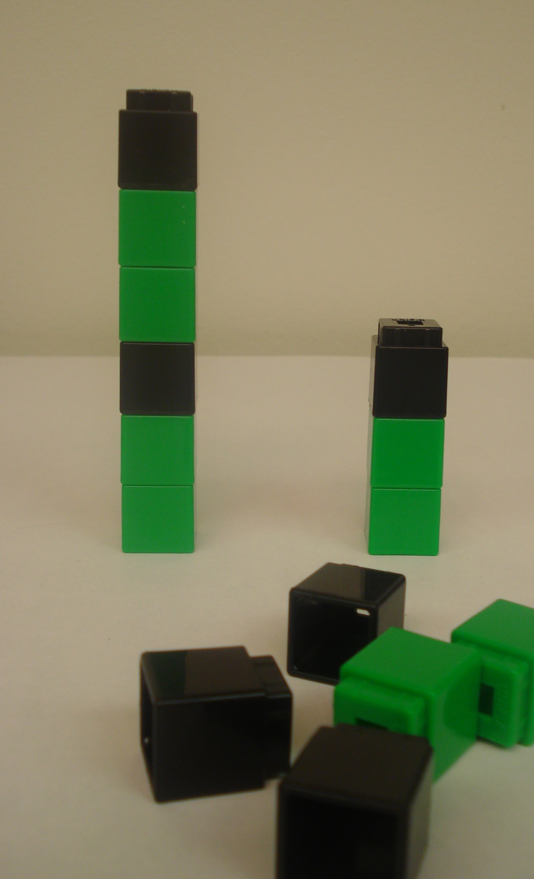  “What is the smallest tower you could make and still keep the same pattern as this?” after a demonstration with an AB tower. (cubes were green and black)

Figure 1. Sample assessment items from each level, including a sample correct response. (Color figure available online.) Adapted from “Emerging Understanding of Patterning in 4-Year-Olds” by B. Rittle-Johnson, E. R. Fyfe, L. E. McLean and K. L. McEldoon, 2013, Journal of Cognition and Development, Vol. 14, p. 381. Copyright [2013] by Taylor & Francis Group. Adapted with permission.

