Running Head: Emerging Understanding of Patterning

Emerging Understanding of Patterning in Four Year Olds

Bethany Rittle-Johnson

Emily R. Fyfe

Laura E. McLean

Katherine L. McEldoon

Vanderbilt University

In press Journal of Cognition and Development

Bethany Rittle-Johnson, Emily R. Fyfe, Laura E. McLean and Katherine L McEldoon, Department of Psychology and Human Development, Peabody College, Vanderbilt University.
This research was supported with funding from the National Science Foundation (NSF) grant DRL-0746565. The opinions expressed are those of the authors and do not represent the views of NSF. A special thanks to the students and teachers at Glen Leven Presbyterian Church Dayschool, Gordon Jewish Community Center Preschool, Holly Street Daycare, and Fannie Battle Day Home for Children for participating in this research. Thanks to Heather Dunham and Katharine Miller for help in coding the data. A special thank you to Maria Blanton, Tom Carpenter, Doug Clements, Janet Eisenband-Sorkin and Jon Star for their expert opinions on the items and construct map.
Correspondence concerning this article should be addressed to Bethany Rittle-Johnson, 230 Appleton Place, Peabody #0552, Nashville, TN 37203, 615-322-8301 (voice), b.rittle-johnson@vanderbilt.edu

Abstract

Young children have an impressive amount of mathematics knowledge, but past psychological research has focused primarily on their number knowledge. Preschoolers also spontaneously engage in a form of early algebraic thinking—patterning. In the current study, we assessed four-year-old children’s knowledge of repeating patterns on two occasions (N = 66). Children could duplicate and extend patterns, and some showed a deeper understanding of patterns by abstracting patterns (i.e., creating the same kind of pattern using new materials). A small proportion of the children had explicit knowledge of pattern units. Error analyses indicated that some pattern knowledge was apparent before children were successful on items. Overall, findings indicate that young children are developing an understanding of repeating patterns before school entry.

Keywords: Mathematics concepts, problem solving, measurement development

Emerging Understanding of Patterning in Four Year Olds
Young children have an impressive amount of mathematical knowledge. Contrary to Piaget’s original hypothesis that young children have very limited mathematical knowledge (Piaget, 1965), over 20 years of research have revealed an array of early emerging knowledge, including the ability to enumerate small sets of objects (e.g., Starkey & Cooper, 1980), to identify equivalent sets (Mix, 1999), and to track the addition and subtraction of small quantities (e.g., Wynn, 1992). In fact, some of this number knowledge emerges within the first year of life and may be innate (Wynn, 1998). However, despite the wide variety of psychological studies on early mathematics knowledge, almost all of the studies have focused on knowledge of number.
In this study, we foreground another central component of mathematics knowledge —knowledge of patterns. Indeed, mathematics has been defined as the science of patterns (Steen, 1988). Furthermore, consensus documents on mathematics education include knowledge of patterns as a central algebraic topic (e.g., National Council of Teachers of Mathematics, 2000). Repeating patterns (i.e., linear patterns that have a unit that repeats) are considered the most accessible type of pattern for young children. For example, in preschool, a learning standard is that “children recognize and duplicate simple sequential [i.e., repeating] patterns (e.g., square, circle, square, circle, square, circle,…)” and in Kindergarten, “children identify, duplicate, and extend simple number patterns and sequential and growing patterns (e.g., patterns made with shapes) as preparation for creating rules that describe relationships” (National Council of Teachers of Mathematics, 2006, pp. 11 - 12). Although evidence is limited, knowledge of repeating patterns has been shown to support knowledge of other areas of mathematics (Warren & Cooper, 2007), particularly early algebra (Papic, Mulligan, & Mitchelmore, 2011).
In addition to patterning activities being central to mathematics, observational studies indicate that young children spontaneously engage in them. For example, during free play, one preschooler painted stripes, saying “pink, purple, pink, purple” (Fox, 2005, p. 316). Indeed, exploring pattern and shape was the most common mathematical activity observed during the play of 4- and 5-year-olds, accounting for 20-40 percent of the observed time in U.S. preschools (Ginsburg, Inoue, & Seo, 1999; Ginsburg, Lin, Ness, & Seo, 2003). Preschool teachers also view patterning activities as important (Clarke, Clarke, & Cheeseman, 2006; Economopoulos, 1998).
Because patterning is a common mathematical activity for children and is a central component of early mathematics knowledge, the current study focused on 4-year-olds’ knowledge of repeating patterns. In particular, we evaluated their understanding of the pattern unit (i.e., the sequence that repeats over and over). As Economopoulos (1998) noted, “To generalize and predict, children must move from looking at a pattern as a sequence of ‘what comes next’ to analyzing the structure of the pattern, that is, seeing that it is made of repeating units” (p. 230).
In this paper, we describe the development of an assessment of young children’s repeating pattern knowledge. We employed a construct modeling approach (Wilson, 2005) and developed a construct map (i.e., a proposed continuum of knowledge progression) for knowledge of repeating patterns. A construct modeling approach allowed us to integrate different tasks and ideas into a unified assessment to predict and evaluate knowledge differences among children. The findings provide insight into the typical sequence in which 4-year-olds acquire repeating pattern knowledge, as well as reveal individual differences. Before describing the current study, we summarize past research on children’s knowledge of repeating patterns and present our hypothesized construct map.

Past Research on Repeating Pattern Knowledge in Young Children
We define pattern in a mathematical context as a predictable sequence. We focus on repeating patterns (i.e., linear patterns that have a unit that repeats, such as ), as this is the most common type of pattern that preschoolers are asked to consider (National Council of Teachers of Mathematics, 2006). Repeating patterns are linear, emphasize a unit that repeats over and over, can often be solved by focusing on a single dimension (e.g., size), and are taught in school. These characteristics distinguish repeating patterns from other tasks, including matrices problems commonly found on non-verbal intelligence tests for school-aged children and adults (e.g., Raven, 2000).
A small literature within mathematics education provides suggestions on what young children may understand about repeating patterns, including potential assessment tasks. This literature provides limited empirical evidence for the difficulty of particular tasks, but it does offer ideas and constraints for proposing a continuum of knowledge growth about repeating patterns (i.e., a construct map). Thus, a contribution of this manuscript is to bridge from the educational to the psychology literature and to provide empirical evidence for the relative difficulty of different patterning tasks.
One of the earliest emerging patterning skills is duplicating a pattern, which involves making an exact replica of a model pattern. A more difficult skill is extending patterns, which involves continuing an existing pattern. For example, children are shown an ABBABB pattern and asked to continue the pattern. Many four year olds can duplicate repeating patterns and some can extend patterns, especially if their preschool curriculum includes work with patterns (Clements, Sarama, & Liu, 2008; Papic et al., 2011; Starkey, Klein, & Wakeley, 2004).
Although four year olds can often duplicate and extend repeating patterns, some researchers have questioned whether success on these tasks necessitates an understanding of patterns at a fundamental level (Economopoulos, 1998; Warren & Cooper, 2006). Children may be able to duplicate and extend patterns through visual matching, without knowing that there is a pattern unit that repeats (Threlfall, 1999).
A more difficult patterning skill, that cannot be solved using visual matching, is abstracting a pattern—recreating a model pattern using a different set of materials (Clements & Sarama, 2009; Mulligan & Mitchelmore, 2009; Warren & Cooper, 2006). For example, children might be shown a “blue, yellow, yellow, blue, yellow, yellow” pattern and be asked to create the same kind of pattern using orange squares and circles. This abstraction requires the child to pay attention to the overall structure of the pattern rather than its surface features. There is no published data on young children’s success on this task. However, psychological research on relational reasoning suggests that four year olds may be able to abstract the underlying pattern on a simpler, match-to-sample task. Four year olds were able to match one instance of a pattern unit with another instance of the same pattern unit using different materials, if the matching pattern varied along the same dimension (e.g., size: match to ) (Kotovsky & Gentner, 1996). With training, 4-to-5-year-olds could match pattern units across dimensions (e.g., from size to color: match to ) (Son, Smith, & Goldstone, 2011). This suggests that some four year olds may be able to abstract the underlying pattern. However, rather than simply select between two possible matches, abstracting pattern tasks typically ask children to generate the new pattern.
Another relatively difficult patterning skill is identifying the pattern unit. For example, children might be asked to say or to circle the part of the pattern that is repeating (e.g., ask child to place a piece of string around the repeating part of the pattern) (Papic et al., 2011; Warren & Cooper, 2006). Alternatively, children might be asked to use the smallest number of objects to make their own pattern while keeping the pattern the same as in the model pattern (Sarama & Clements, 2010). A less explicit measure is to ask children to reproduce a pattern from memory with the same number of units as the model pattern (Papic et al., 2011). Children who were successful on this task typically verbalized the pattern unit and noted how many times it repeated. Individual studies have used only one of these unit identification tasks, so we do not know how well the tasks tap the same understanding or when children develop this skill. However, each task on identifying the pattern unit is thought to be indicative of a more sophisticated understanding of patterning than the ability to duplicate or extend a pattern.
Overall, four year olds are often able to duplicate and extend patterns. Eventually, children learn to abstract the underlying pattern and to identify the unit of repeat, and only these latter tasks clearly demonstrate understanding of repeating patterns. However, there is very limited published data on children’s performance on these more advanced tasks, so little is known about how success on these tasks is related or when these more advanced skills emerge.

Construct Map For Repeating Pattern Knowledge
The primary goal of the current paper was to test predictions for the typical sequence in which 4-year-olds acquire repeating pattern knowledge, based on integrating tasks from different studies and hypothesizing their relative difficulty. Administering a unified assessment to preschoolers will reveal how success on different tasks are related, the relative difficulty of the tasks, and what skills preschoolers have mastered and what skills they are still learning.
To integrate the tasks, we utilized Mark Wilson’s Construct Modeling approach to measurement development (Wilson, 2005). The core idea is to develop and test a construct map, which is a representation of the continuum of knowledge through which people are thought to progress. The construct map guides development of a comprehensive assessment, and both the construct map and the assessment are evaluated using item response theory (IRT) models after the assessment is administered to an appropriate group.
Our construct map for repeating patterns is presented in Table 1, with less sophisticated knowledge represented at the bottom and more advanced knowledge represented at the top. The four knowledge levels differ primarily in the level of abstraction required by the task and are based on the learning trajectory for patterns and structure proposed by Clements and Sarama (2009). The levels are meant to help conceptualize knowledge progression, but are not distinct stages. Rather, knowledge progression is continuous and probabilistic (e.g., Siegler, 1996).
At Level 1 children can duplicate patterns, and at Level 2 they can extend patterns. At Level 3 we hypothesized that children would be able to abstract the underlying pattern well enough to generate a pattern using different materials. At this level, children must be able to represent the pattern at a non-perceptual level to re-create the pattern with new materials. Finally, at Level 4 we hypothesized that children would be able to explicitly recognize the smallest unit of a pattern. Thus, Levels 3 and 4 of our construct map go beyond basic skills with repeating patterns and assess children’s understanding of pattern units. The ordering of Levels 3 and 4 was tentative and based on an informal task analysis. One purpose of this study was to test the relative difficulty of abstracting a pattern and identifying the pattern unit. Overall, the construct map is meant to capture increasingly sophisticated and abstract knowledge of pattern units. At all levels, we focused on success with three- and four-element patterns (e.g., ABB and AABB patterns) because these patterns are more challenging than AB patterns and seem to assess more robust pattern knowledge (Clements & Sarama, 2009).

Current Study
We used our construct map to guide creation of an assessment of repeating pattern knowledge, with items chosen to tap knowledge at each level of the construct map. We administered the assessment to a group of 4-year-old children from middle- and low-income families. We assessed each child twice, before and after a brief feedback session. We included a feedback session so we could evaluate children’s thinking when some assistance was provided. In our analyses, we used an item-response model to evaluate our construct map, as well as classical test theory methods to provide additional evidence for the reliability and validity of the assessment. We also explored children’s errors on the assessment and their verbal explanations during the feedback session to develop a better understanding of children’s thinking about repeating patterns. Overall, the goal was to systematically test predictions for the relative difficulty of different patterning skills for 4-year-olds and reveal whether at least some 4-year-olds have some more advanced patterning skills that indicate understanding of repeating patterns.

Method

Participants
Consent was obtained for 66 children (37 female) attending one of six pre-Kindergarten classes at four preschools. Three of the preschools served primarily Caucasian, middle- and upper-middle-class children (n = 47) and one school served primarily African-American, low-income children (i.e., all qualified for free- or reduced-lunch, n = 19). Approximately 35% of the participants were racial or ethnic minorities (26% African-American) and their average age was 4.6 years (range 4.04 years to 5.3 years). One girl did not participate in the feedback session or Time 2 assessment because she had mastered the content at Time 1 (90% correct).
None of the schools were using a specialized curriculum focused on patterning, but teachers reported doing patterning activities an average of 10 times per week (range 5 to 13 times per week). The most common activity was to have children create their own pattern (M = 3.4 times per week), but duplicating and extending patterns were also common activities (M = 2.8 and 2.3 times per week, respectively). Four of the six teachers also reported identifying the core pattern unit for children (M = 2.2 times per week for these teachers), but only two asked children to abstract patterns (and they reported doing so about once a week).

Design
The assessment was administered twice, a few days apart (Mdn = 3 days). Between the two assessment points, all children received the same, brief, one-on-one feedback session. During the feedback session, children completed five abstract pattern items, received accuracy feedback, and were prompted to try to explain the correct answer. On one item, the experimenter modeled a high-quality explanation using shared labels for the model and target pattern, as shared labels invite comparison and support learning (Graham, Namy, Gentner, & Meagher, 2010; Namy & Gentner, 2002).

Materials
Assessment. Ten assessment items were designed to test children’s thinking about repeating patterns at the four levels of our construct map. Eight of the items were adapted from items in one of two early math assessments (Sarama & Clements, 2010; Starkey et al., 2004). Two additional items, the memory item and unit identification item, were adapted from Papic and colleagues (2011). The 10 items are listed in Table 2, organized by their hypothesized level of difficulty. A sample item from each level, including instructions, is displayed in Figure 1. The distribution of items across levels reflects our primary interest in Levels 3 and 4, given the dearth of research on these levels of understanding.
For each item, the pattern unit contained three elements (i.e., AAB or ABB) or four elements (i.e., AABB). Past research has used one or the other, but not both; our aim was to verify that the two are equivalent. The model pattern for most items was constructed with colored shapes from a tangram puzzle set that had been glued to a strip of cardstock in the desired linear pattern, with two instances of the pattern unit (e.g., AABAAB). The model pattern was within view while children responded, except on the memory item. To respond, children were given enough materials to complete two full units and one partial unit of the model pattern on most items. The exception was the memory item, for which children were provided enough blocks to complete three full units and one partial unit of the model pattern to assess whether children were attending to the number of times the pattern unit repeated. For the duplicate, extend, and memory items, children’s materials were identical to the materials in the model pattern. For the abstract-color items, children’s materials were a uniform three-dimensional shape in two colors that differed from the model pattern. For the abstract-shape items, the model pattern consisted of painted wooden cubes, and children’s materials were small flat shapes of unpainted wood. Finally, for the unit tower item, the model pattern was made of two different colors of Unifix cubes, and children’s materials were Unifix cubes in the same colors.
Parallel items were created to use at Time 1 and Time 2; items at the two time points were structurally identical and varied only in the specific colored shapes that were used in the patterns. Three of the items were anchor items (identified in Table 2 in column 2) and had identical materials at both time points, following the recommendation to use some identical anchor items when creating parallel forms of an assessment (AERA/APA/NCME, 1999).
Finally, the items were administered in one of two fixed orders (either the order presented in Table 2, or the opposite order, with a few exceptions; namely, the duplicate item was always presented first and the memory item was always presented before the unit identification item). Children received the same order at both assessment times; 34 children received items in the original order and 31 children received the items in the opposite order.
Feedback session. Five abstract-shape items were used in the feedback session, with either an AAB or ABB pattern unit. After solving each item, the child was given accuracy feedback. If the child’s pattern was incorrect, the experimenter said, “This is how I would make the pattern the same as mine,” and rearranged the child’s materials to match the model pattern. On four of the five items, children were then prompted to explain, “What is my pattern?” and “How is your pattern the same as mine?” On the remaining item (the third item), rather than prompting the child to explain, the experimenter provided an explanation that focused on the underlying pattern unit in the two patterns (e.g., "For my pattern, I put two that were the same and then one that was different. Then I started over again…. For the new pattern, it also starts with two that are the same and then one that is different. Then, it starts over again….The new pattern goes same, same, different, same, same, different, just like my pattern goes same, same, different, same, same, different”). The shared, general labels of “same” and “different” should invite comparison and encourage a more abstract representation of the pattern. The feedback session was videotaped for later coding.
Working memory measure. To explore the effects of working memory capacity on children’s patterning success, we measured children’s working memory capacity using the forward and backward digit span task from the Wechsler Intelligence Scale (2003). In both tasks, the child was read a series of numbers at a rate of approximately 1 per second. For the forward digit span task, the child was asked to repeat the series of numbers exactly as he or she heard them. For the backward digit span task, the child was asked to repeat the series of numbers backward (in the opposite order it was read). The series length began with two numbers and increased to eight numbers. Two instances of each series length were presented, and the measure was terminated as soon as the child made an error on both instances of a particular series length. Children were given one point for every series they correctly repeated. We were not able to complete the working memory assessment with 6 children due to time constraints.

Procedure
Children participated individually in a quiet room at their preschools on two occasions. On the first day, they completed the Time 1 assessment and the working memory tasks (except for a few children who received the working memory tasks on a different day), and this took approximately 20 minutes. The directions for most of the item types are included in Figure 1. Two of the Level 4 items merit additional information on how they were administered. On the memory item (Unit_Memory_ABB), children were told to remember a pattern exactly like they saw it. Specifically, they were shown a pattern for 5 seconds and asked to: “Make the same pattern as mine, with the same number of blocks in the same places as mine.” They first practiced with an AB pattern. On the unit identification item (Unit_Identification_AAB), children were shown an AAB pattern and asked: “Can you move the stick to show where the pattern starts over again?” after a demonstration on an AB pattern. A few days after the first session, children completed the feedback session (lasting approximately 10 – 15 minutes) and then completed the Time 2 assessment.

Coding
On most items (items 1 – 7), responses were considered correct if the child produced at least one full unit of the pattern and made no errors. Scoring of the remaining 3 items, which were the Level 4 items, was based on past research. On the memory item, the child had to duplicate the model pattern exactly, with no extra units. On the unit identification item, the child had to indicate that the first three items made up the pattern unit. On the tower item, the child had to create a tower that matched the first three elements on the tower and had exactly three elements. We also coded children’s errors on the items, described in Table 3.
Finally, children’s self-explanations during the intervention were coded for content. Answers to the first question (“What is my pattern?”) and second question (“How is your pattern like mine?”) were coded separately. These codes are reported in Table 5.

Expert Ratings
Expert screening of items was obtained from five mathematics education researchers who each had over 10 years of experience conducting research on children’s knowledge of algebra or on preschoolers’ mathematics knowledge. Each expert rated each item on a scale from 1 to 5 (1 = not essential, 3 = important, but not essential, 5 = essential) based on its perceived importance for understanding repeating patterns. Gathering expert ratings is common practice in measurement development to support the face validity of the items within a target community (AERA/APA/NCME, 1999).

Measurement Model
We used a Rasch model to evaluate the assessment, in addition to using methods from classical test theory. Rasch models are a one-parameter member of the item response theory (IRT) family of models (Bond & Fox, 2007). The Rasch model considers both respondent ability and item difficulty simultaneously, estimating the probability that a particular respondent will answer a particular item correctly (Rasch, 1980). Traditional estimation procedures for Rasch models, such as conditional and marginal maximum likelihood estimation, require moderate to large sample sizes to be reliable. Because of this, we used a new estimation procedure called Laplace approximation and empirical Bayesian prediction that has been shown to be stable for sample sizes around 50 (Cho & Rabe-Hesketh, 2011; Hofman & De Boeck, 2011). Our estimation procedure treated both items and respondents as random effects, whereas traditional estimation methods, such as marginal maximum likelihood estimation, treat respondents as a random effect and items as a fixed effect, assuming a normal distribution and variance for the items (Bock & Aitkin, 1981). Laplace approximation was implemented in R (http://www.r-project.org/), using the lmer function of the lme4 package (Bates, Maechler, & Dai, 2008).

Item Screening
Recall that the assessment was administered in one of two orders, so we first evaluated whether order affected accuracy on any of the items. We conducted between-subjects t-tests on accuracy on each item at Time 1 and Time 2 to evaluate order effects. With one exception, accuracy on each item was comparable across the two orders, t’s < 1.85. The exception was the memory item at Time 1, on which children’s accuracy was higher if it was the second item rather than the eighth item presented in the assessment, t(64) = 2.066, p = .043. Similar to the item-by-item analyses, children’s overall accuracy did not differ for the two orders at Time 1 or Time 2, F’s < 1.7. Because order rarely mattered, we did not consider order in further analyses.
Next, we screened the 10 items at Times 1 and 2 for sound psychometric properties. Item-level information is provided in Table 2, including the proportion correct and the item-total correlation for each item at both time points. One item, the unit identification item, was excluded because its item-total correlation was extremely low (0.02 and 0.08 at Times 1 and 2, respectively), indicating that performance on this item was not related to performance on other items. Future research should explore whether modifications to the task instructions would improve the item. The remaining items had item-total correlations ranging from 0.22 to 0.73.

Results
First, we provide evidence for the reliability and the validity of the assessment. Next, we report an analysis of children’s errors on the assessment. Finally, we explore the quality of children’s explanations during the intervention.

Evidence for Reliability
Internal consistency, as assessed by Cronbach’s α, was high for the assessment at Time 1 and Time 2 (α = .824 and.844, respectively). Total scores did improve from Time 1 to Time 2, (M = 3.11, SD = 2.51 vs. M = 3.68, SD = 2.75, respectively, t(64) = -2.40 , p = .02). Nevertheless, relative performance on the assessment was stable between testing times, with a high test-retest correlation, r(63) = .740, p < .01. We were also able to code children’s errors on the items and their explanations during the intervention reliably (the coding schemes are described later). Two coders independently classified all of children’s errors, with a Cohen’s Kappa of .95, and all of their explanations, with a Cohen’s Kappa of .84 (Cohen, 1960). At the most basic level, assessments must be able to yield reliable measurements, and our assessment appeared to yield a reliable measure of children’s repeating pattern knowledge.

Evidence for Validity
Evidence based on test content. Experts’ ratings of items provided evidence in support of the face validity of the test content. Five experts rated all of the test items to be important (rating of 3) to essential (rating of 5) for tapping knowledge of repeating patterns, with a mean rating of 4.5 (see final column of Table 2 for the experts’ average rating on each item).
Evidence based on internal structure. To evaluate the internal structure of our measure, we evaluated whether our a priori predictions about the relative difficulty of items were correct (Wilson, 2005). To do so, we created an item-respondent map (i.e., a Wright map) for each time point using the data generated by the Rasch model, displayed in Figures 2 and 3. In brief, a Wright map displays participants and items on the same scale. In the left column, respondents (i.e., children) are each represented with an X, and children with the highest estimated ability on the construct are located near the top of the map. In the right column, each item is plotted, with items of the greatest difficulty located near the top of the map. When items and participants are at the same position on the map, those participants have a 50% probability of answering those items correctly. The vertical line between the two columns indicates the measurement scale, which was logits. Logits are log-odds units, which are the natural logarithm of the estimated probability of success divided by the estimated probability of failure on an item. A logit scale results in an equal interval linear scale that is not dependent on the particular items or participants used to estimate the scores. The average of the item distribution was set to 0 logits; negative scores indicate items that were easier than average and positive scores indicate items that were harder than average.
The Wright maps in Figures 2 and 3 allow for quick visual inspection of whether our construct map correctly predicted relative item difficulties. As can be seen in Figure 2, at Time 1, the two items we had categorized as Level 4 items, Unit_Memory_ABB and Unit_Tower_AAB, were indeed the most difficult items, clustered near the top with difficulty scores greater than 1. The three items we had categorized as Level 1 and 2 items, Duplicate_AABB, Extend_ABB and Extend_AABB, were indeed fairly easy items, clustered near the bottom of the map with difficulty scores less than 0. The four Level 3 Abstract items fell in between. As predicted, whether the pattern unit had three or four elements had limited influence on item difficulty (e.g., the difficulties of AbstractColor_AAB and AbstractColor_AABB were the same, indicated by being at the same position on the Wright map). In addition, abstracting a pattern to new colors (AbstractColor) or to new shapes (AbstractShape) did not impact difficulty. Rather, the type of task had the largest impact on difficulty, as predicted by our construct map.
At Time 2 (see Figure 3), item difficulties were similar to those at Time 1, when accounting for standard error. We used standard errors to construct 95% confidence intervals around item difficulty estimates at Time 1 and Time 2, and the confidence intervals overlapped for all items at both time points.
The range in difficulty of the items was appropriate for the target population. As shown in Figures 2 and 3, the range of item difficulties matched the spread of children’s locations quite well (i.e., there were sufficiently easy items for the lowest-performing children and sufficiently difficult items for most of the highest-performing children).
Evidence based on relations to other variables. Success on our measure was related to other important variables, including age, working memory capacity, and socio-economic status. Ability estimates increased with age; mean ability estimates progressively increased as age increased at Time 1, r(64) = .422, p < .001 and Time 2, r(63) = .287, p = .021, although they were less related to age after the feedback session (Time 2). Greater working memory capacity was also related to increased ability estimates at Time 1, r(58) = .400, p = .002 and Time 2, r(57) = .434, p = .001. The relation between age and ability was not explained by working memory capacity differences; after controlling for working memory capacity, age continued to be related to children’s ability estimates at Time 1 r(57) = .407, p = .001 and Time 2, r(56) = .294, p = .025. Finally, economically-disadvantaged children had lower ability estimates than children who were not disadvantaged, both at Time 1 (M = –.64, SD = 1.58 vs. M = .31, SD = 1.72), t(64) = 2.08, p = .04, and at Time 2 (M = –1.06, SD = 1.70 vs. M = .50, SD = 1.76), t(63) = 3.24, p = .002. However, after controlling for differences in working memory capacity, these differences were only significant at Time 2 (Time 1: F(1, 57) = 1.92, p = .17; Time 2: F(1, 56) = 6.42, p = .014). Overall, several types of evidence supported the validity of the assessment.

Characterizing Children’s Knowledge
Much of the power of IRT results from the fact that it models participants’ responses at the item level. For example, we can calculate the probability of any participant’s success on any given item using the equation Pr(success) = . where θ is a participant’s ability estimate and β is the item difficulty estimate. This is a powerful tool because it allows us to take a single measure (a child’s ability score) and use it to predict the types of items on which a child will likely struggle – without the usual need for resource intense item-by-item error analysis.
Consider a child with an ability score one standard deviation above the mean (θ = 1.76). This child would be expected to solve the Level 3 AbstractColor_ABB item accurately 84% of the time at Time 1. Sixteen children (24%) had ability estimates at or above 1.76 at Time 1. In contrast, a child with an ability score one standard deviation below the mean (θ = -1.69) would be expected to solve this Level 3 item accurately only 14% of the time, but would be expected to solve the Level 1 Duplicate_AABB item correctly 77% of the time. Thirteen of the children (20%) had ability estimates below this level at Time 1. Finally, a child with an average ability estimate (θ = .03) would be expected to solve the duplicate item correctly (probability of success 95%), to usually solve extend items correctly (probability of success is 66 – 77%), and to sometimes solve abstract items correctly (probability of success is 47%). Thus, ability and item difficulty estimates provide powerful information for predicting children’s performance.

Error Analysis
In addition to considering accuracy, we examined children’s errors to gain further insight into their repeating pattern knowledge. Errors on all items but one, the smallest tower item, could be classified into one of six categories (see Table 3). On these eight items, the most frequent error was to produce a partially correct pattern that included at least one full unit of the model pattern, but also extraneous blocks that did not conform to the pattern. Two additional error types indicated that children had some pattern knowledge, demonstrated by producing patterns that were different from the model pattern. In contrast, several errors were less sophisticated and did not involve patterns – sorting the blocks, placing blocks in random sequences, or using the blocks in an off-task manner. Similar non-pattern errors were made on the smallest tower item, accounting for about half of responses on this item. Other errors on the smallest tower item did reflect some pattern knowledge, either containing more than a single unit of the correct pattern or an AB pattern (each about 20% of responses at Times 1 and 2).
Variability in error types. Overall, children made a variety of error types, with the frequency of each error type at Time 1 presented in Table 3. At Time 1, 59 out of 66 children produced multiple error types on the eight items that could be coded with the same scheme, and the remaining seven children were correct on all eight of these items. Considering only those 59 children who made errors, the number of different error types ranged from 2 to 5 (M = 2.86 out of 6). Over 65% of children produced a partially correct error and nearly half of children displayed blocks in random order, sorted blocks, or produced an AB pattern. Frequency of each error type was similar at Time 2.
Impact of pattern task. To explore whether different tasks elicicted different error types, we compared children’s errors on the extend task versus the abstract task, as error rates were too low on the duplicate task to make meaningful comparisons. Our error analysis revealed one reason why extend items were less difficult than abstract items. As shown in Table 3, children were significantly more likely to produce random sequences of blocks and to revert to a simple AB pattern on the abstract items than on the extend items.
Impact of pattern unit length. Accuracy results suggested that items with 3-element and 4-element pattern units were similar in difficulty; however, a comparison of the error types revealed meaningful differences. Given the small number of items of a particular kind, we collapsed across error codes. On the two extend items, significantly more children produced a correct or partially correct response on the 3-element item than on the 4-element item at Times 1 and 2 (see Table 4). Additionally, children were somewhat less likely to produce a wrong pattern error or a non-pattern error on the 3-element item. Similar trends were found for the abstract items, but with smaller, and rarely significant differences. Thus, although 3-element and 4-element patterns were similar in terms of accuracy, they elicited different quality errors. One possibility is that children who cannot complete the pattern task successfully are in a transitional state and are thus influenced by task characteristics (e.g., unit length). As a result, children who commit errors may struggle more with patterns that take longer to repeat (e.g., after 4 elements rather than 3 elements). Once children understand the task, they are successful regardless of changes in task characteristics. As a result, children who succeed on the 3-element pattern will also succeed on the 4-element pattern.

Children’s Explanations in Feedback Session

Finally, we explored children’s explanations during the feedback session to gain further insights into their repeating pattern knowledge. Recall that children were asked to try to explain correct solutions and were asked both “What is my pattern?” and “How is your pattern the same as mine?” After explaining two solutions without input, children listened as the experimenter modeled a high-quality explanation, and then tried to explain two additional solutions. Children’s explanations were coded into one of seven categories, as shown in Table 5. Children gave non-pattern explanations (named the colors or shapes without reference to their position in the pattern, gave other vague explanations or refused to answer) on about a quarter of items. By far the most common explanation was to label the items in order – to name either the shape or color of consecutive elements in one of the patterns (comprised half of explanations).

Two more sophisticated explanations were a) to abstract beyond naming characteristics of individual pattern elements and refer to elements as same or different or b) to explicitly link individual elements in the new pattern to the model pattern. These more sophisticated explanations were very rare before the experimenter modeled an explanation that included same/different language. After the model explanation, same/different explanations increased dramatically, t(63) = 4.81, p < .001, to over a quarter of explanations.

Exposure to the shared same/different labels, combined with correct examples, may support learning about repeating patterns. During the feedback session, accuracy on the two items presented after the model explanation (M = 1.05, SD = 0.89) was higher than accuracy on the two items presented before it (M = 0.80, SD = 0.92), t(64) = -2.45, p = .017. Further, accuracy on the abstract pattern items at Time 2 (M = 1.71 out of 4, SD = 1.59), which occurred after the feedback session, was higher than on abstract pattern items at Time 1 (M = 1.17 out of 4, SD = 1.52), t(64) = 2.93, p = .005. Finally, accuracy on the abstract items at Time 2 was predicted by how often children generate same/different explanations during the feedback session, controlling for accuracy on the items at Time 1, r(62) = .244, p = .052. Although only exploratory, these findings suggest that presenting examples and providing shared labels when explaining how one pattern is like another may aid learning.

Overall, children were able to give reasonable explanations of correct solutions a majority of the time, the sophistication of their explanations increased after hearing a high-quality explanation from the experimenter that included shared labels, and exposure to correct examples and shared labels may have supported greater accuracy on the abstract patterning task.

Discussion
Preschoolers are able to go beyond duplicating and extending repeating patterns and think more deeply about patterns. A substantial number of four year olds were able to abstract the underlying pattern unit in order to re-create a pattern using new materials, and some were able to explicitly represent the pattern unit. Young children understand more about mathematics than simple number concepts. They are also learning to attend to and abstract patterns, which is considered foundational for algebraic thinking (National Council of Teachers of Mathematics, 2006; Papic et al., 2011).

Preschoolers’ Repeating Pattern Knowledge
To characterize children’s knowledge, we must first have reliable and valid knowledge measures. Our repeating pattern measure was strong on both dimensions. The measure had high internal consistency and good stability (i.e., indicators of reliability) and strong face validity and good internal structure (i.e., indicators of validity).
In addition, our construct map accurately captured variations in the sophistication of children’s knowledge (see Table 1 and Figure 2). The four knowledge levels are meant to help conceptualize knowledge progression, which is continuous and probabilistic. Four-year-olds’ knowledge ranged from only being able to duplicate a repeating pattern to being able to explicitly identify the pattern unit. As hypothesized, identifying the pattern unit was more difficult than abstracting the pattern (Level 4 vs. Level 3 of the construct map). Further, children’s errors indicated that children had some patterning knowledge even when they did not answer correctly. Overall, there were large individual differences among 4 year olds in their repeating pattern knowledge, spanning across the four knowledge levels hypothesized in our construct map.
What developmental mechanisms might underlie improving knowledge of repeating patterns? Although not directly tested in this study, several pieces of evidence suggest possibilities. First, patterning knowledge was related in part to working memory capacity. Working memory capacity has been shown to impact success on a variety of cognitive tasks, including mathematics achievement (Bull, Espy, & Wiebe, 2008). In the context of patterning, increased capacity to consider and manipulate multiple pieces of information likely improves children’s ability to identify and re-create patterns. When duplicating and extending patterns, increased capacity might support matching new elements to existing elements in the model pattern and sequencing them correctly. When abstracting patterns, increased capacity might support coordination of attention across dimensions in the model and new pattern. Indeed, increases in working memory capacity are thought to allow 4- to 6-year-old children to transition from focusing on only one aspect of a task to coordinating attention to two dimensions (Case & Okamoto, 1996).
Independent of working memory capacity, repeating pattern knowledge was also related to age. The relation to age indicates that with maturation and increasing experience, patterning knowledge tends to increase. During preschool, general cognitive abilities are improving that may support patterning knowledge. For example, four year olds are developing increased inhibitory control (Dempster, 1992), and inhibitory control may reduce common non-pattern responses such as sorting or playing with the materials. Their ability to encode and analyze information is also increasing (e.g., Siegler & Chen, 1998), which should help children notice key features of the objects and how those features vary systematically.
Another relevant cognitive skill developing in preschool is relational thinking (Kotovsky & Gentner, 1996). To abstract repeating patterns, children must think about the relations between the objects, rather than simply noticing the perceptual features of individual objects. One effective way to support relational thinking is to provide a shared label for multiple instances of the same relation (e.g., labeling both instances as “blicket”) (Graham et al., 2010; Namy & Gentner, 2002). During our feedback session, we provided shared labels when comparing the model and new pattern to support relational thinking. A substantial minority of children adopted our shared labels and had improved success with abstracting patterns at Time 2. Future research should examine whether individual differences in relational thinking are predictive of our pattern abstraction task and whether providing shared labels indeed promotes success with pattern abstraction.
Experience also increases with age and should support repeating pattern knowledge. For example, the participating preschool teachers reported doing patterning activities an average of 10 times per week, most often asking children to duplicate, extend and create patterns. Preschoolers also spontaneously engage in patterning activities such as making repeating patterns with blocks during free play (e.g., Ginsburg et al., 2003). Thus, children’s success duplicating and extending patterns was likely supported by experience doing these tasks in their classrooms, in part explaining why these tasks were easier for children. A few teachers reported occasionally asking children to abstract patterns or identifying the pattern unit for children, so preschoolers seem to have infrequent experience with these tasks.
We know much less about patterning activities that occur at home. Educational TV shows for preschoolers, such as Sesame Street, include duplicating and extending patterns in some episodes. Educational TV can support learning in preschoolers, and repeated exposure can improve learning even more (Crawley, Anderson, Wilder, Williams, & Santomero, 1999). Thus, exposure to educational TV that includes patterning activities may support young children’s patterning knowledge. Parents may also engage their children in patterning activities.
Experience combined with improving cognitive capacity likely supports development of repeating pattern knowledge, and some four year olds have already developed a fairly good understanding of them. Past research suggests that this understanding is valuable, as it can support improved mathematics knowledge (Warren & Cooper, 2007), particularly in other areas of early algebra (Papic et al., 2011).

Benefits of a Construct Modeling Approach to Measurement Development
A construct modeling approach to measurement development helps elucidate knowledge growth. In particular, it can be used to unify a variety of tasks into a single construct that can be used to chart increasing knowledge in a domain. In addition, the resulting measure is more sensitive to knowledge change than traditional measures that rank children according to performance (Wilson, 2005). Currently, there are only a handful of examples of using a construct modeling approach in the research literature (see Acton, Kunz, Wilson, & Hall, 2005; Claesgens, Scalise, Wilson, & Stacy, 2009; Dawson-Tunik, Commons, Wilson, & Fischer, 2005; Rittle-Johnson, Matthews, Taylor, & McEldoon, 2011; Wilson, 2008; Wilson & Sloane, 2000), and only one is in developmental psychology (Dawson-Tunik et al., 2005). We found construct modeling to be very insightful, and we hope this article will inspire other developmental psychologists to use the approach.
This measurement development process incorporates four phases that occur iteratively: 1) proposal of a construct map based on the existing literature or a task analysis, 2) generation of potential test items that correspond to the construct map and systematic creation of an assessment designed to tap each knowledge level in the construct map, 3) creation of a scoring system for each item that relates each to the construct map and 4) use of Rasch analysis and Wright maps to evaluate and revise the construct map and assessment after it has been administered (Wilson, 2005). The assessment is then progressively refined by iteratively looping through these phases. This criterion-referenced assessment can then be used to chart changes in children’s knowledge over time, either with or without intervention. Our pattern assessment is a very promising measure that can be used in future research to reveal changes in children’s understanding of repeating patterns.

Conclusion
In summary, four year olds are developing important early algebraic knowledge – an understanding of repeating patterns. Many can do more than duplicate and extend repeating patterns; they can also abstract the underlying pattern unit. Future research is needed to understand how this knowledge develops over time and the sources of this knowledge change.
References
Acton, G. S., Kunz, J. D., Wilson, M., & Hall, S. M. (2005). The construct of internalization: Conceptualization, measurement, and prediction of smoking treatment outcome. Psychological Medicine, 35, 395-408. doi: 10.1017/s0033291704003083
AERA/APA/NCME. (1999). Standards for educational and psychological testing. Washington, DC: American Educational Research Association.
Bates, D., Maechler, M., & Dai, B. (2008). The lme4 Package version 0.999375-26. Retrieved from http://cran.r-project.org/web/packages/lme4/lme4.pdf/
Bock, R. D., & Aitkin, M. (1981). Marginal maximum likelihood estimation of item parameters: Application of an EM algorithm. Psychometrika, 46, 443-459. doi: 10.1007/bf02293801
Bond, T. G., & Fox, C. M. (2007). Applying the Rasch model: Fundamental measurement in the human sciences (2nd ed.). Mahwah, NJ: Lawrence Erlbaum Associates Publishers. (2007) xvi, 340 pp.
Bull, R., Espy, K. A., & Wiebe, S. A. (2008). Short-term memory, working memory, and executive functioning in preschoolers: Longitudinal predictors of mathematical achievement at age 7 years. Developmental Neuropsychology. Special Issue: Mathematics ability, performance, and achievement, 33, 205-228. doi: 10.1080/87565640801982312
Case, R., & Okamoto, Y. (1996). The role of central conceptual structures in the development of chidlren's thought. Monographs for the Society for Research in Child Development, 61, v-265.
Cho, S.-J., & Rabe-Hesketh, S. (2011). Alternating imputation posterior estimation of models with crossed random effects. Computational Statistics and Data Analysis, 55, 12-25. doi: 10.1016/j.csda.2010.04.015
Claesgens, J., Scalise, K., Wilson, M., & Stacy, A. (2009). Mapping student understanding in chemistry: The perspectives of chemists. Science Education, 93, 56-85. doi: 10.1002/sce.20292
Clarke, B., Clarke, D., & Cheeseman, J. (2006). The mathematical knowledge and understanding young children bring to school. Mathematics Education Research Journal, 18, 78-102.
Clements, D. H., & Sarama, J. (2009). Other content domains. Learning and Teaching Early Math: The Learning Trajectories Approach (pp. 189-202). New York: Routledge.
Clements, D. H., Sarama, J. H., & Liu, X. H. (2008). Development of a measure of early mathematics achievement using the rasch model: The research-based early maths assessment. Educational Psychology, 28, 457-482. doi: 10.1080/01443410701777272
Cohen, J. (1960). A coefficient of agreement for nominal scales. Educational and Psychological Measurement, 20, 37-46. doi:10.1177/001316446002000104
Crawley, A. M., Anderson, D. R., Wilder, A., Williams, M., & Santomero, A. (1999). Effects of repeated exposures to a single episode of the television program Blue's Clues on the viewing behaviors and comprehension of preschool children. Journal of Educational Psychology, 91, 630-637.
Dawson-Tunik, T. L., Commons, M., Wilson, M., & Fischer, K. W. (2005). The shape of development. European Journal of Developmental Psychology, 2, 163-195. doi: 10.1080/17405620544000011
Dempster, F. N. (1992). The rise and fall of the inhibitory mechanism: Toward a unified theory of cognitive development and aging. Developmental Review, 12, 45-75. doi: 10.1016/0273-2297(92)90003-k
Economopoulos, K. (1998). What comes next? The mathematics of pattern in kindergarten. Teaching Children Mathematics, 5, 230-233.
Fox, J. (2005). Child-initiated mathematical patterning in the pre-compulsory years. Paper presented at the the 29th conference of the International Group for the Psychology of Mathematic Education, Melbourne.
Ginsburg, H. P., Inoue, N., & Seo, K.-H. (1999). Young children doing mathematics: Observations of everyday activities. In J. V. Copley (Ed.), Mathematics in the Early Years (pp. 88-99). Reston, VA: National Council of Teachers.
Ginsburg, H. P., Lin, C.-l., Ness, D., & Seo, K.-H. (2003). Young american and chinese children's everyday mathematical activity. Mathematical Thinking and Learning, 5, 235-258. doi: 10.1207/S15327833MTL0504_01
Graham, S. A., Namy, L. L., Gentner, D., & Meagher, K. (2010). The role of comparison in preschoolers' novel object categorization. Journal of Experimental Child Psychology, 107, 280-290. doi: 10.1016/j.jecp.2010.04.017
Hofman, A., & De Boeck, P. (2011). Distributional assumptions and sample size using crossed random effect models for binary data: A recovery study based on the lmer function.
Kotovsky, L., & Gentner, D. (1996). Comparison and categorization in the development of relational similarity. Child Development, 67, 2797-2822. doi: 10.2307/1131753
Mix, K. S. (1999). Preschooler's recognition of numerical equivalence: Sequential sets. Journal of Experimental Child Psychology, 74, 309-332. doi: 10.1006/jecp.1999.2533
Mulligan, J., & Mitchelmore, M. (2009). Awareness of pattern and structure in early mathematical development. Mathematics Education Research Journal, 21, 33-49. doi: 10.1007/BF03217544
Namy, L. L., & Gentner, D. (2002). Making a silk purse out of two sow's ears: Young children's use of comparison in category learning. Journal of Experimental Psychology: General, 131, 5-15. doi: 1O.1037//O096-LWS1.31.I.5
National Council of Teachers of Mathematics. (2000). Principles and Standards for School Mathematics. Reston, Va: NCTM.
National Council of Teachers of Mathematics. (2006). Curriculum focal points for Prekindergarten through Grade 8 Mathematics. Reston, Va: National Council for Teachers of Mathematics.
Papic, M. M., Mulligan, J. T., & Mitchelmore, M. C. (2011). Assessing the development of preschoolers' mathematical patterning. Journal for Research in Mathematics Education, 42, 237-268.
Piaget, J. (1965). The Child's Conception of Number. Oxford: W. W. Norton & Co.
Rasch, G. (1980). Probabilistic model for some intelligence and attainment tests. Chicago, IL: University of Chicago Press.
Raven, J. (2000). The Raven's Progressive Matrices: Change and stability over culture and time. Cognitive Psychology, 41, 1-48. doi: Doi 10.1006/Cogp.1999.0735
Rittle-Johnson, B., Matthews, P. G., Taylor, R. S., & McEldoon, K. L. (2011). Assessing knowledge of mathematical equivalence: A construct-modeling approach. Journal of Educational Psychology, 103, 85-104.
Sarama, J., & Clements, D. H. (2010). Elementary math assessment. Columbus, OH: SRA/McGraw-Hill.
Siegler, R. S. (1996). Emerging minds: The process of change in children's thinking. New York: Oxford University Press.
Siegler, R. S., & Chen, Z. (1998). Developmental differences in rule learning: A microgenetic analysis. Cognitive Psychology, 36, 273-310. doi: 10.1006/cogp.1998.0686
Son, J. Y., Smith, L. B., & Goldstone, R. L. (2011). Connecting instances to promote children's relational reasoning. Journal of Experimental Child Psychology, 108, 260-277. doi: Doi 10.1016/J.Jecp.2010.08.011
Starkey, P., & Cooper, R. G. (1980). Perception of numbers by human infants. Science, 210, 1033-1035. doi: 10.1126/science.7434014
Starkey, P., Klein, A., & Wakeley, A. (2004). Enhancing young children's mathematical knowledge through a pre-kindergarten mathematics intervention. Early Childhood Research Quarterly, 19, 99-120. doi: 10.1016/j.ecresq.2004.01.002
Steen, L. A. (1988). The science of patterns. Science, 240, 611-616.
Threlfall, J. (1999). Repeating patterns in the early primary years. In A. Orton (Ed.), Pattern in the Teaching and Learning of Mathematics (pp. 18-30). London: Cassell.
Warren, E., & Cooper, T. (2006). Using Repeating Patterns to Explore Functional Thinking. Australian Primary Mathematics Classroom, 11, 9-14.
Warren, E., & Cooper, T. (2007). Repeating Patterns and Multiplicative Thinking: Analysis of Classroom Interactions with 9-Year-Old Students that Support the Transition from the Known to the Novel. Journal of Classroom Interaction, 41, 7-17.
Wechsler, D. (2003). Wechsler Intelligence Scale for Children - 4th Edition (WISC-IV). San Antonio, TX: Harcourt Assessment.
Wilson, M. (2005). Constructing measures: An item response modeling approach. Mahwah, NJ: Lawrence Erlbaum Associates.
Wilson, M. (2008). Cognitive diagnosis using item response models. Journal of Psychology, 216, 74-88. doi: 10.1027/0044-3409.216.2.74
Wilson, M., & Sloane, K. (2000). From principles to practice: An embedded assessment system. Applied Measurement in Education, 13, 181-208. doi: 10.1207/s15324818ame1302_4
Wynn, K. (1992). Addition and subtraction by human infants. Nature, 358, 749-750. doi: 10.1038/358749a0
Wynn, K. (1998). Psychological foundations of number: Numerical competence in human infants. Trends in Cognitive Sciences, 2, 296-303. doi: 10.1016/s1364-6613(98)01203-0

Table 1
Construct Map for Repeating Patterns
Level | Skill | Sample task
Level 4: Pattern unit recognition | Identifies the pattern unit | "What is the smallest tower you could make and still keep the same pattern as this?”
Level 3: Pattern abstraction | Translates patterns into new patterns with same structural rule. | "I made a pattern with these blocks. Please make the same kind of pattern here, using these cubes” (using new colors and shapes).
Level 2: Pattern extension | Extends patterns at least one pattern unit. | “I made a pattern with these blocks. Finish my pattern here the way I would.”
Level 1: Pattern duplication | Duplicates patterns. | "I made a pattern with these blocks. Please make the same kind of pattern here.”
Note. Adapted from Clements and Sarama (2009, 2010).
Table 2
Description of and Summary Statistics for Repeating Pattern Assessment Items
Expected Level | Item Type_Pattern Unit* | Time | Proportion correct (SD) | Item total correlation | Item difficulty (SE) | Expert rating
1 | Duplicate_AABB | 1 | .77 (.42) | .47 | -2.89 (.41) | 3.8
 |  | 2 | .75 (.43) | .59 | -2.47 (.43)
2 | Extend_ABB (anchor item) | 1 | .52 (.50) | .49 | -1.20 (.38) | 4.8
 |  | 2 | .58 (.50) | .72 | -1.24 (.40)
2 | Extend_AABB | 1 | .42 (.50) | .61 | -0.64 (.38) | 4.8
 |  | 2 | .34 (.48) | .40 | 0.24 (.40)
3 | AbstractShape_AABB (anchor item) | 1 | .32 (.47) | .59 | 0.03 (.39) | 4.8
 |  | 2 | .35 (.48) | .59 | 0.24 (.40)
3 | AbstractColor_ABB | 1 | .30 (.46) | .64 | 0.13 (.40) | 4.8
 |  | 2 | .37 (.49) | .60 | 0.14 (.40)
3 | AbstractColor_AABB | 1 | .30 (.46) | .68 | 0.13 (.40) | 4.8
 |  | 2 | .46 (.50) | .72 | -0.44 (.40)
3 | AbstractColor_AAB (anchor item) | 1 | .30 (.46) | .70 | 0.13 (.40) | 4.8
 |  | 2 | .52 (.50) | .73 | -0.83 (.40)
4 | Unit_Memory_ABB | 1 | .18 (.39) | .29 | 1.04 (.43) | 3.6
 |  | 2 | .15 (.36) | .29 | 1.71 (.45)
4 | Unit_Identification_AAB (dropped) | 1 | .09 (.29) | .02 | NA | 4.4
 |  | 2 | .15 (.36) | .08 | NA
4 | Unit_Tower_AAB | 1 | .08 (.27) | .22 | 2.16 (.52) | 4.2
 |  | 2 | .14 (.35) | .33 | 1.85 (.46)

Note: *For example Duplicate_AABB indicates that the child was asked to duplicate an AABB pattern.
Table 3

Errors: Descriptions and Percentage of Trials on Which the Error was Produced at Time 1, Overall and on Extend and Abstract Items.

Error type | Description | Example for ABB pattern
 |  |  | Overall | Extend | Abstract
Correct | Correct. May have partial unit at beginning or end. | ABBABB | 42 | 47 | 30**
Partial Correct | At least one full unit of model pattern; includes errors as well. | ABBAAB | 15 | 17 | 16
Wrong Pattern AB | Produces an AB pattern. May contain errors at beginning or end. | ABABABAB | 10 | 5 | 11*
Wrong Pattern Other | Produces a wrong 3- or 4-element pattern. May contain errors at beginning or end. | AABBAABB | 6 | 8 | 8
Sort | Sorts by color or shape. | AAAABBBB | 9 | 12 | 11
Random Order | Makes linear sequences of blocks in random order. | ABABAAA | 11 | 8 | 15*
Off Task | Using blocks but not in a way related to the pattern. | Made a tower | 6 | 4 | 8

Note. Difference between tasks based on paired t-test: ** p < .005, * p < .05, p < .10

Figure 1. Sample Items from Each Level, Including a Sample Correct Response
Duplicate Pattern AABB  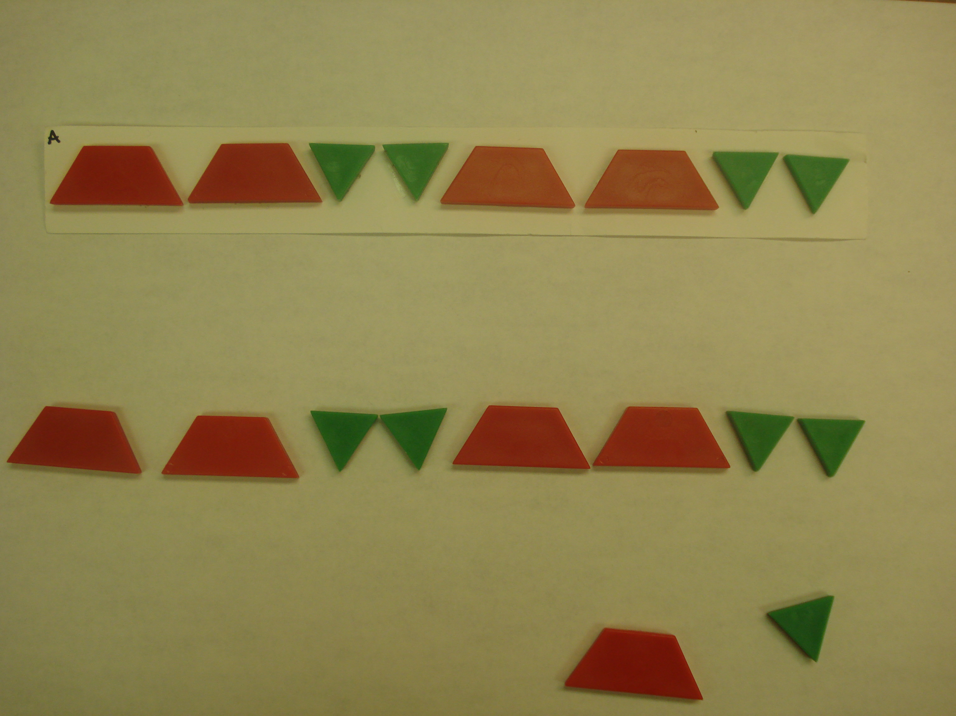  “I made a pattern with these blocks. Please make the same kind of pattern here.” (Trapezoids were red; triangles were green.) | Extend Pattern ABB  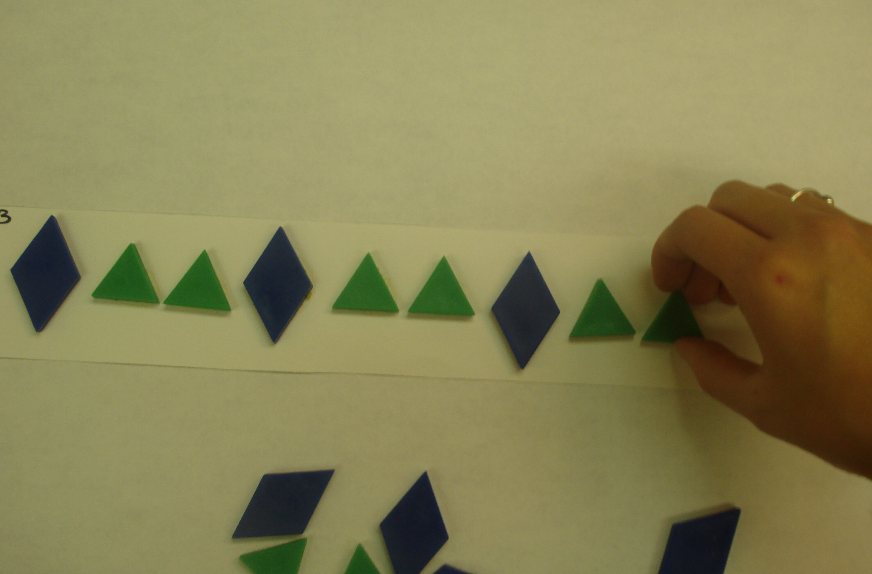  “I made a pattern with these blocks. Finish my pattern here the way I would.” (Diamonds were blue; triangles were green)
Abstract Color AABB  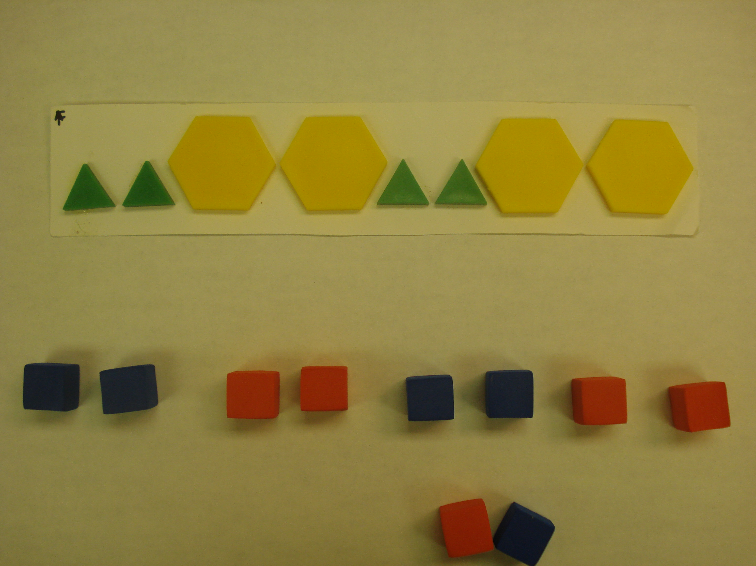  “I made a pattern with these blocks. Please make the same kind of pattern here, using these cubes.” (Triangles were green; hexagons were yellow; blocks were blue and red) | Unit Tower AAB  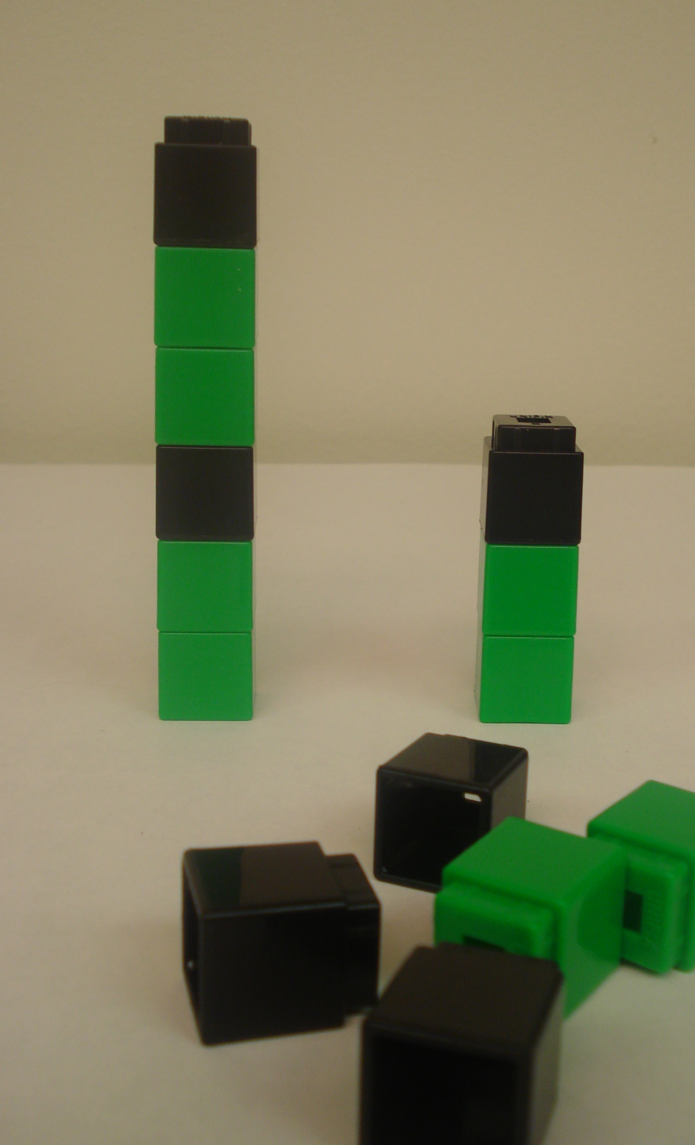  “What is the smallest tower you could make and still keep the same pattern as this?” after a demonstration with an AB tower. (cubes were green and black)
Figure 2. Wright map for repeating pattern assessment at Time 1.
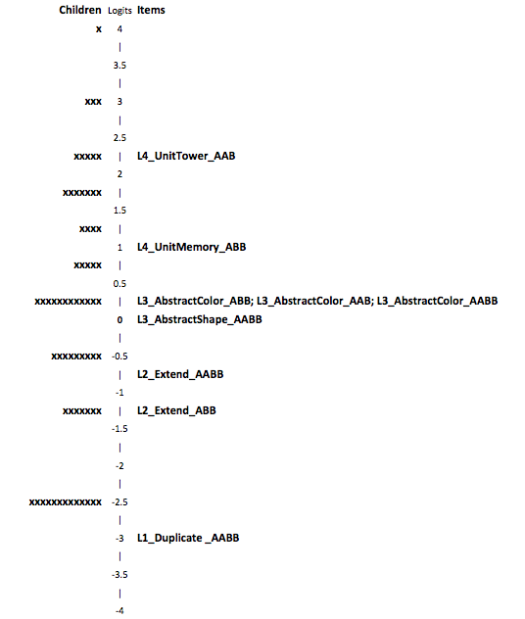
Note. The L1, L2, L3, and L4 labels represent each item’s expected level of difficulty, with L1 indicating Level 1, etc.
Figure 3. Wright map for repeating pattern assessment at Time 2.
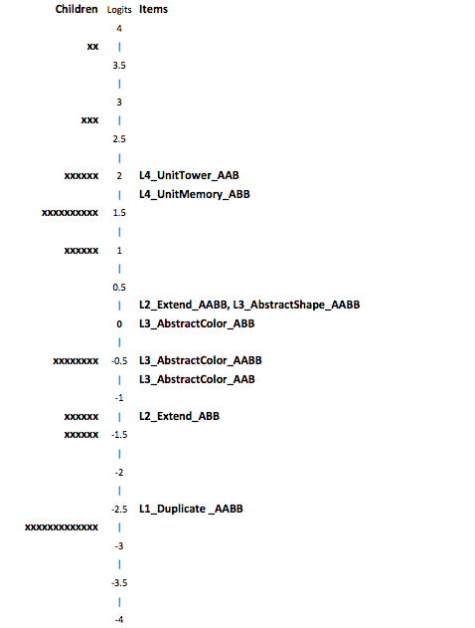
Note. The L1, L2, L3, and L4 labels represent each item’s expected level of difficulty.

Table 4

Comparison of Error Types on 3- vs. 4-element Extend Items, Reported as Percentage of Children Who Produced Each Error Type

 | Extend Task: Time 1 |  | Extend Task: Time 2
 | 3-element | 4-element | 3-element | 4-element
Correct and Partial Correct | 74 | 55** | 68 | 48**
Wrong Pattern AB and Other | 6 | 18 | 12 | 22
Not Pattern Related | 20 | 27 | 20 | 31

Note. Difference between tasks based on McNemar’s test for nominal data: ** p = .005, p < .10

Table 5
Characteristics of Children’s Explanations During the Feedback Session
Name | Description | Example | Frequency before model explanation | Frequency after model explanation
Link Patterns | Links individual items or units from own pattern to experimenter’s pattern. | “Blue is really like yellow” [points to yellow block] “and green is really like orange” [points to orange block] | 4 | 5
Same/  Different | Uses the words ‘same’ and/or ‘different’ (in reference to specific elements) correctly. | “One different, two the same, one different, two the same” [while pointing to each block] | 1 | 26
Labels Items in Order | Says characteristic (color, shape, etc.) of at least three consecutive items. | “Yellow, blue, blue, yellow, blue, blue” [while pointing to each block] | 60 | 44
Gestures to Pattern | Points to or sweeps over their own pattern, but does not provide a verbal explanation. | Points to each item in order | 7 | 6
Names Characteristic | Names characteristics of the patterns such as color or shape without reference to position. | “Yellow and blue” | 6 | 4
Vague | Attempts some explanation, but it’s not about the pattern. | “Long” | 16 | 13
No Response | Gives no response or gives a response of uncertainty. | “I don’t know” | 6 | 2

