The Influence of Relational Knowledge and Executive Function on Preschoolers’ Repeating Pattern Knowledge
Michael R. Miller, Bethany Rittle-Johnson, Abbey M. Loehr, and Emily R. Fyfe
Vanderbilt University

Author Note
Michael R. Miller, Bethany Rittle-Johnson, Abbey M. Loehr, and Emily R. Fyfe, Department of Psychology and Human Development, Peabody College, Vanderbilt University. Michael R. Miller is now at Department of Paediatrics, Children’s Health Research Institute, Western University.
This research was supported with funding by National Science Foundation (NSF) grant DRL-0746565 to Bethany Rittle-Johnson and Institute of Education Sciences (IES) post-doctoral training grant R305B080008 to Vanderbilt University. The opinions expressed are those of the authors and do not represent the views of NSF or IES. The authors thank Kayla Ten Eycke and Sarah Hutchison for providing feedback on an early version of the manuscript.
Correspondence concerning this article should be addressed to Michael R. Miller, Department of Paediatrics, Children’s Health Research Institute, Western University, 800 Commissioners Road East, Rm E2-604, London, Ontario, Canada, N6A 5W9. Phone: 519-685-8500 ext. 53050. E-mail: michael.miller@lhsc.on.ca
Abstract
Children’s knowledge of repeating patterns (e.g., ABBABB) is a central component of early mathematics, but the developmental mechanisms underlying this knowledge are currently unknown. We sought clarity on the importance of relational knowledge and executive function (EF) to preschoolers’ understanding of repeating patterns. 124 children between the ages of 4 and 5 years were administered a relational knowledge task, 3 EF tasks (working memory, inhibition, set shifting), and a repeating pattern assessment before and after a brief pattern intervention. Relational knowledge, working memory, and set shifting predicted preschoolers’ initial pattern knowledge. Working memory also predicted improvements in pattern knowledge after instruction. The findings indicated that greater EF ability was beneficial to preschoolers’ repeating pattern knowledge, and that working memory capacity played a particularly important role in learning about patterns. Implications are discussed in terms of the benefits of relational knowledge and EF for preschoolers’ development of patterning and mathematics skills.
Keywords: Patterns, executive function, relational knowledge, preschool children, mathematics concepts
The Influence of Relational Knowledge and Executive Function on Preschoolers’ Repeating Pattern Knowledge
Patterning, or identifying a predictable sequence, is a spontaneous, recurrent activity of young children that is recognized as a central component of early mathematics knowledge (National Council of Teachers of Mathematics, 2000). One of the first types of patterns introduced to children are repeating patterns, which are linear in structure, consist of a unit that repeats (e.g., O∆∆O∆∆), and can often be constructed by focusing on a single dimension (e.g., shape or color). Patterning is a common free-play activity of preschoolers (Ginsburg, Inoue, & Seo, 1999), and there is increasing support that knowledge of repeating patterns is especially important for mathematics learning if emphasis is placed on the underlying structure of the pattern, or the unit of repeat (Economopoulos, 1998; Papic, Mulligan, & Mitchelmore, 2011; Threlfall, 1999; Warren & Cooper, 2006). For example, Mulligan and colleagues (Mulligan & Mitchelmore, 2009; Papic & Mulligan, 2007) found that young children’s ability to identify the unit of repeat in a pattern was not only related to improvements in pattern knowledge, but it also was associated with knowledge in other mathematical domains (e.g., multiplicative thinking).
While there is general agreement that repeating pattern knowledge is important for children’s mathematics development, it remains unclear how this knowledge develops in early childhood. For instance, to comprehend a repeating pattern, children likely need to draw connections between the elements within a pattern (e.g., shapes or colors), relying on relational knowledge and other cognitive abilities. In the present study, we sought to bring greater clarity to how children develop repeating pattern knowledge by examining the associations among preschoolers’ knowledge of repeating patterns and underlying cognitive abilities, specifically relational knowledge and executive function. First, we summarize research on children’s knowledge of repeating patterns. Next, we explore links among relational knowledge, executive function, and patterning in preschool-aged children. Finally, we describe the present study.
Children’s Knowledge of Repeating Patterns
Recent empirical studies have provided insight into the progression of preschoolers’ pattern knowledge and skills (Clements & Sarama, 2009; Mulligan & Mitchelmore, 2009; Papic et al., 2011; Rittle-Johnson, Fyfe, McLean, & McEldoon, 2013). Early on, children’s understanding of repeating patterns is demonstrated on simple tasks, such as duplicating and extending patterns. Duplicating involves making an exact copy of a model pattern, and extending involves continuing a model pattern (e.g., shown ABBABB pattern and asked to keep going). Although these skills are important to children’s early understanding of repeating patterns, they may not necessitate a true understanding of pattern structure. For instance, children may be able to duplicate and extend patterns by focusing on single elements of the pattern (e.g., matching by color or by shape) rather than focusing on the underlying unit of repeat (Economopoulos, 1998; Threlfall, 1999).
Two advanced patterning skills that are more indicative of a fundamental understanding of repeating pattern structure include abstraction and pattern unit recognition. Unlike duplicating or extending patterns, pattern abstraction involves recreating a model pattern using a different set of materials (Clements & Sarama, 2009; Rittle-Johnson et al., 2013). For example, if shown a “yellow, yellow, green, yellow, yellow, green” pattern, children may be asked to make the same kind of pattern (i.e., AABAAB) using red triangles and circles. Pattern unit recognition requires even more explicit knowledge of pattern structure as children are asked to identify the unit of repeat in reference to a model pattern (Papic et al., 2011; Sarama & Clements, 2010; Warren & Cooper, 2006). For example, children may be shown a tower of blocks in a “blue, orange, orange, blue, orange, orange” pattern and asked to make the smallest tower possible while keeping the pattern the same as the model tower (i.e., blue, orange, orange). Thus, relative to duplication and extension, pattern abstraction and pattern unit recognition items place greater emphasis on the unit of repeat rather than on concrete perceptual features.
Rittle-Johnson and colleagues (2013) recently documented the relative difficulty of these different patterning tasks in preschool-aged children. In the fall of the preschool year, 4-year-olds were administered a repeating pattern assessment that included duplicate, extend, abstract, and pattern unit recognition items. Item-response models indicated that the preschoolers exhibited a wide-range of repeating pattern knowledge. Most preschoolers could duplicate and extend patterns, less than half could abstract patterns, and few could identify the pattern unit. A follow-up study at the end of the preschool year revealed that the preschoolers’ pattern knowledge had improved (Rittle-Johnson, Fyfe, Loehr, & Miller, in press). In particular, performance on the abstract items increased despite limited practice on abstract patterns in the classroom. One reason for these improvements may be related to increases in preschoolers’ cognitive ability.
Relations Between Preschoolers’ Cognitive Ability and Patterning
Research has consistently shown that children experience dramatic changes in cognitive ability that are particularly pronounced during the preschool-years (Carlson, 2005; Clements, 2000; Diamond, 2006; Zelazo & Müller, 2010). Moreover, a wealth of empirical evidence indicates that preschoolers’ cognitive ability is related to both concurrent and prospective mathematics skills (Blair & Razza, 2007; Bull & Lee, 2014; Espy et al., 2004; Miller, Müller, Giesbrecht, Carpendale, & Kerns, 2013; Welsh, Nix, Blair, Bierman, & Nelson, 2010). However, relatively little is known about the influence of cognitive ability on the development of pattern knowledge.
One cognitive ability believed to be a central component of children’s pattern knowledge is relational knowledge (English, 2004; Threlfall, 1999; Papic et al., 2011), which involves drawing comparisons among objects and experiences on the basis of underlying similarities (Ball, Hoyle, & Towse, 2010; Gentner, 1983; Richland, Morrison, & Holyoak, 2006). For example, to recognize the unit of repeat in a pattern, children likely need to identify the relations between different elements within the pattern. Three major theories that account for the development of relational knowledge in young children are the Relational Primacy, Relational Shift, and Relational Complexity theories.
In accordance with the Relational Primacy (Goswami, 1995) and Relational Shift (Gentner, 1989) theories, children’s knowledge of relations should be instrumental to understanding similarities among repeating pattern elements. Both theories suggest that children’s overall experience with relations is most important for the development of relational knowledge. In particular, the Relational Primacy theory posits that relational knowledge is an innate capability that emerges as children accumulate knowledge of applicable relations (Goswami, 1995; 2001). Alternatively, the Relational Shift theory proposes that children first attend to perceptual similarities between objects (e.g., similarity between a slice of pie and a slice of pizza) until they accumulate sufficient domain-specific, relational knowledge over time. This is referred to as the relational shift, which enables children to then focus on relational similarities between objects (e.g., similarity between a duck floating on water and a balloon floating in the air; Gentner & Loewenstein, 2002; Rattermann & Gentner, 1998). Both theories are supported by research that shows experience with relational similarities is related to age-related increases in children’s relational knowledge. For instance, Gentner and Rattermann (1991) reviewed a wealth of research showing that children are capable of matching sequences of objects in terms of concrete, perceptual similarities before matching sequences of objects based on abstract, relational similarities.
The Relational Complexity theory (Halford, 1993; Halford, Wilson, & Phillips, 1998) highlights the importance of working memory for processing relational similarities, suggesting that working memory capacity should play a role in the development of repeating pattern knowledge. Working memory is a short-term mental system that enables individuals to actively maintain and regulate a limited amount of task-relevant information (Baddeley & Logie, 1999). Thus, the greater the degree of relational complexity in a particular situation, the more children will rely on working memory capacity for relational knowledge. For instance, because of increasing demands on working memory capacity, children often find it easier to understand relations between two items than relations among three items (Bunch, Andrews, & Halford, 2007). In support of the Relational Complexity theory, Rittle-Johnson et al. (2013) found that 4-year-olds’ working memory capacity was positively correlated with repeating pattern knowledge. This suggests that children’s ability to comprehend relations within a repeating pattern may be limited by their capacity to process and compare elements of the pattern in working memory.
Extending beyond the Relational Complexity theory, it seems reasonable to suggest that, in addition to working memory, other cognitive abilities are also influential to children’s pattern knowledge. For instance, working memory is often classified as a component of executive function (EF), which refers to higher-level cognitive abilities that are involved in the conscious control of action and thought (Zelazo & Müller, 2010). Two other common components of EF include inhibitory control and set shifting. Inhibitory control is defined as the ability to suppress prepotent responses, and set shifting refers to the ability to switch attention between multiple tasks, ideas, or dimensions. Both abilities show substantial development during the preschool years (Diamond, 2006; Zelazo & Müller, 2010). Along with working memory, these other EF skills may also aid in the development of pattern knowledge. For instance, inhibitory control may aid children’s awareness of the pattern unit by increasing their focus on the structure of the pattern (e.g., AAB) over the perceptual features of the pattern (e.g., colors and shapes). Moreover, set shifting may facilitate children’s ability to distinguish between different pattern elements (e.g., shifting between the A and B components of a ABBABB pattern). Indeed, Bennett and Müller (2010) found that preschoolers’ set shifting was significantly correlated with their ability to extend repeating patterns. This evidence suggests that EF skills can potentially impact preschoolers’ understanding of repeating patterns. However, it remains unknown whether multiple EF skills contribute to preschoolers’ repeating pattern knowledge and which EF skills are particularly important.
Past theory and research suggest that relational knowledge and EF both contribute to preschoolers’ knowledge of repeating patterns. Greater relational knowledge and experience with repeating patterns is likely to aid preschoolers in understanding the relations among elements of a repeating pattern, in line with the Relational Primacy and Relational Shift theories. At the same time, being able to hold and manipulate information in working memory, suppress irrelevant pattern features through inhibitory control, and flexibly shift attention between elements of a pattern may aid preschoolers’ repeating pattern performance as well, in line with the Relational Complexity theory. However, the association between preschoolers’ pattern knowledge and cognitive ability is currently unclear as previous research has only included one EF measure and no measures of relational knowledge.
Present Study
The goal of the present study was to investigate the relation between preschoolers’ cognitive abilities and repeating pattern knowledge. Specifically, we sought to characterize preschoolers’ repeating patterning knowledge across a range of patterning tasks, and we wanted to examine the extent to which relational knowledge and EF contribute to preschoolers’ understanding of repeating patterns. We expected both relational knowledge and EF to be positively related with preschoolers’ repeating pattern knowledge. In accordance with the Relational Primacy and the Relational Shift theories, we expected children’s knowledge of patterns to be related to relational knowledge and improve in response to experience with repeating patterns. In accordance with the Relational Complexity theory, we expected preschoolers’ repeating pattern knowledge to be positively associated with individual differences in EF, over and above age, experience with patterns, and relational knowledge. The results of this study will bring greater clarity to how preschoolers are learning to understand repeating patterns, which in turn is influential for later mathematical skills and achievement. It will also provide important evidence for theories of children’s development of relational knowledge.
Method
Participants
Consent was obtained for 145 children attending 10 preschools in a metropolitan area. Data from 21 children were excluded (8 due to distractions and off task behaviors, 7 due to absences, 5 due to experimenter error, and 1 due to special needs). The final sample consisted of 124 children (53 female, M_{age} = 4;7 years, SD_{age} = 0;5 years, range: 4;0-5;10 years), the majority of whom were Caucasian and came from middle-class families. Approximately 23% of the participants were racial or ethnic minorities (13% African-American, 5% Asian, 3% Middle Eastern, and 2% Hispanic). None of the participating preschools were using a specialized curriculum focused on patterning, but teachers reported doing patterning activities an average of 10 times per week (range: 4 to 22 times per week).
Measures
Pattern assessment. The repeating pattern assessment (adapted from Rittle-Johnson et al., 2013) included four types of patterning tasks (see Figure 1). The tasks included duplicating a model pattern by making an exact replica, extending an existing pattern by at least one full unit, abstracting patterns by recreating a model pattern using a different set of materials, and identifying the pattern unit by (a) moving a stick to where an AAB pattern repeated, and (b) building the smallest block tower possible while keeping the same pattern as a larger tower. Based on previous research (Rittle-Johnson et al., 2013), the pretest pattern assessment consisted of one duplicate item, two extend items, and two abstract items. The posttest pattern assessment included the same five pretest-items along with an additional abstract item and the two pattern unit recognition items for a total of eight items. Table 1 provides a summary of each of the pattern items used in the pre- and posttest. The same order of items was used on the pre- and posttest because previous research (Rittle-Johnson et al., 2013) found no significant differences in accuracy based on the order of item presentation.
For each item, the pattern unit contained three (i.e., AAB or ABB) or four (i.e., AABB) elements. The model pattern for most items was constructed with colored tangram shapes glued to a strip of cardstock with two instances of the pattern unit (e.g., AABAAB). The model pattern remained within view at all times, and children were given enough materials to complete two full units and one partial unit of the model pattern on most items. For the duplicate, extend, and unit-stick items, children’s materials were identical to the materials in the model pattern. For the abstract items, children’s materials were either small flat shapes of unpainted wood or uniform three-dimensional cubes in two colors that differed from the model pattern. Finally, for the unit-tower item, both the model pattern and the children’s materials were made of the same two colors of Unifix cubes.
Relational knowledge. Relational knowledge was assessed using a Match-To-Sample task used in previous research (Kotovsky & Gentner, 1996; Son, Smith, & Goldstone, 2011) that required children to match picture cards of objects sharing the same relational rule (i.e., A-B-A, A-A-B, or A-B-B). On each trial, children were shown a target card (e.g., big red circle, big white circle, big red circle) and two response cards, one of which shared the relational rule of the target card (e.g., big black square, little black square, big black square) and one that did not share the relational rule (e.g., big black square, big black square, little black square). The target and response cards could differ by color (i.e., red, blue, white, and black), size (i.e., big and small), and shape (i.e., circle and square). Children were asked to choose the response card that was like the target card, and then put that card into a slotted box. The task began with two training trials in which children matched identical animals, and then eight test trials were administered. Children received one point for each correct relational-choice match. The Match-to-Sample task differed from the pattern assessment because it only involved a single unit that did not repeat, children were not required to generate the answer, and all items required attention to relations.

Working memory. Working memory was assessed with the Backward Digit Span (Wechsler, 2003), in which children verbally repeated a single-digit, non-sequential number series in reverse order. The task began with a training phase adapted from Slade and Ruffman (2005) in which the experimenter explained how to say a three-digit series backwards through the aid of a picture. Once children understood the task, the picture was removed, and children were given a two-digit practice trial with corrective feedback. Children were then read a series of numbers at a rate of one per second and asked to repeat the series backward. The series length began with two numbers and increased by one-digit increments with two instances of each series length presented. The task was terminated when children made an error on both instances of a particular series length. Children received one point for every series they correctly repeated.
Inhibitory control. Inhibitory control was assessed with Luria’s Hand Game (Luria, Pribram, & Homskaya, 1964; adapted from Hughes, 1996). Children first received the imitative phase in which they were asked to make the same hand gestures as the experimenter (i.e., make a fist or point a finger) in order to perform and build a prepotent response. Hand gestures were presented in an intermingled order and continued until children consecutively imitated three fist gestures and three point gestures. Children then received the conflict phase in which they were instructed to make the opposite hand gesture as the experimenter (i.e., make a fist when the experimenter pointed, and point when the experimenter made a fist). The conflict phase consisted of 10 trials, with each type of hand gesture occurring five times and never more than three times in succession. Children received one point for every correct gesture during the conflict phase, with self-corrections (e.g., for a point gesture, switching from point to fist) counted as incorrect (similar results were found with self-corrections counted as correct).
Set shifting. Set shifting was assessed using the Flexible Item Selection Task (FIST; Jacques & Zelazo, 2001). Due to time constraints, we used the short version of the FIST consisting of 12 trials, including a demonstration trial and two practice trials on which children received corrective feedback. On each trial, children were shown a set of three pictures that could vary in color (i.e., blue, red, and yellow), shape (i.e., boat, shoe, and teapot), and size (i.e., small, medium, and large). All three pictures shared one dimension (e.g., shape), and one picture always matched both other pictures on differing dimensions (e.g., color and size). For example, one set of pictures consisted of a small yellow teapot, a small blue teapot, and a large yellow teapot. The small yellow teapot matched the small blue teapot in terms of shape and size and also matched the large yellow teapot in terms of shape and color. On each trial, children were instructed to choose two pictures that matched in one way (e.g., small teapots for size). Children were then instructed to make a second selection by identifying two pictures that matched in another way (e.g., yellow teapots for color). A correct response required children to select one of the three pictures twice (e.g., the small yellow teapot) according to different dimensions. Children received one point for each of the nine test trials in which they made two correct selections.
Procedure
Children worked one-on-one with an experimenter in a quiet room at their preschools over two days (Mdn = 1 day apart). The session was split over two days in order to reduce children’s fatigue and maximize retention of a brief intervention designed to explore the merits of instruction for pattern learning. On the first day, children completed the pretest pattern assessment, inhibitory control and set shifting measures, and received instruction on six abstract pattern items in the form of practice problems and worked examples. On the second day, children received additional instruction on four abstract pattern items, and then completed the working memory measure, posttest pattern assessment, and relational knowledge task. A fixed task order was chosen to facilitate comparisons between tasks (see Carlson & Moses, 2001). Both sessions lasted approximately 30 minutes each and included a short break halfway through. For the instruction, children were originally assigned to one of three conditions that differed in terms of receiving instructional-explanations (i.e., experimenter explained how a pair of abstract patterns shared the same underlying unit of repeat), providing self-explanations (i.e., child was asked to explain how a pair of abstract patterns were similar), or a combination of both instructional- and self-explanations. However, there was no significant effect of condition on children’s repeating pattern performance; thus, performance was collapsed across conditions (for additional information on the condition manipulation, see Rittle-Johnson et al., in press).
Measurement Model
To evaluate performance on the pre- and posttest pattern assessments, we used Rasch models, which are one-parameter item response theory models (Bond & Fox, 2007). The Rasch model simultaneously evaluates individual ability and item difficulty on the pattern assessment, estimating the probability that a particular child will answer a particular item correctly (Rasch, 1980). We utilized Laplace approximation estimation with empirical Bayesian prediction, which has been shown to be reliable for sample sizes around 50 participants (Cho & Rabe-Hesketh, 2011). The estimation procedure treated individuals and items as random effects, whereas traditional estimation methods (e.g., marginal maximum likelihood estimation) treat individuals as a random effect and items as a fixed effect, assume a normal distribution and variance for the items, and often require at least 100 participants (Bock & Aitkin, 1981). Laplace approximation was implemented in the statistical software program R (http://www.r-project.org/) using the lmer function of the lme4 package (Bates, Maechler, & Dai, 2008). Standardized residual values were calculated to estimate item fit to the data, with absolute values < 1.96 used as an indication of good item fit (Sinharay, 2005). As shown in Table 1, all items fit the data well at both pre- and posttest.
Results
Descriptive Statistics
Table 2 displays descriptive statistics for all variables. There were no univariate or multivariate outliers, and all variables had acceptable distributions with only minor departures from normality. In addition, no variables had significant gender differences. In the regression analyses, six children were dropped due to missing data on the relational knowledge, working memory, or inhibitory control measures. In all cases, missing data were the result of children failing to understand the task rules, and no children had missing data on more than one task. Table 3 shows partial correlations among variables controlling for age. With the exception of inhibitory control, all variables were positively correlated. Surprisingly, inhibitory control was only correlated with set shifting and not with working memory.
Pattern Assessment Performance
To examine the relative difficulty of items on the pre- and posttest pattern assessments, we created Wright maps (i.e., individual-item maps) using the ability estimates generated by the Rasch models (see Figures 2 and 3). In the Wright maps, each X in the left column represents one child, with children with higher ability estimates located near the top. Similarly, each item in the assessment is plotted in the right column, with items of greater difficulty located near the top. When children and items are directly across from each other, those children have a 50% probability of correctly responding to those items. Moreover, the greater the distance of an item below a child, the greater the probability that the child will correctly solve that item, and the greater the distance of an item above a child, the greater the probability that the child will not correctly solve that item. The middle column displays the measurement scale in terms of logits (i.e., log-odd units), which are the natural logarithm of the estimated probability of success on an item divided by the estimated probability of failure on the item. A logit scale results in an equal interval linear scale that is not dependent on the particular items or individuals used to estimate the scores. The average of the item distribution was set to 0 logits, with negative scores indicating items that were easier than average and positive scores indicating items that were more difficult than average.
Preschoolers had a range of patterning abilities. At pretest, the duplicate item was the easiest, the extend items were of medium difficulty, and the abstract items were the most difficult (see Figure 2). This finding was consistent with past research on the repeating pattern assessment (Rittle-Johnson et al., 2013). With the addition of three items at posttest, the duplicate item remained the easiest, the pattern unit recognition items were the most difficult, and the extend and abstract items were of medium difficulty (see Figure 3). Surprisingly, the Extend-AABB item was more difficult than all of the abstract items at posttest. In particular, whereas the item-difficulty of the Extend-AABB item increased from 0.5 to 0.7 logits from pre- to posttest, the item difficulties of the abstract items decreased from 1.3 to around 0.0 logits from pre- to posttest (see Figures 2 and 3). This likely was a consequence of children receiving extra practice and instruction on abstract patterns between pre- and posttest, thereby boosting abstract pattern performance at posttest. Consistent with this claim, for the five items that were the same across the pre- and posttest, children performed equally well on the duplicate and extend items (ps > .05), but their performance improved on the two abstract items (M_{pretest} = 0.76, M_{posttest} = 1.33, t = -8.20, df = 123, p < .001, two-tailed; McNemar tests for individual items, ps < .001).
Effects of Relational Knowledge on Pattern Performance
Hierarchical multiple regression analyses were conducted to examine the influence of relational knowledge on preschoolers’ knowledge of repeating patterns over and above EF. First, we examined the effect of relational knowledge on pretest pattern knowledge controlling for age and all EF variables. With the pretest pattern ability estimate as the dependent variable, the first regression block included age, working memory, inhibitory control, and set shifting. Relational knowledge was then entered into the second block. The final model was significant, F(5, 112) = 18.90, p < .001, and relational knowledge significantly predicted pretest pattern performance over and above age and all EF variables (see Table 4). Moreover, including relational knowledge in the analysis resulted in significant model change, F(5, 112) = 6.14, p < .05.
Next, we examined the influence of relational knowledge on preschoolers’ posttest pattern knowledge, controlling for pretest knowledge and individual differences. Posttest pattern ability was the dependent variable, and the first regression block included age, pretest pattern ability, and all three EF variables. Relational knowledge was again entered in the second block. The final model was significant, F(6, 111) = 23.88, p < .001, but the addition of relational knowledge in the analysis did not result in significant model change, F(6, 111) = 1.74, p > .10. Moreover, relational knowledge did not significantly predict posttest pattern knowledge over and above age, pretest pattern ability, and EF (see Table 4). Overall, relational knowledge contributed to preschoolers’ repeating pattern knowledge at pretest, but it did not have a significant effect on repeating pattern performance at posttest over and above age, EF, and prior pattern knowledge.
Effects of Executive Function on Pattern Performance
In the next series of hierarchical multiple regression analyses, we examined the influence of EF on preschoolers’ repeating pattern knowledge over and above relational knowledge. Similar analyses were performed as in the previous section, except that relational knowledge was always entered in the first block of the analysis and the EF variables were always entered in the second block. With pretest pattern ability as the dependent variable, including the EF variables in the second block resulted in significant model change, F(5, 112) = 10.07, p < .001. In addition, both working memory and set shifting significantly predicted pretest pattern ability over and above age, relational knowledge, and the other EF measures (see Table 5). Inhibitory control, however, did not significantly predict pretest pattern ability.
With posttest pattern ability as the dependent variable, the addition of the EF variables also resulted in significant model change, F(6, 111) = 7.58, p < .001. Moreover, working memory was the only significant EF predictor over and above age, pretest pattern ability, relational knowledge, and the other EF measures (see Table 5), suggesting that working memory was particularly important for preschoolers’ learning about repeating patterns. In summary, both working memory and set shifting predicted preschoolers’ repeating pattern knowledge at pretest, but only working memory contributed to pattern learning from pre- to posttest over and above age and relational knowledge.
For exploratory purposes, we also examined the influence of EF and relational knowledge on each type of repeating pattern task, as indicated in Figure 1. Accuracy was summed for each type of pattern task, and regression analyses were performed for both pre- and posttest pattern performance using the same approach as reported above. Most interesting, working memory (ß = .27, p < .01) and set shifting (ß = .26, p < .01) both significantly predicted posttest pattern unit recognition performance over and above age, pretest pattern ability, and relational knowledge. This suggests that EF is particularly useful for preschoolers’ higher-level understanding of repeating patterns. At the same time, relational knowledge did not significantly predict any type of pattern task over and above EF at either pre- or posttest.
Discussion
In the present study, we examined the contribution of relational knowledge and EF to preschoolers’ knowledge of repeating patterns. The findings were consistent with previous research on repeating pattern knowledge (Rittle-Johnson et al., 2013), indicating that preschoolers have a range of repeating pattern knowledge that extends across tasks of varying difficulty. Further, both relational knowledge and EF uniquely predicted preschoolers’ initial pattern knowledge at pretest, over and above age and other individual differences. However, after accounting for age and prior pattern knowledge, working memory was the only unique predictor of preschoolers’ pattern knowledge at posttest. The findings are discussed in turn.
Preschoolers’ Pattern Knowledge
Rasch modeling enabled us to estimate individual children’s repeating pattern ability as well as individual pattern-item difficulties. Consistent with previous research (Rittle-Johnson et al., 2013), we found that preschoolers have a range of repeating pattern skills with relatively large individual differences in overall pattern knowledge. Indeed, the extent of preschoolers’ pattern knowledge is noteworthy as it has implications for supporting and improving children’s mathematics knowledge (Papic et al., 2011; Warren & Cooper, 2007). Further, such variability suggests that preschoolers’ pattern knowledge is not merely a function of classroom instruction or practice, but is likely influenced by a variety of other factors (e.g., cognitive ability).
For the most part, pattern duplication was the least difficult task, followed by pattern extension, then pattern abstraction, and finally pattern unit recognition. This supports the notion that abstracting patterns and identifying the pattern unit are tasks that tap a deeper, more fundamental understanding of the pattern structure than pattern duplication or pattern extension (Economopoulos, 1998; Threlfall, 1999; Warren & Cooper, 2006). Further, the item difficulty ordering matched our expectations based on previous research (Rittle-Johnson et al., 2013). The only exception was that, at posttest, the abstract items were easier than the Extend-AABB item.
One potential reason for the unexpectedly high difficulty of the Extend-AABB item may be that children received focused practice and instruction on abstract pattern items between the pre- and posttest assessments. Another potential reason is that the pattern unit length consisted of four elements as opposed to three elements, like the Extend-ABB item. However, previous research suggests that three- and four-element units are equal in difficulty for preschoolers (Rittle-Johnson et al., 2013). Further, children in the present study performed equally well on all abstract items, regardless of the pattern unit length.
Role of Relational Knowledge and Executive Function
Relational knowledge, working memory, and set shifting all contributed to pattern performance at pretest. However, only working memory remained significant at posttest after controlling for age, pretest pattern ability, and other individual differences. This suggests that working memory is particularly important for helping preschoolers identify, recreate, and learn about patterns. Overall, the findings (a) supported the notion that relational knowledge is a key component of children’s pattern knowledge (English, 2004; Threlfall, 1999; Papic et al., 2011), and (b) were consistent with previous studies that reported relations between preschoolers’ repeating pattern knowledge and EF skills, specifically working memory (Rittle-Johnson et al., 2013) and set shifting (Bennett & Müller, 2010). Our findings are strengthened by the fact that we controlled for relational knowledge and multiple aspects of EF, indicating that the link between repeating pattern knowledge and working memory is rather robust.
Including measures of relational knowledge and EF enabled us to examine claims of the Relational Primacy, Relational Shift, and Relational Complexity theories. The Relational Primacy (Goswami, 1995; 2001) and Relational Shift (Gentner, 1989) theories focus on children’s relational experiences as being central to the development of relational knowledge, which is believed to aid pattern development (English, 2004; Threlfall, 1999; Papic et al., 2011). In support of this claim, we found that individual differences in relational knowledge significantly contributed to pattern knowledge at pretest, over and above age and EF. In addition, at posttest, relational knowledge only became non-significant to pattern knowledge once the EF variables were included in the analysis (see Table 5). Further, preschoolers’ prior knowledge and experience with repeating patterns likely contributed to their pattern knowledge at both pre- and posttest. First, receiving instruction on abstract patterns between pre- and posttest likely aided preschoolers’ abstract pattern performance at posttest (see Kidd et al., 2013; 2014). In addition, teachers reported doing patterning activities on average 10 times a week, indicating that most preschoolers were receiving substantial experience with patterning; however, these activities rarely focused on the more advanced patterning skills of abstraction and pattern unit recognition. Overall, our findings suggest that preschoolers’ relational knowledge is important to understanding repeating patterns, but it cannot uniquely explain pattern performance. Rather, it seems that preschoolers rely on both relational knowledge and EF skills for understanding repeating patterns.
Our findings also were in line with predictions from the Relational Complexity theory (Halford, 1993; Halford et al., 1998). Working memory capacity seemed particularly important for preschoolers’ repeating pattern knowledge, over and above age and relational knowledge. Moreover, the association between working memory and repeating patterns is consistent with other research linking working memory capacity with other aspects of children’s mathematics knowledge (Bull & Lee, 2014; Miller et al., 2013; Swanson, 2006; Welsh et al., 2010). For patterning, it seems likely that greater working memory capacity facilitates children’s ability both to process and to learn about pattern components, which may in turn increase awareness and understanding of relational similarities in repeating patterns. In line with previous research (Bennett & Müller, 2010), we also found that set shifting predicted preschoolers’ pretest pattern performance. This finding goes beyond the claims of the Relational Complexity theory and suggests the possibility that additional EF abilities are relevant to children’s development of relational knowledge. Although there was no significant effect of set shifting on patterning ability at posttest, the initial effect at pretest suggests that greater set shifting capacity aids preschoolers’ ability to distinguish pattern elements. It may be the case that with repeating pattern experience, preschoolers rely less on set shifting over time. For instance, after gaining awareness of the relational components of repeating patterns, preschoolers may eventually begin to view the components as a unit (e.g., ABB) as opposed to differing elements (e.g., A elements and B elements); longitudinal research is needed to further examine this possibility.
Our exploratory analyses of the different types of patterning tasks revealed that working memory and set shifting were associated with preschoolers’ knowledge of pattern unit recognition. This suggests that preschoolers rely most on EF capacity for higher-level patterning skills that likely require children to consciously think about the underlying structure of the repeating pattern. Thus, in the context of patterning, EF skills may be most beneficial for helping preschoolers improve and advance their knowledge of higher-level repeating patterns. However, due to the exploratory nature of these analyses, we express caution in interpreting these findings and suggest that further research be conducted on the influence of individual EF skills on specific patterning tasks.
Inhibitory control was the one measured EF component that was not significantly related to preschoolers’ repeating pattern knowledge. We originally expected that greater inhibitory control would help preschoolers suppress attention to irrelevant pattern features, thereby aiding patterning ability. However, inhibitory control was not correlated with pattern knowledge. The lack of a relation may be the result of the selected inhibitory control task, the Hand Game. The Hand Game has often been used as a measure of inhibitory control with children (e.g., Hughes, 1996; 1998), and it has been shown to be related to other EF skills in this age range (Schoemaker, Mulder, Deković, & Matthys, 2012); moreover, in the present study, there were no observable problems with the task. However, as a measure of EF, the Hand Game was only correlated with set shifting and not with working memory. Research shows that the structure of EF is relatively undifferentiated during the preschool years, possibly involving a degree of inseparability between different EF components (Miller, Giesbrecht, Müller, McInerney, & Kerns, 2012; Usai, Viterbori, Traverso, & De Franchis, 2014; Wiebe, Espy, & Charak, 2008; Willoughby, Blair, Wirth, Greenberg, 2010; 2012). Thus, it is possible that, due to the age range of the sample, we were unable to adequately distinguish between components of inhibitory control and set shifting. Alternatively, scoring the Hand Game in terms of correct trials may not have captured preschoolers’ inhibitory control as sensitively as recording reaction times (see Simpson & Riggs, 2011). Unfortunately, we only recorded preschoolers’ responses to each Hand Game trial and were unable to examine reaction times. Future research should further examine the influence of inhibitory control on children’s repeating pattern knowledge through the use of additional measures and methods of scoring.
There were a number of other limitations in the present study that also need to be acknowledged. First, each cognitive ability was assessed with only one task, which may have limited the construct validity of the underlying ability being measured. To explore this issue, we created a latent EF factor from the three EF measures, and similar results were found. Nevertheless, future research should consider including multiple tasks of the same cognitive ability in order to increase the potential for reliable associations between tasks (Bryant & Yarnold, 1995). Another limitation was that the timeframe between the pre- and posttest pattern assessments was relatively short in length, allowing for the possibility of practice effects. Further, the short timeframe only briefly exposed children to pattern instruction, and this instruction only focused on abstracting patterns; a greater number of instructional sessions covering a wider-array of patterning skills may have supported greater gains in preschoolers’ pattern knowledge at posttest. Finally, our pattern assessment focused specifically on preschoolers’ knowledge of repeating patterns. Thus, the findings may not generalize to other types of patterning skills, such as growing patterns and non-linear patterns.
Instructional Implications
There are several potential instructional implications that arise from this work. First, brief instruction with abstract patterns did not seem to improve performance on the duplicate or extend items at posttest. It may be that general pattern instruction, as opposed to specific pattern skill instruction, is more useful for preschoolers’ development of overall pattern and math concepts. For instance, Kidd et al. (2013; 2014) found that general pattern instruction improved struggling first-graders’ scores on tests measuring patterns and general mathematics concepts. In addition, Papic et al. (2013) have developed an extended pre-Kindergarten patterning curriculum that focuses on duplicating, extending, and abstracting patterns, and this curriculum shows promise for improving pattern knowledge. Second, given the relations among patterning, EF, and relational knowledge, pattern instruction may provide more domain-general, cognitive benefits rather than just benefitting pattern knowledge. Kidd et al. (2013; 2014) found that patterning instruction over six-months led to improvements in both general math achievement and reading achievement; further, the authors suggested that patterning instruction helped students learn from regular classroom instruction. Overall, the current study adds to a growing body of research on the potential benefits of experience and instruction with patterning that go beyond simple duplication of patterns.
Conclusion
The present results indicate that preschoolers have a range of repeating pattern knowledge, a central component of early mathematics knowledge (Kidd et al. 2013; 2014; Papic et al., 2011; Warren & Cooper, 2007). By including measures of relational knowledge and EF, we were able to examine the unique influence of different cognitive abilities on preschoolers’ understanding of repeating patterns. In particular, working memory capacity was the most consistent predictor of preschoolers’ repeating pattern knowledge, both at pre- and posttest. These results help to examine predictions of theories on the development of relational knowledge and bring greater awareness to the cognitive processes that are important to preschoolers’ understanding and learning of repeating patterns.

References
Baddeley, A. D., & Logie, R. H. (1999). Working memory: The multiple-component model. In A. Miyake, & P. Shah (Eds.), Models of working memory: Mechanisms of active maintenance and executive control (pp. 28-61). New York, NY: Cambridge University Press.
Ball, L. J., Hoyle, A. M., & Towse, A. S. (2010). The facilitatory effect of negative feedback on the emergence of analogical reasoning abilities. British Journal of Developmental Psychology, 28, 583-602.
Bates, D., Maechler, M., & Dai, B. (2008). The lme4 package version 0.999375-26. Retrieved from http://cran.r-project.org/web/packages/lme4/lme4.pdf/
Bennett, J., & Müller, U. (2010). The development of flexibility and abstraction in preschool children. Merrill-Palmer Quarterly, 56, 455-473.
Blair, C., & Razza, R. P. (2007). Relating effortful control, executive function, and false belief understanding to emerging math and literacy ability in kindergarten. Child Development, 78, 647-663.
Bock, R. D., & Aitkin, M. (1981). Marginal maximum likelihood estimation of item parameters: Application of an EM algorithm. Psychometrika, 46, 443-459.
Bond, T. G., & Fox, C. M. (2007). Applying the Rasch model: Fundamental measurement in the human sciences (2nd ed.). Mahwah, NJ: Lawrence Erlbaum.
Bryant, F. B., & Yarnold, P. R. (1995). Principle-components analysis and exploratory and confirmatory factor analysis. In L. G. Grimm & P. R. Yarnold (Eds.), Reading and understanding multivariate statistics (pp. 99-136). Washington, DC: American Psychological Association.
Bull, R., & Lee, K. (2014). Executive functioning and mathematics achievement. Child Development Perspectives, 8, 36-41.
Carlson, S. M. (2005). Developmentally sensitive measures of executive function in preschool children. Developmental Neuropsychology, 29, 595-616.
Carlson, S. M., & Moses, L. J. (2001). Individual differences in inhibitory control and children’s theory of mind. Child Development, 72,
Cho, S.-J., & Rabe-Hesketh, S. (2011). Alternating imputation posterior estimation of models with crossed random effects. Computational Statistics and Data Analysis, 55, 12-25.
Clements, D. H. (2000). Standards for preschoolers. Teaching Children Mathematics, 7, 38-41.
Clements, D. H., & Sarama, J. (2009). Other content domains. Learning and Teaching Early Math: The Learning Trajectories Approach (pp. 189-202). New York, NY: Routledge.
Diamond, A. (2006). The early development of executive functions. In E. Bialystok & F. I. M. Craik (Eds.), Lifespan cognition: Mechanisms of change (pp. 70-95). Oxford, England: Oxford University Press.
Economopoulos, K. (1998). What comes next? The mathematics of pattern in kindergarten. Teaching Children Mathematics, 5, 230-233.
English, L. D. (2004). Promoting the development of young children’s mathematical and analogical reasoning. In L. D. English (Ed.), Mathematical and analogical reasoning of young learners (pp. 201-213). Mahwah, NJ: Lawrence Erlbaum.
Espy, K. A., McDiarmid, M. M., Cwik, M. F., Stalets, M. M., Hamby, E., & Senn, T. E. (2004). The contribution of executive functions to emerging mathematic skills in preschool children. Developmental Neuropsychology, 26, 465-486.
Gentner, D. (1983). Structure-mapping: A theoretical framework for analogy. Cognitive Science, 7, 155-170.
Gentner, D. (1989). The mechanisms of analogical learning. In S. Vosniadou & A. Ortony (Eds.), Similarity and analogical reasoning (pp. 199-241). Cambridge: Cambridge University Press.
Gentner, D., & Loewenstein, J. (2002). Relational language and relational thought. In E. Amsel & J. P. Byrnes (Eds.), Language, literacy, and cognitive development: The development and consequences of symbolic communication (pp. 87-120). Mahwah, NJ: Lawrence Erlbaum.
Gentner, D., & Rattermann, M. J. (1991). Language and the career of similarity. In S. A. Gelman & J. P. Byrnes (Eds.), Perspective on thought and language: Interrelations in development (pp. 225-277). New York, NY: Cambridge University Press.
Ginsburg, H. P., Inoue, N., & Seo, K.-H. (1999). Young children doing mathematics: Observations of everyday activities. In J. V. Copley (Eds.), Mathematics in the early years (pp. 88-99). Reston, VA: National Council of Teachers.
Goswami, U. (1995). Transitive relational mappings in three- and four-year-olds: The analogy of Goldilocks and the Three Bears. Child Development, 66, 877-892.
Goswami, U. (2001). Analogical reasoning in children. In D. Gentner, K. J. Holyoak, & B. N. Kokinov (Eds.), The analogical mind: Perspectives from cognitive science (pp. 437-470). Cambridge, MA: MIT Press.
Halford, G. S. (1993). Children’s understanding: The development of mental models. Hillsdale, NJ: Lawrence Erlbaum.
Halford, G. S., Wilson, W. H., & Phillips, S. (1998). Processing capacity defined by relational complexity: Implications for comparative, developmental, and cognitive psychology. Behavioral and Brain Sciences, 21, 803-864.
Hughes, C. (1996). Control of action and thought: Normal development and dysfunction in autism: A research note. Journal of Child Psychology and Psychiatry, 37, 229-236.
Hughes, C. (1998). Finding your marbles: Does preschoolers’ strategic behavior predict later understanding of mind? Developmental Psychology, 34, 1326-1339.
Jacques, S., & Zelazo, P. D. (2001). The Flexible Item Selection Task (FIST): A measure of executive function in preschoolers. Developmental Neuropsychology, 20, 573-591.
Kidd, J. K., Carlson, A. G., Gadzichowski, K. M., Boyer, C. E., Gallington, D. A., & Pasnak, R. (2013). Effects of patterning instruction on the academic achievement of 1st-grade children. Journal of Research in Childhood Education, 27, 224-238.
Kidd, J. K., Pasnak, R., Gadzichowski, K. M., Gallington, D. A., McKnight, P., Boyer, C. E., & Carlson, A. (2014). Instructing first-grade children on patterning improves reading and mathematics. Early Education and Development, 25, 134-151.
Kotovsky, L., & Gentner, D. (1996). Comparison and categorization in the development of relational similarity. Child Development, 67, 2797-2822.
Luria, A. R., Pribram, K. H., & Homskaya, E. D. (1964). An experimental analysis of the behavioral disturbance produced by a left frontal arachnoidal endothelioma (meningioma). Neuropsychologia, 2, 257-280.
Miller, M. R., Giesbrecht, G. F., Müller, U., McInerney, R. J., & Kerns, K. A. (2012). A latent variable approach to determining the structure of executive function in preschool children. Journal of Cognition and Development, 13, 395-423.
Miller, M. R., Müller, U., Giesbrecht, G. F., Carpendale, J. I. M., & Kerns, K. A. (2013). The contribution of executive function and social understanding to preschoolers’ letter and math skills. Cognitive Development, 28, 331-349.
Mulligan, J., & Mitchelmore, M. (2009). Awareness of pattern and structure in early mathematical development. Mathematics Education Research Journal, 21, 33-49.
National Council of Teachers of Mathematics (2000). Principles and Standards for School Mathematics. Reston, Va: National Council of Teachers of Mathematics.
Papic, M., & Mulligan, J. (2007). The growth of early mathematical patterning: An intervention study. In J. Watson & K. Beswick (Eds.), Proceedings of the 30th annual conference of the Mathematics Education Research Group of Australasia. Mathematics: Essential research, essential practice (Vol. 2, pp. 591-600). Adelaide, Australia: MERGA.
Papic, M. M., Mulligan, J. T., & Mitchelmore, M. C. (2011). Assessing the development of preschoolers’ mathematical patterning. Journal for Research in Mathematics Education, 42, 237-268.
Rasch, G. (1980). Probabilistic model for some intelligence and attainment tests. Chicago, IL: University of Chicago Press.
Rattermann, M. J., & Gentner, D. (1998). More evidence for a relational shift in the development of analogy: Children’s performance on a causal-mapping task. Cognitive Development, 13, 453-478.
Richland, L. E., Morrison, R. G., & Holyoak, K. J. (2006). Children’s development of analogical reasoning: Insights from scene analogy problems. Journal of Experimental Child Psychology, 94, 249-273.
Rittle-Johnson, B., Fyfe, E. R., Loehr, A. M., & Miller, M. R. (in press). Beyond numeracy in preschool: Adding patterns to the equation. Early Childhood Research Quarterly.
Rittle-Johnson, B., Fyfe, E. R., McLean, L. E., & McEldoon, K. L. (2013). Emerging understanding of patterning in four year olds. Journal of Cognition and Development, 14, 376-396.
Sarama, J., & Clements, D. H. (2010). Elementary math assessment. Columbus, OH: SRA/McGraw-Hill.
Schoemaker, K., Mulder, H., Deković, M., & Matthys, W. (2012). Executive functions in preschool children with externalizing behavior problems: A meta-analysis. Journal of Abnormal Child Psychology, 41, 457-471.
Simpson, A., & Riggs, K. J. (2011). Under what conditions do children have difficulty in inhibiting imitation? Evidence for the importance of planning specific responses. Journal of Experimental Child Psychology, 109, 512-524.
Sinharay, S. (2005). Assessing fit of unidimensional item response models using a Bayesian approach. Journal of Education Measurement, 42, 375-394.
Slade, L., & Ruffman, T. (2005). How language does (and does not) relate to theory of mind: A longitudinal study of syntax, semantics, working memory and false belief. British Journal of Developmental Psychology, 23, 117-141.
Son, J. Y., Smith, L. B., & Goldstone, R. L. (2011). Connecting instances to promote children’s relational reasoning. Journal of Experimental Child Psychology, 108, 260-277.
Swanson, H. L. (2006). Cross-sectional and incremental changes in working memory and mathematical problem solving. Journal of Educational Psychology, 98, 265-281.
Threlfall, J. (1999). Repeating patterns in the early primary years. In A. Orton (Ed.), Pattern in the teaching and learning of mathematics (pp. 18-30). London, England: Cassell.
Usai, M. C., Viterbori, P., Traverso, L., & De Franchis, V. (2014). Latent structure of executive function in five- and six-year-old children: A longitudinal study. European Journal of Developmental Psychology, 11, 447-462.
Warren, E., & Cooper, T. (2006). Using repeating patterns to explore functional thinking. Australian Primary Mathematics Classroom, 11, 9-14.
Warren, E., & Cooper, T. (2007). Repeating patterns and multiplicative thinking: Analysis of classroom interactions with 9-year-old students that support the transition from the known to the novel. Journal of Classroom Interaction, 41, 7-17.
Wechsler, D. (2003). Wechsler Intelligence Scale for Children – 4th Edition (WISC-IV). San Antonio, TX: Harcourt Assessment.
Welsh, J. A., Nix, R. L., Blair, C., Bierman, K. L., & Nelson, K. E. (2010). The development of cognitive skills and gains in academic school readiness for children from low-income families. Journal of Educational Psychology, 102, 43-53.
Wiebe, S. A., Espy, K. A., & Charak, D. (2008). Using confirmatory factor analysis to understand executive control in preschool children: I. Latent structure. Developmental Psychology, 44, 575-587.
Willoughby, M. T., Blair, C. B., Wirth, R. J., & Greenberg, M. (2010). The measurement of executive function at age 3 years: Psychometric properties and criterion validity of a new battery of tasks. Psychological Assessment, 22, 306-317.
Willoughby, M. T., Blair, C. B., Wirth, R. J., & Greenberg, M. (2012). The measurement of executive function at age 5: Psychometric properties and relationship to academic achievement. Psychological Assessment, 24, 226-239.
Zelazo, P. D., & Müller, U. (2010). Executive function in typical and atypical development. In U. Goswami (Ed.), Blackwell handbook of childhood cognitive development (2nd ed., pp. 574-603). Malden, MA: Blackwell.

Table 1

Pattern Assessment Items

Pattern Type | Repeating Element | Model Pattern Materials | Child Pattern Materials | Z_{i}
Duplicate | AABB | A: Red trapezoid  B: Blue rhombus | A: Red trapezoid  B: Blue rhombus | 0.83; 0.82
Extend | ABB | A: Blue rhombus  B: Green triangle | A: Blue rhombus  B: Green triangle | 0.23; 0.36
Extend | AABB | A: Green triangle  B: Red trapezoid | A: Green triangle  B: Red trapezoid | -0.10; -0.23
Abstract | AABB | A: Green cube  B: Purple cube | Wooden stars and triangles | -0.97; -0.23
Abstract | AAB | A: Orange square  B: Blue rhombus | Green and yellow cubes | -0.93; 0.39
Abstract (posttest only) | AABB | A: Green triangle  B: Yellow hexagon | Red and blue cubes | 0.33
Unit-stick (posttest only) | AAB | A: Orange square  B: Yellow hexagon | N/A | -1.23
Unit-tower (posttest only) | AAB | A: Green blocks  B: Black blocks | Green and black blocks | -0.86
Note. Z_{i} = standardized residuals of item fit at pre- and posttest, with values closer to 0 indicating better fit, and absolute values < 1.96 indicating good fit.

Table 2

Descriptive Statistics

Variable | N | M | SD | Range
Pretest pattern assessment
Total score out of 5 | 124 | 2.90 | 1.44 | 0-5
Ability estimate | 124 | 0.00 | 1.12 | -2.35-1.68
Posttest pattern assessment
Total score out of 8 | 124 | 4.77 | 2.10 | 0-8
Ability estimate | 124 | 0.00 | 1.13 | -2.65-1.94
Relational knowledge | 121 | 6.51 | 1.56 | 2-8
Working memory | 123 | 1.64 | 1.31 | 0-4
Inhibitory control | 122 | 4.83 | 2.31 | 0-9
Set shifting | 124 | 6.24 | 2.36 | 0-9
Age in years | 124 | 4.58 | 0.44 | 3.99-5.82
Note. The mean values for the pattern ability estimates at pre- and posttest were by default set to zero to scale the Rasch models for estimation.

Table 3

Partial Correlations Controlling for Age (N = 124)

Variable | 1 | 2 | 3 | 4 | 5 | 6
1. Pretest pattern ability | -
2. Posttest pattern ability | .57** | -
3. Relational knowledge | .39** | .38** | -
4. Working memory | .39** | .49** | .26** | -
5. Inhibitory control | -.04 | .17 | .07 | .09 | -
6. Set shifting | .43** | .42** | .35** | .22** | .21* | -
*p < .05. **p < .01.

Table 4

Summary of Hierarchical Multiple Regression Models for Relational Knowledge Predicting Pattern Ability Over and Above Executive Function (N = 118)

Variable | B | SE B | ß | ∆R² | Adjusted R²
Pretest pattern ability as DV
Block 1 |  |  |  | .43 | .41
Age | 0.72 | 0.19 | .29**
Working memory | 0.26 | 0.07 | .30**
Inhibitory control | -0.06 | 0.04 | -.13
Set shifting | 0.17 | 0.04 | .35**
Block 2 |  |  |  | .03 | .43
Relational knowledge | 0.14 | 0.06 | .20*
Posttest pattern ability as DV
Block 1 |  |  |  | .56 | .54
Age | 0.34 | 0.18 | .13
Pretest pattern ability | 0.40 | 0.09 | .40**
Working memory | 0.24 | 0.06 | .28**
Inhibitory control | 0.05 | 0.03 | .11
Set shifting | 0.07 | 0.04 | .15*
Block 2 |  |  |  | .01 | .54
Relational knowledge | 0.07 | 0.06 | .10
Note. DV = dependent variable.
*p < .05. **p < .01.

Table 5

Summary of Hierarchical Multiple Regression Models for Executive Function Predicting Pattern Ability Over and Above Relational Knowledge (N = 118)

Variable | B | SE B | ß | ∆R² | Adjusted R²
Pretest pattern ability as DV
Block 1 |  |  |  | .31 | .30
Age | 0.72 | 0.21 | .31**
Relational knowledge | 0.27 | 0.06 | .37**
Block 2 |  |  |  | .15 | .43
Working memory | 0.22 | 0.07 | .26**
Inhibitory control | -0.06 | 0.03 | -.13
Set shifting | 0.14 | 0.04 | .29**
Posttest pattern ability as DV
Block 1 |  |  |  | .47 | .46
Age | 0.37 | 0.20 | .15
Pretest pattern ability | 0.51 | 0.08 | .50**
Relational knowledge | 0.13 | 0.06 | .18*
Block 2 |  |  |  | .09 | .54
Working memory | 0.23 | 0.06 | .26**
Inhibitory control | 0.05 | 0.03 | .11
Set shifting | 0.06 | 0.04 | .13
Note. DV = dependent variable.
*p < .05. **p < .01.

Duplicate - AABB  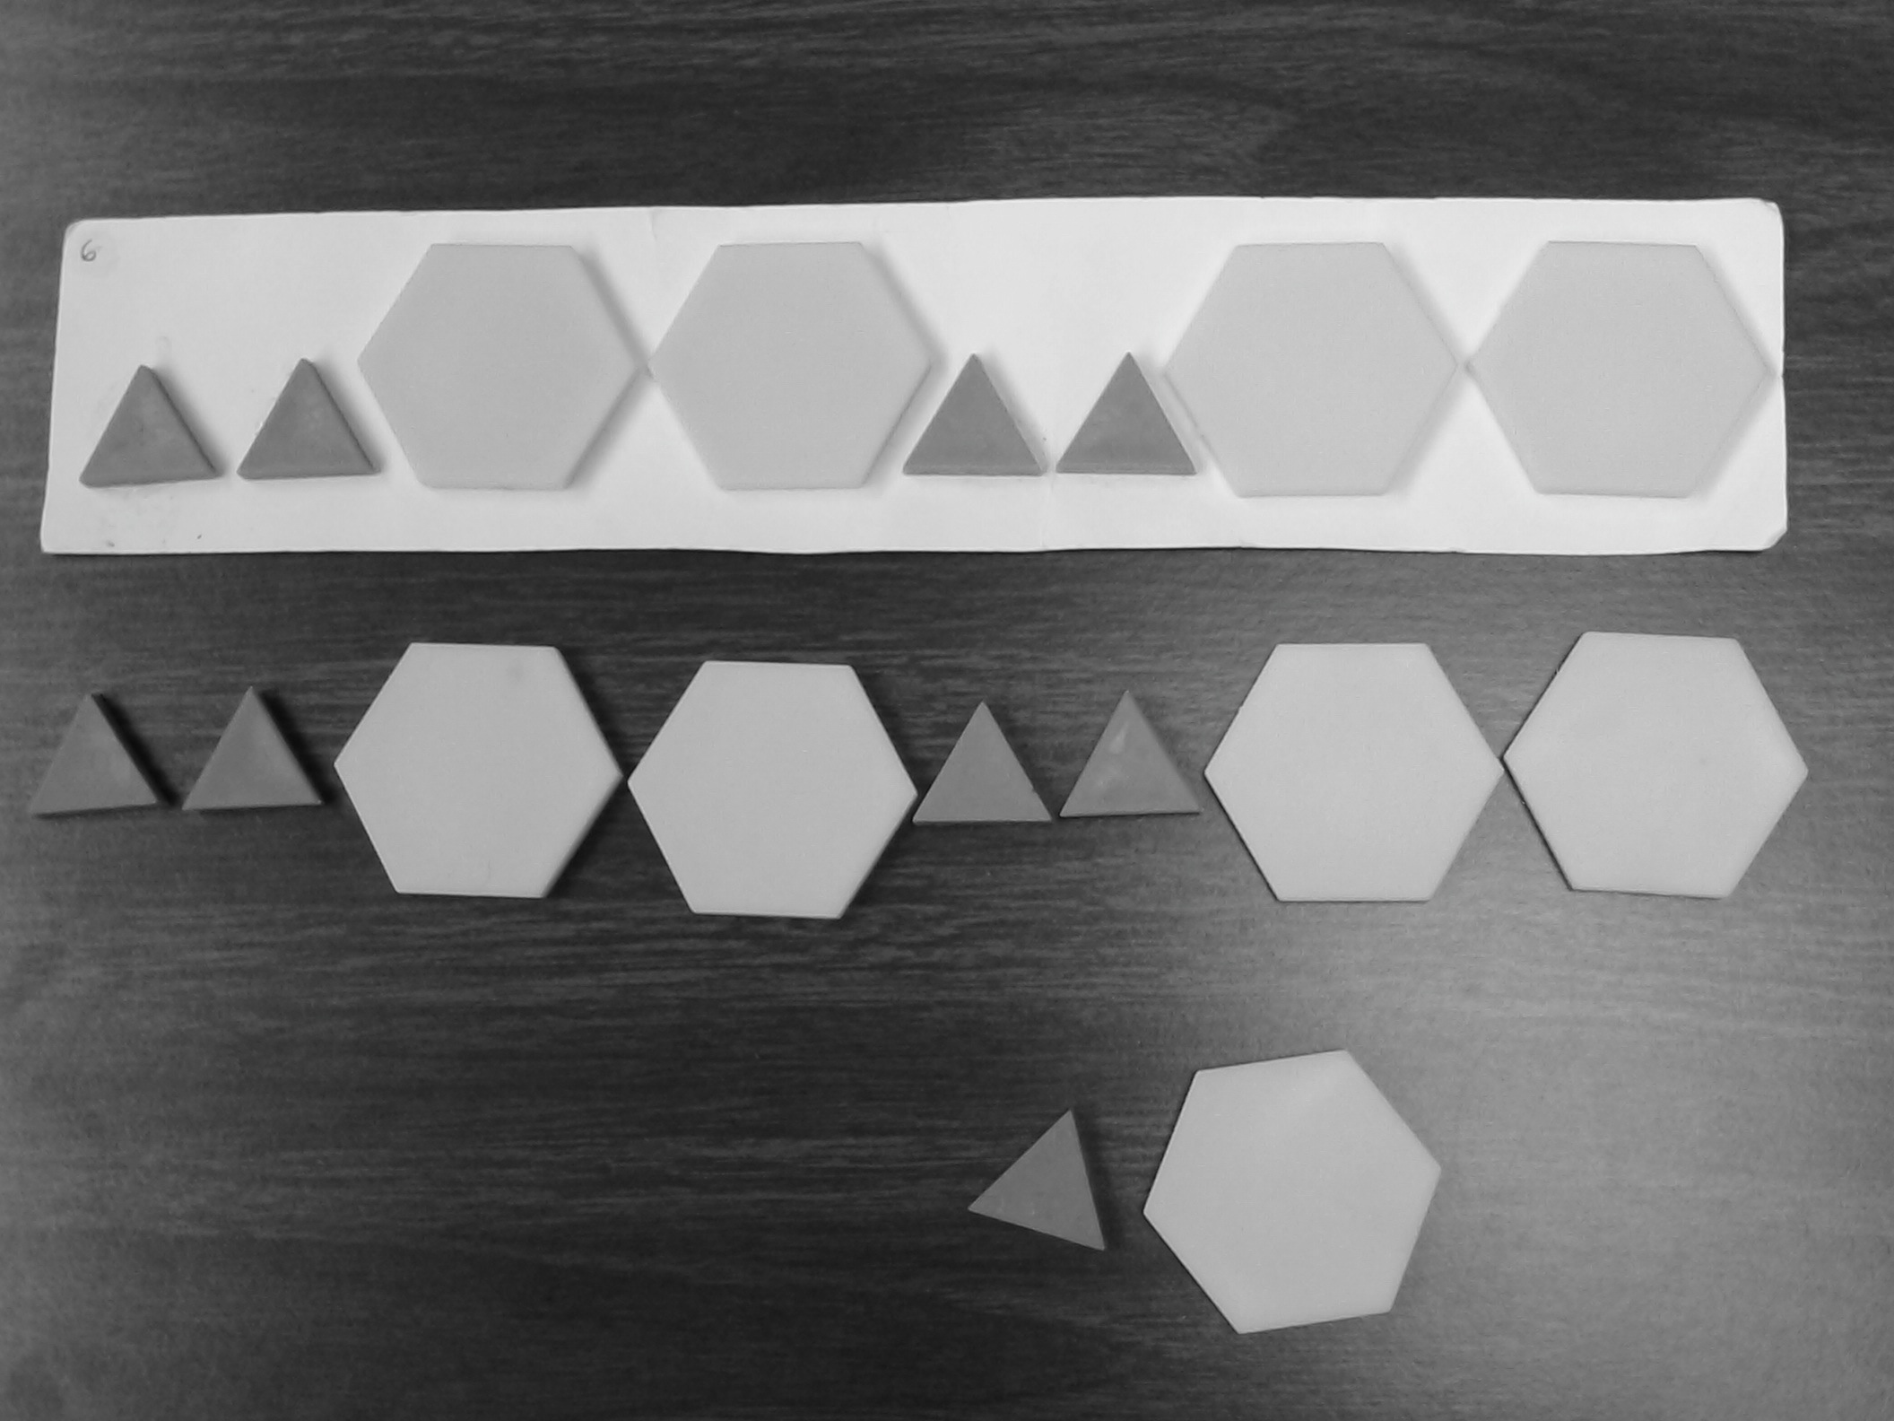  “I made a pattern with these blocks. Please make the same kind of pattern here.” (Triangles were green; hexagons were yellow) | Extend - ABB  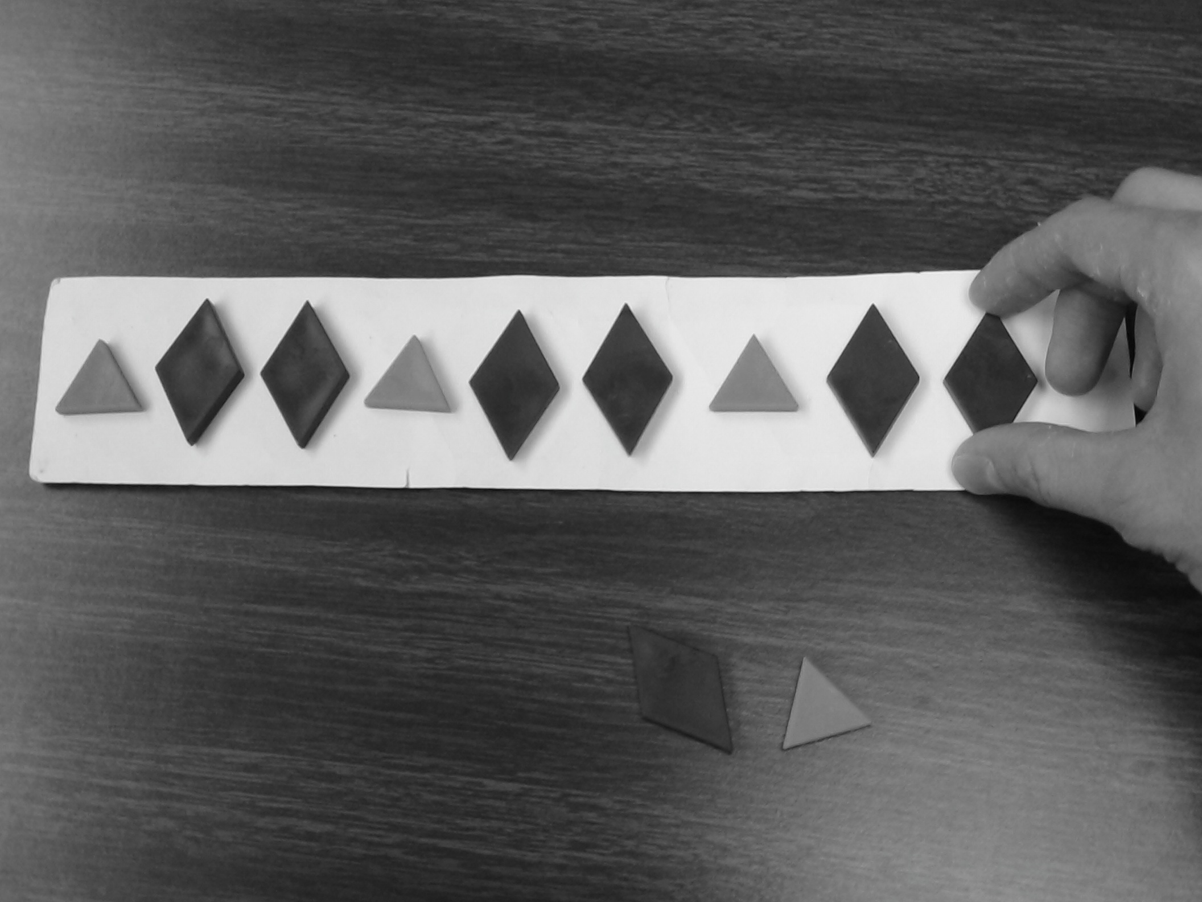  “I made a pattern with these blocks. Finish my pattern here the way I would.” (Triangles were green; diamonds were blue)
Abstract - AABB  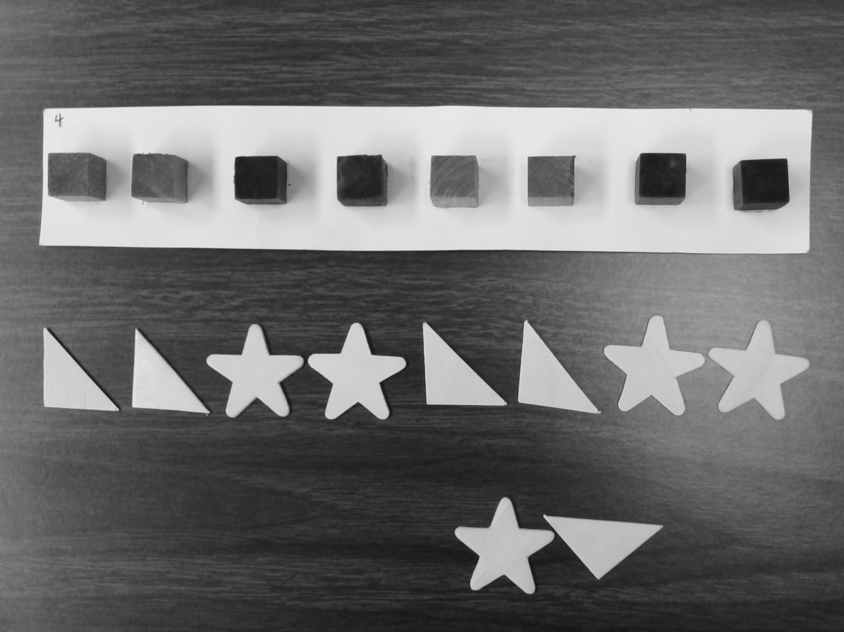  “I made a pattern with these blocks. Please make the same kind of pattern here, using these shapes.” (Cubes were green and purple; triangles and stars were unpainted wood) | Unit-Tower - AAB  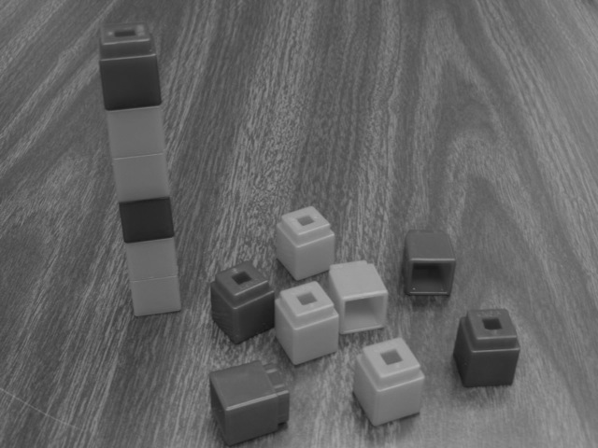  “What is the smallest tower you could make and still keep the same pattern as this?” after a demonstration with an AB tower. (Cubes were orange and blue)
Figure 1. Sample items for each type of pattern task, including a sample correct response.

PRETEST PATTERN ASSESSMENT
Children | Logits | Items
 | 2.5
XXXXX | |
 | 2
 | |
XXXXXXXXXXXXXXXXXXXXX | 1.5
 | | | Abstract-ABB; Abstract-AABB
 | 1
XXXXXXXXXXXXXXXXXXXXXX | |
 | 0.5 | Extend-AABB
 | |
XXXXXXXXXXXXXXXXXXXXXXXXXXXX | 0
 | |
 | -0.5 | Extend-ABB
XXXXXXXXXXXXXXXXXXXXXXXXXXXXX | |
 | -1
 | |
 | -1.5
XXXXXXXXXXXXXXXXXXX | |
 | -2 | Duplicate-AABB

Figure 2. Wright map for the pretest pattern assessment. Items directly across from a child (X) are expected to be solved 50% of the time. The greater the distance of an item below/above a child, the greater the expectation that the child will/will not correctly solve that item.

POSTTEST PATTERN ASSESSMENT
Children | Logits | Items
 | 3
 | |
XXX | 2.5
 | |
XXXXXXXXXXX | 2
 | | | UnitTower-AAB; UnitStick-AAB
XXXXXXXXX | 1.5
 | |
XXXXXXXXXX | 1
 | | | Extend-AABB
XXXXXXXXXX | 0.5
 | |
XXXXXXXXXXXXXXXXXXXXXXXXXX | 0 | Abstract-AABB
 | | | Abstract-AAB; Abstract-AABB
XXXXXXXXXXXXXXXXXXXXXXXXXXXXXX | -0.5
 | | | Extend-ABB
 | -1
XXXXXXXXXXXXXXXXXX | |
 | -1.5
XXXXXXX | |
 | -2 | Duplicate-AABB

Figure 3. Wright map for the posttest pattern assessment.

