PRETEST 1 (AAB PATTERN)
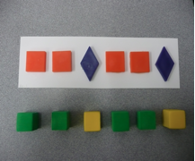

EXAMPLE 1 (AB PATTERN)
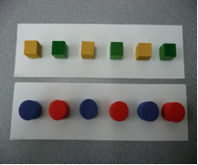

SOLVE 1 (AB PATTERN) SOLVE 2 (AB PATTERN)
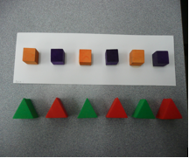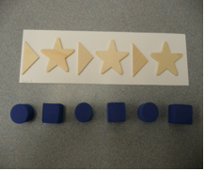
EXAMPLE 2 (AAB PATTERN)
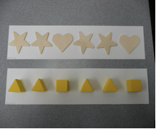

SOLVE 3 (AAB PATTERN) SOLVE 4 (AAB PATTERN)
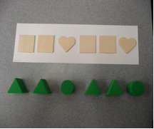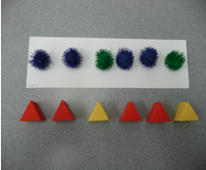

EXAMPLE 3 (ABB PATTERN)
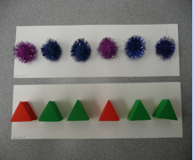

SOLVE 5 (ABB PATTERN) SOLVE 6 (ABB PATTERN)
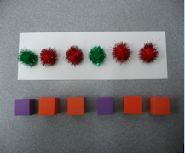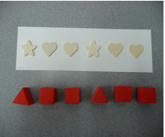

SOLVE 7 (AABB PATTERN) SOLVE 8 (ABC PATTERN)
