Vanderbilt Story Problems 2 (VSP2)

1) Tommy has 4 red checkers and 3 black checkers. Jacob has 9 checkers. How many more checkers does Jacob have than Tommy?

2) Mrs. Bell had 9 kittens. Then she gave away 4 kittens. How many kittens does Mrs. Bell have now?

3) Maria had 2 hair bows. Then her mom bought her 4 more hair bows. Maria gave some hair bows to her sister and she has 3 left. How many hair bows did Maria give to her sister?

4) There are 4 monkeys at the Nashville Zoo. There are 6 lions. How many more lions are there than monkeys?

5) Tanya and Callie won 7 Field Day ribbons altogether. Tanya won 4. How many ribbons did Callie win?

6) Jordan had 8 music CDs. Then he sold some. Now Jordan has 3 CDs. How many CDs did Jordan sell?

7) Karen had some pennies. Then Matt gave her 4 more pennies. Now Karen has 6 pennies. How many pennies did she have to start with?

8) Mr. Pipe’s class baked 3 cherry pies and 4 apple pies. How many pies did the class bake altogether?

9) Charles is 5 years older than his sister, Jill. Jill is 2 years old. How old is Charles?

Costs at Snack Shop
Hamburger | 

Soda
Fries
Cookie | ?
Each stands for $1.

- This graph shows the costs of food at the snack shop. A hamburger and cookie cost $6 in all. How much does the cookie cost?

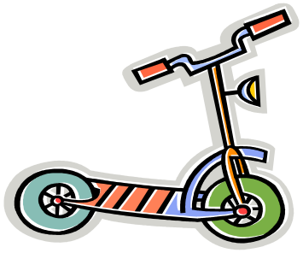
1 Scooter
5 Yo-Yos
6 Toy Soldiers

11) Last year, Mike had 1 toy soldier. Then, he got some more. The picture shows how many toy soldiers Mike has now. How many new toy soldiers did he get?


Ms. Taylor
bread:$1
milk: ?
crackers:$3
apples: $6

12) The picture shows how much money Ms. Taylor spent. She spent $3 less on bread than on milk. She also bought 2 bags of apples. How much did Ms. Taylor spend on milk?

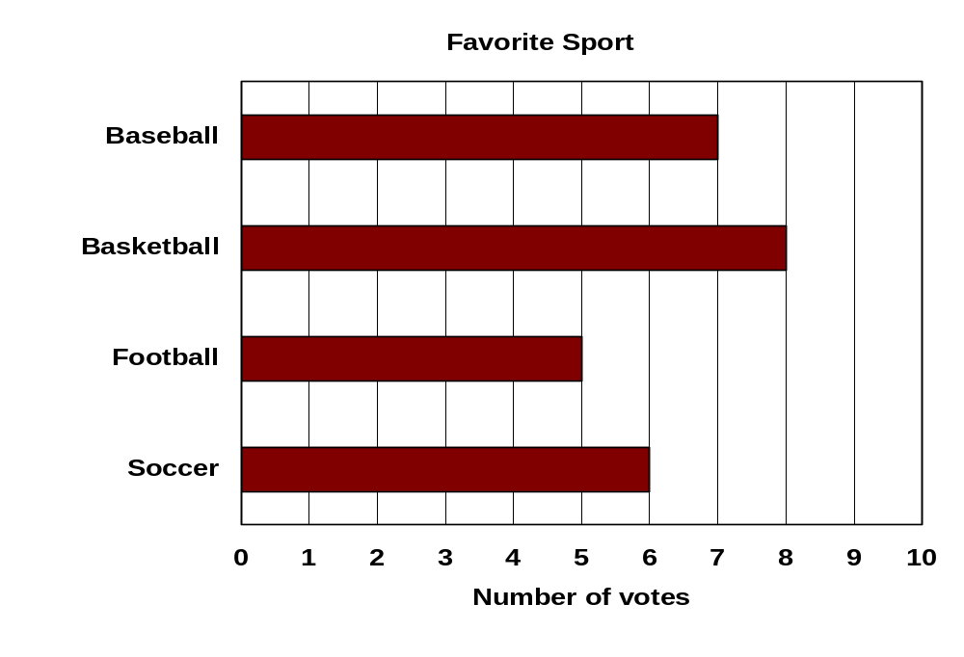
13) This chart shows how many kids voted for football as their favorite sport. Then, 4 more kids voted for football. How many votes are for football now?

A B C D
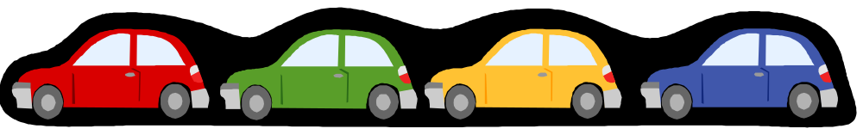
? $3 $2 $5

14) This picture shows how much toy cars cost. Car A and Car B cost $6 altogether. How much does Car A cost?

Number of Books Read

Rob | 

Joan
Pam
Brett | ?
Each stands for 2 books.

15) The chart shows how many books the students in Mr. Carter’s class read. Rob read 4 books more than Brett. Mr. Carter read 12 books. How many books did Brett read?

Each 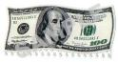 stands for $1.
Costs of Toys
Legos
Jump Rope
Doll
Movie

16) This graph shows the costs of some toys. Diana had some money. Then she bought a jump rope and a doll. Now she has $2 left. How much money did Diana have to start with?

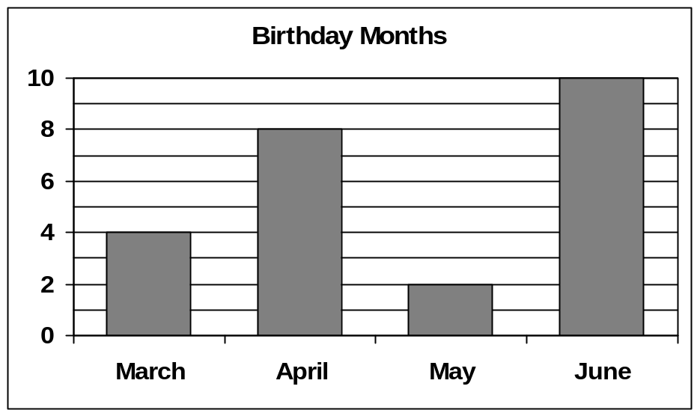

17) This chart shows how many boys and girls have birthdays in March, April, May, and June. How many students have birthdays in March and April?

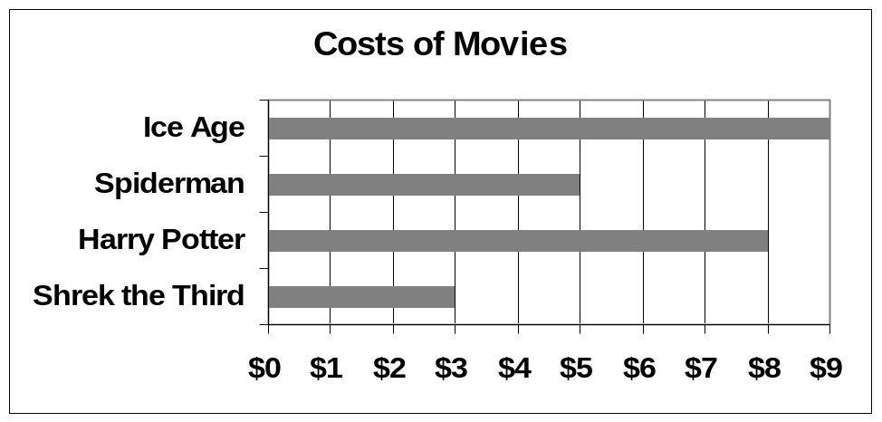

18) This chart shows the costs of movies. Each movie lasts 2 hours. How much more does Harry Potter cost than Spiderman?

