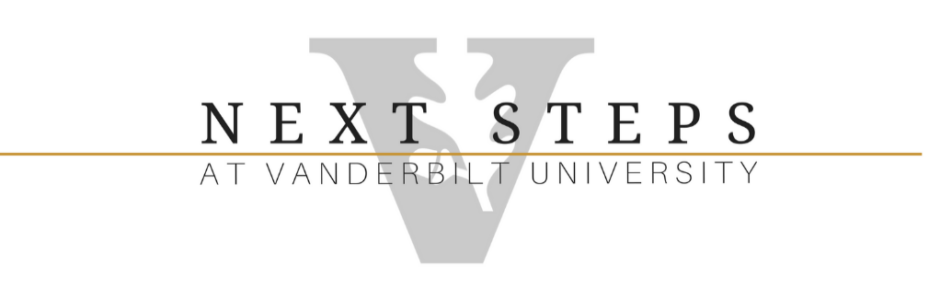
HOW DO WE PAY FOR NEXT STEPS AT VANDERBILT?
FINANCIAL AID AVAILABLE FOR ELIGIBLE STUDENTS 2023-2024
Is the tuition affordable? Yes! Students enrolled through Next Steps do not pay full Vanderbilt undergraduate tuition. Many families get additional support through a combination of sources like Tennessee’s educational scholarships, Vocational Rehabilitation, federal financial aid, Vanderbilt tuition assistance, and outside scholarships.
- VOCATIONAL REHABILITATION- Active Vocational Rehabilitation clients who receive Transitional Learning Services are currently awarded $3,000 per semester for 8 semesters. http://tennessee.gov/humanserv/rehab/vrs.html.
- FEDERAL FINANCIAL ASSISTANCE- Eligible students can be awarded Federal Pell Grant, Federal Supplemental Educational Opportunity Grant, and Federal Work-Study programs. The estimated Federal Pell Grant is $6,895 annually based on need. Students who were born before January 1, 2000 do not need to provide their parent’s income. Apply early. The Free Application for Federal Student Aid (FAFSA) for the 2023-2024 is available now. https://studentaid.ed.gov/sa/eligibility/intellectual-disabilities
- STEP UP SCHOLARSHIP- Students who graduated from a Tennessee high school, who are a Tennessee resident, and have been out of high school for less than 16 months are eligible to receive $4,500 each year for freshmen and sophomores and $5,700 for juniors and seniors to help cover tuition. The FAFSA must be completed along with the Step Up application.
https://www.tn.gov/collegepays/money-for-college/state-of-tennessee-programs/tennessee-step-up-scholarship.html
- TN PROMISE SCHOLARSHIP- Students who graduated from a Tennessee high school and completed Promise Program requirements during their final year of school are eligible for this award. Tuition costs up to $ 2,208 per semester. The FAFSA and TN Promise applications must be completed prior to stated deadlines. https://www.tn.gov/tnpromise
- TN RECONNECT GRANT- Students that are Tennessee residents, have been out of high school for longer than 16 months, have not already earned a higher education degree, and have a Free Application for Federal Student Aid (FAFSA) status of “independent” are eligible for this grant. AFTER state and federal aid have been applied, this award can pay tuition costs up to $2,208 per semester. The FAFSA application must be completed prior to stated deadlines. https://www.tnreconnect.gov/
- TN STUDENT ASSISTANCE AWARD PROGRAM- (TSAA) was established to provide non-repayable financial assistance to financially needy undergraduate students who are residents of Tennessee. Students must complete the FAFSA application each year between Oct. 1 and Feb. 1 to be eligible. Approx. $4000 per year. Please note that students that receive TSAA would not qualify for the TN Promise or Reconnect. https://www.tn.gov/collegepays/money- for-college/grant-programs/tennessee-student-assistance-award.html
- INDIVIDUAL EDUCATION AND TRAINING SERVICES- an option for ECF (Employment and Community First Choices) recipient funds for the reimbursement of college expenses, i.e. tuition, books, transportation, up to $500 per year. The Managed Care Organization is the responsible party to authorize a service for a member based on their needs and assessment. https://www.tn.gov/didd/employment-and-community-first-choices.html
- DEPENDENT TUITION ASSISTANCE- Vanderbilt University faculty and staff may also be eligible for the Dependent Tuition Assistance benefit. This university benefit awards 55% of the cost of tuition to the dependents of eligible employees.
- PRIVATE and NONPROFIT SCHOLARSHIPS- Students and families should explore scholarship opportunities through their communities, local agencies, and diagnosis-related organizations. Past students have received $1,000 and $2,000 scholarships from their church families, The Arc, Ruby’s Rainbow, Down Syndrome Associations, Williams Syndrome Association and the Community Foundation of Middle Tennessee.
The tuition during the 2023-2024 academic year will be: $25,696 ($12,848 per semester).
These scenarios are possible tuition assistance amounts, for the 2023/2024 academic year, based upon the student’s/family circumstances and this year’s tuition cost. Please keep in mind these are estimates and do not include the cost of books, meals, and other incidentals. The cost of tuition is subject to change.
Example 1  Student recently graduated from TN high school, is eligible for federal aid, i.e. Pell Grant:  Federal Aid: $6,895 2023-2024 Tuition $25,696  TN Promise 4,416 Potential Aid 21,811  Step Up 4,500  Remaining tuition $3,885  VR 6,000 or per semester $1,943  Total $21,811  NOTE:  Jr. and Sr. students receive $5,700 annually from Step Up. | Example 2  Student recently graduated from TN high school, completed TN Promise requirements, is not eligible for federal aid:  Step Up: $4,500 2023-2024 Tuition $25,696  TN Promise 4,416 Potential Aid 17,124  VR 6,000 Remaining tuition $ 8,572  Total $17,124 or per semester $4,286  NOTE:  Jr. and Sr. students receive $5,700 annually from Step Up.
Example 3  Student is TN resident, graduated over 16 months ago, has independent status on FAFSA application, and would qualify as financially-needy:  Federal Aid: 6,895 2023-2024 Tuition $25,696  TSAA 4,000 Potential Aid 16,895  VR 6,000 Remaining tuition: $8,801  Total $16,895 or per semester: $4,400 | Example 4  Student is TN resident, graduated over 16 months ago, has independent status on FAFSA application, and would not qualify as financially needy, may be eligible for TN ReConnect:  Federal Aid: $6895 2023-2024 Tuition $25,696  VR $6000 Potential Aid 12,895  Total $ 12,895 Remaining tuition: $12,801  Or per semester $6,400
Example 5  Student is not a TN resident, is eligible for federal aid, and would qualify as financially needy:  Federal Aid: $6,895 2023-2024 Tuition $25,696  TSAA 4,000 Potential Aid $10,895  Total $10,895  Remaining tuition: $14,801  Or per semester $7,400 | Example 6  Student is not a TN resident, has independent status on FAFSA application, and would not qualify as financially needy:  Federal Aid: $6,895 2023-2024 Tuition $25,696  Total $6,895 Potential Aid $6,895  Remaining tuition: $18,800  Or per semester $9,400
Important- Students enrolled through Next Steps are eligible for the Vandy Plan interest free tuition payment plan but must get this started in the spring semester for the following academic year. https://finance.vanderbilt.edu/stuaccts/payments/options-fall.php
Students enrolled through Next Steps can ride the MTA buses free using their Vanderbilt ID cards to and from campus.
Next Steps at Vanderbilt – For more information please visit our website at www.vu.edu/nextsteps .
If you would like to make an appointment to review this financial assistance information with a staff member, please email Lauren Bethune-Dix, Assistant Director, Lauren.Bethune@Vanderbilt.Edu .

