Jazz
Jury Form
Blair School of Music
Vanderbilt University
2400 Blakemore Avenue
Nashville, TN 37211
Student Name here
Type term here
Degree / Program
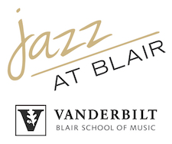
Instrument

Credit Hours
Teacher

Grading Key
A=Outstanding
B=Good
C=Satisfactory
D=Minimum Pass Work
F=Failure

JURY GRADE
Teacher name (typed/printed)
Teacher signature/date
Recommended Listening:

Repertoire studied this semester:

Teacher Comments: (Strengths)

Fundamentals / Exercises emphasized:

Teacher Comments: (Weaknesses)

Teacher Comments: (Goals for the Future)

