**6th Grade Worksheets**

Follow along with your VSVS team using these sheets and info!

**Observation Sheet**

**Circle the Traits your creature has.**

|  |  |  |  |
| --- | --- | --- | --- |
| **Trait** | **Variation 1** | **Variation 2** | **Variation 3** |
| Leg Length | Short | Long |  |
| Wings | Absent | Present |  |
| Foot Shape | Webbed | Talon |  |
| Tail Length | Short | Long |  |
| Arm Length | Short | Long |  |
| Antenna Shape | Knob | Star |  |
| Antenna Length | Short | Long |  |
| Beak Shape | Trumpet | Crusher |  |
| “Hand” Shape | Claw | Paw |  |
| Ear Shape | Mouse | Elephant |  |
| Skin Color | Red | Purple | Blue |
| Eye Color | Red | Green | Stop-and-Go |

**Tally Chart**

For each scenario, give a +1 or -1 in the tally box for the appropriate trait. At the end add up the net score.

|  |  |  |  |
| --- | --- | --- | --- |
| **Trait** | **Variation** | **Tally** | **Net Score** |
| **Leg Length** | *Long* |  |  |
|  | *Short* |  |  |
| **Wings** | *Wings* |  |  |
|  | *No Wings* |  |  |
| **Foot Shape** | *Talon* |  |  |
|  | *Webbed* |  |  |
| **Tail Length** | *Short* |  |  |
|  | *Long* |  |  |
| **Arm Length** | *Short* |  |  |
|  | *Long* |  |  |
| **“Hand” Shape** | *Claw* |  |  |
|  | *Paw* |  |  |
| **Antenna Shape** | *Star* |  |  |
|  | *Knob* |  |  |
| **Antenna Length** | *Short* |  |  |
|  | *Long* |  |  |
| **Beak Shape** | *Crusher* |  |  |
|  | *Trumpet* |  |  |
| **Ear Shape** | *Mouse* |  |  |
|  | *Elephant* |  |  |
| **Skin Color** | *Red* |  |  |
|  | *Blue* |  |  |
|  | *Purple* |  |  |
| **Eye Color** | *Red* |  |  |
|  | *Green* |  |  |
|  | *Red and Green* |  |  |

**Potential Energy Observation Sheet**

**Name._______________________________**



**Data Collection For** **Potential Energy Related To Height (Mass Held Constant)**

1. Distance block moved when 1 block (2cm height) under track _______
2. Distance block moved when 2 blocks (4cm height) under track _______
3. Distance block moved when 3 blocks (6cm height) under track _______
4. Make a **line graph** showing results.
5. Predict (from the line graph) the distance block will move with 4 blocks (8 cm) under track _______
6. **Test prediction:**

Distance block moved when 4 blocks (8cm height) under track _______



**Data Collection For Potential Energy Is Related To Mass (Height Held Constant)**

Use 3 blocks (6 cm height) for all trials.

Which ball has more mass?

Predict which ball will make the block move a greater distance?

1. Distance block moved when squash ball is used. _______
2. Distance block moved when golf ball is used. _______
3. Make a **bar graph** showing results.

**Potential Energy - Answer Sheet**

**Data Collection for** **Potential Energy related to height (mass held constant)**

1. Distance block moved when 1 block (2cm height) under track _____________________
2. Distance block moved when 2 blocks (4cm height) under track _____________________
3. Distance block moved when 3 blocks (6cm height) under track _____________________
4. Predict the distance block will move with 4 blocks (8 cm) under track _______________
5. Test prediction:

Distance block moved when 4 blocks (8cm height) under track _____________________

**Data Collection for Potential Energy is related to mass (height held constant)**

Use 3 blocks (6 cm height) for all trials.

Which ball has more mass? *The golf ball*

Predict which ball will make the block move a greater distance? *The golf ball*

1. Distance block moved when squash ball is used. _____________________
2. Distance block moved when golf ball is used. _____________________

**Instruction Sheet**

**POTENTIAL ENERGY**

**Fall 2017**

**I. Introduction -** Definitions of energy are discussed.

**II. Demonstrations**

Three devices are used to show Conservation of Energy and conversions between potential and kinetic energy.

**III. Demonstration**

VSVS members demonstrate the activity students will do in part IV.

**IV. Gravitational Potential Energy is Related to Mass and Height**

**A. Potential Energy is related to height (mass held constant)**

**Trial Run #1**

1. Place one of the supports so that its large flat area is lying on the desk or floor surface, and the black line is facing up.

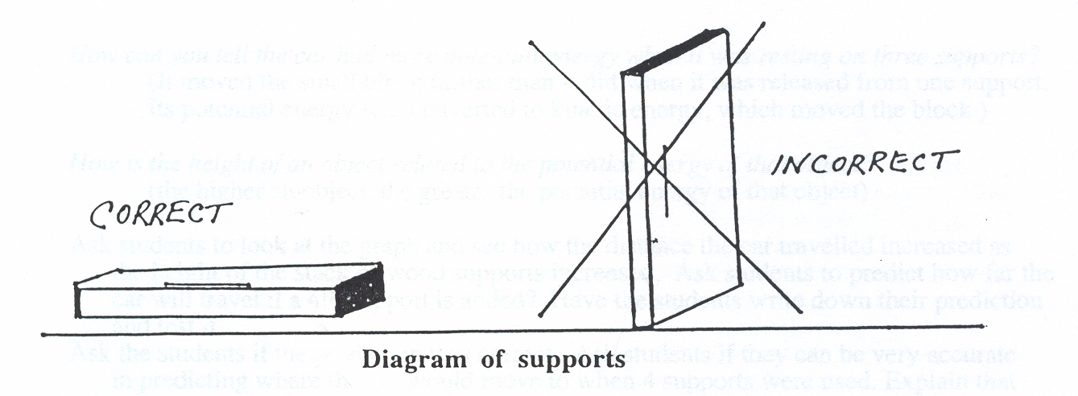

2. Rest the "START” end of the track on the surface of **one** ofthe supports so that the track edge lines up with the line on the block.

3. Place the small block on the track at the "0 cm” mark with the red end of the block even with the line drawn on the track.

4. Hold a ball on the track at the starting point where the track is resting on the block.

5. Release the ball and observe what happens to the block. Measure the distance the block moved from its starting "0 cm” mark.. Make sure that the tape measure starts at the“0" mark, and is pulled out taught, and that the distance is measured to the red end of the block.

6. Record this value on your graph at the 2cm (one support) line by using their pencil to make a small, filled-in circle.

**Trial Run #2**

1. Add another support under the "START” end of the track. Repeat steps 1- 6 from Trial Run #1.

2. Record the distance moved on the graph at the 4cm (two support) line.

**Trial Run #3**

1. Add another support under the "START” end of the track.

2. Repeat steps 1-6 from Trial Run #1.

3. Record the distance moved on the graph at the 6cm (three support) line.

**Investigative Run:** Draw a line through the dots on your graph (you will need to use a ruler or straight edge) and extend the line so that it goes through the “8cm” line. Predict how far the ball will travel if a 4th support is added. Test your prediction.

**B. Potential Energy is related to mass (height held constant)**

Use only 3 wooden supports under the track**.**

**Trial Run #1**

1. Rest the "Start” end of the track on the surface of thethree supports so that the track edge lines up with the line on the block.

2. Place the small block on the track at the "0 cm” mark with the red end of the block even with the line drawn on the track.

3. Hold the **lighter squash ball** on the starting point of the track.

4. Observe what happens to the small block when the ball is released.

5. Measure the distance the small block was moved from its starting point.

6. Record the measurement as a **bar** on your graph at the line that corresponds with the mass of the squash ball.

**Trial Run #2**

1. Use the **heavier** golf ball.

2. Care should be taken that the track rests at the same position as in Trial 1, and that the ball

starts from the same position on the track.

3. Repeat steps 1 - 6 from Trial Run #1.

**V. Review**

**CHEMICAL ENERGY CONVERSIONS OBSERVATION SHEET**

**Name ___________________________________________**

**Circle the correct energy conversion for the following questions:**

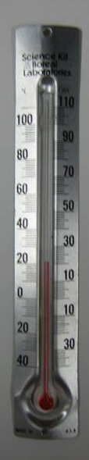1. When the light stick was activated, chemical energy was converted to:

a. thermal energy b. light energy c. electrical energy

What evidence do you have for this conversion? __________________________

2. When the button was pushed (or disc bent) in the recyclable hand warmer, chemical energy

was converted to:

a. electrical energy b. thermal energy c. light energy

What evidence do you have for this energy conversion? ____________________

3. Activity: Reading the Thermometer

Look at your thermometer. Mark the height to which the red liquid has reached. This is the temperature the thermometer senses. Record this temperature below.

Initial temperature reading of the thermometer diagram: ______ °C

4. Potassium Chloride Activity

Repeat temperature reading after the thermometer has been in the water.

Determine what the temperature the water is and record below:

Temperature of water **(A)**: ______ °C

Repeat temperature reading after potassium chloride has been added and dissolved, and record below:

Temperature of water + potassium chloride **(B)**: ______ °C

Temperature change **(A-B)**: ______ °C

In this activity, _____________energy was converted to chemical energy

5. Exploding Can Demonstration.

When the powder was ignited in the coffee can, chemical energy was converted to several

other forms. Circle all the conversions and give the evidence for the conversion:

Chemical to light ______________________________________________

Chemical to sound ______________________________________________

Chemical to mechanical ______________________________________________

Chemical to nuclear ______________________________________________

Chemical to thermal ______________________________________________

Chemical to electrical _________________________________________

Where did the chemical energy come from? _________________________________________________________________________

**ANSWER SHEET**

**CHEMICAL ENERGY CONVERSIONS OBSERVATION SHEET**

1. When the light stick was activated, chemical energy was converted to:

a. thermal energy **b. light energy** c. electrical energy

What evidence do you have for this conversion? _____**lightstick lit up**________

2. When the button was pushed/disc bent in the recyclable hand warmer, chemical

energy was converted to:

a. electrical energy **b. thermal energy** c. light energy

What evidence do you have for this energy conversion?__**It felt warmer**________

3. Activity: Reading the Thermometer

Put a mark next to the line on the thermometer diagram that is even with the top

of the black line in the middle of the thermometer. Record the temperature

represented by this mark on the blank below.

Temperature reading of the thermometer diagram: __**24**__ °C

4. Potassium Chloride Activity

Draw a line on the picture of the thermometer that matches where the top of the

red line is on your thermometer in the water. Determine what the temperature

the water is and record below:

Temperature of water **(A)**: _**21 (varies)**_ °C

After potassium chloride has been added and dissolved, measure the

temperature of the water using the same method as before and record below:

Temperature of water + potassium chloride **(B)**: **14 (varies)**_ °C

Temperature change **(A-B)**: -10 to -14_ °C

In this activity, ___**thermal**___energy was converted to chemical energy

6. When the powder was ignited in the coffee can, chemical energy was converted to several other forms. Circle all the conversions and give the evidence for the conversion:

**Chemical to light**  Observed a yellow flame

**Chemical to sound** Heard a loud noise

**Chemical to mechanical** The lid blew off.

**Chemical to nuclear** none

**Chemical to thermal**  The lid and can felt warm

**Chemical to electrical** none

Where did the chemical energy come from? Stored in the chemical bonds of the

powder. The energy was released when the powder burned.

**Observation Sheet - Saltwater Density**

**IIC. Floating/Sinking Beads in Vials**

Is the bead more or less dense than freshwater? __________

Is the same bead more or less dense than saltwater? __________

**III. Separation Challenge**

Look at the table of bead densities and predict the order in which they will float as spoons of salt are added to the water.

1.___________________________________________________________________________

2. ___________________________________________________________________________

3. ___________________________________________________________________________

4. ___________________________________________________________________________

|  |  |
| --- | --- |
| **Bead** | **Approximate Density** |
| **#1, white, oval** | **< 1.00g/mL** |
| **#2, blue, cylindrical** | **1.05-1.07g/mL** |
| **#3, yellow, ylindrical** | **1.13-1.16g/mL** |
| **#4, clear, cylindrical** | **> 1.276g/mL** |

Write down what happens to the beads after each addition.

|  |  |  |
| --- | --- | --- |
| **Number of Spoons Added** | **Density salt water** | **What Happened to the Beads?** |
| 0 | 1.00 |  |
| 1 | 1.0163 |  |
| 2 | 1.0326 |  |
| 3 | 1.0489 |  |
| 4 | 1.0652 |  |
| 5 | 1.0815 |  |
| 6 | 1.0978 |  |
| 7 | 1.114 |  |
| 8 | 1.1304 |  |
| 9 | 1.1467 |  |
| 10 | 1.163 |  |

Look at the Density Table for Recyclable Plastics (on your Handout) and determine what kinds of plastics might have been used in this lesson.

**white, oval = ________________ blue, cylindrical = __________________ yellow, cylindrical = ________________ clear, cylindrical = __________________**

**Observation Sheet Answers - Saltwater Density**

**IC. Floating/Sinking Beads**

Is the bead in the vial more or less dense than freshwater? **More_____**

Is the same bead in the vial more or less dense than saltwater? **Less_**_____

**III. Separation Challenge**

Look at the table of bead densities and predict the order in which they will float as spoons of salt are added to the water.

1.**white, oval** will float in pure water, since its density is less than the density of water

1. **blue, cylindrical**

3. **, yellow, cylindrical**

4. **clear, cylindrical**

|  |  |
| --- | --- |
| **Bead** | **Approximate Density** |
| **#1, white, oval** | **< 1.00g/mL** |
| **#2, blue, cylindrical** | **1.05-1.07g/mL** |
| **#3, yellow, cylindrical** | **1.13-1.16g/mL** |
| **#4, clear, cylindrical** | **> 1.276g/mL** |

Write down what happens to the beads after each addition.

|  |  |  |
| --- | --- | --- |
| **Number of Spoons Added** | **Density salt water** | **What Happened to the Beads?** |
| 0 | 1.00 |  |
| 1 | 1.0163 |  |
| 2 | 1.0326 |  |
| 3 | 1.0489 |  |
| 4 | 1.0652 |  |
| 5 | 1.0815 |  |
| 6 | 1.0978 |  |
| 7 | 1.114 |  |
| 8 | 1.1304 |  |
| 9 | 1.1467 |  |
| 10 | 1.163 |  |

Look at the Density Table for Recyclable Plastics (on your Handout) and determine what kinds of plastics might have been used in this lesson.

**white, oval = HDPE, LDPE, PP blue, cylindrical = PS**

**yellow, cylindrical = PVC clear, cylindrical = PETE, PVC**