7th Grade Worksheets

Follow along with your VSVS team using these sheets and info!

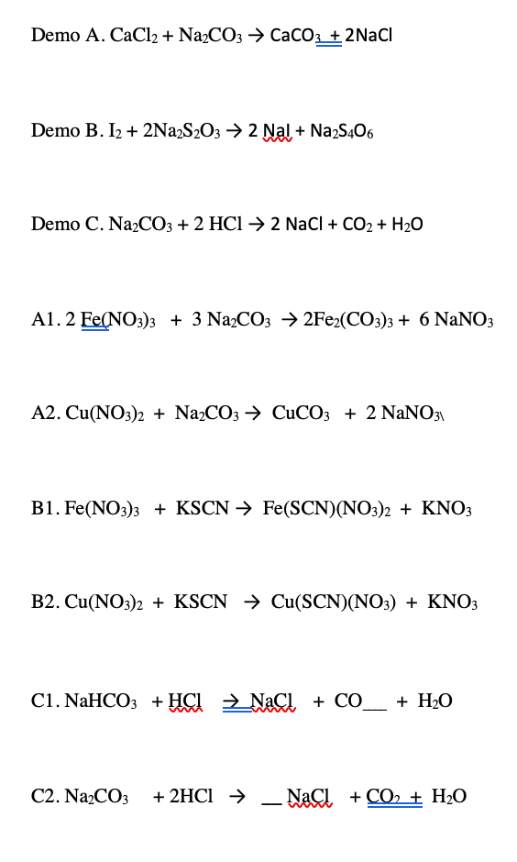
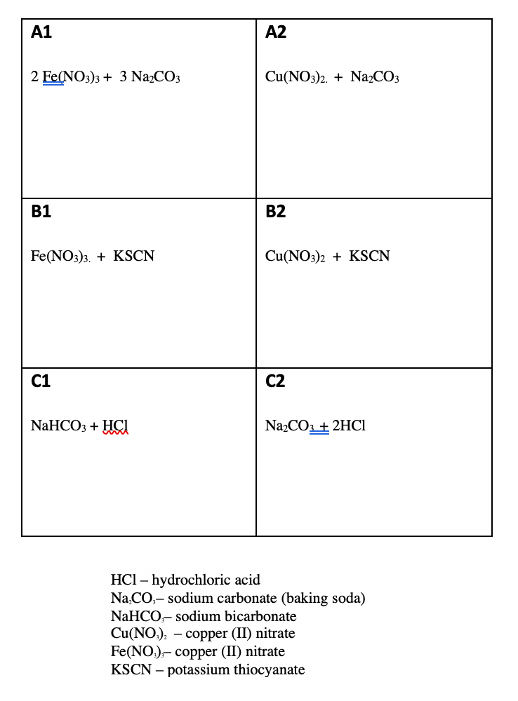
Chemical Reactions Observation Sheet

Effect of Carbon Dioxide on the Environment
Observation Sheet Student’s Name__________________________

Lesson Activity | Observations
II. Comparing Dry Ice to H₂O Ice
a) What happens to the dry ice in the bag? The regular ice?
b) What happened to the dry ice left on the plate? The regular ice?
III. Carbon Dioxide in Ocean Water
What color did the Universal Indicator solution turn when dry ice was added?
What does this tell you about the effect of carbon dioxide dissolved in ocean water?

IV. Cave Formation
What happens to the Tums when acid was added to it
What does this tell you about the effect of carbon dioxide dissolved in rain water on limestone, coral reefs and sea shells ?

Effect of Carbon Dioxide on the Environment
Observation Sheet
Answer Sheet

Lesson Activity | Observations | Change of State
II. Comparing Dry Ice to H₂O Ice in a bag  A What happens to the dry ice in the bag?  B The regular ice? | A Ziploc bag with dry ice fills with gas (CO₂).  B. Ziploc bag with ice doesn’t change in size | A. solid to gas (sublimes)  B. none
II. Comparing Dry Ice to H₂O Ice on the plate  A What happened to the dry ice left on the plate?  B the regular ice? | A1 Dry ice CO₂ changes from solid to gas  A2 Water vapor in air is cooled by dry ice to form tiny particles of ice water, seen as “smoke(water vapor).  B Water ice melts | A1. solid to gas (sublimes)  A2. gas to liquid to solid  B. solid to liquid
III. Carbon dioxide in Ocean Water  What color did the Universal Indicator solution turn when dry ice was added?  What does this tell you about the effect of carbon dioxide dissolved in ocean water? | From blue to green to yellow to red. | No change of state This is a chemical change
IV. Cave Formation  What happens to the Tums when acid was added to it  What does this tell you about the effect of carbon dioxide dissolved in rain water on limestone, coral reefs and sea shells ? | The Tums tablet fizzes in the acid and disintegrates. | No change of state This is a chemical change.

Crazy Traits
Observation Sheet

Trait | Genotype of mother for the trait | Genotype of father for the trait | Genotype of offspring (after tossing coins) | Phenotype of offspring
Gender | XX | XY
Skin color | Tt | Tt
Leg | Tt | Tt
Foot | Tt | Tt
Arms | Tt | Tt
Hands | Tt | Tt
Eye Color | Tt | Tt
Eyebrows | Tt | Tt
Beak | Tt | Tt
Ears | Tt | Tt
Antenna | Tt | Tt
Antenna shape | Tt | Tt
Tail | Tt | Tt
Wings | Tt | Tt

Look around at the creatures for other groups. Do any of the creatures look the same?

List the dominant traits below.

List the recessive traits below.

Are there any traits that are not dominant or recessive?
Crazy Traits
Observation Sheet Answers

Trait | Genotype of mother for the trait | Genotype of father for the trait | Genotype of offspring (after flipping) | Phenotype of offspring
Gender | XX | XY
Skin color | Tt | Tt
Leg | Tt | Tt
Foot | Tt | Tt
Arms | Tt | Tt
Hands | Tt | Tt
Eye Color | Tt | Tt
Eyebrows | Tt | Tt
Beak | Tt | Tt
Ears | Tt | Tt
Antenna | Tt | Tt
Antenna shape | Tt | Tt
Tail | Tt | Tt
Wings | Tt | Tt

Look around at the creatures for other groups. Do any of the creatures look the same?
No, and they should not, even though all of the parents had the same genotype. This is because the creatures are determined by genotype of parents and by chance.
List the dominant traits below.
Short legs, webbed feet, long arms, paws, unibrow, trumpet beak, elephant ears, long antenna, knob antenna shape, no wings.
List the recessive traits below.
Long legs, talons, short arms, claws, separate eyebrow, crusher beak, mouse ears, short antenna, star antenna shape, wings.
Are there any traits that are not dominant or recessive? Skin color, tails and eye color do not display typical inheritance. See lesson for explanation.
Blood Typing Lab Data Sheet NAME ___________________________
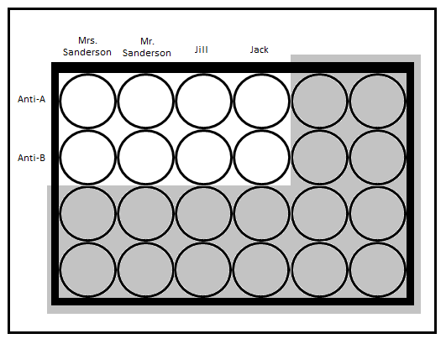

 | Column 1 | Column 2 | Column 3 | Column 4
 | Mrs. Sanderson | Mr. Sanderson | Jill | Jack
Row A Anti-A serum
clumping occurs = +
nothing happens = -
Row B Anti-B serum
clumping occurs = +
nothing happens = -
Blood Type (Phenotype)
(A, B, AB or O)
Possible Genotype
(AA, AB, BB, AO, BO, OO)

