Teaching Strategies Training Session

#1: How to keep students engaged

Tip 1: Keep it fun!

- Did you enjoy your genchem and physics lectures? Probably not! The same is true for our middle school students -- they enjoy VSVS for the hands-on experiments we bring. The lectures components of VSVS lessons are certainly important, as they introduce key concepts, but keep them brief. And when you are lecturing, make it an interactive lecture. Pose questions to the students and have them try to answer.

Tip 2: Roam the classroom

- What separates your VSVS team from a classroom teacher? Well, for one, there’s up to 5 of you. Use this to your advantage. If one VSVSer is leading an experiment at the front of the classroom, the remaining VSVSers should walk around the classroom to make sure students are following along.

Tip 3: Avoid breaks

- It’s happened to all of us: your team writes the vocab words on the board, gives the 5-min lecture introduction, then spends the next 5 minutes trying to figure out where things are in the kit. In these 5 minutes, your students will forget everything you just told them and lose any engagement they may have had in the lesson. Have your group multitask! Unpack and pass things out in preparation for the next demonstration.

#2: How to structure/organize your ideas

Tip 1: Focus on the big picture

- VSVS lessons have many substeps and mini experiments along the way. It’s easy to get lost and forget what the lesson is really trying to teach. Always think to yourself, “how does this experiment, this vocabulary word, or this demonstration connect by back to the lesson title?” In some sense, this style of thinking is akin to forming an essay’s thesis statement. It’s the idea you center around and routinely return to.

Tip 2: Connect ideas throughout the lesson

- Sometimes, especially during training, it can be difficult to see how the experiments within a lesson flow from one to another. However, there is always a logical flow. The challenge is often determining what exactly that flow is, and then explaining it to students (see Tip 3). In the car ride to your school, take a look at the demonstrations your group is running, and try to connect the dots between them: How does one lead to the next? What question posed here is answered in the next part?

Tip 3: Go step by step

- You know that feeling when your professor skips an “obvious” step in a derivation, leaving you (and probably the rest of the class) completely lost? The same thing happens to middle-school students when we explain “obvious” concepts like pH. Try to imagine yourself in the kids’ shoes -- learning an unfamiliar, vague concept for the first time. This is especially important when leading experiments!

#3: How to explain concepts to children without resorting to complex jargon

Tip 1: Involve the students in the “defining” process!

- Write the vocabulary words on the board and ask students what they think they mean. Wait for responses! Too many students ask but don't take hands. Look at the types of words they are using to get a better idea for what they know so far. You can use this to guide you as to what analogies and metaphors are better.

Tip 2: Use visual analogies!

- Students works best with analogies they are familiar with or analogies that they can sense or see.
- For instance, if you are explaining humidity:
  - Use a basket and apples! Big basket holds 20 apples there are 10 in the basket, so the RH is 50%. But what if the temperature dropped? It’s a smaller basket! It only holds 10 apples, so RH is 100%. Now, what if it is a tiny basket? It only holds 5 apples, so 5 apples fall out! This is precipitation. Students can visualize this!
  - This is a great website to use to find analogies: http://www.metamia.com/analogize.php%3Fq%3Dq

Tip 3: Be careful with acronyms or words with multiple meanings!
- Acronyms can be confusing at times. Make sure that you clearly explain them if your lesson uses them frequently. A great way to make sure that they are clear is to either use the full name every time, or write the acronym on the board to remind students what they mean.
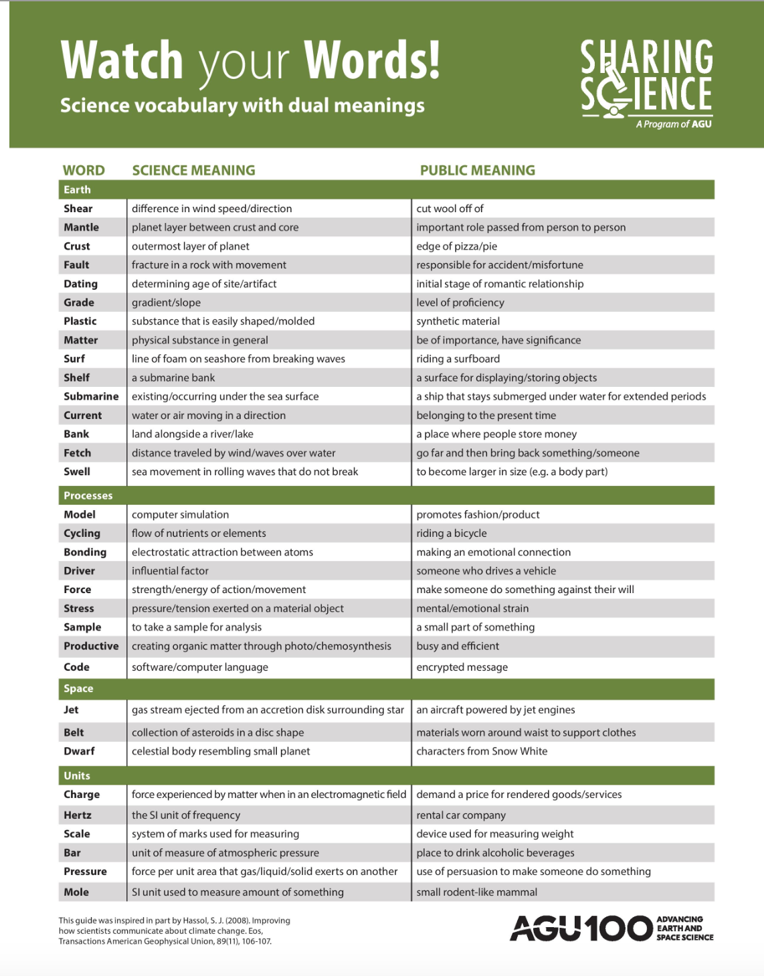

#4: How to work effectively with your classroom teacher

Tip 1: Maintain clear lines of communication between your team and your class’s teacher!

- Ask your teacher what their preferred mode of communication is. Some teachers have commented that they wished their VSVS group would text them instead of emailing them.
- About an hour before your lesson, email or text your teacher with an update. Include the following: the expected time that you’ll get there, what the lesson will be about, and what the teacher should be on the lookout for (for instance, if it’s a messy lesson, let them know!)

Tip #2: Don’t feel bad if the teacher corrects you during your lesson!
- As one teacher noted: “Don't feel that if the teacher interjects, the idea is that he or she is saying the college students doesn't know. The teacher just knows their class and what might work to make the ideas sink in to their brains.”

Tip #3: It’s okay to ask the teacher for advice on what methods or techniques work best for their class!
- This is a great way to learn more about the personalities of the class before you go to teach a lesson. For instance, if the teacher tells you that their class is very high energy, this can be useful in determining your teaching approach.
- Oftentimes, the students have had some level of exposure with the concepts you are teaching. The teacher is a great resource for getting to know how much prior knowledge the students have and what methods were used to teach them those topics.

We asked teachers for feedback on what things they wished VSVS teams did better. Here is what they said:

To keep students engaged:
Please do: Passing out, place items in center of table call and response, "class class, yes, yes. This year we have "East eagles, --rise up". Or the faithful, " if you hear my voice clap once. . .

Please do: I typically go over instructions before handing out materials. I also remind students to "not touch" before and during material pass out time. While passing out materials I also quiz students on the procedure. "What are we going to do 1st? 2nd? next?" etc.

For passing out papers, have them ready at the beginning, or as they are working on something else, pass out papers for the next activity. Make sure to emphasize they are needed for later.

If 1 team member is giving directions/instructions, other team members don't need to be having conversations with student(s). That just breeds the idea of "oh, I don't need to listen, I can talk to my friends" -- since they see the adult VSVS person doing it.

I think any attention signal would work as long as the VSVS students know to explicitly teach it and review it at the beginning of each lesson. I personally use "class, class" and the student respond with "yes, yes". If you google "whole brain call backs", there are a ton of choices. It has to be something the volunteers are comfortable with and will remember. I have one or two students pass out and collect papers and materials.

To structure/organize your ideas:

Be familiar with what order the lab will go in, assign each group member a section of the lesson to be "in charge" of. Reading the lesson out loud to the students isn't a bad thing, just be prepared for questions.

They need to ask questions and then wait for a response. Way too many of my VSVS groups ask a question but then never take any hands/answers.

Just relax and not worry if things don't go perfect. Read over the material and learn to sum it up. Figure what main concept you want them to understand (objective to the lesson). Sometimes I put the main parts of a lesson on the board and then I check them off as I do them.

To explain concepts without using jargon:

List key vocab on the board; use real world examples

If they want they can relate it to something in real life- real life examples are great for students. Or change it to something students can visualize.

Remember they are 10 and 11 and they all come with different science background. Ask every once and awhile if the kids know what a certain term means. Those that do are then able to help those who don't by sharing. And when the kids tell, their peers understand the language better.

To work more effectively with the teacher:

Since we have to make alternate plans if a team cannot make come, it would be nice to know more than an hour in advance. I know emergencies happen however.

A quick check-in before the lesson (even a text), making sure to let us know what is happening ("we are running 5 minutes behind") or explanation about what is coming up (this will be a messy lab, let the students know!). These little things will be helpful in some cases with new labs we may not have seen before.

I wish they would take/use my cell phone. Shoot me a text to tell me you're running late (or better yet, be on time!!). It is way easier for me to check my cell phone than my school email.

If they can't make it for any reason, we need a 24-hour notice so we can come up with alternative plans. If they're running late, a quick email or text would help us so we know to do a filler activity but not start a lesson.

