IVVANDERBILT STUDENT VOLUNTEERS FOR SCIENCE
http://studentorg.vanderbilt.edu/vsvs
Rates of Chemical Reactions
Spring 2019

Goal: To understand factors which affect the rates of chemical reactions - temperature, surface area (particle size), and concentration.
Fits TN standards: 5.PS1.3, 5.PS1.4

VSVSer Lesson Outline
_______ I. Background
Gives overview of experiment.
________ II. Effect of Temperature
Students observe how fast bubbles of carbon dioxide are produced when room-temperature water and ice water are added to effervescent tablets .
_______ IIIa. Effect of Surface Area – Demonstration.
Dust in a flame - Spray lycopodium powder into the flame of the tea candle. This produces a large flame because of the rapid burning of the lycopodium powder due to its small particle size and therefore its large surface area that is exposed to the oxygen in the air.
_______ IIIb. Effect of Surface Area – Experiment with Tablets.
Students observe how fast bubbles of carbon dioxide are produced when water is added to a whole tablet and a crushed tablet.
_______ IV. Effect of Concentration
Students observe the difference in how fast bubbles of carbon dioxide are produced when two different concentrations of vinegar are added to baking soda.
________ V. Review

LOOK AT THE VIDEO BEFORE YOU GO OUT TO YOUR CLASSROOM https://studentorg.vanderbilt.edu/vsvs/lessons/
USE THE PPT AND VIDEO TO VISUALIZE THE MATERIALS USED IN EACH SECTION.

1. Before the lesson:
In the car ride, read through this quiz together as a team. Make sure each team member has read the lesson and has a fundamental understanding of the material.
- Describe how the following factors influence the rate of a chemical reaction: temperature, concentration, surface area.
- What are some visual indications that a chemical reaction has occurred?

2. Use these fun facts during the lesson:
- The name of a famous James Bond movie, “Diamonds are Forever” doesn’t quite hold up in reality. Diamond is a form of carbon that exists only at very high pressures well below the Earth’s surface; at the Earth’s surface, carbon’s more stable form is the graphite you see in your pencils. However, the rate of the reaction from diamond to graphite is very slow, so the diamonds in your jewelry aren’t going anywhere anytime soon.
- An example of how temperature affects reaction rates is that cookies bake faster at higher temperatures.
- Some reactions take thousands of years while others can happen in less than a second. The decomposition of dead animals into oil is a prime example of the former and the reaction of vinegar and baking soda is instantaneous.

Unpacking the Kit – What you will need for each section:
VSVSers do this while 1 person is giving the Introduction.

Note that students are put into groups of 3
One VSVS team member should write the following vocabulary words on the board while another member starts discussing the background information:
rate, chemical reaction, surface area, concentration
Students should have their pencils ready

For Part I. (At end of Introduction)
22 Instruction Sheets (in sheet protectors) (5 for VSVS team)
32 Observation Sheets (one per student)

For Part II The Effect of Temperature on the Rate of a Reaction
1 container of ice
10 3.5 oz cups marked for 50 mL containing ice
10 3.5 oz cups marked for 50 mL (empty)
20 10 oz. clear plastic cups
10 200 mL bottles of water
10 plates
10 packets of 2 effervescent tablets
10 pairs of scissors
For Part IIIa. The Effect of Surface Area: Demonstration
1 box of matches 1 lighter 1 vial of lycopodium "dust” powder
1 pipette (jumbo size) 1 tea light candle 1 aluminum pan
1 sugar cube 1 small plate

For Part IIIb. The Effect of Surface Area on the Rate of a Reaction Experiment
20 10 oz dry cups, 10 packets of 2 effervescent tablets, 10 small Ziploc bags
(Students should already have two 3.5 oz cups that they used in Section II, the bottle of water, a pair of scissors, and a plate.)

For Part IV. Effect of Concentration on the Rate of a Reaction

Materials for demonstration
1 plastic bag containing:
2 100 mL graduated cylinders (clear),
1 jar Koolaid powder,
1 200 mL bottle of water
1 piece of copy paper,
1 mini scoop,
Materials for the experiment:
10 Ziploc bags containing:
2 10 oz. clear plastic cups, 2 containers with 50 mL of 20% vinegar, 5% vinegar solutions, 1 container of baking soda and 1spoon

I. Introduction
Learning Goals:
- Students understand what is meant by “the rate of a reaction”.
- In Parts II-V, students will understand the different factors that affect the rate of a reaction and why.
Why is the science in this lesson important
Knowing and controlling the rate of reactions is important in living cells and industry.
In the body chemical reactions must take place at the correct rate to supply your cells with exactly what they need when they need it.
In industry, the products of chemical reactons make money so it is important to be able to speed up the rate and make them as cheaply as possible

Share the following information with the students:
- A chemical change or chemical reaction occurs when two or more substances react to form new substances with different chemical properties.

Share the following information with the students:
- The rate of a chemical reaction is how fast the reaction occurs.
- Many reactions occur so fast that you cannot measure how long it takes. Others take years or longer to occur.
- Factors that affect the rate of reaction include temperature, concentration, surface area, and catalysts. Write these factors on the board so that you can reference them over the course of the lesson
- Tell students that the activities today will demonstrate how these factors influence the rate of a chemical reaction.

Ask students what they know about Alka Seltzer or effervescent tablets.
Include the following information in the discussion.
- Tell students that effervescent tablets are commonly referred to as Alka Seltzer tablets because these were the first effervescent tablets available.
- Effervescent tablets contain citric acid and sodium bicarbonate. When water is added, these ingredients dissolve and react with each other to produce carbon dioxide gas. This is a chemical reaction as evidenced by the production of a gas.
- Write on the board: citric acid + sodium bicarbonate releases carbon dioxide
- The rate of the reaction of Alka Seltzer in water can be measured by measuring the rate at which carbon dioxide is given off

II The Effect of Temperature on the Rate of a Reaction
Learning Goals: Students understand the effect of temperature on the rate of a reaction.
Introduction
Ask students: What happens to food that is left out in the open on a hot day or in a hot room?
melts, spoils, molds, gets hard, ripens, stays the same and other responses – depending on the food item
Ask students: Since some foods spoil in heat, what do we do to slow down the rate of food spoilage?

Include the following information in the discussion:
- We refrigerate or freeze foods to delay the rate of food spoilage.
- The lower the temperature, the slower the reaction. Conversely, the higher the temperature, the faster the reaction.
- Since food spoilage is a chemical reaction, this example illustrates the effect of temperature on the rate of a chemical reaction.
Note: While one VSVS volunteer starts handing out materials to each group, other VSVS volunteers should fill 12 of the 3.5 oz measuring cups to the 50 mL line with ice. This cup and another empty 3.5 oz measuring cup should be given to each group.
Procedure:
Give each GROUP of THREE the following:
1 plate
1 200 mL bottle of water
2 10 oz. cups
1 pair of scissors
1 packet of 2 effervescent tablets
1 3.5 oz cup filled with ice to the 50 mL line
1 3.5 oz cup marked with a 50 mL line (empty)
3 observation sheets

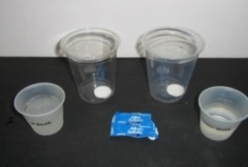
Have students do the following (these instructions are on their Instruction Sheet):
- Place the two 3.5oz cups (one already contains ice) on a plate.
- Fill both cups to the 50 mL line with water. (The ice cup will not require much water to reach the mark.)
- Carefully cut open one end of the packet of effervescent tablets.
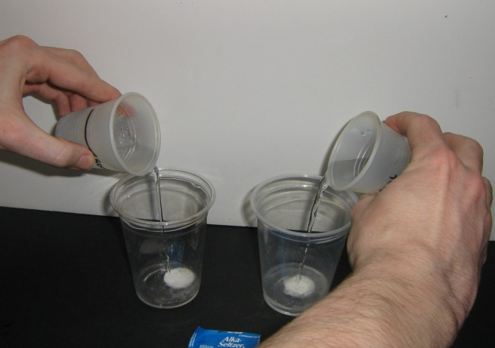
- Carefully remove the effervescent tablets from the packet.
- Add a whole tablet to each of the 10oz clear dry cups.
- Place the two cups with the tablets on the plate.
- VSVS team members should make sure groups are ready by asking two students from each group to hold a 3.5oz cup with water or ice water in a “ready” position over the dry cup containing a tablet. Tell all students to be ready to observe what happens when the tablets are added.
- Then one of the VSVS team says "1,2,3, Go,” and on “Go,” the students add all the water or ice from their cups to the tablets in the 10oz cups at the exact same time from the exact same height.
- Observe what happens and write your observations on the observation sheet.

Ask students: Was the reaction faster in the ice water or the water at room temperature?
Note: Students should save the 3.5oz measuring cups for Part V. VSVS members should collect the used 10oz cups. Dry ones need to be used in the next section.
Room temperature water, bubbles of carbon dioxide come off more slowly in ice water.

Discussion:

Ask students: How does this illustrate the effect of temperature on the rate of reaction?
The rate of bubbles coming off in ice water was slower so the lower the temperature the slower the reaction; and the higher the temperature the faster the reaction

Ask students: How do you think we could make the reaction occur even faster? If they are struggling, suggest a comparison with the effect of temperature of food spoilage mentioned earlier. Do NOT just give them the answer!!!
Answer: Heat the water to a higher temperature.

Ask students: Is the total amount of carbon dioxide given off in both the slow and fast reaction the same if you wait until the reaction is over?
Yes. It is important for students to realize that since we started with the same amount of substance, as represented by the whole tablet in both cases, we will get the same amount of carbon dioxide gas when water is added - whether the reaction is fast or slow. The ice water/tablet cup will continue to fizz long after the other one has stopped.

IIIa. The Effect of Surface Area: Demonstration
Learning Goals: Students understand surface area as a concept and can distinguish between larger (crushed tablets) and smaller (whole tablets) surface area reagents.
Materials – 1 sugar cube and 1 plate
- Ask students: What is surface area? Students probably will not be familiar with the concept of surface area, so share the following information with them.
- Surface area is the exposed surface of an object.
- Show students the sugar cube. Ask them to describe what the surface area of it. Point to the different faces
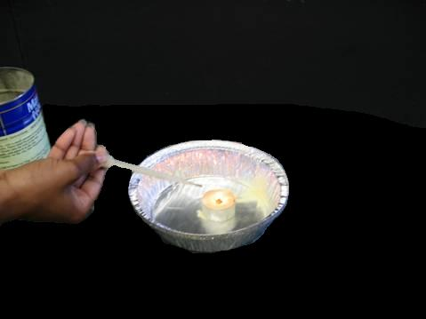
- Now break the cube into sugar crystals (on a plate) and ask them to describe the surface area.
  - Is it larger than the cube? (yes)
Ask them to predict which would dissolve faster in water – the whole cube or the smashed cube?
Tell students that the next demonstration will illustrate the effect of surface area or particle size on the rate of a reaction.

Materials needed for the Dust in a Flame Demonstration
1 box of matches 1 vial of lycopodium "dust” powder
1 pipette (jumbo size) 1 tea light candle
1 aluminum pan
- Show the students the lycopodium "dust” powder.
- Place a small pile of powder on the aluminum pan and attempt to light it with a match. (Depending on how long the match is held to the powder - it will either not burn or will burn enough to char a little.)
- Light the tea candle and place it on the aluminum pan.
- Load the pipette with a small amount of dust powder (enough to fill the tip). Do not turn the pipette upside down. There must be powder at the tip of the pipette for this to work.
- Hold the pipetteso the tip is facing down, about 6 inches above the flame and squeeze the pipette bulb to release the lycopodium powder into the flame.
- There will be a flash of fire.

Ask students: Why was there a flash of fire?
More of the surface of the particles is exposed to the oxygen in the air when the particles are sprayed into the flame. This causes a flash of fire that indicates more rapid burning (combustion) of the lycopodium powder.

This demonstration illustrates why workers in grain elevators, saw mills, and flour mills have to be very careful about sparks. A spark can ignite burnable dust in the air to produce a large explosion. Show students the picture of a dust explosion in a rubber factory.
Explanation: When the powder is in a pile, it will not light. Oxygen cannot get inside the pile to react with enough particles of powder; it can only react with the particles on the outside of the pile. When the powder is suspended in the air, it has more surface area than when it was in a pile. This is because the particles are extremely small. When they are sprayed into the air near the flame, the particles are spread out so the oxygen in the air reaches more particles at the same instant – hence more particles are burning at the same time, and you see a big flash of flame. (Lycopodium powder is a dried-up moss. It is used for this type of demonstration because the powder has extremely small particles.)

IIIb. The Effect of Surface Area on the Rate of a Reaction: Experiment
• Ask students to use what they learned about surface area in the last experiment to suggest ways to increase the surface area of the tablets to speed up the rate of the reaction.
You may have to guide this a little, but students should say that crushing the tablet will give a faster reaction because it has a larger surface area. Make the comparison with the lycopodium dust powder that failed to ignite in a clump. The tablet is in a clump. How can we change that?

Give each GROUP OF 3 the following:
2 10 oz dry cups, 1 packet of 2 effervescent tablets, 1 small Ziploc bag
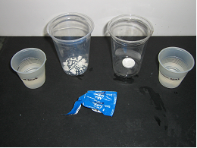
(Students should already have two 3.5 oz cups that they used in Section II, the bottle of water, a pair of scissors, and a plate.)

- Place the two 3.5 oz measuring cups on the plate.
- Fill the two cups to the mark using the bottle of water.
- Carefully cut open the packet of effervescent tablets and remove them from the packet.
- Place one whole tablet in the bottom of one of the dry 10 oz plastic cups.
- Place the other tablet in a small Ziploc bag, seal the bag, and crush the tablet by tapping on the bag with the water bottle or the palm of their hand.
- Shake all of the crushed tablet into one bottom corner and cut the other bottom corner off.
- Then pour the crushed tablet through the bottom cut corner into the other dry 10 oz plastic cup.
- Ask students to observe the two tablets now and tell which tablet has more surface area.
The crushed tablet - more of the inside surface of the tablet is now exposed.
Additionally, the crushed tablet takes up more space by covering the base of the cup
than does the whole tablet.
- VSVS team members should make sure groups are ready by asking two students from each group to hold a cup of water in a “ready” position over either the cup with a whole tablet or the crushed tablet. Tell them they should be ready to pour all the contents into the cup on the count of 1,2,3, Go.
- Make sure students realize the importance of making sure they add ALL the contents at the same time and from the same height just above the cup containing the Alka Seltzer solid. If a reaction takes a certain amount of time to occur, it is very important that the start times be the same so that comparisons can be made without the error resulting from different initiation times.
- Then one of the VSVS team says "1,2,3, Go,” and on “Go,” the students should add all the water from their cups.
- Record the results.

Ask students: Which tablet had a faster reaction?
Bubbles of carbon dioxide come off more quickly from the crushed tablet than from the whole tablet.

Ask students: How does surface area affect the rate of a reaction?
A larger surface area will increase the rate of reaction.

IV. Effect of Concentration on the Rate of a Reaction
Learning Goals: Students understand the concept of concentration and how to tell how concentrated a liquid is.

Materials for demonstration
2 100 mL graduated cylinders (clear)
1 jar grape Koolaid powder
1 200 mL bottle of water
1 piece of copy paper
1 mini scoop

Share the following information with students:
The concentration of a solution refers to how much of a substance is dissolved in water.
A stronger (more concentrated) solution has more molecules of the reacting substance in water than a weaker (more dilute) solution does.

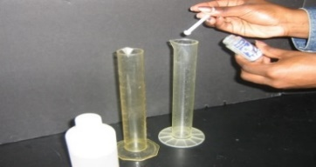
Demonstration #1:
Hold up the bottle of Koolaid powder and make sure class can see what you are doing.
- Add 1 scoop to 1 cylinder and 4 scoops to the other.
- Fill both graduated cylinders to 100 mL mark with water.
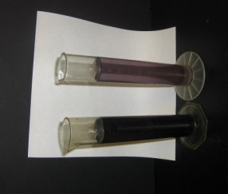
- Hold graduated cylinders up so students can see the difference in intensity of the color. (Use the piece of white copy paper behind the cylinders to help students see the difference.)
- Ask students which solution would have a stronger taste?
  - The solution made with 4 scoops is stronger. It is four times as strong (ie four times more concentrated) as the solution with one scoop.
- Tell students that the weak and stronger vinegar solutions were prepared in a similar way.

Experiment:
Ask students: Have you ever mixed vinegar and baking soda? What happened?
Most students have done this and will remember that bubbles were formed.
Tell the students that they will be adding 2 different strengths of vinegar to baking soda.
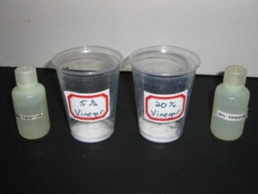
Warn students that the reactions in the next experiment will be very fast, and they must observe closely or they will miss the reaction.

Give each GROUP OF 3 the following:
2 10 oz clear plastic cups
1 Ziploc bag containing:
- bottle with 50 mL of strong vinegar (20%),
- bottle with 50 mL of weaker vinegar (5%)
1 container of baking soda, 1 spoon
(They should already have a plate and bottle of water per team)

- Place each of the 2 vinegar solutions beside the cups
- Place a level spoon of baking soda in each cup.
- VSVS team members should make sure groups are ready by asking two students from each group to remove the top from the vinegar containers and hold it in a “ready” position over a cup of baking soda. The other students should observe closely to see the results.
- Then one of the VSVS team says "1,2,3, Go,” and on “Go,” the students should add all the vinegar solution from their containers to the cups of baking soda at the exact same time from the exact same height.
- Record the results.

Ask students to describe what happened.
Bubbles of carbon dioxide come off more slowly from the lower concentration (weaker) vinegar.

Ask, How does this illustrate the effect of concentration on the rate of reaction?
The rate of carbon dioxide bubble formation is slower for the weaker solution of vinegar. The stronger the solution, the more substance there is to react and the faster the reaction will occur.
Ask students: Which reaction was faster? The strong vinegar should have given a faster reaction.
Ask students: How does this illustrate the effect of concentration on the rate of reaction?
The stronger the solution, the more substance there is to react and the faster the reaction will occur.

V. Review (Time Permitting)
Review the vocabulary words on the board. Then review the factors that affect the rate of chemical reaction.
In each activity one of the factors that influence the rate of chemical reactions was varied while the others were held constant.
1. Ask students: What effect did temperature have on the rate of reactions?

The lower the temperature, the slower the reaction. The higher the temperature, the faster the reaction.
2. Ask students: What effect did surface area have on the rate of reactions? The temperature of the water was constant, and the surface area was varied by using a whole tablet and a crushed tablet.

In this case, the crushed tablet reacted faster because of the higher surface area of the particles as compared to the whole tablet.
- Ask students: What effect did concentration have on the rate of reactions?
Lesson written by Dr. Melvin Joesten, Chemistry Department, Vanderbilt University
Return of the Kit: It is important that all items be returned to the kit box. Be sure to collect all instruction sheets (in sheet protectors) and put them back in the kit box. Be careful not to place wet objects in kit.
Kits should be returned to SC 5234 as soon as you return to campus from the school.
Pat Tellinghuisen, Program Coordinator 1998-2018, Vanderbilt University
Susan Clendenen, Teacher Consultant, Vanderbilt University
Reference: Journal Editorial Staff, J. Chem. Educ. 1998, 75, p. 1120A
ANSWER SHEET
Rates of Reaction
Name _____________________________________

Vocabulary words: rate, concentration, chemical reaction, surface area

II. Effect of Temperature – Ice water vs. room temperature water

Which was faster? ____Room Temperature____ How can you tell? _Bubbles come off faster

Which one finished before the other? __Room Temperature
How could we change the temperature to make the reaction occur even faster? Heat the water to a higher temperature before adding the tablet. The higher the temperature, the faster the reaction will occur.

III. Effect of Surface Area

1. Demonstration of lycopodium “dust” powder (dried-up moss)
Why was there a flash of fire when a pipette of lycopodium powder was sprayed across a burning match, but only some charring occurred when a burning match was held close to a pile of lycopodium powder?
More of the surface area of lycopodium powder was exposed to the oxygen in the air.

2. Which tablet reacts faster – crushed or whole? The crushed tablet reacts faster. Why?
The smaller particles in the crushed tablet expose more of the surface area to react with
the water.

IV.. Effect of Concentration – weak vs strong vinegar
Which was faster? Strong vinegar.
How can you tell? Bubbles come off faster

OBSERVATION SHEET – Rates of Reaction
Name ____________________________
Vocabulary words: rate, concentration, chemical reaction, surface area

II. Effect of Temperature – Ice water vs. room temperature water Which was faster?
Circle the correct answer: room temperature water ice water tempeature

How can you tell? ________________________________________________________

How could we change the temperature to make the reaction occur even faster?
_______________________________________________________________________
III. Effect of Surface Area
1. Demonstrations of lycopodium “dust” powder (dried-up moss)
Why was there a flash of fire when a pipette of lycopodium powder was sprayed across a burning match, but only some charring occurred when a burning match was held close to a pile of lycopodium powder?
______________________________________________________________________________

______________________________________________________________________________

2. Which tablet reacts faster? Circle the correct answer: – crushed whole

Why? ________________________________________________________________________

IV. Effect of Concentration –weak vs. strong vinegar
Which was faster? Circle the correct answer: weak vinegar strong vinegar

How can you tell?_______________________________________________________________

Rates of Chemical Reactions Instruction Sheet

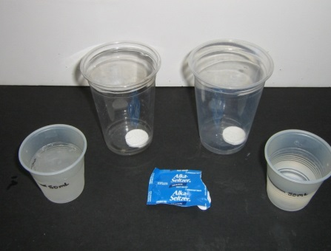
II. EFFECT OF TEMPERATURE - IMPORTANT: Use different 10 oz cups for each experiment.
- Place the two 3.5 oz cups (one already contains ice) on the plate and fill both cups to the 50 mL line with water. (The ice cup will not require much water to reach the mark.
- Use the scissors to carefully cut open one end of the packet of effervescent tablets.
- Carefully remove the effervescent tablets from the packet and add a whole tablet to each of the 2 10 oz clear DRY cups. Place the two cups with the tablets on the plate.
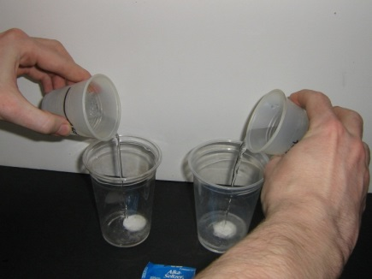
- Two students from each group should hold a 3.5 oz cup with water or ice water in a “ready” position over a DRY cup containing a tablet. Be ready to pour all the contents onto the tablet on the count of 1,2,3, Go. (It is important to make sure you add the water at the same time and from the same height just above the cup containing the tablet.)
- When one of the VSVS team says "1,2,3, Go” on “Go” add all the water or ice from your cups to the tablets in the 10 oz cups.
- Observe what happens and record your observations on your observation sheet.
- Save the 3.5 oz measuring cups for Section III.
- Set aside the used cups with alka seltzer tablets for VSVS members to collect.

III. EFFECT OF SURFACE AREA (PARTICLE SIZE) - TABLETS
Demonstration by VSVS team - Lycopodium Powder
EXPERIMENT - IMPORTANT: Use 2 different DRY 10 oz cups for each experiment.
- Place the two 3.5 oz measuring cups on the plate and fill the two cups to the 50 mL mark using the bottle of water from Section II.
- Carefully cut open the packet of effervescent tablets and remove them from the packet.
- Place one whole tablet in the bottom of one of the DRY 10 oz plastic cups
- Place one of the tablets in a small ziploc bag, seal the bag, and crush the tablet by using the palm of your hand or water bottle.
- Shake all the crushed tablet into one bottom corner and cut the other bottom corner off. Then pour the crushed tablet through the bottom cut corner into the other DRY 10 oz plastic cup.
- Observe the two tablets now and tell which tablet has more surface area.
- VSVS team members will make sure groups are ready by asking two students from each group to hold a cup of water in a “ready” position over either the cup with a whole tablet or the crushed tablet. Be ready to pour all the contents into the cup on the count of 1,2,3, Go.
- Then when one of the VSVS team says "1,2,3, Go”, on “Go” add all the water from your cups.
- Observe what happens and record your observations on your observation sheet.
- Set aside the used cups with alka seltzer tablets for VSVS members to collect.

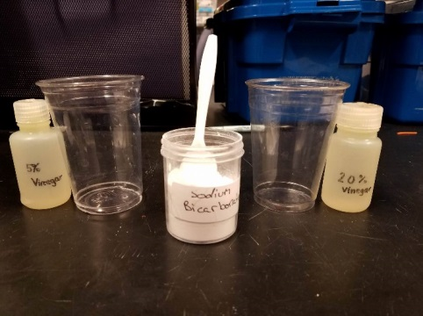
IV. EFFECT OF CONCENTRATION IN A SOLUTION - IMPORTANT: Use 2 different 10 oz cups for each experiment.
- Place the vinegar solutions beside the matching 10 oz cup. (strong (20%), weak (5%))
- Place a spoon of baking soda in each cup.
- Two students from each group should remove the top from a 5% or 20% vinegar container and hold it in a “ready” position over a cup of baking soda. They should be ready to pour ALL the contents into the cup on the count of 1,2,3, Go.
- The rest of the group should be ready to observe closely to see the results.
- When one of the VSVS team says "1,2,3, Go”, on “Go” the students should add ALL the vinegar solution from their containers to the cups of baking soda.
- Observe what happens and record your observations on your observation sheet.

