VANDERBILT STUDENT VOLUNTEERS FOR SCIENCE
http://studentorg.vanderbilt.edu/vsvs
Deep Ocean Currents
Spring 2019

Goal: To teach students about deep ocean currents by allowing them to visualize and understand how and why the currents form.

To introduce students to convection in liquids .
Fits Tennessee standards 6.ESS2.1, 6.ESS2.2

VSVSer Lesson Outline:
________ I. Introduction to Ocean Currents
________ II. Density Background Information:
  - Demonstration – students will observe that a liquid with lower density (oil) will float on water.
_______ III A. Saltwater in the Ocean:
  - The VSVS team will share some information about oceans with the students.
  - Saltwater demonstration: Students will add colored salt water to one side of a partitioned rectangular container and fresh water to the other side. Plugs in the partition will be removed and students will watch the flow of water. Pepper will be added to the surface of the water on both sides and students will observe the circulation.
B. Cold Water in the Ocean
Students will observe the flow of cold water into warm water.
________ IV. Where Are The Deep Ocean Currents?
    - Students look at a map of deep ocean currents.
________ V. Review

LOOK AT THE VIDEO BEFORE YOU GO OUT TO YOUR CLASSROOM https://studentorg.vanderbilt.edu/vsvs/lessons/
USE THE PPT AND VIDEO TO VISUALIZE THE MATERIALS USED IN EACH SECTION.

1. Before the lesson:
In the car ride, read through this quiz together as a team. Make sure each team member has read the lesson and has a fundamental understanding of the material.
Deep Ocean Currents & Air Convection Currents Lesson Quiz
- Which ocean current is driven by the temperature and density of the water? (Deep vs surface)
- Which is denser? Pure water or salt water?
- Why does the sea contain so much salt, but lakes, streams, and rivers do not have much salt at all?
- True or False? With time, the seas have gotten less salty.
- Why was pepper used in one of the experiments?
- Where does deep water formation occur?
- True or False? When ocean water freezes into icebergs and ice sheets, the ice is made up of water with no salt.
- Which is denser? Cold water or warm water?
2. During the Lesson:
Here are some Fun Facts
- A. well-known density-driven current occurs where the saltier Mediterranean Sea empties into the Atlantic Ocean. During World War II submarines used this current to enter and leave the Mediterranean without even turning on their engines http://sciencehowstuffworks.com/
- If the salt in all of the earth’s seas could be removed and spread evenly over the Earth’s surface, it would form a layer more than 500 feet thick – that’s about as tall as 2.5 Batman buildings (in Nashville)!
- The oceans move 1.4 trillion cubic kilometers of water each day!
- Radioactive tritium is used to trace the world’s currents because it is easily detected and it travels at the same speed as the water carrying it.
- It takes a minimum of 500 years and up to 1,000 years for the oceans’ water to cycle itself globally.

Unpacking the Kit– What you will need for each section:
Divide the class into 10 groups (of 3).

For Part II. Density Background Information and Demonstrations
10 oil/salt water bottles (1 per 3-4 students)

For Part III. Movement of Saltwater in the Ocean
10 containers of salt, 10 spoons, 10 rectangular containers, 10 16oz/500 mL bottles water
20 16oz cups with marked water level [~250mL]
2 blue food coloring dropper bottles
1 pair plastic gloves (for VSVS members to wear when using food coloring)
2 pepper container
10 oval plates

For Part IIIB. Cold Water in the Ocean
20 2oz jars with holes in lids
2 16oz styrofoam cups containing ice
2 L water
Food Coloring from Part III
10 plastic plates
10 Clear plastic squares
Set-up:
VSVSers will put 2 drops of blue food coloring in 10 of the jars and then pack with ice.
(Just before the students do this experiment, VSVSers will pour room temperature water into all containers so they are FULL.)

For Part IV. Where Are The Deep Ocean Currents?
- World Maps with Ocean Salinity

I. Introduction to Ocean Currents
Why is the science in this lesson important?
Learning Goals: Students understand the two types of ocean currents
The movement of deep ocean currents are partly responsible for global temperatures, as they cycle cold water to different areas of the globe. Changes in deep ocean currents due to climate change can alter ecosystems around the world.

Ask students if they know the names of the 2 types of ocean currents?
Ocean currents are divided into 2 types - surface and deep.
Surface currents are driven by the wind blowing over the ocean, the earth’s rotation, and large land masses.
Surface currents occur at the surface of the ocean.
They are only about 400m (1300ft) deep (occur in the top 400m of the ocean).
That’s about that the height of two Batman Buildings! (192m (630.5ft ))
Deep ocean currents are driven by the temperature and density of the water.
Sometimes they are called submarine rivers.
90% of the ocean water is moved by deep ocean currents.
Ocean water becomes denser when it is colder and has more salt dissolved in it.
Tell students they will investigate the behavior of dense salt water, which is similar to that found in the deep ocean waters AND the behavior of cold water compared with room temperature water

II. Density Background Information
Learning Goals: Students observe how manipulations of mass and volume affect density.
- Ask the students if they know what density is. Tell them that they can think of density as how much mass there is in a given fixed volume. A good example would be the different densities of a golf ball and ping pong ball. They have the same volume but different mass.
- Density of Liquids - Demonstration
Learning Goals: Students investigate solutions with different densities and find that a lower density solution layers on top of a solution with higher density.
Materials
10 oil/salt water bottles (1 per 3-4 students)
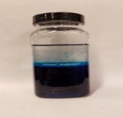
Pass out the oil/salt water bottles. Tell students that the water was colored blue to make the layers easier to see.
Share that density is a property of solids, liquids, and gases.
- Ask students: what do you notice? There are two separate layers, the saltwater is on the bottom and the oil is on the too
- Ask students: why do you think the two liquids layer? Saltwater is more dense than oil, so the oil floats on top of the saltwater.
Write these facts on the board:
Pure water has a density of 1g/cm³.
Ocean water at the sea surface has a density of about 1.027 g/cm³.
Oil has a density of 0.83g/cm³ (depends on type of oil – we used baby oil).
Tell students that a liquid with low density will float on top of a liquid with a high density.

III. Saltwater in the Ocean
Learning Goals: Students understand and observe how density drives deep ocean currents.
Why does ocean water have a higher salinity?
- Ocean water is saltier than fresh water.
- Ask students why they think the sea contains so much salt but lakes, streams, and rivers do not have much at all.
  - The salt in the ocean comes from the gradual process of weathering and erosion of the Earth’s crust, as well as the wearing down of mountains.
  - Rain and streams then transport the salt to the sea.
- Some salts may have come from volcanic emissions when earth was being formed.
- Some salts also come from the magma at the mid-ocean ridges.
- As time has passed, the seas have actually gotten saltier. Evaporation of water from the ocean leaves salts in the ocean while weathering continues to add salts.

What kind of salts are in the ocean?
- Seawater is actually very complex and contains salts made up of combinations of at least 72 elements, most in very small amounts. Salts of sodium, chloride, magnesium, sulfate and calcium are the most abundant.

Divide the class into 10 groups (of 3).
Tell students they will make their own salt water and observe what happens when it “meets” fresh water.
Pass out the following materials to each group:
1 16oz bottle water
2 16 oz cups marked at the 250ml level
1 2 oz container of salt
1 spoon
1 plastic container with divider in middle and holes punched at bottom & top with plugs (aka nails) inserted
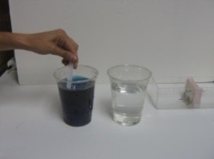
1 oval plate

- Tell students to add water to ONE of the cups and add 3 full spoons of salt to it. Set this cup aside until the VSVS member comes to your table.
- A VSVS member will add a squirt of blue food coloring to the SAME salted water cup until the solution is dark blue. This is your salt water cup.
- Now add water to the second cup to the 250 mL mark. This is the freshwater cup.
- Make sure the students understand the differences between the 2 waters. The salt water (blue) is denser than the “fresh” water (clear).
- VSVS members: Draw a sketch of the container with the divider on the board. Tell students they will be adding the salt water to the LEFT side and fresh water to the right side BUT NOT YET! (point out that the sides of the container are labeled & make sure they have it turned the correct way)
Right
Left
Salt Water (Blue)
Fresh Water (Clear)
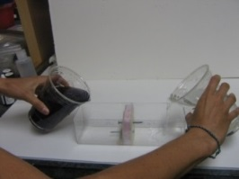
- Ask the students to predict what will happen when the 2 waters are added and plugs are removed.
Accept all answers and write them on the board. Students may not have the
correct answer at this time! Do not correct them.
- Have one student per group be responsible for the salt water and another responsible for the fresh water. Tell these students to pour their water solutions into the correct sides AT THE SAME TIME

Check that the water level on both sides is above the top nail. If it is not, add water so that the level is above the nails. Do not proceed until this is done.

- Tell the students that they are going to be removing the plugs and that they ALL need to be ready to observe the water from the sides of the container once the plugs have been removed.
Have one student be in charge of the top plug on the salt water side and another student in charge of the bottom plug on the fresh water side.
Tell them they will remove both plugs on the count of 3. Count to 3 loudly, so everyone can hear.
- Have VSVS members go to each group to sprinkle pepper on the top of the water on BOTH sides. Once this is done, the students should also observe the water from the top.
The other VSVS members should be circulating the room helping students.
- Students should make their observations through of the sides and from the top of the container for about 5 minutes and record their observations on their observation sheet. Students may need to have their eyes at the level of the lowest nail to see what is going on.

11. Ask students what happens to the salt water.
It moves through the bottom hole underneath the clear fresh water.

12. Ask the students what happens to the fresh water.
It moves through the upper hole and layers on top of the blue salt water.

13. Ask the students what they noticed when the pepper was added.
The pepper/water on the right (originally just clear water) seemed not to move much, but the pepper/water on the left side (originally blue salt water) is moving away from the hole and is circling around that side.

Explain to the students they have just created currents, similar to those in the ocean. The blue salt water is more dense than the fresh water, so it acts like the colder, saltier water of the ocean while the fresh water acts like the warmer, less salty water of the ocean. Deep ocean currents are formed when denser water sinks/flows beneath less dense water, which in turn flows on top of the denser water, as they observed in their experiment.

You can also mention that when the pepper water hits the side of the container and circles around the left side, the effect is similar to that of water hitting large landmass – one of the causes of surface currents.

Set aside the model – the students can refer to it as they look at the map of ocean currents. They will observe the model again before the end of class to see that there are 2 distinct layers that do not seem to be mixing.

IIIB. Movement of Cold Water in the Ocean

Learning Goals: Students understand and observe how temperature drives deep ocean currents.
Materials
20 2oz jars with holes in lids
Ice
Water
Food Coloring
Plates
Plastic squares
Set-up:
VSVSers will have already put 2 drops of blue food coloring in 10 of the jars packed with ice.
Now pour room temperature water into all containers so they are FULL.
Tell students that the blued water tells them that the water is COLD.
Students must do the following in this order:

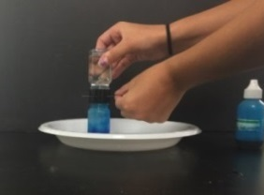
      - Take one bottle of cold and one of room temperature. Place the plastic square on top of the ROOM TEMPERATURE bottle. Hold the square securely to keep water from pouring out, turn it upside down and place on top of a bottle of blue cold water. Once in place, have one member of the group (or VSVSer) hold the 2 bottles securely and slide the plastic square out. Observe what happens. Not much! There may be some initial movement of water due to the disturbance created when the plastic is removed.
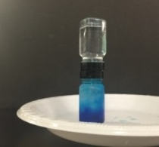
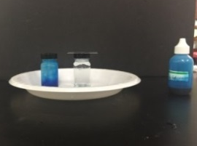

      - Separate the 2 bottles (a little water will spill, so keep on the plate. “Top” up the bottles with water if needed. (It is important to have both bottles full to the top.)
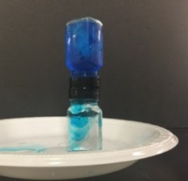
      - Place the plastic square on top of the COLD bottle, turn it upside down and place on top of the room temperature water bottle. Once in place, have one member of the group (or VSVSer if needed) hold the bottles securely and slide the plastic square out. Observe what happens. The cold water will flow, and continue to flow, into the bottom warmer bottle.
Explanation: Cold water is denser than warm water and so will sink to the bottom. Warm water will rise up through cold water. Cold water will sink below warmer water.

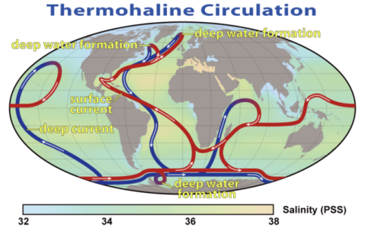
IV. Where Are The Deep Ocean Currents?
Tell students to look at the map of ocean currents (pass this out if you haven’t already).
Have the students notice where deep water formation occurs (3 areas in the Arctic & Antarctic).

Robert Simmon, NASA
http://earthobservatory.nasa.gov/Features/Paleoclimatology_Evidence/paleoclimatology_evidence_2.php
Explanation:
- The biggest source of deep water is highly saline surface water from the Gulf Stream in the North Atlantic. This water is cooled by the polar air and sinks to the bottom. It flows south to Antarctica.
- The densest water is in the Weddell Sea of Antarctica. It forms in the southern winter when sea ice forms, leaving more salt in the water below the ice. This water sinks to the bottom of the ocean and flows north.

- The average temp of surface sea water is 17.5 ºC (63.5 ºF). 75% of all ocean water has a temperature of between 0 ºC (32 ºF) and 5 ºC (41 ºF). So most of the water that fills the oceans is much colder than surface water.

- When ocean water freezes into icebergs and ice sheets, the ice is made of pure water with no salt. That salt is left in the water, so the ocean becomes saltier and denser. (This can be related to the marble demonstration - if all of the salt remained but a few marbles were removed, (became ice) then there would be more salt per marble).

- Have them trace the paths of the current with their fingers, following the arrows. Start at the northern-most point. Tell students that the entire trip for the current to return to its starting point can take over 1000 years!

- Have students look at where the water appears to warm up (blue changes to red). This happens in warm areas of the world, near Hawaii and off the coast of Africa.When the blue line turns red, the water has become less dense by warming up and/or becoming less salty, and hence rises above the denser water.

Have students look once more at their water experiment to notice the layering effect of the salt water and fresh water. Explain to them that these layers will remain separated for several hours

V. Review
- Ask students why saltwater is more dense than freshwater? For the same volume of saltwater and freshwater, saltwater is more dense because it has a higher mass.
- Ask students: What can we say about cold water versus warm water?
Cold water sinks.
Warm water rises.
Lesson written by: Patricia Tellinghuisen, Program Coordinator of VSVS 1998-2018, Vanderbilt University
Courtney Luckabaugh, VSVS Lab Assistant, Undergraduate, Vanderbilt University

Deep Ocean Currents Answer Sheet
Name _____________________________

- Draw arrows on the diagram below showing the movement of the blue salt water and the clear fresh water.
Salt Water (Blue)
Fresh Water (Clear)

What happens to the salt water? Moves through the bottom hole and stays below the fresh water
What happens to the fresh water? Moves through the top hole and stays above the salt water
What happens to the pepper? The pepper/water on the right (originally just clear water) does not move much, but the pepper/water on the left side (originally blue salt water) moves away from the hole and is circling around on that side.

- Draw arrows on the diagram to show the movement of blue cold water and the clear room temperature water.
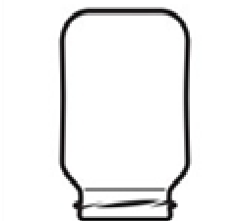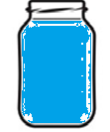

Look at the map of ocean currents to answer the following questions.
In what parts of the Earth does deep water formation occur? 3 areas in the Arctic & Antarctic
Why does deep water formation occur in these regions? Cold temperatures and salty water.
Deep Ocean Currents Observation Sheet
Name _____________________________

      - Draw arrows on the diagram below showing the movement of the blue salt water and the clear fresh water.
Salt Water (Blue)
Fresh Water (Clear)

What happens to the salt water? ____________________________________________
What happens to the fresh water? ___________________________________________
What happens to the pepper? ______________________________________________

2. Draw arrows on the diagram to show the movement of blue cold water and the clear room temperature water.

ICE WATER
(BLUE)
WARM
WATER
ICE WATER
(BLUE)
WARM

WATER

- Look at the map of ocean currents to answer the following questions.
In what parts of the Earth does deep water formation occur? ______________________
Why does deep water formation occur in these regions? __________________________
Deep Ocean Currents – Instruction Sheet
Density of Liquids -Activity
Look at the jars with 2 different liquids.
What do you notice?
Why do you think the two liquids layer?

Movement of Saltwater in the Ocean
- Fill the cups with tap water to the 250 mL mark
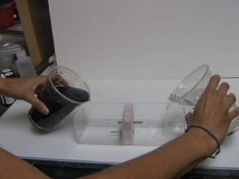
- Add 3 full spoons of salt to ONE of the cups of water.
- A VSVS member will come around and add blue food coloring to that cup.
- Predict what will happen when the two waters are added to the container.
- At the same time (when told to do so), one person will add the blue salt water to one side and another will add the clear fresh water to the other side (as shown by this diagram).
- Be ready to make observations.
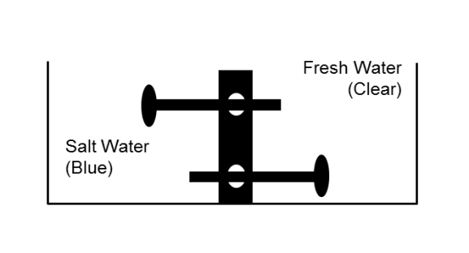
- When the VSVS member counts to three, remove both plugs at the same time.
- A VSVS member will come around and sprinkle black pepper on the water on both sides.
- Observe the flow of water from the side and from the top of the container.
- Record your observations on your observation sheet by drawing arrows on the diagram as directed and answering the three questions under it.
Movement of Cold Water in the Ocean
You must do the following in this order.
      - Take one bottle of blue ice water and one at room temperature (clear).
      - Place the plastic square on top of the ROOM TEMPERATURE bottle.
      - Hold the square securely to keep water from pouring out, turn it upside down and place on top of the bottle of blue cold water.
      - Once in place, have one member of the group (or a VSVSer) hold the 2 bottles securely and slide the plastic square out.
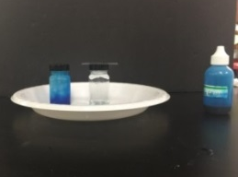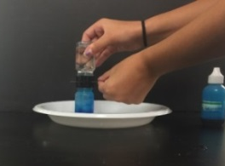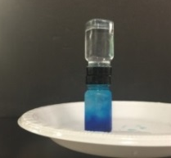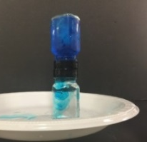
Step 2. Step 3. Steps 4 and 5 Steps 7, 8 and 9
      - Observe what happens.
      - Separate the 2 bottles and make sure both bottles are filled to the top with water (some may have leaked out
      - Place the plastic square on top of the COLD bottle, turn it upside down and place on top of the room temperature water bottle.
      - Once in place, have one member of the group (or a VSVSer) hold the bottles securely and slide the plastic square out.
      - Observe what happens
Analyzing the Map of Deep Ocean Currents
Look at the map of ocean currents and answer the last two questions on your observation sheet. Use the information you learned in the previous examples and exercise to answer the next two questions.

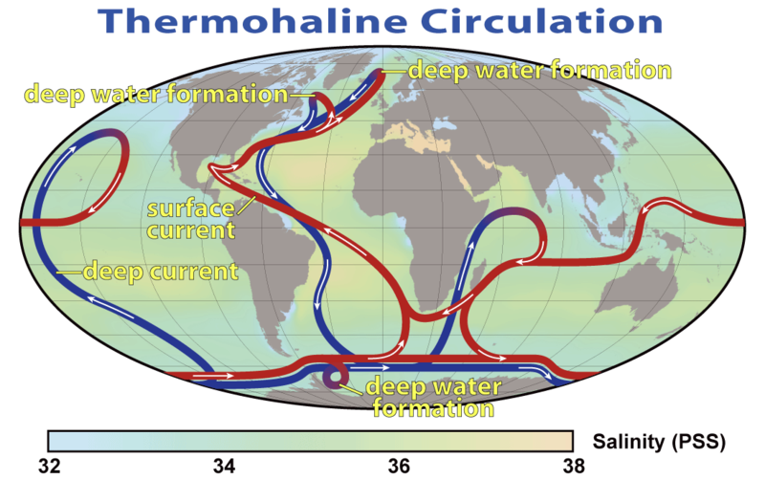
Robert Simmon, NASA
http://earthobservatory.nasa.gov/Features/Paleoclimatology_Evidence/paleoclimatology_evidence_2.php

