VANDERBILT STUDENT VOLUNTEERS FOR SCIENCE
http://studentorg.vanderbilt.edu/vsvs
Vacuums and Air Pressure
Spring 2019
Goals: To introduce students to atmospheric pressure and vacuums
https://www.youtube.com/watch?v=Ssqi-CkysvQ
Fits TN Standards: 6.ESS2.6

VSVSer Lesson Plan
______ I. Introduction to Air Pressure
A. What is the Atmosphere?
B. What is Air Pressure?
- Activity: Water in a jar held upside-down remains inside when covered by a card.
C. Atmospheric Mat: How can we Prove Air Pressure Exists?
- Activity: Pressure acting on a mat prevents it from being picked up in the center.
______ II. What is a Vacuum?
A. Investigating the Action of a Vacuum Pump: How does a Vacuum Pump Work?
- Activity: The force required to pull a piston increases as more air is removed.
B. Does Air have Mass?
- Activity: The mass of a jar previously held under vacuum increases when air
enters it.
C. Demonstration: How Much Air is Being Removed from the Bell Jar?
- Activity: Water rushes into a jar held under vacuum because no air is inside that jar.
______ III. What Happens when Air Pressure is Decreased?
A. Balloon in Jar: Pressure is All About Balancing the Inside and the Outside!
- Activity: A deflated balloon inflates when placed in a vacuum.
B. Marshmallow: How are Marshmallow Bubbles like Balloons?
- Activity: A marshmallow expands when placed in a vacuum.
C. The Suction Cup (Optional)
- Activity: Removing atmospheric pressure causes suction cups to fall.
______ IV. Use Magdeburg Hemispheres to Illustrate Air Pressure (Optional)
- Activity: Atmospheric pressure acting outside a hemisphere holds it in place.
______ V. Review

Materials
1 Atmospheric mat
1 bag containing 15 Madgeberg hemispheres – change if can to increase from 10-15
11 plastic bags with a 1bell jar, syringe and tubing (10 for students, 1 for VSVS members
1 bag containing 10 balloons, slightly inflated (about 3-4 cm in diameter). The balloon should easy to put into bell jar
1 bag containing 10 large marshmallows
1 bag containing 10 suction cups
1 plastic container with 10 scales
1 tub about 3L, large enough to immerse bell jar into it
3L water to fill above container
1 plastic box containing:
1 jar (2oz) and 1 laminated card
100 mL water in bottle
16 handouts
32 observation sheets
1 box of goggles (for all to wear)

Before the Lesson: In the car ride, read through this quiz together as a team. Make sure each team member has read the lesson and has a fundamental understanding of the material.
Lesson Quiz
1. How does the atmosphere cause atmospheric pressure?
2. If you squeeze a marshmallow, the pressure from your hand crushes it. Why does air pressure not
crush humans?
3. What is the purpose of a check valve?
4. True of False: The inside of a deflated balloon is completely empty.
5. Why does a deflated balloon inflate when it is placed in a vacuum?

Divide students into groups of 3-4 (there are 10 sets of bell jars).
Unpacking the Kit
I.B What is Air Pressure?
Pass out student handouts and observation sheets.
1 plastic box containing:
1 jar (2oz) and 1 laminated card
100 mL water in bottle
I.C. Atmospheric Mat
- Atmospheric mat

II. What is a Vacuum?
- Investigating the Action of a Vacuum Pump
Distribute the bell jar apparatus – there are 10 per class (plus one for VSVS members to use), so divide students into groups of 3-4. D
Distribute goggles to all students.
B. Does Air have Mass?
Distribute the10 scales to groups.
C. Demonstration: How Much Air is Being Removed from the Bell Jar?
1 tub large enough to immerse bell jar into it
3L water to fill above container
Fill the plastic tub with water

III. What Happens when Air Pressure is Decreased?
- Balloon in Jar
Pass out 10 slightly inflated balloons
- Marshmallow
Pass out 10marshmallows
- Suction Cup (optional, time permitting)
Pass out 10 suction cups

IV. Use Magdeburg Hemispheres to Illustrate Air Pressure (Optional)
Distribute 15 Madgeberg hemispheres

Students and volunteers must wear goggles at all times
- Introduction
Learning Goals:
Students understand that gases in the atmosphere create an atmospheric pressure that acts in all directions.
Students understand that vacuums decrease pressure within an enclosed region. Students understand that air, which consists of elemental and small molecular gases, has mass.
Students understand that pressure acts both within and outside a region, and that these two forces must be in balance. Students can conceptualize that decreases in pressure cause increases in volume.

- What is the Atmosphere?
Our planet is wrapped in a blanket of air called the atmosphere. The atmosphere is a thin layer of gases as well as liquid and solid particles.
Ask students if they know what gases are in the atmosphere? – Nitrogen, Oxygen, carbon dioxide, argon plus very small amounts of “trace” gases.
What are other particles in the atmosphere? Water vapor, dust, smoke, chemicals….

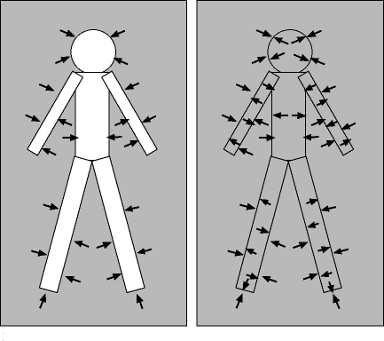
- What is Air Pressure?
Gravity acts on the air
All of these gases and particles have mass. The weight of the air above earth presses down on us - we call this atmospheric pressure.
Can you feel the atmosphere? Why don’t we get crushed?
Because at the same time as the atmosphere is pushing down on us, pressure is being applied equally in all directions outside and inside our bodies.

Demonstration:
Materials: 1 plastic box containing ar of water plus card
Fill the glass jar with water and cover it with a card. Hold jar over plastic box. Invert jar (slowly) while holding on to card. Carefully remove hand from card.
The card remains “attached” to the jar, and the water stays in the jar.
Atmospheric pressure keeps the card in place

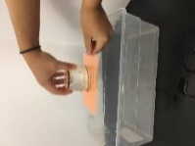
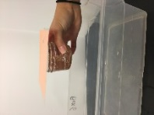
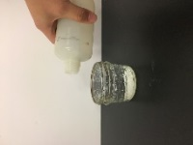

- Atmospheric Mat
If you can’t feel the atmosphere, how do you know it is there?
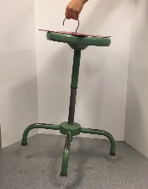
Demonstration:
Place the mat on a flat-topped desk or table. Move it around the table to show students that it is not glued down.
Pick it up by its edge. Easy!
Ask a volunteer, or the teacher, or another VSVS member to try to pull the mat up, using the hook.

Put it down again and lift it by the hook. Impossible!
Release the hook, and lift it by the edge again to show that it is not stuck at all.

Attach it to a free-standing object (a stool, book,….) and demonstrate that you can lift the object

Explanation:
The mat is held down by atmospheric pressure, which is approximately 15 pounds per square inch.
The area of the mat is about 100 square inches (10.5 x10.5 ).
A quick calculation leads to a total pressure of over 1500 lbs pushing down on the mat (assuming no air at all is under the mat).
Note - Imperfections in the rubber can lead to bumps and leaks, breaking the seal.

The Atmospheric Mat is unique in that you don’t need to apply any force to make it work.
(Suction cups, for example, also stay put because of atmospheric pressure, but the way they are applied may make it seem like they adhere to the surface, rather than being pushed there from outside.)

- What is a Vacuum?
- Investigating the Action of a Vacuum Pump
Distribute the bell jar apparatus – there are 10 per class, so divide students into groups of 3-4.

Show students the handout of the apparatus. Point out the parts: a bell jar and its base, syringe/plunger, tubing with 2 check valves, connectors
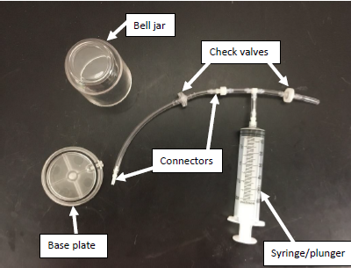
- Ask students what is in the bell jar? Air is present - nothing is not the correct answer.
- Have one team member pull the syringe to the top. Team members take turns listening to the “short” tubing end while the piston is pushed back in. They will hear air coming out.
Point out the check valves. The check valves will allow air to flow in one direction but not in the other. See diagram.

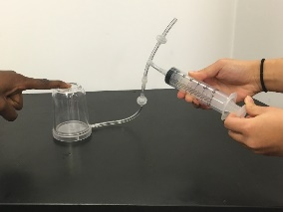
- Tell one person in each group to push down on the bell jar to make certain that the bell jar is pressing against the “O” ring. Another student should pull the syringe out to the 60 mark.
Ask students where does the air come from that fills the syringe?
The air comes from the bell jar (so there is now less air than in the bell jar than before).
How hard was it to pull out the piston? (Not very).

- Let go of the piston and watch what happens. Now push the piston all the way back into the syringe. Where did the air go (hint – listen for the sound of moving air at the end of the open tube). Air moves out of the open end at point E.
- Repeat the following steps five times in rapid succession:
  - Pull the piston out to the 60ml mark;
  - Let go of the piston, and see what happens;
  - Push the piston all the way in.

Ask students: what happened to the amount of force required to pull out the piston? (The force needed increased.)
Explain why. (Less air pressure inside the jar, which used to initially helped push the piston out)

- Repeat the steps in #5 another 10 -15 more times until it is very difficult to pull the piston out.
- What has happened towards the end of the pull/pushes? What is in the bell jar now? (Very little air will be in the jar = partial vacuum)
- Tell students to keep the vacuum in the jar for the next experiment.

B. Does Air have Mass?
- Tell students to place the scale on flat surface, remove any protective cover, and turn it on.
- Press the on/off button to switch on and wait until “0.00” is shown on the screen. .
- Make sure it is zeroed by pressing the button labelled T,- this is called taring.
- The icon in the screen should read “g”. If it does not, toggle the “mode” button ( on the side) until it does. There are other icons – oz, ozt and ct. We want to measure the mass of the bell jar plus its air in grams.
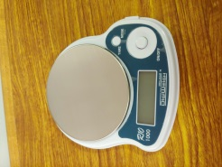
- Detach tubing where tubing couples into syringe assembly. Do this by twisting gently.
On/Off
Tare
Icon
toggle
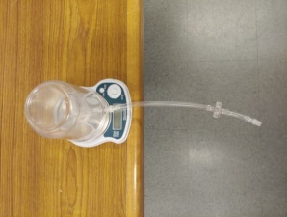
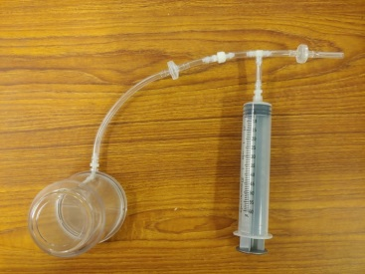

Tubing hangs over
side of desk. It must
not rest on desk.

- Place bell jar apparatus with this remaining small piece of tubing on the scale. Place the scale close to the edge of the table, the tubing can hang over the edge (you do not want the tubing to rest on the table.)
- Mass the above set-up. and record the value.
- Remove the tubing from the bell jar so that the air rushes in.
- Replace the tubing and mass the apparatus again.
Was there any difference? (In the VSVS lab, we found it about .1-.3 g lighter)

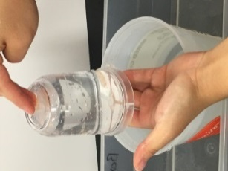
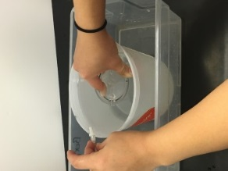
Demonstration: How much air is being removed from the bell jar?
Fill the plastic tub with water.
Repeat the procedure for evacuating the jar: pull the piston of the syringe to the 60 ml mark and push it all the way back in. Do this 24 times in rapid succession.
Detach tubing where D tubing couples into syringe assembly. Do this by twisting gently.
HOLD THE BELL JAR UPSIDE DOWN and immerse it in the bucket of water. While the jar is immersed, detach the tubing from the bell jar. Water will fill the chamber. CAREFULLY lift the bell jar out, keeping the jar and its bottom intact. Turn upright and show students how much water and air is in the jar.

- What Happens when Air Pressure is Decreased?
What happens to the volume of an object when the pressure is changed?
VSVS Information only: Use the equation PV=nRT If you decrease the pressure, the volume will increase.

Ask students if they have noticed what happens to a plastic bottle if it is carried up to a higher altitude (such as going up a mountain)?
As air pressure decreases, the density of the contents decreases as well. The plastic bottle may feel “tighter” as the gas expands.
On the other hand, a plastic bottle will look “crushed” if it is taken from high altitude (lower air pressure) to sea level where the pressure is greater.

- Balloon in Jar:
Show students the slightly inflated balloon (about 3-4 cm in diameter). The balloon should be tight.
Ask students to hypothesize what will happen to the volume of the air in the balloon if the pressure is decreased?
Tell students to place the balloon in the bell jar and make sure that no part of the balloon touches the black O-ring of the bell jar.
Tell one person in each group to push down on the bell jar to make certain that the bell jar is pressing against the “O” ring. Another student should pull the syringe out to the 60 mark and
start pumping the piston:
What happens to the balloon after a few pumps? It grows larger.
Why? The pump removed air surrounding the balloon that had been pressing inward. The air inside the balloon wants to stay at the same pressure as the air around it. The air inside the balloon is still pressing outward, so the balloon expands.
What do you think will happen when the chamber is re-pressurize?
Loosen the end connected to the bell jar. What do you hear, and what happens to the balloon? Air moves back into the bell jar and crushes the balloon.

Explanation:
If you put a partly blown up balloon in a bell jar and then pump out the air from the bell jar the balloon will slowly expand. This is because the air inside the balloon is at a room pressure and when the air outside the balloon is removed there is a bigger pressure difference between the inside and outside of the balloon. The balloon therefore expands to balance this difference.
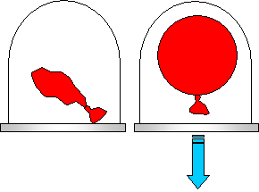

Room Pressure Vacuum
This is how our lungs fill with air. A muscle called the diaphragm contracts downward to increase the space in your chest. As volume increases, pressure decreases. Imagine the balloons represent your lungs. Since there is now less pressure pushing against your lungs, they begin to expand as outside air rushes inside.
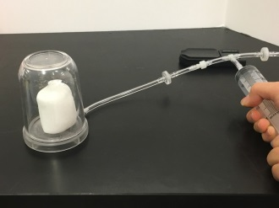
- Marshmallow . Repeat with a marshmallow. Predict what will happen.
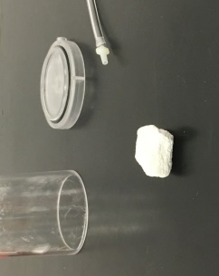
Marshmallows have small bubbles of air trapped inside them. These bubbles are at atmospheric pressure. When the air inside the container is sucked out the pressure is reduced. The air bubbles inside the marshmallows are therefore at a much higher pressure than the air surrounding the marshmallows, so those bubbles push outwards, causing the marshmallows to expand. When air is let back into the container, the surrounding pressure increases again, and the marshmallows deflate back to their normal size.
Note that the marshmallow now looks funky.
Some of the gas inside the marshmallow was also drawn out of the chamber so there is now less air in the marshmallows than before. What happens if you try it again with the same marshmallow?

VSVS Information only: This illustrates Boyle’s Law (as the pressure on a gas decreases, its volume increases).

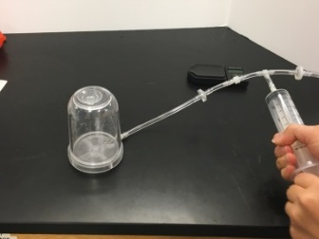
- The suction cup – optional if time permits
Stick the suction cup firmly to the stop of the bell jar.
  - Why does the suction cup stick to the jar? Atmospheric pressure of 15lb per square inch pushes on the suction cup (and us)
  - What do think will happen when some of the pressure is removed?
Pull the piston of the syringe to the 60 ml mark and push it all the way back in. Repeat until something happens to the suction cup.
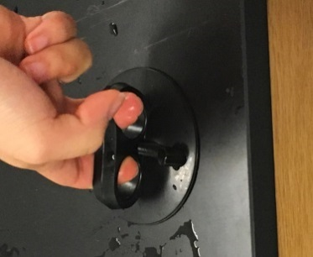
The suction cup eventually falls off because the pump has removed the outside pressure that held the cup on the surface.

IV. Optional – If Time Permits Use Magdeburg Hemispheres to Illustrate Air Pressure
Background Information:
Historically, the Magdeburg hemisphere is a pair of copper hemispheres that can be sealed together, by applying grease around the rim, then connected t a
vacuum pump so as to create a near "perfect vacuum" inside of the sealed sphere. In this vacuumed-out state, the pressure of the weight of surrounding atmosphere, (piled upwards of 62-miles above the sphere), acts to hold the spheres together tightly with great force by pressing inward on the outer casing.
The Magdeburg hemispheres were invented by German engineer Otto Guericke who became mayor of Magdeburg (hence the name), from 1646 to 1676.

Activity:
- Each student /pair will use one half a hemisphere.
- Tell students to press the hemisphere down onto a flat desk top and then try to lift it up.
Explanation:
When the hemisphere is pressed against a flat surface, most of the gas molecules in the air are forced out. There are a lot of air molecules on the outside of the hemisphere. This results in the atmospheric pressure being much greater on the outside, so that it pushes the hemisphere down and forms a seal with the surface.

Lesson ideas taken from Educational Innovations “Bell Jar and Vacuum Pump Set”
Lesson written by
Pat Tellinghuisen, VSVS Program Coordinator 1998-2018, Vanderbilt University
James Dohm, Undergraduate student, Vanderbilt University
Significant edits by Zach Ullmann, Frank Cai, Vincent Huang, Undergraduate students, Vanderbilt University

Vacuums and Air Pressure Observation Sheet
Name:____________________________________________

Part 1 – What is Atmospheric Pressure? Circle the correct italicized answer
In both the water jar and atmospheric mat experiments, what force caused the results we observed?
Atmospheric pressure atmospheric clouds vapor pressure

In which direction does this force point? Up outwards inwards all directions

Part 2 – What is a Vacuum? The Bell Jar
(a) As you pull-out the piston, what are you removing from the bell jar? air nothing

(b) Over time, the piston becomes easier harder to pull-out.

This happens because, over time, the air pressure inside the bell jar (decreases, increases, remains the same) while the atmospheric pressure (decreases, increases, remains the same).

(c) We made a vacuum inside the bell jar. This means the air pressure inside the bell jar was (less than, greater than) the atmospheric pressure pushing on the outside of the jar.

(d) When the vacuum is released from the bell jar, what happens to the jar’s mass? increased decreased

Why?________________________________________________________________________________________________

(e) In the last demonstration, the amount of water that entered the bell jar was equal to the amount of _____________________ that was removed from the bell jar.

Part 3 – What Happens when Air Pressure Decreases?
- & B. The Balloon and Marshmallow
As air is taken out of the bell jar, the pressure in the jar drops. What happens to the balloon and marshmallow?
The balloon and marshmallow inflate deflate do not change
Why? __________________________________________________________________

C. The Suction Cup (If Time Permits)
What force causes suction cups to stick to walls? Atmospheric pressure vapor pressure

IV. The Magdeburg Hemisphere (If Time Permits)

Do you think the Magdeburg hemisphere would work if we used it on a bumpy surface, like sandpaper, instead of a flat surface? Why or why not? _________________________________________________________________________________________________

_________________________________________________________________________________________________

Vacuums and Air Pressure Observation sheet = Answers

Part 1 – What is Atmospheric Pressure?

In both the water jar and atmospheric mat experiments, what force caused the results we observed? atmospheric pressure
In which direction does this force point? all directions

Part 2 – What is a Vacuum?

The Bell Jar

(a) As you pull-out the piston, what are you removing from the bell jar? air

(b) [Circle the correct italicized answers]. Over time, the piston becomes (harder) to pull-out.
This happens because, over time, the air pressure inside the bell jar (decreases,) while the atmospheric pressure ( remains the same).

(c) We made a vacuum inside the bell jar. This means the air pressure inside the bell jar was (less than) the atmospheric pressure pushing on the outside of the jar.

(d) When the vacuum is released from the bell jar, what happens to the jar’s mass? Why? The bell jar’s mass increases because air rushes inside the jar once the vacuum is released. This shows that air has mass.

(e) In the last demonstration, the amount of water that entered the bell jar was equal to the amount of air that was removed from the bell jar.

Part 3 – What Happens when Air Pressure Decreases?

A & B The Balloon and Marshmallow

As air is taken out of the bell jar, the pressure in the jar drops. What happens to the balloon and marshmallow?
The balloon and marshmallow inflate

C.The Suction Cup (If Time Permits)
What force causes suction cups to stick to walls? atmospheric pressure

IV. The Magdeburg Hemisphere (If Time Permits)

Do you think the Magdeburg hemisphere would work if we used it on a bumpy surface, like sandpaper, instead of a flat surface? Why or why not? The Magdeburg hemisphere would not work. On a bumpy surface, the hemisphere would not be able to form a tight seal with the ground. Air from the atmosphere could then enter the hemisphere, resulting in atmospheric pressure within the hemisphere.

Vacuums and Air Pressure Instruction Sheet

Put on your goggles and keep them on until the end of the lesson.

- Introduction
- What is the Atmosphere?
- What is Air Pressure?
Look at the diagrams on your handout.
Watch the VSVS team demonstrate how air pressure can hold a card in place so that water will not spill out of an upside-down jar.
- Atmospheric Mat
Watch the VSVS team demonstrate how a mat can be held down by atmospheric pressure, so that it is impossible to lift up when the hook is used.

- What is a Vacuum?
- Investigating the Action of a Vacuum Pump
Look at the handout to learn the parts of the vacuum apparatus.
- Have one team member pull the syringe to the top. Team members take turns listening to the tubing end while the piston is pushed back in.
- Have one person in each group to push down on the bell jar to make certain that the bell jar is pressing against the “O” ring.
- Another student should pull the syringe out to the 60 mark.
Where does the air come from that fills the syringe?
How hard was it to pull out the piston?
- Let go of the piston and watch what happens.
- Now push the piston all the way back into the syringe.
Where did the air go (hint – listen for the sound of moving air at the end of the open tube).
- Repeat the following steps five times in rapid succession:
  - Pull the piston out to the 60ml mark;
  - Let go of the piston, and see what happens;
  - Push the piston all the way in.
  - What happened to the amount of force required to pull out the piston.
- Repeat the steps in #6 another 10 - 20 more times until it is very difficult to pull the piston out. What has happened towards the end of the pull/pushes?
What is in the bell jar now?
- Keep the vacuum in the jar for the next experiment.
On/Off
Tare
Icon
toggle

- Does Air have Mass?
- Place the scale on flat surface, remove any protective cover, and turn it on.
- Press the on/off button to switch on and wait until “0.00” is shown on the screen.
- Make sure it is zeroed by pressing the button labelled tare - this is called taring.
- The icon in the screen should read “g”. If it does not, toggle the “mode” button ( on the side)
until it does. There are other icons – oz, ozt and ct. We want to measure the mass of the bell jar plus its air /partial vacuum in grams.

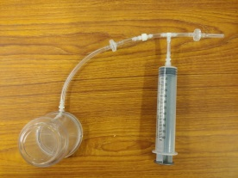
- Detach tubing where tubing couples into syringe assembly. Do this by twisting gently.
- Place bell jar apparatus with this remaining small piece of tubing on the scale. Place the scale close to the edge of the table so the tubing can hang over the edge (you do not want the tubing to rest on the table.)
- Mass the above set-up.
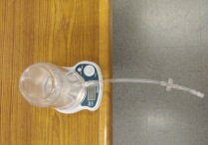
- Remove the tubing from the bell jar so that the air rushes in. Replace the tubing and mass the apparatus again.
- Was there any difference?
Tubing hangs over edge of desk

Watch the demonstration that will show you how much air is being removed from the bell jar
- What Happens when Air Pressure is Decreased?
- Balloon in Jar:
- Place the balloon in the bell jar and make sure that no part of the balloon touches the black O-ring of the bell jar.
- Have one person in each group to push down on the bell jar to make certain that the bell jar is pressing against the “O” ring.
- Another student should pull the syringe out to the 60 mark and start pumping the piston:
What happens to the balloon after a few pumps? Why?
Room Pressure Vacuum
What do you think will happen when the chamber is re-pressurize?
- Loosen the end connected to the bell jar. What do you hear, and what happens to the balloon?
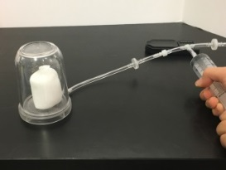
- Marshmallow .
- Repeat with a marshmallow. Predict what will happen.
- Let the air back into the container. What happens

- The suction cup – optional if time permits
- Stick the suction cup firmly to the stop of the bell jar.
Why does the suction cup stick to the jar?
What do think will happen when some of the pressure is removed?
- Pull the piston of the syringe to the 60 ml mark and push it all the way back in. Repeat until something happens to the suction cup.

IV. Optional – If Time Permits Use Magdeburg Hemispheres to Illustrate Air Pressure
- Each student /pair will use one half a hemisphere.
- Tell students to press the hemisphere down onto a flat desk top and then try to lift it up.

Vacuums and Air Pressure Student Handout
Atmospheric Pressure
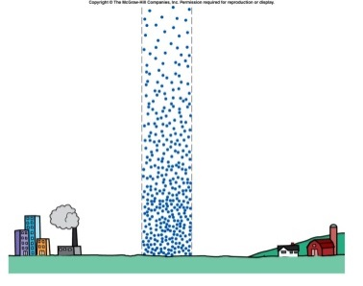
There are gas particles about 300 miles above us. This is atmospheric pressure.
At the same time as the atmosphere is pushing down on us, pressure is being applied equally in all directions outside and inside our bodies.

Apparatus

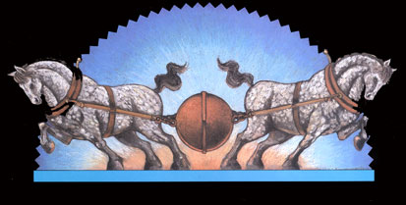
Magdeburg Hemispheres

