VANDERBILT STUDENT VOLUNTEERS FOR SCIENCE
http://studentorg.vanderbilt.edu/vsvs
Inheritance and Blood Typing
Spring 2019

GOAL To introduce the students to the study of genetics through an activity dealing with blood typing
Fits TN standards: 7.LS3.3
VSVSer LESSON OUTLINE
_______ I. Introduction
Give a brief introduction to the volume and the components of blood in the body.
_______ II. Red blood cell demonstration
Show the models of red blood cell and explain what an antigen is and how it relates to blood type.
_______ III. The Kidney Problem
Students will perform an experiment to determine the blood types of family members to see if they qualify as kidney donors for their mother/wife.
_______ IV. Analysis
Using the data obtained from part III, the students will analyze their results.
_______ V. Optional: Blood genetics and Punnett squares
Explain how blood type is determined genetically and show how Punnett squares can be used to determine genotype. Provide definitions for genotype, phenotype, dominant, and recessive.

LOOK AT THE VIDEO BEFORE YOU GO OUT TO YOUR CLASSROOM https://studentorg.vanderbilt.edu/vsvs/lessons/
USE THE PPT AND VIDEO TO VISUALIZE THE MATERIALS USED IN EACH SECTION.
Students will work in pairs for the activity.

1. Before the lesson:
In the car ride, read through this quiz together as a team. Make sure each team member has read the lesson and has a fundamental understanding of the material.
1. Explain the differences in the antigens and antibodies among the blood types.
2. a. Which blood types can Type A donate to and receive transfusions from? Why?
b. Type B? c. Type AB? d. Type O?
3. Why is blood typing so important? What would happen if someone received a transfusion of an incompatible blood type?
4. Finish this Punnett square to determine the possible blood types of the children from parents with AO and BO types:
A O

B

O

2. During the Lesson:
Here are some Fun Facts for the lesson – for VSVSers
- Usually a person has one blood type for their whole life, but infection, malignancy (like cancer), or autoimmune diseases can cause a change. A bone marrow transplant may also do this; the patient will eventually convert to the donor's blood type.
- Blood typing is important during pregnancies; if the father has an incompatible blood type to the mother, care must be taken so that the mother doesn't develop antibodies against the baby's blood that attack the baby's RBCs (hemolytic disease of the newborn (HDN) - has to do with Rh + and -, but not covered in lesson). Mothers often receive shots (Rho(D) immune globulin) to prevent this from happening.
- Blood typing also used to be heavily used for paternity tests and in criminal investigation. Actual blood isn't always necessary; about 80% of the population secretes the antigens/proteins/antibodies/enzymes characteristic of their blood type in other bodily fluids and tissues. A serologist could, for example, be able to tell if the source of a sample of blood came from the victim or the criminal. DNA testing, though, is used for detailed analysis.
- Type O is generally considered the "universal donor" type because it does not contain A or B antigens that would be rejected by A, B, or AB blood types. (However, there are other antigens that come into play, so in real life situations, hospitals categorize blood type on a more detailed level.)
- Even though Type O is recessive, it is the most common blood type because it is the ancestral form; the A and B antigens are mutations.
- Infants get antibodies passively from their mothers but start making them independently when they
are three months old.
- Clinical trials are being done on a bacterial enzyme that can convert RBCs of A, B, and AB types into O by stripping away their antigens. This could have profound implications for blood transfusions.

UNPACKING THE KIT – what you will need for each part
FOR PART I. INTRODUCTION:
- 1 liter bottle (containing liquid with red dye)
FOR PART II RED BLOOD CELL DEMONSTRATION:
Set of blood cell models (Wards Blood Typing Demonstration Model, 14W8327)
Each set for VSVS demonstration contains
  - 1 plastic bag containing 2 plastic blood cells each with a blue “A” peg (the A antigen) attached and 1 yellow Y –shaped pieces (the “B” antibodies)
  - 1 plastic bag containing 2 plastic blood cells each with a yellow “B” peg (the B antigen) attached and 1 blue Y -shaped pieces (the “A” antibodies)
  - 1 plastic bag containing 2 plastic blood cells each with both a blue “A” peg (the A antigen) AND a yellow “B” peg (the B antigens) attached. (No antibodies included)
  - 1 plastic bag containing 2 plastic blood cells with no antigens attached and 1 blue Y -shaped piece (the “A” antibody) and 1 yellow Y –shaped piece (the “B” antibody)
15 Blood Types handouts.
FOR PART III. THE KIDNEY PROBLEM:
15 24-well plates, 15 plates, 15 blood testing worksheets, 30 safety goggles
15 ziploc bags with
1 dropping bottle containing fake blood labeled “Mrs. Sanderson”
1 dropping bottle containing fake blood labeled “Mr. Sanderson”
1 dropping bottle containing fake blood labeled “Jill”
1 dropping bottle containing fake blood labeled “Jack”
1 dropping bottle containing “Anti-A serum”
1 dropping bottle containing “Anti-B serum
I. INTRODUCTION
Learning Goals:
- Students describe the composition of blood, including how antigens and antibodies determine blood type in different individuals.
- Students understand the relationship between antigens and antibodies, and identify which blood types are compatible as donors and receivers

Write the following vocabulary words on the board:
Antibodies, antigen, Punnett square, blood cell, ABO blood type
Ask students: How much blood do you think is in the human body? About 5 liters of blood.
At this point, show the students the 1-liter bottle and tell them that their bodies contain about 5 liters of blood.

Ask students: What is in blood? (What makes up blood?)
Briefly Explain::
Blood is composed of a liquid (plasma) and solids (red and white blood cells and platelets).
Plasma—yellow-colored liquid that is primarily (92%) water; makes up most of blood volume (55%). It carries metabolites, nutrients, hormones, wastes, salts and proteins throughout the body and contains the anti-A and anti-B antibodies
Red blood cells (RBCs)—shaped like a donut, but without a hole; carry oxygen; give blood the red color; make up 40-45% of blood.
White blood cells (WBCs)—cells that are a part of the immune system. There are several types of white blood cells; one can produce antibodies which can help destroy bacteria and viruses.
Platelets—cell fragments that are responsible for clotting and scab formation
Tell the students that this activity will focus on characteristics of red blood cells.

Ask students: What are the different blood types? There are four blood types: A, B, AB, and O.
Blood typing is one way of characterizing what kind of blood someone has. It is determined by the
type of antigen that is present on the surface of the red blood cells.

II. RED BLOOD CELL DEMONSTRATION
MATERIALS
Set of blood cell models (Wards Blood Typing Demonstration Model, 14W8327)
Each set for VSVS demonstration contains
  - 1 plastic bag containing 2 plastic blood cells each with a blue “A” peg (the A antigen) attached and 1 yellow Y –shaped pieces (the “B” antibodies)
  - 1 plastic bag containing 2 plastic blood cells each with a yellow “B” peg (the B antigen) attached and 1 blue Y -shaped pieces (the “A” antibodies)
  - 1 plastic bag containing 2 plastic blood cells each with both a blue “A” peg (the A antigen) AND a yellow “B” peg (the B antigens) attached. (No antibodies included)
  - 1 plastic bag containing 2 plastic blood cells with no antigens attached and 1 blue Y -shaped piece (the “A” antibody) and 1 yellow Y –shaped piece (the “B” antibody)
15 Blood Types handouts.

- The red blood cell has proteins on its surface that determines what blood type a person is. These proteins are called antigens. An antigen is a chemical tag that the body can identify with antibodies. An antigen is any substance to which the immune system can respond.
- Blood cells are named by the type of antigen on its surface.

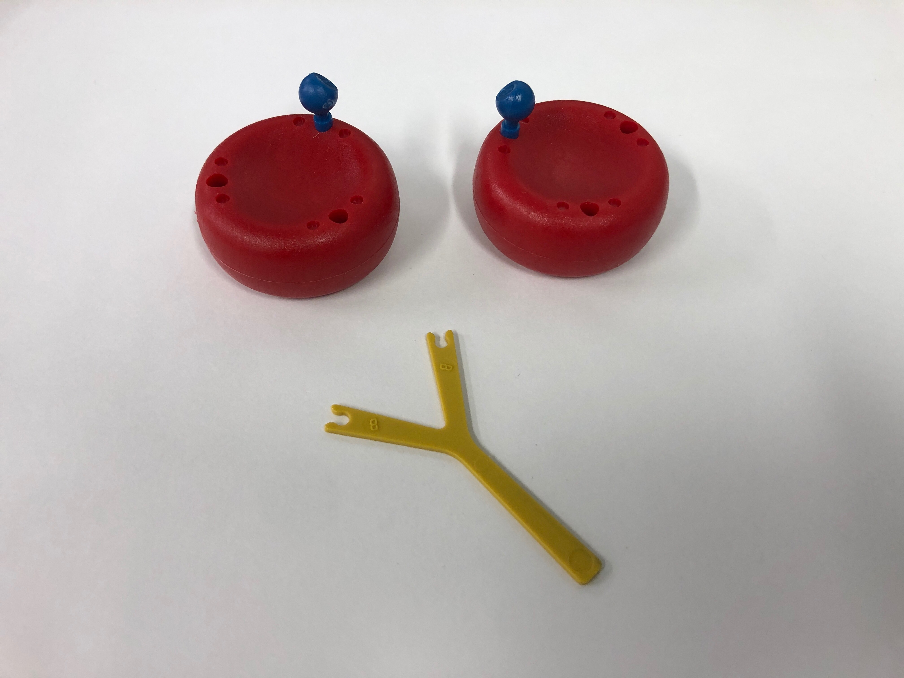
- Show students the bags of blood cells. Tell students that the red donut shape is a model for a red blood cell. The pegs are the antigens (blue is the “A” antigen, yellow is the “B” antigen). The Y-shapes are the antibodies.

- Show students the bag containing blood cells that have the blue pegs attached – this red blood cell now has an “A” antigen. It is a Type A blood cell. It also contains a yellow Y-shaped anti-B antibody present in the plasma.
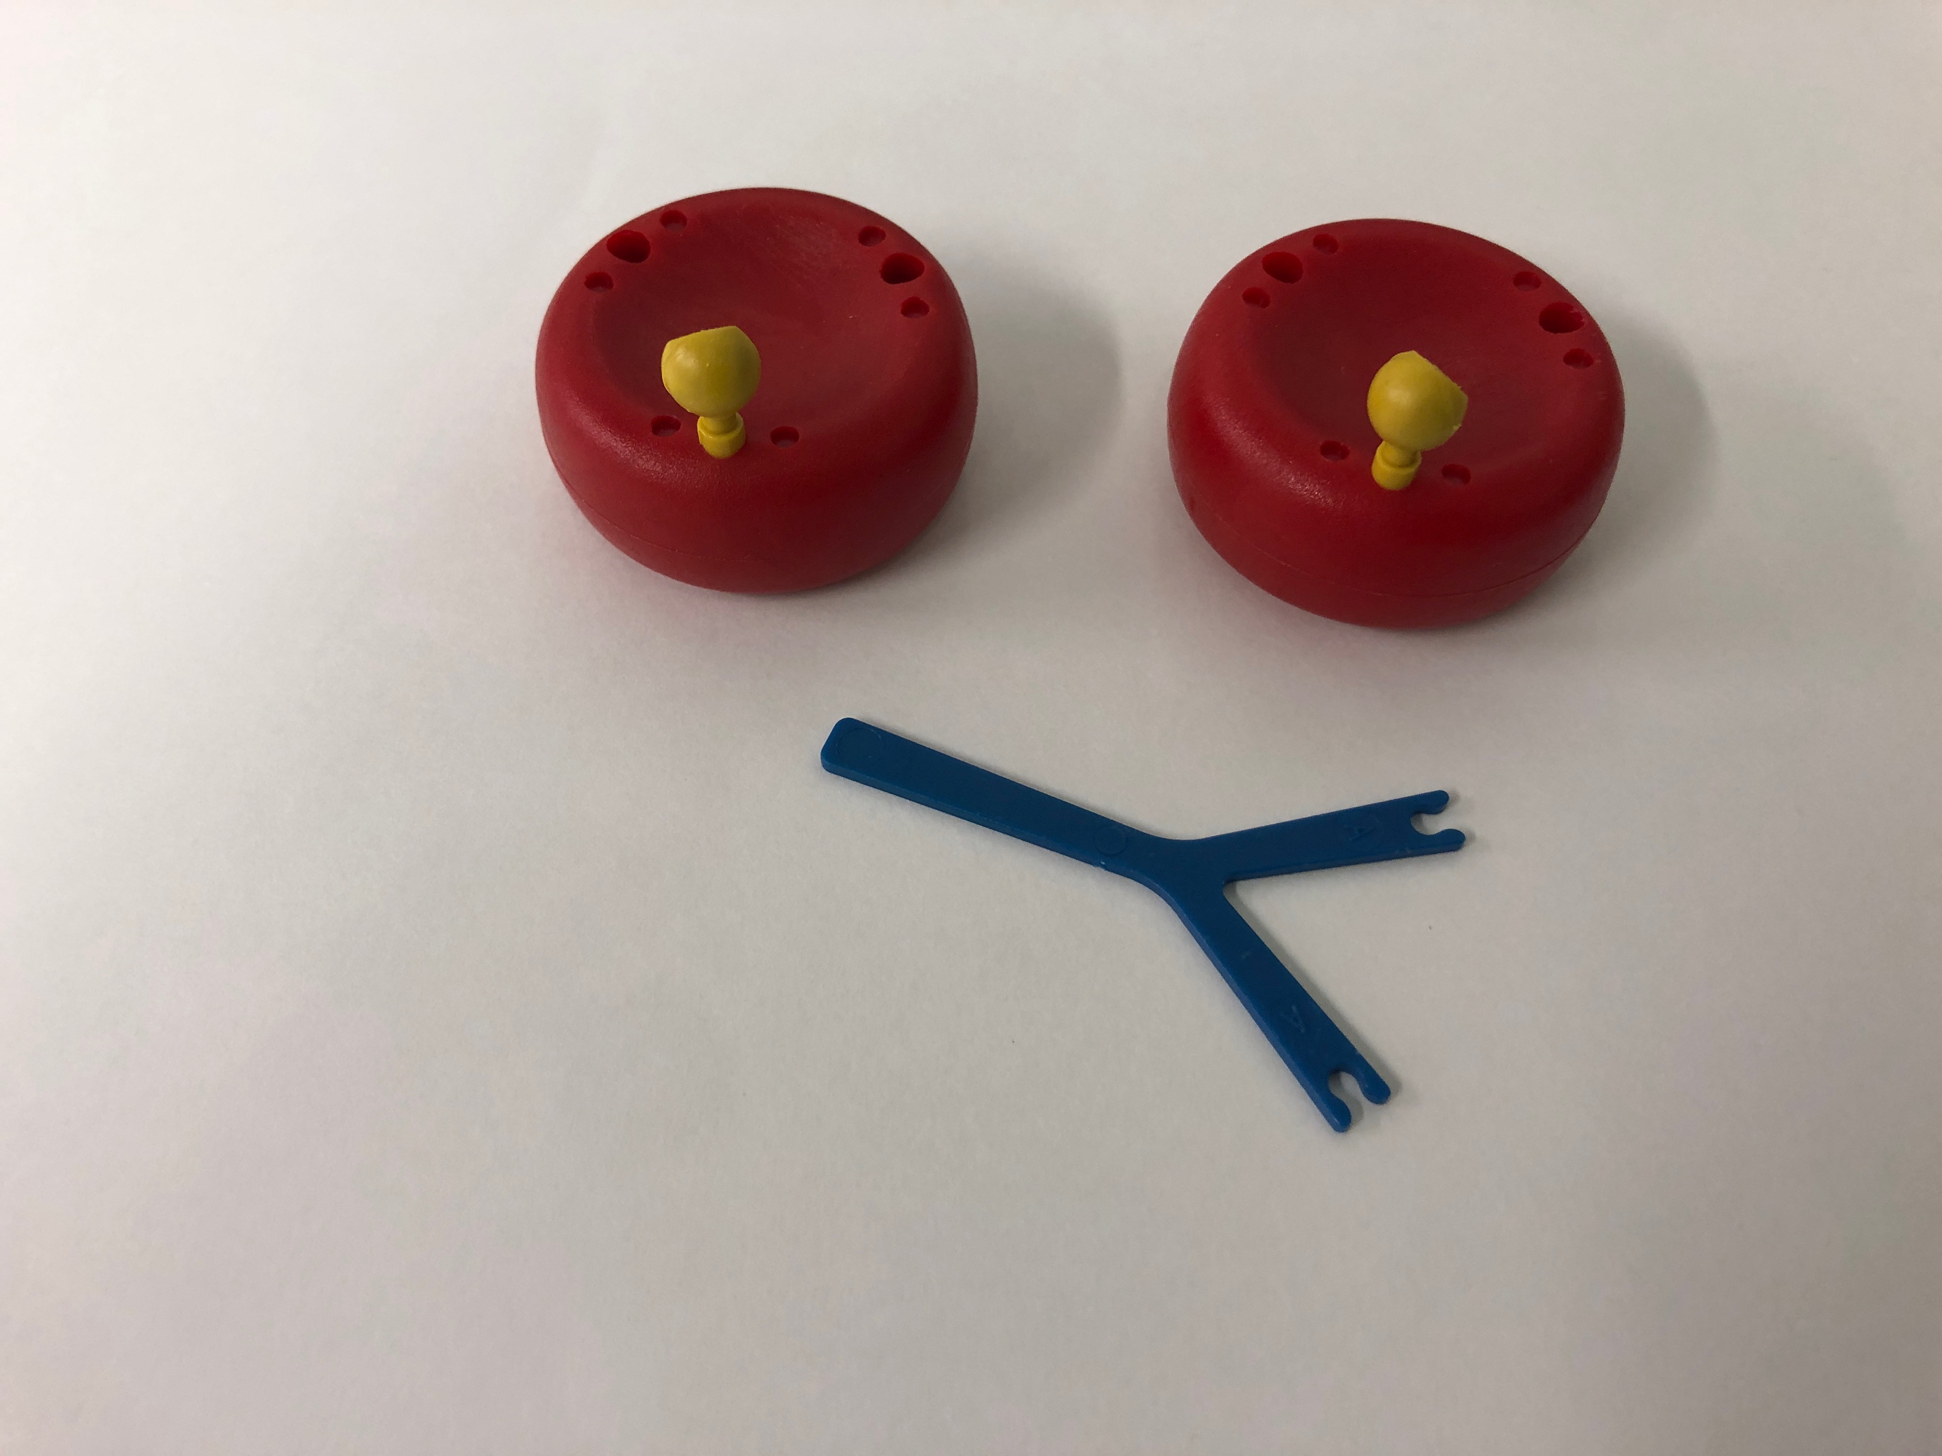
- Show students the bag containing blood cells that have the yellow pegs attached. This red blood cell has a “B” antigen – it is a Type B blood cell. It also contains a blue Y-shaped anti-A antibody present in the plasma.

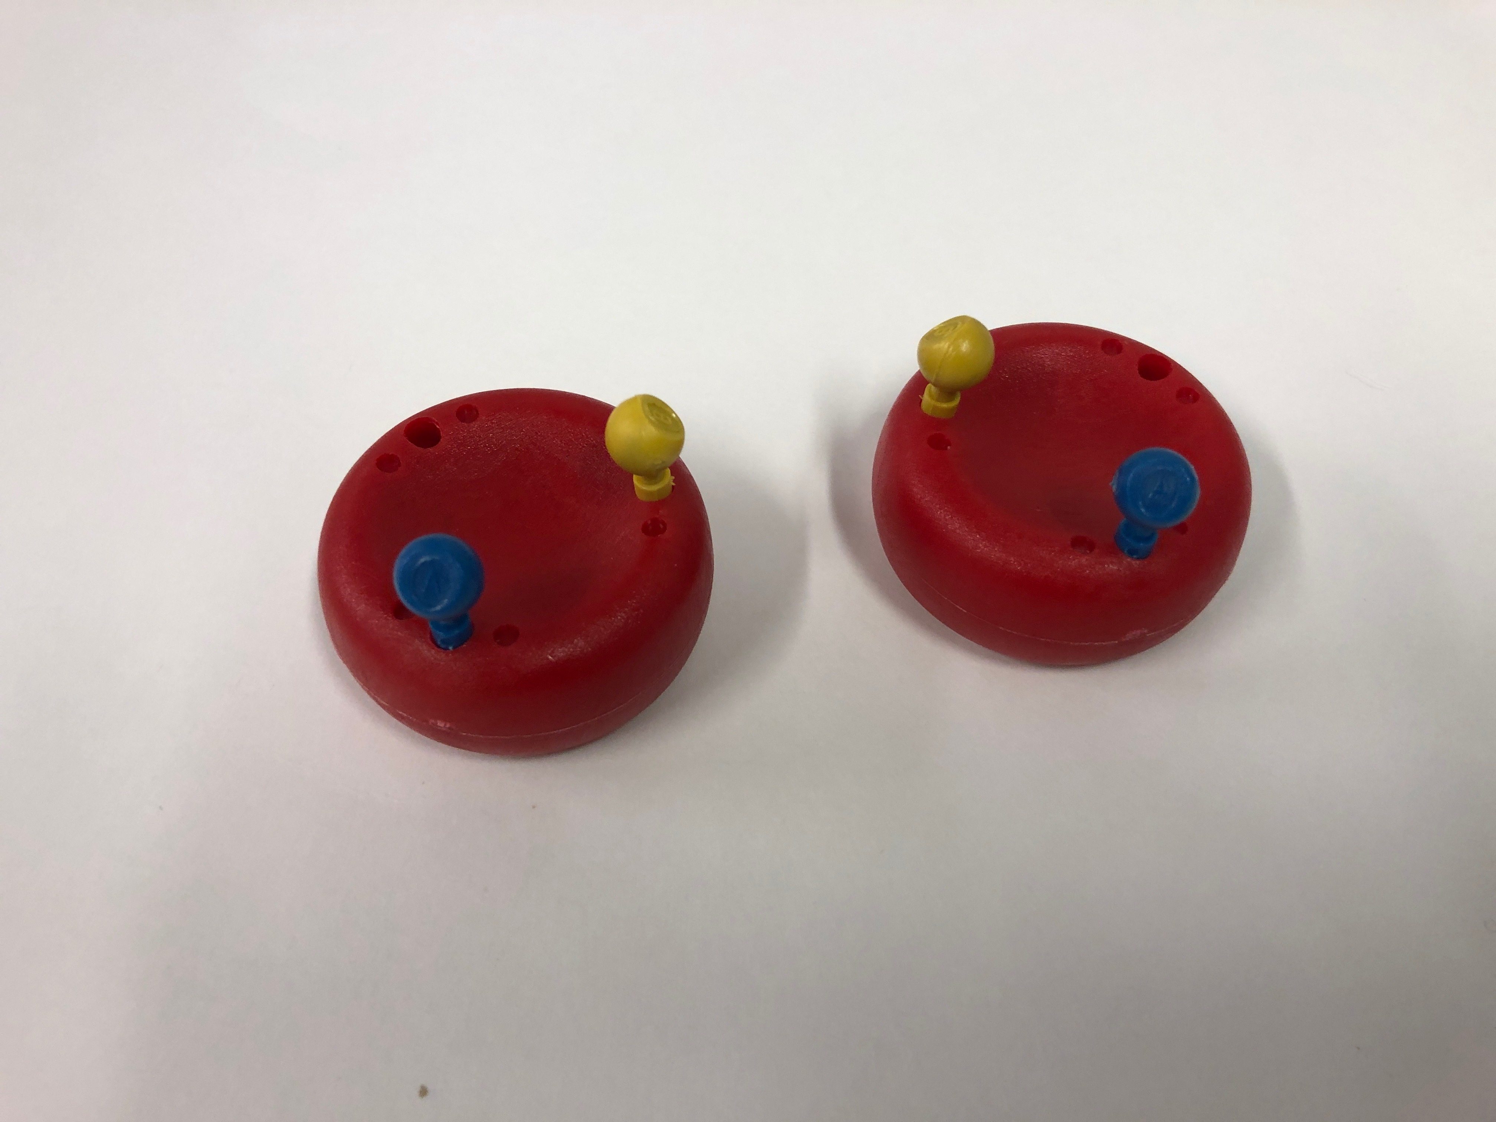
- Show students the bag containing blood cells that have the blue AND yellow pegs attached. Ask the students what type of blood cell this is. Answer: an AB blood cell. There are no antibodies in the plasma.

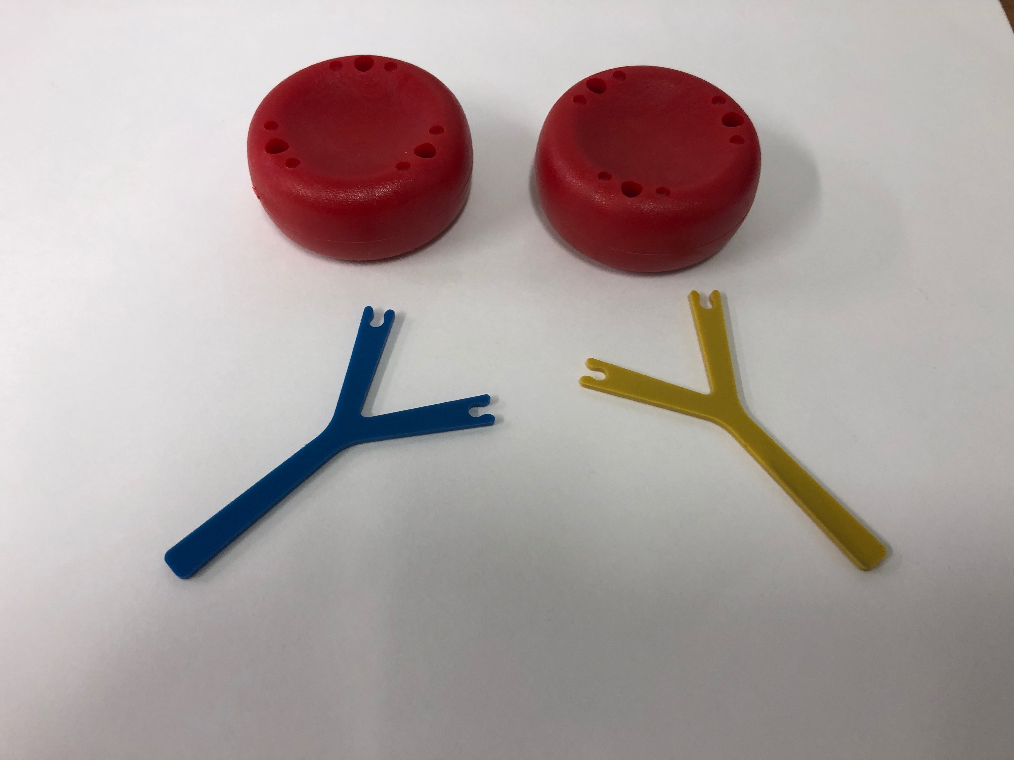
- Show the students the bag containing the fourth blood cell that does not have any antigens on its surface. Ask the students what type of blood cell this is. Answer: an O blood cell (if the students are confused, tell them to think of the cell has having zero (O) antigens on its surface)
There are both A and B antibodies present in the plasma and in the plastic bag.

- Tell students to look at Table 1 on the handout to see a comparison of the different types of blood cells side-by-side, and the relative representation of blood types in the American population.
- The A-B-O blood typing system classifies blood by the antigens on the red blood cell surface and the antibodies in the plasma.
- Antibodies help in removing unwanted things from the blood. If the immune system encounters an antigen that is not found on the body's own cells, it will launch an attack against that antigen. Many antibodies recognize antigens by being able to match the shape and remove them by binding to the antigens – seen as clumping in the experiment.
- If a person has blood cells with the A antigen, that person will have antibodies against the B antigen in the plasma. It does not normally have antibodies against cells with the A antigen. If it had A antibodies, it would be like having a double agent on your team – the A antibodies would attack the healthy cells in your body. This is the basis of autoimmune disorders where the body’s immune system incorrectly attacks healthy cells.
- If someone has blood cells with the B antigen, that person has antibodies against cells with the A antigen in its plasma.
- People with AB blood cells do not have antibodies to either type of antigen, while people with O blood cells have antibodies to both.

Tell students to look at the Table 1in the handout.
Table 1
ABO  Blood Type | Contains  Antigens  A | Plasma Contains Antibodies | Agglutination (clumping) occurs with
A | A | Anti- B | Anti-A serum only
B | B | Anti-A | Anti-B serum only
AB | A and B | None | Both Anti-A serum and Anti-B serum
O | None | Anti-A and Anti-B | Neither

Blood Transfusions and Organ Transplantations
When transfusions of blood were first attempted, some were successful but others often fatal. For a blood transfusion to be successful, the recipient’s blood must not contain antibodies that will react with/attack the antigens in the donor’s blood.
Important: donor’s blood contains ONLY red blood cells. There is no plasma in the donor’s blood. Therefore, there are no antibodies in the donor’s blood.
If a person has blood type A, he cannot receive Type B or Type AB blood because the Anti-B antibodies in the recipient’s blood will bind to the B antigen in the donor’s blood and destroy these cells.
- Ask students if they can determine what types of blood a person with Type B blood can receive? O and B.
- Ask students if they can determine what types of blood a person with Type AB blood can receive? A, B, AB, O. This person is called a universal recipient.
- Ask students if they can determine what types of blood a person with Type O blood can receive?
Only O. But this person can give blood to anyone and is called a universal donor.
These results are summarized in the Table 1 on the handout.

This reactivity demonstrates why people have their blood tested prior to a transfusion or transplantation. If blood types are not compatible, any transferring of blood can have negative consequences.
Learning Goals:
- Students understand the relationship between antigens and antibodies, and identify which blood types are compatible as donors and receivers
- With support, students identify a method for determining blood type

III. THE KIDNEY PROBLEM

MATERIALS
15 24-well plates
15 ziploc bags with
1 dropping bottle containing fake blood labeled “Mrs. Sanderson”
1 dropping bottle containing fake blood labeled “Mr. Sanderson”
1 dropping bottle containing fake blood labeled “Jill”
1 dropping bottle containing fake blood labeled “Jack”
1 dropping bottle containing “Anti-A serum”
1 dropping bottle containing “Anti-B serum”
15 plates
15 blood testing worksheets
30 safety goggles

Tell students that they will work to determine the blood type of the members of a “family” so that a donor match can be found.

Scenario: Mrs. Sanderson developed a rare kidney disease that causes the kidney to lose function over time. She had been doing well for the past few years, but it seems that her kidney is starting to decline rapidly. Her doctors suggest that the best way for her to live a long life is for her to receive a kidney transplant. Her family has just been informed of her health situation and they are asked to undergo a blood test. If a family member shares her blood type and is willing to donate a kidney to her, Mrs. Sanderson will probably be able to get better.

(OPTIONAL INFO) The major function of the kidney is to filter the blood to get rid of various wastes such as urea. People only need one kidney in order to live normally.

Blood Typing
Tell the students that they will be blood test specialists.
Remind the students that the blood samples are not really blood.
In order to donate a kidney (or blood), there must be a match of blood types between the donor and the recipient to prevent the recipient’s antibodies from attacking the donor cells.
There is a simple test to determine blood type of the recipient and possible donor.
Antisera are made containing either A antibodies or B antibodies. Serum is a “purified” form of plasma that contains the antibodies.
When the antiserum is added to each blood sample, it can react with the blood sample and cause the red blood cells to clump together – this is called agglutination. This would eventually result in clogged blood vessels and cause kidney failure.

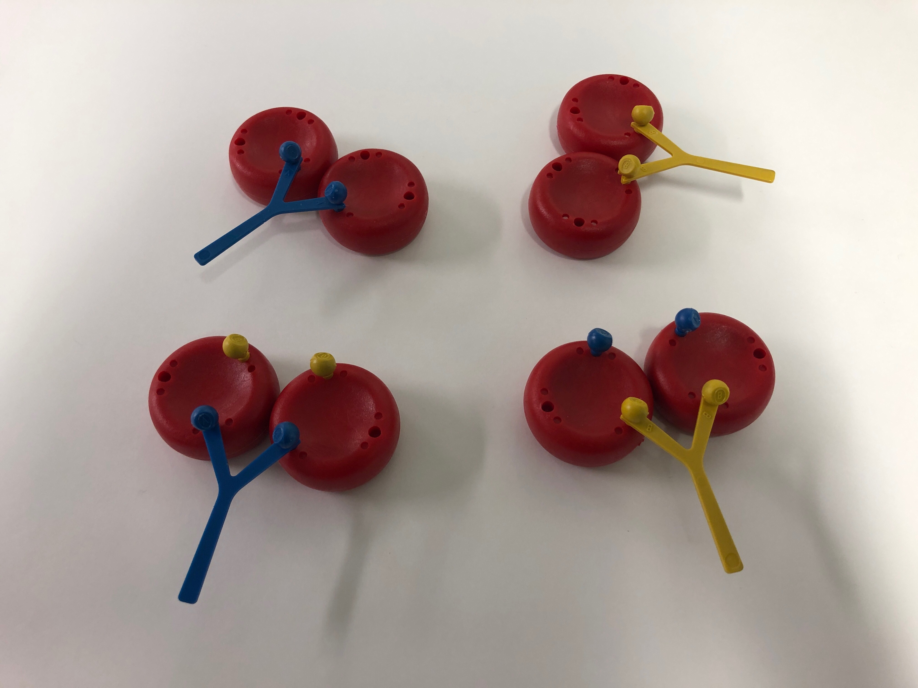
Show students the two red blood cell models that are labelled Type “A”. Connect the two blue antigens on the cells with the blue anti-A serum Y- shape. This represents the reaction of clumping or agglutination.
Similarly, show the students the two red blood cell models that are labelled Type “B”. Connect the two yellow antigens on the cells with the yellow anti-B serum Y- shape.
These results are summarized on the handout in Table 1 and the “Clumping” picture.
- If the blood clumps in the anti-A serum and not the anti-B serum, then the blood type is A.
- If it clumps for the anti-B and not for the anti-A, then the blood type is B.
- If it clumps for both, the blood type is AB.
- If there is no clumping, then the blood type is O.
Divide the students into pairs. Pass out safety goggles and one set of materials to each pair of students.
Tell the students:
1. Put on the goggles and wear them until after they finish using the dropper bottles.
2. Look at the 24-well plate and find the column labels 1-6 (across the top) and the row labels
(A-D) (along the side). You will be using columns 1-4 and rows A and B.
3. Add a squirt of Mrs. Sanderson’s samples to 1A and 1B (the first two wells in Column 1).
Replace the cap on the bottle labelled Mrs. Sanderson.
Add a squirt of anti-A (blue) to the first well in row A(1A). Observe whether a precipitate (or cloudiness) occurs. If a precipitate or cloudiness occurs, enter a “+” in square A-1 in the table below. If nothing happens, enter a “−“.
Add a squirt of anti-B (yellow) to 1B, recording a “+” or a “− “ in the appropriate square of
the table.
4. Repeat for Mr. Sanderson’s samples in 2A and 2B (the first two wells under Column 2) and
enter your results. Replace the cap on the bottle labelled Mr. Sanderson.
5. Repeat for Jill’s samples to 3A and 3B (the first two wells under Column 3). Record the
results. Replace the cap on the bottle labelled Jill.
6. Repeat for Jack’s samples to 4A and 4B (the first two wells under column 4). Replace the
cap on the bottle labelled Jack. Replace the caps on the bottles labelled anti -A and anti-B.
7. Determine the blood type:
-- Type A will clump only in anti-A serum
-- Type B will clump only in anti-B serum
-- Type AB will clump in both anti-A and anti-B serum
-- Type O does not clump when either serum is added.

IV. ANALYSIS

1. From the data that was obtained, tell the students to figure out what the blood type of each family member is. The instructions on how to determine the blood type of each individual are written in the last step of the handout. Write these answers on the board and/or share with the class.
Learning Goals: Students understand the relationship between antigens and antibodies, and identify which blood types are compatible as donors and receivers
2. From the data tables, ask the students if any of Mrs. Sanderson’s family will be able to donate their kidney to her.

Because Mrs. Sanderson’s blood clumps in the anti-A serum, she is blood type A. In the same way, Mr. Sanderson has type B blood and Jill has type AB blood and they will not be able to donate. However, Jack, with type O blood, can and does donate a kidney, saving his mother’s life.

V. BLOOD GENETICS AND PUNNETT SQUARES
Learning Goals: Students use Punnett squares and basic genetics to construct an explanation for why people have certain blood types

We can tell what blood type someone has by analyzing their red blood cells for their antigens.
Ask the students: Can we tell what possible blood types an offspring will have just by knowing what his or her parents’ blood types are? Accept answers. Yes, by using a Punnett square.

Ask the students: What do you think determines which antigens end up on the red blood cells?
Tell students that antigens and thus, blood type, are determined by the genes (on chromosome 9!) that get passed on from parents (in the same way that other traits are passed down from parents).

An individual's ABO type is determined by the inheritance of 1 of 3 alleles (A, B, or O) from each parent.
Explain that each parent has two blood type alleles. This is what’s known as a genotype.
Each parent will pass on one of these alleles (remember that they have two!) to their child.
These alleles are for the A antigen (blood type A), the B antigen (blood type B) or no antigens (blood type O). The combination of two of these alleles will determine what the blood type will be.

Ask students to determine the possible genotypes of offspring? If they do not know how to use Punnett squares, briefly explain by drawing the square on the board:
- Draw a Punnett square (Figure 1.) and compare it to a four-square court. The mother’s genes are on top and the father’s genes are on the left side.
- The empty boxes are filled by writing the each of the mother’s genes in the boxes directly below it and each of the father’s genes in the boxes directly to the right of it (figure 2). In this example, the mother has an AA blood genotype, while the father has an AB blood genotype.

MOTHER’S GENES Gene 1 Gene 2
Gene 1 FATHER’S
GENES
Gene2
Figure 1. Punnett Square
MOTHER’S GENES TYPE AA
AA | AA
AB | AB
A A

A FATHER’S
GENES TYPE AB
B

Figure 2. Filling in the Punnett Square

- After filling in the empty boxes by bringing down both A genes contributed by the mother and bringing over the A and B genes contributed by the father, we find that their offspring will either have an AA genotype or an AB genotype.

- Review the terms dominant and recessive with the students.
In the case of blood, the A and B genes are co-dominant. This means that if a child inherits both an A gene and a B gene, both A and B antigens will be found on the surface of an RBC and the phenotype will be AB.
Individuals who have an AO genotype will have an A phenotype.
People who are type O have OO genotypes. In other words, they inherited a recessive O allele from both parents.
- Tell students to fill out the last line in the observation sheet, assigning possible genotypes to the family members.

- Tell students to look at the Punnett square on the Handout.

The possible ABO alleles for one  parent are in the top row and the  alleles of the other are in the left  column. Offspring genotypes  are shown in black. Phenotypes  are red in the brackets.
  Parent Alleles | A | B | O
  A | AA  (A) | AB  (AB) | AO  (A)
  B | AB  (AB) | BB  (B) | BO  (B)
  O | AO  (A) | BO  (B) | OO  (O)

http://anthro.palomar.edu/blood/ABO_system.htAsk students:

If Jack has type O blood, what are the genotypes for his mother and father. Have the students fill out their Punnett square using all the possible genotypes for Mr. and Mrs. Sanderson.
For VSVS Information: make sure you know the logic used in determining the possible genotypes.
Since Jack is type OO, he must have the genotype OO. He has to get one O from his mother and one O from his father. So Mrs. Sanderson must have AO and Mr. Sanderson must have BO
Answer sheet
Blood Typing Lab Data Sheet
 | Column 1 | Column 2 | Column 3 | Column 4
 | Mrs. Sanderson | Mr. Sanderson | Jill | Jack
Row A  Anti-A serum | + Yes | - No | + Yes | - No
Row B  Anti-B serum | - No | + Yes | + Yes | - No
Blood Type  (A, B, or O) | A | B | AB | O
Possible Genotype | AA or AO | BB or BO | AB | OO

Written by Josh Beckham, GTF, GK-12 Program, Vanderbilt University
Joe Lopez, Center for Science Outreach and VSVS
Mel Joesten, Professor Emeritus, Vanderbilt University
Pat Tellinghuisen, Program Coordinator 1998-2018, Vanderbilt University
Significant edits by Vincent Huang, Aakash Bansu and Sarah Baumgarten, Undergraduate Students, Vanderbilt University

Inheritance and Blood Typing Handout, Spring 2019
Four Basic Blood Types
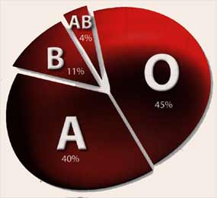
Blood Type A
A antigen
Blood Type B
B antigen
Blood Type A-B
A and B antigens
Blood Type O
No antigens
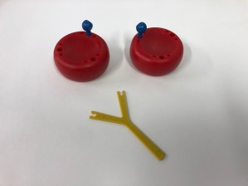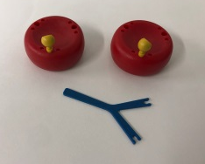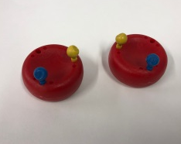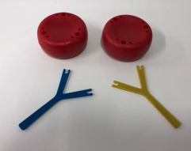
Plasma contains anti-B antibodies

Plasma contains anti-A antibodies

Plasma contains no antibodies

Plasma contains anti-A AND anti-B antibodies

% Blood Types in the
Clumping (Agglutination) of Blood Cells and Antibodies Population
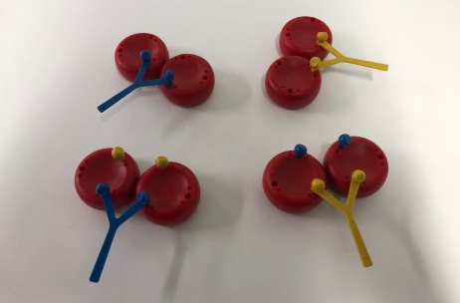
Type A blood clumping from being attacked by anti-A antibodies
Type B blood clumping from being attacked by anti-B antibodies
Type A B blood clumping from being attacked by anti-A OR anti-B antibodies
Table 1
ABO  Blood Type | Red Blood Cells Contain  Antigens | Plasma Contains Antibodies | Agglutination (clumping) occurs with
A | A | Anti- B | Anti-A serum only
B | B | Anti-A | Anti-B serum only
AB | A and B | None | Both Anti-A serum and  Anti-B serum
O | None | Anti-A and Anti-B | Neither

The possible ABO alleles for one parent are in the top row and the alleles of the other are in the left column. Offspring genotypes are shown in black. Phenotypes are red.
  Parent Alleles | A | B | O
  A | AA  (A) | AB  (AB) | AO  (A)
  B | AB  (AB) | BB  (B) | BO  (B)
  O | AO  (A) | BO  (B) | OO  (O)

Blood Typing:
TAKE GOGGLES

Blood Typing:
TAKE GOGGLES

Blood Typing:
TAKE GOGGLES
Blood Typing Lab Instruction Sheet

1. Put on your goggles and wear them until after you finish using the dropper bottles.

2. Look at the 24-well plate and find the column labels 1-6 (across the top) and the row labels
(A-D) (along the side).

3. Add a squirt of Mrs. Sanderson’s samples to 1A and 1B (the first two wells in Column 1).
Slowly add 2-3 drops of anti-A (blue) to the first well in row 1(1A). Observe whether a precipitate (or cloudiness) occurs If a precipitate or cloudiness occurs, enter a “+” in square A-1in the table below. If nothing happens, enter a “−“.

Slowly add 2-3 drops of anti-B (yellow) to 1B, recording a “+” or a “− “ in the appropriate square of
the table.

4. Repeat for Mr. Sanderson’s samples in 2A and 2B (the first two wells under Column 2) and enter your results.

5. Repeat for Jill’s samples to 3A and 3B (the first two wells under Column 3). Record the results.

6. Repeat for Jack’s samples to 4A and 4B (the first two wells under column 4).

7. Determine the blood type:
-- Type A will clump only in anti-A serum
-- Type B will clump only in anti-B serum
-- Type AB will clump in both anti-A and anti-B serum
-- Type O does not clump when either serum is added
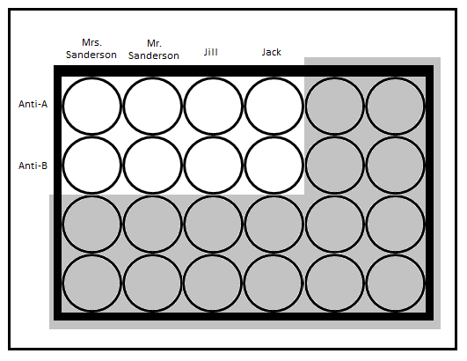

Blood Typing Lab Data Sheet NAME ___________________________

 | Column 1 | Column 2 | Column 3 | Column 4
 | Mrs. Sanderson | Mr. Sanderson | Jill | Jack
Row A Anti-A serum
clumping occurs = +
nothing happens = -
Row B Anti-B serum
clumping occurs = +
nothing happens = -
Blood Type (Phenotype)
(A, B, AB or O)
Possible Genotype
(AA, AB, BB, AO, BO, OO)

Mrs Sanderson

Mr Sanderson
Mrs Sanderson

Mr Sanderson

Recipe for One Liter of Blood Typing Solutions

A type (Mrs. Sanderson): 60 g anhydrous CaCl₂ per liter of distilled water plus V drops of food coloring

B type (Mr. Sanderson): 120 g hydrated AlCl₃ ( AlCl₃ . 6 H₂O) per liter of
distilled water plus X drops of food coloring

AB type (Jill): 120 g hydrated AlCl₃ ( AlCl₃ . 6 H₂O) plus 60 g anhydrous CaCl₂ per liter of distilled water + Z drops red food coloring

O type (Jack): 1 liter of distilled water +Y drops red food coloring

Anti A: 0.1 M sodium oxalate (Na₂C₂O₄) - 13.4 g per liter of distilled water plus 10 drops of blue food coloring

Anti B: 1 liter of household ammonia plus 10 drops of yellow food coloring

Always test new solutions to make sure the correct results are obtained.
A plus anti-A gives a precipitate
A plus anti-B – no change
B plus anti-A – no change
B plus anti-B – precipitate
AB plus either anti-A or anti-B gives a precipitate
No change is observed for O type with either anti-A or anti-B

