**VANDERBILT STUDENT VOLUNTEERS FOR SCIENCE**

[**http://studentorgs.vanderbilt.edu/vsvs**](http://studentorgs.vanderbilt.edu/vsvs)

**Potential Energy**

**Fall 2017**

**GOALS:** To show how gravitational potential energy is related to the height and mass of an object.

To investigate different forms of potential energy.

Fits TN State standards:

GLE 0507.10.1: Design an experiment to illustrate the difference between potential and kinetic energy

GLE 0607.10.1: Compare and contrast the three forms of potential energy.

**VSVSer LESSON OUTLINE**

**________ I. Introduction - Energy Definitions**

Definitions of energy are discussed with the students.

**________ II. Demonstrations: Potential Energy/Kinetic Energy Conversions**

The conversion of potential energy to kinetic energy and the law of conservation of energy are illustrated by three demonstrations.

**________ III. Demonstration: Potential Energy**

Students are shown the activity they will do in part IV.

**----------- IV. Gravitational Potential Energy (PE) is related to Mass and Height**

Students learn how potential energy is related to the height and mass of an object by observing the distance a wooden block moves.

**1. PE is related to height (mass held constant)**

A ball is rolled down a ramp and collides with a small block of wood. The students will repeat this multiple times, each time changing the height (and thus potential energy) at which the ball is dropped on the ramp. Students record and graph the distance the block moves and then predict what will happen when a fourth ramp support is added.

**2. PE is related to mass (height held constant)**

Students use two balls of different mass and measure the distance traveled by the wood block after it has collided with each ball.

**LOOK AT THE VIDEO BEFORE YOU GO OUT TO YOUR CLASSROOM (https://studentorg.vanderbilt.edu/vsvs/lessons/)**

**USE THE PPT AND VIDEO TO VISUALIZE THE MATERIALS USED IN EACH SECTION.**

**1. Before the lesson:**

**In the car ride, read through this quiz together as a team. Make sure each team member has read the lesson and has a fundamental understanding of the material.**

1. What is the definition of mechanical energy? Which energy types contribute to total mechanical energy?
2. At what height **must** you drop the astroblaster from?
3. How can one tell when the ball in demonstration #3 has the most potential energy?
4. What is the difference between mass and weight?
5. Where do the balls in Newton’s cradle have the most potential energy?
6. When should safety eyewear be worn during this lab?
7. Are the supports laid under the track on their large or thin side?
8. What is the maximum number of supports a student should place underneath the track?

**2. During the Lesson:**

**Here are some fun facts about the lesson:**

* Most rollercoasters only have motors to get you to the top of the first hill; the rest of the ride is entirely dependent on gravitational potential energy
* When you pull back the arrow in a bow-and-arrow, you are increasing the potential energy of the system and when you let go, that is converted into kinetic energy as it flies toward the target

**Unpacking the Kit – What you will need for each section:**

**While one team member starts the introduction, another should write the following vocabulary words on the board:**

Mechanical energy, Kinetic energy, Potential energy, Conservation of Energy, Elastic Potential Energy

Another member should assemble ten tracks - one track for each group**.**

**Be sure to assemble the pieces in the correct sequence. They are numbered 1, 2, 3 on the topside and are labeled to show you how to put them together (see training Powerpoint, slide 4). Each 3-piece track requires 2 plastic joiners.**

# For Part II. Demonstrations: Potential Energy/Kinetic Energy Conversions

1 Newton’s Cradle, 1 Tennis ball, 1 Dropper Popper, 1Astroblaster

**For Part III. Demonstration: Potential Energy**

Use a student set of: 3 pieces of track with 2 plastic connectors, 32 Observation sheets, 10 Instruction sheets,

1 plastic bag containing: 1golf ball, 1 small block of wood (approximately 0.75”x 1.5”) and 1 track support (9x6x2cm piece of wood)

**For Part IV. Gravitational Potential Energy Is Related To Mass and Height**

10 sets of 3 pieces of track (joined) with 2 plastic connectors

10 Ziploc bags containing 1golf ball, 4 pieces of wood (track supports), 1small block of wood, 1 tape measure

Pencils - students use their own

**I. Introduction – Energy Definitions**

**Background information for VSVS members:**

The Law of Conservation of Energy states that:

Energy can be neither created nor destroyed.

Energy can only be converted from one form to another.

During a collision, energy is transferred from one object to another.

**Learning Goals: Students identify examples of potential and kinetic energy in the real world.**

Ask students: *What is energy?*

**Energy is the ability to do work (like applying a force to move an object) and cause change.**

Tell students they are going to investigate **Mechanical Energy**.

**Mechanical Energy is the total energy of an object due to its motion and position.**

Ask students: *What is potential energy?*

**Potential energy** is the energy of an object has due to its position or shape.

Ask students to give examples of potential energy**.**

**Elastic potential energy:** a stretched rubber band, a wound-up spring.

**Gravitational potential energy:** a boulder at the top of a hill, water in a lake at the top of a mountain.

Ask students: *What is kinetic energy?*

**Kinetic energy** is the energy of an object due to its motion.

Ask students to give some examples of kinetic energy.

All moving objects: a swinging hammer, a wrecking ball, a moving car.

Explain to students that under ideal conditions, energy is never lost.

It is just changed from one form or state to another.

**This is the law of conservation of energy.**

# II. Demonstrations: Potential Energy/Kinetic Energy Conversions

**Learning Goals: Students understand conservation of energy and how energy can be converted between potential and kinetic.**

The following demonstrations are designed to get the students thinking about different types of potential energy.

**Materials:**

1 Newton’s Cradle

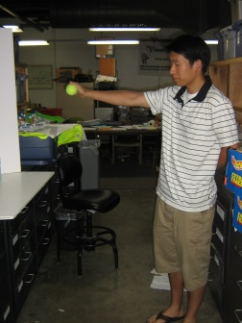1 Tennis ball

1 Dropper Popper

1 Astroblaster

1. **Comparing a Dropper Popper and Tennis Ball**

* Drop the tennis ball from shoulder height and tell students to pay attention to the height the ball reaches after one bounce.
* Now invert the **dropper popper** (rubber half-dome), hold it at the same shoulder height and let it drop. Tell the students to pay attention to where the popper reaches after one bounce. (Catch it!)

Ask the students: **what forms of mechanical energy are illustrated by dropping the tennis ball and the dropping the dropper popper?**

1. **Tennis ball:** gravitational potential energy (when the tennis ball is lifted) and kinetic energy (when the ball is moving).
2. **Dropper Popper:** gravitational potential energy (when the dropper popper is lifted) AND elastic potential energy (work is done to invert popper) and kinetic energy (when the popper is moving).

Ask the students **what energy transformations occurred in each transformation?**

1. **Tennis ball:** gravitational potential energy is transformed to kinetic energy (as the object falls from a stationary position) then transformed back to potential (kinetic energy used to lift ball).
2. **Dropper Popper:** gravitational plus elastic PE is transformed to kinetic then back to potential.

**Explanation and Discussion:**

Ask the students which of the two bounced back higher. Ask them if they know why.

By lifting the tennis ball, work was done to the ball. This work was converted to **gravitational potential energy** as it was raised. When the ball was dropped, the potential energy was converted to **kinetic energy**, which was then converted to potential energy as it bounced back.

The popper had the same gravitational potential energy as the ball (assume equal masses-do not bring this up at this point) PLUS **elastic potential energy**, which it got when it was turned inside out. The work that was done to invert it was converted into elastic potential energy. Thus, the popper started off with more potential energy and bounced higher.

**IMPORTANT:**  **The demonstrator must wear the safety goggles.**  Other members must watch and retrieve the ball. Make sure to drop the “Astroblaster so that the small ball will shoot straight up and **will** come back down again. **This demonstration must be done on a table so that all students can see it.**

**IMPORTANT: DO NOT drop the astroblaster from shoulder height.** The small ball will fly off the rod at an uncontrollable speed and direction, and could cause injury to students.

**B. Astroblaster** (rod with multicolored balls)

* 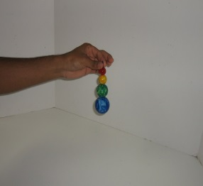Take the red ball off the rod. Hold the ball 4 inches above table level and let it drop. Point out the height it reaches after one bounce. **Catch it!**
* Place the ball back on the rod, hold the “Astroblaster” by the tip of the rod at the same height above the table, make sure it is pointed directly down, and let the entire rod drop.
* Point out the height the small ball now reaches. **Retrieve the ball.**

Ask the students **what forms of energy are illustrated by the demonstration? Answer -** Gravitational potential (lifting) and kinetic (moving).

Ask the students **what do they think is happening?**

**Explanation**:

Ask students if they think they know what is happening. Point out that the astroblaster starts out with gravitational potential energy gained from its height from the floor and the total mass of all balls. As it falls, its potential energy is converted to kinetic energy until it reaches the floor. There, the four balls collide with the ground, **but three cannot bounce upward**. All their energy is transferred to the red ball in the form of kinetic energy, causing the ball to fly off the rod and reaching a higher height than before (**because of the extra energy**).

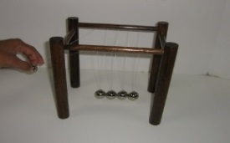**C. Newton’s Cradle – Conservation of Energy**

Show the students Newton’s Cradle. Tell them that this is a common toy that can be used to demonstrate the Law of Conservation of Energy.

* Lift up the first ball about 3 inches above from the other 4 balls. Let it go and have the students observe what happens. (When the first ball hits the 4 stationary balls, only one ball at the other end will be moved.)
* Ask students if they noticed how high the last ball reached. *Some may have noticed that it rose to nearly the same height as the first ball.*
* Repeat, lifting the ball to the same position, and have another VSVS memberpoint to the position the last ball rises to.
* Repeat again, this time raising the first ball to the highest level possible. Ask students what

happens to the height reached by the last ball. *It increases because raising the first ball higher increases its energy. This energy is transferred to the last ball.*

Remind students: *Energy can be converted between potential and kinetic energy.*

**Follow-up Questions:**

Refer back to the Newton’s Cradle:

Ask students the following questions:

Where does the first ball have the most potential energy? *When it was held at the highest position*

Where does the first ball have the least potential energy? *Just before it collided with the other 4 balls.*

What happened to the potential energy? *It was converted to kinetic energy.*

Where does the first ball have the most kinetic energy? *Just before it collided with the other 4 balls.*

Where does the first ball have the least kinetic energy? *When it was not moving.*

**III. Demonstration: Potential Energy**

**Learning Goals: Students use a ramp to understand how height and mass are related to potential energy.**

Materials 3 pieces of track with 2 plastic connectors

1 plastic bag containing: 1 golf ball, 1 small block of wood (approximately 0.75”x 1.5”) 1 track support

1. Write the formula for gravitational potential energy on the board:

**Gravitational Potential Energy = mgh (m=mass, g is a constant, h=height)**

Emphasize that the potential Energy of an object can be changed by changing mass or height. If you increase mass you increase potential energy. Explain that in the following demonstrations, you will be testing the effect of each of these variables.

1. Demonstration
   1. Place the 3-piece track on a flat surface so that all students can see the demonstration.
   2. Put the track support under the start end of the track.
   3. Place the ball at the beginning of the track and release it.
   4. Point out to the students that the ball has gravitational potential energy at the start of the track, which is converted to kinetic energy as it rolls down the slope.
2. Changing Potential Energy
   1. Tell students that they will observe how potential energy changes as you change the height of an object, or as you change the mass of an object.
   2. 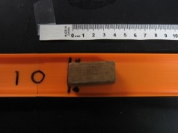Tell them they will determine the relative potential energy of a ball by measuring the work done by it as it rolls and collides with a stationary object, which will be moved a certain distance. Remind students that this was what was happening in the Newton’s Cradle experiment.
   3. Place the red end of the small wooden block on the black line on the track. (This is the 0 cm mark).
   4. Place the ball back at the top of the track and release it so that it collides with the small block.
   5. Measure how far the block moved (in cm).

Ask students if the block will move farther if the ball is given more potential energy by placing it at a higher position (*Yes)*

Tell them they are going to test this and other hypotheses.

**Organize students into 10 groups.**  **Students should take turns performing tasks.**

**Note: These activities require good classroom control. Tell students that they must stay on task and under control in order to do these activities. If they cannot maintain control, VSVS members may do all of the activities in small groups (3-4) as demonstrations. Tell students that they should treat all the materials as science equipment, not playthings.**

**IV. Gravitational Potential Energy Is Related To Mass and Height**

**A. Potential Energy Is Related to Height (mass held constant)**

**Learning Goals:** **Students use a ramp to understand how height and mass are related to potential energy.**

Materials per group

1 3-piece track set

1 golf ball

4 9x6x2cm wood supports

1 small block of wood

1 tape measure

4 observation sheets (graphs) – 1 per student

1 Instruction sheet in sheet protectors

Give each group one of the instruction sheets and tell them to follow the directions. VSVS members should each monitor 1-2 groups and guide them through the procedures, making sure they understand the instructions.

Tell students that in the next experiment the track will be elevated first onone wood support, then on two supports, and finally on three supports. Each wooden support measures 9 x 6 x 2 cm, so the height will be increased by 2 cm each trial run.

Make sure the students understand that the **mass** of the golf ball does not change. **The only variable is height.**

Refer to the equation for potential energy and ask students to predict which stack of supports (1, 2 or 3) will give the ball the most potential energy. Record the predictions on the board (Correct answer = 3).

**Trial Run #1**

Have each group look at the first picture on the instruction sheet and set up their materials in the same way.

1. Place one of the supports so that its large flat area is lying on the desk or floor surface, and the black line is facing up.
2. 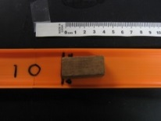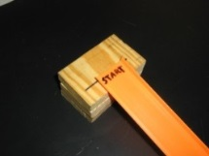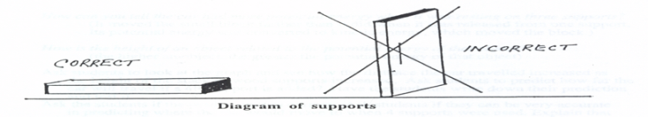Rest the "START” end of the track on the surface of the support so that the track edge lines up with the line on the support.

3. Place the small block of wood on the track so that its red end is on the black "0 cm” mark.

4. Hold the golf ball on the track at the starting point and release it.

5. Use the measuring tape to measure the distance the block moved from its starting "0 cm” mark. Make sure that the tape measure starts at the “0" mark, and is pulled out taught, and that the distance to the red end of the block is measured.

6. Have all students record this value on their graph at the 2cm (one support) line by using their pencil to make a small, filled-in circle.

Students will need to be shown how to do this.

**Trial Run #2**

Have each group do the following:

1. Add another support under the "START” end of the track.

2. Repeat steps 1- 6. Be careful! Make sure that:

* Students line up the track with the black line on the wood support
* That they start the ball from the beginning (“START”) of the track each time
* That the small block is at the black“0 cm" line at the beginning for each run.

3. Have all students record the new distanced traveled on their graph at the 4cm (two support) line.

**Trial Run #3**

Have each group do the following.

1. Add another support under the "START” end of the track.

2. Repeat steps 1- 6 from Trial Run #1.

3. Have all students record the new distanced traveled on their graph at the 6cm (three support) line.

**Follow-Up Questions:** Ask students the following questions:

1. What state of energy did the ball have at the top of the track? *(potential energy)*
2. Did the ball have more potential energy when it was resting on one, two, or three supports? *(three)*
3. How can you tell the ball had more potential energy when it was resting on three supports? *(The ball moved the small block farther than it did when it was released from one support.)*
4. How is the height of an object related to its potential energy? *(the higher an object, the greater the potential energy of that object)*



**Investigative Run**

1. Ask students to look at the graph and see how the distance the ball and block of wood traveled increased as the height of the supports increased.
2. Have students draw a line through the dots on their graph (students will need to use a ruler or straight edge) and extend the line so that it goes through the “8cm” line. **Students will need help drawing the line, especially if the dots do not line up exactly.** A ‘line of best fit” is appropriate. Explain: sometimes, we care more about the general trend than about connecting the dots precisely.
3. Ask students to predict how far the ball will travel (using their graph) if a 4th support (8cm) is added?
4. Have the students write down their prediction and test it.

**The graphs should look like the one at the right.**

1. Ask the students if their prediction was correct.
2. Ask students if they were accurate in their prediction. Explain that errors occur in all science experiments, even to the best scientists.
3. Ask students what factors might influence the measurement (friction, some energy lost and converted to heat)

**B. Potential Energy Is Related to Mass (height held constant)**

**Materials per group** (same as above plus 1 squash ball (29 gm))

**Note: Explain to students that the term "weight” is often used in place of "mass.” Weight and mass are not the same. The mass of a body is constant, but its weight is the force exerted upon it by gravitational attraction (usually earth’s gravity). For example, your mass would be the same on the moon as it is on the earth, but your weight on the moon would be much less.**

1. Tell a student in each group to hold the golf ball in one hand and the squash ball in the other. Ask a student which ball has more mass? (*the golf ball*)
2. Tell students that the squash ball has a mass around 29 grams, while the golf ball has a mass of about 45 grams. (**The masses are recorded on the balls**.)
3. Tell them that the height will be changed to 6cm (3 supports).
4. Ask students to predict what effect increasing the ball’s mass will have on the distance the block travels. (Refer back to the formula, PE = mgh, where m = mass.)
5. Tell students they will now conduct the experiment to see if their predictions are correct.

**Trial Run #1**

1. Rest the "Start” end of the track on 3 supports so that the track edge lines up with the black line on the block.

2. Place the red end of the small block on the 0cm black line drawn on the track.

3. Hold the squash (lighter) ball on the starting point of the track.

4. Release the squash ball and measure the distance the small block was moved (from the "0 cm” mark to the red end of the block).

5. Have students record the measurement on their graph at the line that corresponds with the mass of the

squash ball. **Students will need help doing this.**

**Trial Run #2**

1. Use the heavier golf ball.

2. Tell the students that care should be taken that the “start” end of the track rests at the same position as in Trial #1, and that the ball starts from the same position on the track.

3. Repeat steps 1 - 5 from Trial Run #1, but for the golf ball.

The graphs should look like the one at the right.All graphs will vary depending on the ball and small block of wood used.

**Follow-Up Questions:**

1. Ask students what effect did the larger mass have on the distance the block moved? (The greater the mass; the farther the block moved.)
2. Ask students why did the ball have more gravitational potential energy? *(It had more mass.)*

**V. Questions and Information for Review**

What is energy? *The ability to do work*

What is kinetic energy? *Energy of motion*

What is potential energy? *Energy of position*

Mechanical energy can be separated into kinetic and potential energy.

Potential energy is changed to kinetic energy as an object falls or gets closer to the earth.

**Clean-up: Make sure that the correct number of balls is returned - please count them before you leave the room.**

Lesson written by Pat Tellinghuisen, Director of VSVS, Vanderbilt University

Dr. Melvin Joesten, Chemistry Department, Vanderbilt University

Susan Clendenen, ENCORE Teacher, Metro Nashville Public Schools

We gratefully acknowledge the assistance of Claire Ivanov, Metro Nashville Public Schools Science Teacher

**Potential Energy Observation Sheet**

**Name._______________________________**



**Data Collection For** **Potential Energy Related To Height (Mass Held Constant)**

1. Distance block moved when 1 block (2cm height) under track _______
2. Distance block moved when 2 blocks (4cm height) under track _______
3. Distance block moved when 3 blocks (6cm height) under track _______
4. Make a **line graph** showing results.
5. Predict (from the line graph) the distance block will move with 4 blocks (8 cm) under track _______
6. **Test prediction:**

Distance block moved when 4 blocks (8cm height) under track _______



**Data Collection For Potential Energy Is Related To Mass (Height Held Constant)**

Use 3 blocks (6 cm height) for all trials.

Which ball has more mass?

Predict which ball will make the block move a greater distance?

1. Distance block moved when squash ball is used. _______
2. Distance block moved when golf ball is used. _______
3. Make a **bar graph** showing results.

**Potential Energy - Answer Sheet**

**Data Collection for** **Potential Energy related to height (mass held constant)**

1. Distance block moved when 1 block (2cm height) under track _____________________
2. Distance block moved when 2 blocks (4cm height) under track _____________________
3. Distance block moved when 3 blocks (6cm height) under track _____________________
4. Predict the distance block will move with 4 blocks (8 cm) under track _______________
5. Test prediction:

Distance block moved when 4 blocks (8cm height) under track _____________________

**Data Collection for Potential Energy is related to mass (height held constant)**

Use 3 blocks (6 cm height) for all trials.

Which ball has more mass? *The golf ball*

Predict which ball will make the block move a greater distance? *The golf ball*

1. Distance block moved when squash ball is used. _____________________
2. Distance block moved when golf ball is used. _____________________

**Instruction Sheet**

**POTENTIAL ENERGY**

**Fall 2017**

**I. Introduction -** Definitions of energy are discussed.

**II. Demonstrations**

Three devices are used to show Conservation of Energy and conversions between potential and kinetic energy.

**III. Demonstration**

VSVS members demonstrate the activity students will do in part IV.

**IV. Gravitational Potential Energy is Related to Mass and Height**

**A. Potential Energy is related to height (mass held constant)**

**Trial Run #1**

1. Place one of the supports so that its large flat area is lying on the desk or floor surface, and the black line is facing up.

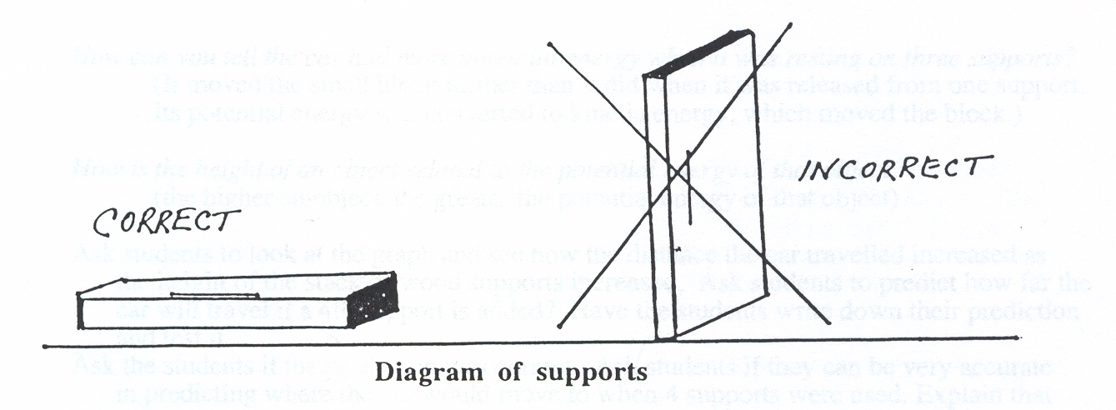

2. Rest the "START” end of the track on the surface of **one** ofthe supports so that the track edge lines up with the line on the block.

3. Place the small block on the track at the "0 cm” mark with the red end of the block even with the line drawn on the track.

4. Hold a ball on the track at the starting point where the track is resting on the block.

5. Release the ball and observe what happens to the block. Measure the distance the block moved from its starting "0 cm” mark.. Make sure that the tape measure starts at the“0" mark, and is pulled out taught, and that the distance is measured to the red end of the block.

6. Record this value on your graph at the 2cm (one support) line by using their pencil to make a small, filled-in circle.

**Trial Run #2**

1. Add another support under the "START” end of the track. Repeat steps 1- 6 from Trial Run #1.

2. Record the distance moved on the graph at the 4cm (two support) line.

**Trial Run #3**

1. Add another support under the "START” end of the track.

2. Repeat steps 1-6 from Trial Run #1.

3. Record the distance moved on the graph at the 6cm (three support) line.

**Investigative Run:** Draw a line through the dots on your graph (you will need to use a ruler or straight edge) and extend the line so that it goes through the “8cm” line. Predict how far the ball will travel if a 4th support is added. Test your prediction.

**B. Potential Energy is related to mass (height held constant)**

Use only 3 wooden supports under the track**.**

**Trial Run #1**

1. Rest the "Start” end of the track on the surface of thethree supports so that the track edge lines up with the line on the block.

2. Place the small block on the track at the "0 cm” mark with the red end of the block even with the line drawn on the track.

3. Hold the **lighter squash ball** on the starting point of the track.

4. Observe what happens to the small block when the ball is released.

5. Measure the distance the small block was moved from its starting point.

6. Record the measurement as a **bar** on your graph at the line that corresponds with the mass of the squash ball.

**Trial Run #2**

1. Use the **heavier** golf ball.

2. Care should be taken that the track rests at the same position as in Trial 1, and that the ball

starts from the same position on the track.

3. Repeat steps 1 - 6 from Trial Run #1.

**V. Review**