VANDERBILT STUDENT VOLUNTEERS FOR SCIENCE
http://studentorgs.vanderbilt.edu/vsvs
Solar Energy and Fuel Cells
Fall 2015

Goal: To become familiar with the solar cell to be used in following investigations, and to gain experience in making scientific observation

I. Introduction
Explain what a solar panel is and how it works
II. Investigation of Solar Energy
A. Why does the angle that light hits a surface matter?
Students shine a light on a piece of paper at different angles and trace the outline of the light, then calculate the area of each to determine the energy density of each.
B. Maximizing the energy coming from the solar panel
Students attach the solar panel to the load measurement box and determine the ideal angle of incidence of the light onto the panel
C. Charging the fuel cell with the solar panel
Students attach the solar panel to the fuel cell to see how long the car will run when charged by the solar panel.

III. Discussion

Students will work in groups of 3’s or 4’s. There are 8 sets of materials, so divide the class into enough groups to use all the materials.

I. Introduction

Individual solar cells convert the radiant energy of sunlight into electricity. The solar panel provided consists of several solar cells connected in series. The panel can generate enough electricity to power the fuel cell car.

Solar cells are examples of useful electrical technology as they can transform the sustainable energy of sunlight into electricity. The light source we will be using in our investigations is an incandescent lamp, but in practical applications sunlight is used. The sun is earth’s nearest star and the sun seems to move across our sky each day. But in fact, the earth travels in an orbit around the sun, spinning (once a day) as it goes. However, we often need electrical power when sunlight is not available, for example at night time. This means that if we want to collect the maximum sunlight with a stationary solar array, we have to place it in the best position to receive the maximum amount of energy available. If a solar cell is connected to an electrolyzer, the radiant energy of the sunlight can be stored as hydrogen and oxygen gas. A fuel cell can use these gases to make electricity when it is needed.

The principle of a solar cell is that it converts a stream of photons (the radiant energy of sunlight) into a stream of electrons (electricity). The conversion or transfer of energy from one form to electricity is the principle behind any electrical generator. Electrical generators include solar panels, diesel or gas engine generators, hydroelectric turbines and fuel cells.

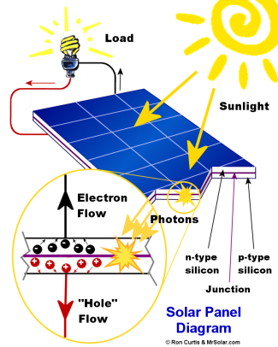

A solar cell contains layers of two types of doped silicon (when small numbers of atoms of other elements have been added to the silicon). Light particles called photons hit the surface and knock electrons free, which then are drawn to the other layer. When a circuit is set up to connect the two types of silicon, electricity will flow through that circuit and power devices.
The flow of electrons is observed as an electric current. As more light is supplied to the solar panel, more photons are available to knock the electrons loose, and more current is generated.

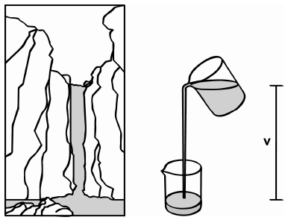
This flow of electrons may be thought of as similar to a waterfall and has two values that are easily measured. One measurement is like the height of the waterfall, which is a fixed value. In electrical units, this is the electric potential, measured in volts. The other measurement is like the amount of water that falls down the waterfall, and allows us to actually do work with the water. In electrical units, this is called the current, measured in amperes (or simply amps). Thousandths of an ampere are called milliamperes, or mA.

II. Investigation of Intensity of Solar Energy
Materials
8 flashlights
16 sheets of paper
8 rulers
8 lamps
8 load measurement boxes
8 sets of patch cables (1 red and 1 black)
8 solar panels
8 solar panel orientation mats
8 angle alignment mats
8 plastic cups
8 plastic plates
1 box with small bottles of distilled water
1 roll of paper towels

Give each group a flashlight, two sheets of paper, and a ruler

A. How does the angle light hits a surface matter?
- Have one student shine the flashlight directly at one of the pieces of paper on the desk. The flashlight should be 6 inches away from the paper, and held directly perpendicular.
- Have a second student draw the outline of the circular spot of light. Then do 12 inches above. Is the size of the circle of light (density of photons) the same or different?
The circle made when the light is farther away will be smaller
- On the second piece of paper, have one student shine the flashlight at the paper at an angle. (ideally 45º, but as long as the outline fits on the paper so it can be traced any angle is ok)
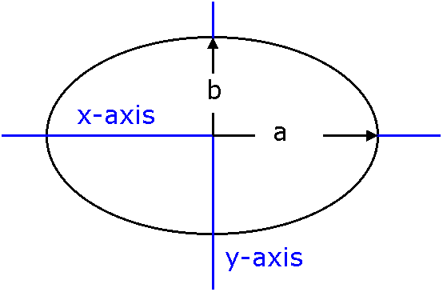
- Trace the outline of the light ellipse on the second piece of paper.
- Have the students calculate the area of the ellipse and the circle
using the following equations:
Ellipse: $A=\left(\frac{π}{4}\right)× a × b$
Circle: $A=π × r^{2}$

A=area, a=width of one axis of the ellipse, b=width of the other axis of the ellipse, r= radius of the circle
- Have students compare the density of photons hitting the circle surface with the density of photons hitting the ellipse surface, assuming that the number of photons coming from the flashlight is the same.
The density is the number of photons per area. Since the number of photons is constant, and since the origin of the photons is the same (same flashlight), the larger the area becomes, the smaller is the density of photons.

Give each group a lamp, a load measurement box, a set of patch cables, a solar panel, a solar panel orientation mat and an angle alignment mat.

B. Maximizing the energy coming from the solar panel

- Have students use the patch cables to connect the solar panel to the load measurement box CURRENT terminals – red to red and black to black.
- Position the light source in front of the solar panel using the provided mat
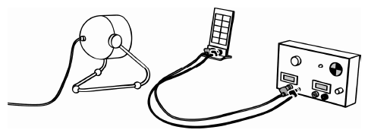
- Turn the selectable LOAD knob on the box to SHORT CIRCUIT, then turn the box on.
- Check if a number appears in the “A” window. If nothing appears, check your connections. If a negative number appears, then you have the connections reversed and should change them.
- Adjust the solar panel so the angle of incidence (the angle that the light hits the panel) is exactly at 0 degrees. This means the panel should face directly toward the light source.
- Turn on the light, and move the light either towards or away from the solar panel until the current shown in the “A” window is between 0.100 and 0.150 amperes.
- Measure and record this distance; students should keep it constant for all measurements
- Write the current displayed in the ammeter into the table on their worksheet.
- Rotate the solar panel so the angle of incidence is exactly 90 degrees from the light source, taking care to keep the center of the solar panel exactly the same as before. Write this value into the table as well.
- Have students adjust the angle of incidence of the solar panel to the remaining marked degrees (25, 50, and 75)
- Record the actual current in the table
- Once all measurements are collected, have students draw a graph to show their findings.
- Make sure students turn off the lamps once finished collecting data to ensure the solar panels have time to cool down.

Give each group a fuel cell, a fuel cell car, a plastic cup, a plastic plate, and a bottle of distilled water.

C. Charging the fuel cell with the solar panel

- Put the fuel cell upside down (number facing down) on the plate placed on a flat surface.
- Remove the stoppers
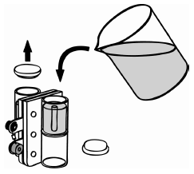
- Pour distilled water into both storage cylinders until the water reaches the tops of the small tubes in the center of the cylinders.
- Tap the fuel cell lightly to help water flow into the area surrounding the membrane and metal current-collecting plates.
- Add more water until it starts to overflow into the tubes in the cylinders.
- Place the stoppers back onto the cylinders. Make sure no air is trapped inside the cylinder. Small air bubbles will cause no problems.
- Turn the fuel cell right side up.
- Make sure the lamp is still positioned correctly on the provided mat so that it is around 10 inches from the lamp, and positioned directly perpendicular to the lamp.
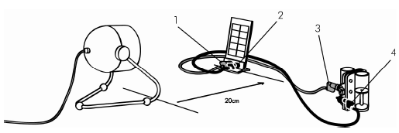
- Connect the red patch cable from the red terminal on the solar panel (1) to the red terminal on the fuel cell (3).
- Connect the black patch cable from the black terminal on the solar panel (2) to the black terminal on the fuel cell (4).
- Have a student get ready with a stopwatch. When ready, have that student start timing while a second student turns on the lamp.
- Allow the fuel cell to charge for 5 minutes. Note down the amount of hydrogen generated in 5 minutes. When the five minutes are up turn off the lamp and disconnect the cables from the solar panel to the fuel cell.
- Carefully attach the charged fuel cell to the fuel cell car. Make sure they do not attach the cables until instructed to do so.
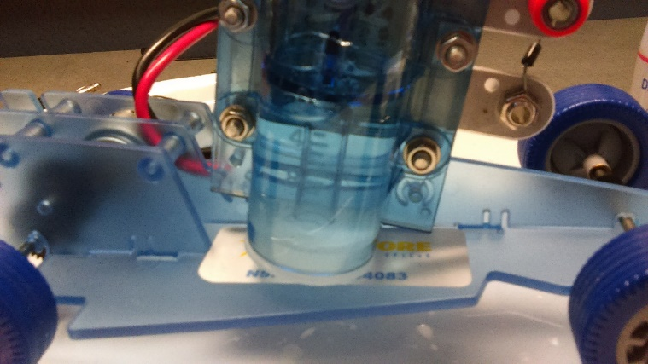
- Place the fuel cell car on a cup. Make sure that the wheels are touching neither the cup not the ground.
- Plug in one of the cables into the fuel cell car, and make sure the stopwatch is ready. Once all is ready, plug in the second cable and begin timing. Make sure to connect the red cable into the red terminal and the black cable into the black terminal
**REMEMBER: The car will begin running as soon as both cables are plugged in to the fuel cell.
- Once the car comes to a stop, stop the stopwatch and record the time.
- Disconnect the cables from the car and reconnect the cables leading to the solar panel.
- Rotate the solar panel so it hits the surface at 50º, and repeat the experiment.
- With this information and the data from section B, predict how long the car will run if charged for 5 minutes at 25º. What about at 75º?
The students will have seen in Part B that the current decreases as the solar panel is rotated from 0º to 90º. They may notice that the curve is not linear. Their guess for 25º should be between 0 and 50, but closer to 0. Their guess for 75 should be less than 50.

III. Discussion
Ask students some or all of the following questions:
- What is an ampere? What is a milliampere?
An ampere is a measurement of electrical current. A milliampere is one one-thousandth of an ampere.
- Is the milliampere a useful measure to see at which angle the solar panel works best?
The milliampere is a useful measurement of the best working angle of the solar panel as it is a small measure suited to the solar cell array and it is sensitive enough to allow us to see how the angle of incidence of the light source affects the current flowing from the solar panel.
- What did you find out about the orientation of the solar panel to the light source?
Students learned that as the light source changed from a low angle of incidence to a higher angle of incidence, the current decreased.
- Why is it important to keep the center of the solar panel exactly at the same distance away from the light source for each different angle? Is this important when using sunlight as a source?
It is important to keep the center of the solar panel exactly the same distance away from the light source for each different angle if we want to compare all the results. When we use sunlight as the light source, the sun is so far away from the solar panel that the additional distance on this end is insignificant.
- How did your prediction for the 10-degree angle compare to the actual result? How did you adjust your predictions for the other angles? Did they become more accurate as a result of your actual measurements?
The prediction for the 10-degree angle was (likely) different from the actual result. Students likely presumed there would be a larger difference between 0 and 10 degrees. The differences between each measurement grew larger as the angle of incidence increased so I increased the differences each time.
- With your graph, could you make a fairly accurate prediction of the current for 25 degrees or 75 degrees? Is there any way to check your predictions for those angles?
The predictions could be checked by actually taking the measurements
- Will the rate of electrical energy production be the same for every day of the year? Why or why not? How could this be planned for? Would the solution necessarily be practical?
The rate of electrical energy production will not be the same for every day of the year because of the weather or time of the year. Students could make a motorized mount for a solar panel that would automatically track the sun wherever it is or find the brightest spot in an overcast sky. It might be too expensive to set it up this way and might present more problems or things that could go wrong.
- How can we maximize the electrical power coming from the solar panel?
We can maximize the electrical energy coming from the solar cell if it is positioned correctly.

VANDERBILT STUDENT VOLUNTEERS FOR SCIENCE
http://studentorgs.vanderbilt.edu/vsvs
Solar Energy Investigation Worksheet

Part A:
Hold the flashlight 4 cm above the paper. Trace the outline of circular spot. Calculate the area of the light circle from directly 4cm above paper
$$A=π × r^{2}$$
Use $π$ =3.142
r = _______

A= 3.142 x ______ = ____________

Keep the light 4cm above the paper and tilt the flashlight to an angle (About 45º). Trace the outline of elliptical spot.
Calculate the area of the light ellipse:
$A=\left(\frac{π}{4}\right)× a × b$ a = _________ b = ________
Use $\left(\frac{π}{4}\right)=$3.142/4 = 0.785

A – 3.142 x _____ x______ = ___________

Part B and C:

Angle of Incidence  (degrees) | Current  (mA) | Time car runs after 5 min charge
0
25
50
75
90

Place lamp here
Place the origin of the angle mat on the red X
Do not place solar panel closer than 8 inches to the lamp!
Keep solar panel behind this line

