VANDERBILT STUDENT VOLUNTEERS FOR SCIENCE
http://studentorgs.vanderbilt.edu/vsvs
Endothermic/Exothermic Reactions
Fall 2016
Goal: To help students understand endothermic and exothermic processes.
TN Curriculum Alignment: GLE 0807.9.3 Interpret data from an investigation to differentiate between physical and chemical changes.

Lesson Outline:
I. Introduction
Define endothermic (heat absorbed) and exothermic (heat given off). Students will study examples of both chemical and physical changes that are endothermic or exothermic.
II. Endothermic Processes
Students learn about endothermic processes by adding ammonium nitrate to water and adding sodium bicarbonate solid to citric acid solution.
III. Exothermic Chemical Processes
A. Setting up the HotHands hand warmer – Activity started by students. To be left aside and returned to in part C.
B. Anhydrous calcium chloride mixed with water –Activity done by students. Anhydrous calcium chloride absorbs water to become hydrated calcium chloride, which then dissolves in water.
C. Demonstrate how reactions happen using molecular models. Use the diagrams passed out to class to further explain why some reactions are endothermic or exothermic.
D. Checking the HotHands Hand Warmer – Students make observations. VSVS members explain the chemistry behind the exothermic process.
IV. Review
Materials:
1 box containing 36 goggles
16 plates
16 stirrers
16 yellow spoons
16 white taster spoons
16 thermometers
16 test tube racks (in separate box)
48 test tubes
8 4 oz containers of ammonium nitrate
8 4 oz containers of calcium chloride
8 4oz containers of sodium bicarbonate
16 2oz bottles citric acid solution (10 gm per 100 mL)
1 cold pack
8 250 ml water bottles
1 Ziploc bag containing:
1 4 oz bottle for a HotHands hand warmer that will be cut open in Part IVC.
1 scissors to cut open HotHands hand warmer
1 4 oz bottle containing contents of hand warmer that has been open for 24 hours
8 chemical hand warmers (HotHands)
1 trash bag
1 large funnel
1 waste container
1 set of molecular models
32 observation sheets
16 instruction sheets in sheet protectors

Note: One team member should put the following vocabulary words on the board:
endothermic, exothermic,, ammonium nitrate, , calcium chloride

Divide students into pairs.
For Part I. Introduction
32 observation sheets, 16 instruction sheets in sheet protectors
For Part II. Endothermic Processes
- Endothermic Experiment – Dissolving Ammonium Nitrate in Water
1 cold pack
16 test tube racks, containing 3 test tubes, 16 thermometers, 8 4 oz jars of ammonium nitrate, 8 yellow plastic scoops (shared by pairs) , 8 water bottles (shared by pairs)
1 paper towel
Goggles for ALL
1 set of molecular models

- Endothermic Experiment #2– Reacting Sodium Bicarbonate with Citric Acid
16 clean test tubes in test tube rack from above, 16 thermometers (from above)
16 white taster spoons 16 2oz bottles citric acid solution
8 jars sodium bicarbonate
For Part III. Exothermic Reactions
A. Chemical (HotHands) Hand Warmer
8 HotHands hand warmers
1 ziploc bag containing:
1 4 oz bottle with 1 HotHands hand warmer (to be cut open)
1 pair of scissors to cut open HotHands hand warmer
1 4 oz bottle containing contents of hand warmer exposed to air for 24 hours

B. Anhydrous Calcium Chloride mixed with water
16 new test tubes in test tube rack, 16 thermometers (from above)
8 4 oz jars of anhydrous calcium chloride (shared by pairs), 16 scoops (yellow) , 16 water bottles
I. Introduction
Share the following explanation of endothermic and exothermic processes with students:
- Tell students that the word “exothermic” describes processes that give off heat.
“Ex” indicates “out of” or “giving off”, for example, exit, exhale (to breathe out), and exodus.
“Thermic” indicates heat.
- “Endothermic”, the opposite, is used for processes that absorb heat.
“En” means “in”, such as “entrance,
In all reactions, energy must be supplied to break bonds and energy is released when bonds are formed.
Tell students to look at the energy level diagrams:
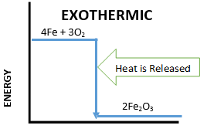
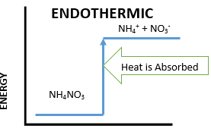

In an exothermic reaction, the energy released from forming new bonds is greater than the energy needed to break existing bonds.
Exothermic reactions usually feel hot .
The example shown is for rusting of iron to iron oxide (rust). Students will do this experiment
with the HotHands warmer.

In an endothermic reaction the energy needed to break existing bonds is greater than the energy released from forming new bonds.
Endothermic reactions usually feel cold.
The example shown is for dissolving ammonium nitrate in water, Students will do this experiment as well as be shown a cold pack that uses ammonium nitrate.
II. Endothermic Processes
Materials: GOGGLES for ALL
1 cold pack
16 test tube racks, containing 3 test tubes
16 thermometers
8 4 oz jars of ammonium nitrate
8 yellow plastic scoops (shared by pairs)
8 water bottles (shared by pairs)
1 paper towel
32 observation sheets
16 instruction sheets in sheet protectors
Examples are:
  - Melting ice to water and boiling water to water vapor.
Some curious students may find it difficult to understand why ice melting is an endothermic reaction, because it seems that absorbing energy should make things hotter. But when you hold a piece of ice on your hand, the ice melts because it is absorbing heat from your hand. As a result, your hand gets colder.
  - Dissolving solids in liquids, such as salt in water.
  - An important endothermic process is sweating. It helps maintain our body temperature at normal by cooling us because the evaporation of water from our skin absorbs excess heat from our skin.
  - Photosynthesis is an excellent example of an endothermic chemical reaction where light energy is supplied by the sun.

- Endothermic Experiment – Dissolving Ammonium Nitrate in Water
- Ask students if they know what a cold pack is? When is it used?
It is a product that is used to treat muscle sprains or minor injuries.
- Show the students a cold pack. Activate it (by squeezing it) and pass it around the room for the students to feel. (Make sure it is returned to the VSVS lab.)
- Share the following information with the students:
Some cold packs use the chemical ammonium nitrate. There is a plastic bag of water and a plastic bag of ammonium nitrate inside the cold pack. The cold pack is activated by breaking the plastic divider (done by squeezing the pack) between the water and ammonium nitrate, causing them to mix. When ammonium nitrate dissolves in water, heat is absorbed and the packet feels cold as heat is lost.
In this next activity the temperature change will be measured for the process of dissolving ammonium nitrate in water.

Safety Note: Ammonium nitrate solution is a skin irritant and causes a burning sensation. It is toxic by ingestion and inhalation and is a skin, eye and respiratory irritant.

- In this experiment, ammonium nitrate is dissolved in water, and thermal energy from the water is absorbed. The temperature change will be measured to show that thermal energy is used.
- Background: When dissolving a solid in a liquid, energy is required to break the bonds that hold the solid together. This energy is supplied by thermal energy from the liquid, and thus when most solids dissolve, the temperature of the liquid drops.
- Ask students how they will be able to tell if thermal energy is being used. The temperature will decrease.
Give each pair the following:
1 test tube rack containing 3 test tubes
1 plate
1 stirrer
1 thermometer
1 water bottle
1 scoop (yellow)
2 observation sheets
1 instruction sheet in a protector
2 pair goggles
Distribute the 8 ammonium nitrate jars and 8 yellow scoops so that two pairs of students can share them.

Tell each pair to:
  - Fill the test tubes to the mark with water.
  - Place the thermometer in the water.
  - Record the temperature of the water on the observation sheet. Use the Celsius scale.
  - Remove the thermometer.
  - Add 2 scoops of ammonium nitrate to the test tube.
  - Stir with a plastic stirrer until the solid is mostly dissolved (there can be a little solid left in the bottom).
  - Put the thermometer back into the test tube and record the lowest temperature reached.
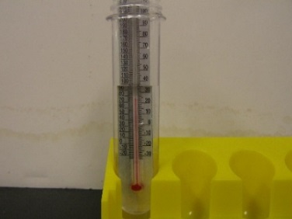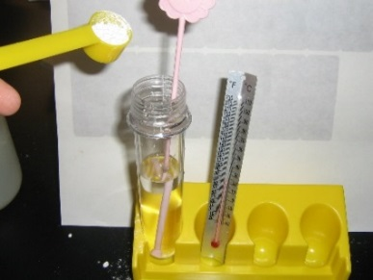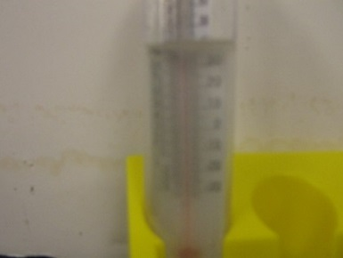
Ask students what temperature difference they observed.
Write some values on the board. (Students should observe a decrease of close to 10 degrees).
Ask students: Is this an exothermic or endothermic process? Endothermic because the temperature decreased.

Explaining Dissolving at a Molecular Level
Ask students: What is happening when you dissolve ammonium nitrate?
Dissolving the ammonium nitrate separates it into ions.
Tell students to refer to the energy diagram on their Handout.
Have students look at the diagram of NaCl (salt) solid dissolving in water.
Explain that energy is needed to break the bonds in the NaCl solid salt molecule to form Na⁺ and Cl⁻ ions.
Similarly, ammonium nitrate absorbs energy from the water to use as dissolving energy.
This causes the temperature of the water to decrease.
Show students the ammonium nitrate model.
When the ammonium nitrate dissolves in water, it breaks into two separate ions.
NH₄NO₃ _{(s)} → NH₄⁺ _{(aq)} + NO₃⁻ _{(aq)}
Energy is needed to break bonds.
Pull apart the model and explain that we needed energy to do this.

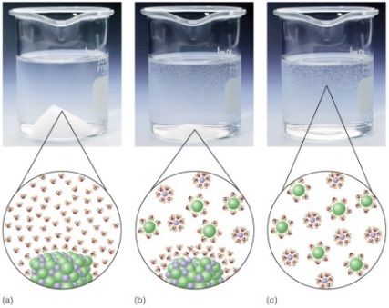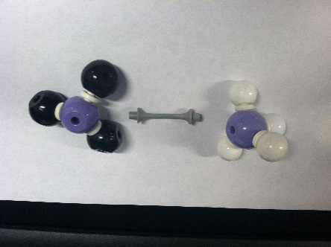

Disposal: Pour the solutions from the test tubes into the sink or the waste bottle provided, or tell students to securely screw the lids onto the test tubes and return to the VSVS lab. MAKE SURE THAT NO LIQUIDS CAN LEAK – PLEASE.

Endothermic Experiment #2– Reacting Sodium Bicarbonate with Citric Acid
Materials
16 clean test tubes in test tube rack
16 thermometers (from above)
16 white taster spoons 16 2oz bottles citric acid solution
8 jars sodium bicarbonate
Tell each pair to:
- Wipe the thermometer dry with a paper towel.
- Pour the citric acid from the bottle into the test tube.
2. Place the thermometer in the liquid.
3. Record the temperature on the observation sheet.
- Add 1 white taster spoon of sodium bicarbonate to the test tube.
- When the bubbles have stopped, add another taster spoon of sodium bicarbonate.
- Record the temperature reading reached. This will take a few minutes. (Students should observe a decrease of about 4 degrees C )
Ask students: Is this an exothermic or endothermic process? Endothermic because the temperature decreased.
In the presence of water, citric acid [C₆H₈O₇] and sodium bicarbonate [NaHCO₃] (aka baking soda) react to form sodium citrate [Na₃C₆H₅O₇], water, and carbon dioxide [CO₂].

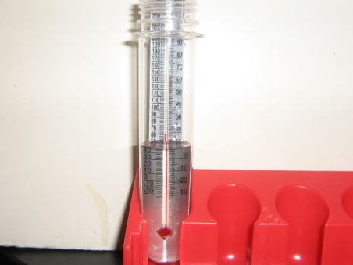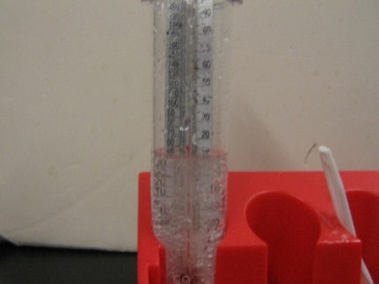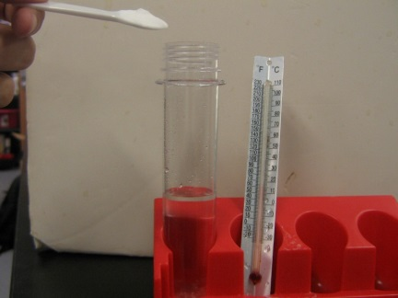
III. Exothermic Reactions
Materials
16 new test tubes in test tube rack
16 thermometers (from above)
8 4 oz jars of anhydrous calcium chloride (shared by pairs)
16 scoops (yellow)
16 water bottles
8 HotHands hand warmers
1 ziploc bag containing:
1 4 oz bottle with 1 HotHands hand warmer (to be cut open)
1 pair of scissors to cut open HotHands hand warmer
1 4 oz bottle containing contents of hand warmer exposed to air for 24 hours

Tell students to refer to the Energy diagram on their handout.
Remind them that FORMING a chemical bond releases energy and is therefore exothermic.

Liquid water freezing to ice releases heat – it is exothermic.
An example of an application of this is the practice of spraying water on fruit trees in northern Florida when a light freeze is expected. The water freezes on the fruit, and in the process, releases enough heat to keep the fruit from freezing.
Burning natural gas (like propane) to heat homes is another example of an exothermic chemical change.

Exothermic Experiments:
A. Chemical (HotHands) Hand Warmer
- Distribute the 8 HotHands hand warmers to every other pair and tell students to share among two pairs.
- Have one of the students tear open the plastic covering, have the group members feel the hand warmer and note that it is at room temperature.
- A group member should shake it, and put it aside.

Note: The directions on the plastic covering suggest waiting 30 minutes, but students will be able to feel warmth from the hand warmer after about ten minutes.
Have students go on to Part B while they are waiting for the handwarmers to get warm.

B. Anhydrous Calcium Chloride mixed with water
Distribute 8 4-oz anhydrous calcium chloride jars with 8 yellow plastic spoons so they can be shared by two pairs.
Tell each pair to:
1. Fill the test tubes to the mark with water.
2. Place the thermometer in the water.
3. Record the temperature of the water on the observation sheet.
4. Remove the thermometer.
5. Add 1 scoop of anhydrous calcium chloride to the test tube.
6. Stir carefully with the plastic stirrer.
- Put the thermometer back into the test tube and record the highest temperature reached.
Students should observe an increase of 10-20º C

Ask students: Is this an exothermic or endothermic process? Exothermic because heat is given off.

Earlier we said that it takes energy to dissolve molecules, so why does water heat up when we add CaCl₂ to it? The calcium molecule is special, because it forms a strong bond with the water.

We are going to demonstrate this phenomenon using our molecular models. Take the molecule out of the bag labelled calcium chloride.
Break apart the calcium chloride molecule. Energy is needed to break the molecule apart to dissolving it.

Now make the molecule with a calcium ion and 2 water molecules. Forming bonds creates energy. There is more energy created than used, and this causes the temperature of the water to increase.
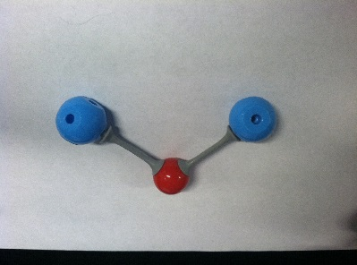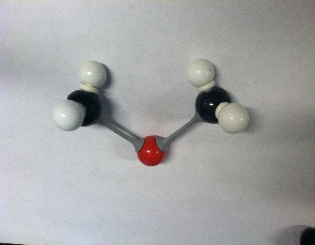

Disposal: Put the screw lid on the test tube or pour the solutions from the test tubes into the waste bottle provided. Waste solutions can be poured down the sink at the school.

Tell students that anhydrous calcium chloride is used to salt roads in the winter. Calcium chloride is better than sodium chloride for three reasons:
(1) calcium chloride gives off heat when it mixes with water
(2) calcium chloride absorbs water to become hydrated calcium chloride - this removes the water so that there is less available to re-freeze
Ingredients in “HotHands”
Iron Powder
Water
Salt
Activated Charcoal
Vermiculite

C. Checking the HotHands Hand Warmer
- Have the students feel the hand warmer. (It should feel warm.)
- Have students look at their observation sheet to read the list of ingredients in the Hothands warmer.
- Tell the class that the “missing ingredient” that is needed to make the hand warmer warm up is oxygen. When the plastic covering is removed, the inside pouch is porous enough to allow air to enter the pouch. The oxygen in air reacts with iron to form iron oxide with the release of heat. This is the common reaction called RUSTING.
- Ask students if this is an example of an endothermic or exothermic process? Exothermic, heat is released
- Take the empty 4 oz jar, cut open a hand warmer pouch and pour the contents inside the
jar. Show the students this jar and compare what the contents look like with the jar that contains contents of a HotHands hand warmer that were exposed to air for 24 hours.
- (In the 24-hour jar, the black color of iron powder has changed to a brownish, somewhat clumpy solid, which is iron oxide. The change in color and characteristics of the solid are evidence for a chemical change.)
Background Information: The HotHands hand warmer is an exothermic chemical reaction that occurs when powdered iron is mixed with activated carbon, water, salt, and vermiculite in the presence of air. This involves the quick formation of iron oxide (activated carbon catalyzes the reaction). The same reaction (iron + oxygen + water in the presence of salt) is the corrosion (rusting) process, but it happens much more slowly.

- The Hothands handwarmer can be left in the classroom with the teacher or the students, returned to the VSVS lab or kept by the VSVS members.

IV. Review:
- Be sure to go over the answers carefully. Students will not likely have correct responses for the last row so it is important that you discuss these and ask them to write the correct answers on their observation sheet. See answer sheet on next page.
Lesson written by: Dr. Melvin Joesten, Professor Emeritus, Vanderbilt University
Pat Tellinghuisen, Program Coordinator of VSVS, Vanderbilt Universit

Endothermic and Exothermic Processes - Instruction Sheet
I. Introduction - Look at the Energy Diagrams on your Handout.
Put on your goggles and keep them on throughout the lesson.
II. Endothermic Experiment #1 – Dissolving Ammonium Nitrate in Water
Put a test tube in the rack.
  - Fill the test tubes to the mark with water.
  - Place the thermometer in the water.
  - Record the temperature of the water on the observation sheet. Use the Celsius scale.
  - Remove the thermometer
  - Add 2 scoops (yellow) of ammonium nitrate to the test tube.
  - Stir with a plastic stirrer until the solid is mostly dissolved (there can be a little solid left in the bottom).
  - Put the thermometer back into the test tube and record the temperature.

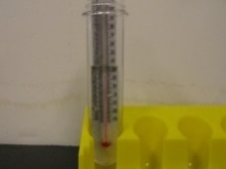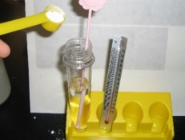
Look at the diagram of NaCl (salt) solid dissolving in water. Energy is needed to break the bonds in the NaCl solid salt molecule to form Na⁺ and Cl⁻ ions.

Endothermic Experiment #2– Reacting Sodium Bicarbonate with Citric Acid
- Put a clean test tube in the rack.
- Wipe the thermometer dry with a paper towel.
- Pour the citric acid from the bottle into the test tube.
- Place the thermometer in the liquid.
- Record the temperature on the observation sheet.
- Add 1 white “taster spoon” of sodium bicarbonate to the test tube.
- When the bubbles have stopped, add another taster spoon of sodium bicarbonate.
- Record the temperature reading reached. This will take a few minutes.
Is this an exothermic or endothermic process?
III. Exothermic Reactions
- Recyclable Hand Warmer – share with another pair
- When instructed to do so, tear open the plastic covering, take out the hand warmer, shake it, and put it aside until after you do part B.
B. Anhydrous calcium chloride mixed with water
- Put a clean test tube in the rack.
- Fill the test tubes to the mark with water.
- Place the thermometer in the water.
- Record the temperature of the water on the observation sheet.
- Remove the thermometer.
- Add 1 scoop of anhydrous calcium chloride to the test tube.
- Stir carefully with the plastic stirrer.
- Put the thermometer back into the test tube and record the highest temperature reached.
Is this an exothermic or endothermic process?
C. Checking the HotHands Hand Warmer
- Feel the hand warmer.
- Record your observations on the observation sheet.
- The VSVS team will cut open a HotHands hand warmer and pour the contents into a jar. Observe this jar and the jar that contains contents left in open air for 24 hours. Record your observations about these contents on the Observation Sheet.
Is this an example of an endothermic or exothermic process?

Endothermic/Exothermic Handout

In an endothermic reaction energy is needed In an exothermic reaction, energy is released
to break existing bonds . from forming new bonds.

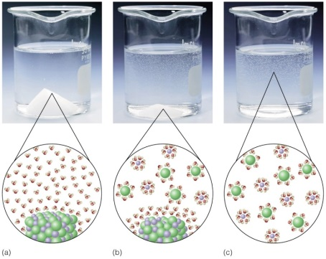
Energy is needed to break the bonds in the solid salt molecule (NaCl) to form Na⁺ and Cl⁻ ions. This causes the temperature of the water to decrease. Similarly, ammonium nitrate absorbs energy from the water to use as dissolving energy.
Dissolving Ammonia
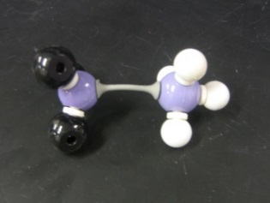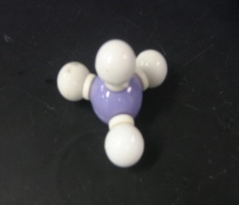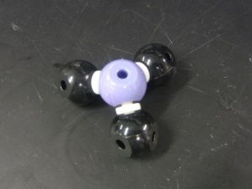
NH₄NO₃ _{(s)} → NH₄⁺ _{(aq)} + NO₃⁻ _{(aq)}
When the ammonium nitrate dissolves in water, it breaks into two separate ions. Energy is needed to break bonds.
Calcium Chloride in Water
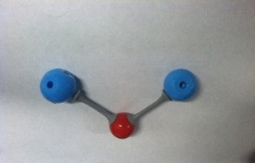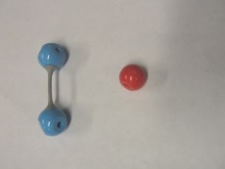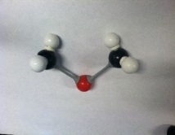
Forming bonds creates energy. There is more energy created than used, and this causes the temperature of the water to increase.
Ingredients in “HotHands” Iron Powder, Water, Salt, Activated Charcoal, Vermiculite
ENDOTHERMIC/EXOTHERMIC OBSERVATION SHEET

NAMES _____________________________________________________________________

Vocabulary words:
endothermic ammonium nitrate sodium bicarbonate citric acid
exothermic calcium chloride Hot Hands

Ingredients in chemical hand warmer (Hot Hands): Iron, activated carbon, water, salt, and vermiculite.

 | Ammonium Nitrate added to water | Sodium Bicarbonate added to Citric Acid | Calcium Chloride added to water | Hot Hands
Temperature of liquid |  |  |  | X
Temperature of liquid + chemical |  |  |  | X
Temperature change
Did it get hotter or colder?
Is it Endothermic or Exothermic?
Why? (Circle answer) | Bonds are being broken – energy is used.  Bonds are broken and then formed – more energy is created than used.  Bonds are being formed – energy is created. | Bonds are being broken – energy is used.  Bonds are broken and then formed – more energy is created than used.  Bonds are being formed – energy is created. | Bonds are being broken – energy is used.  Bonds are broken and then formed – more energy is created than used.  Bonds are being formed – energy is created. | Bonds are being broken – energy is used.  Bonds are broken and then formed – more energy is created than used.  Bonds are being formed – energy is created.

ENDOTHERMIC/EXOTHERMIC OBSERVATION SHEET

NAMES _____________________________________________________________________

Vocabulary words:
endothermic ammonium nitrate sodium bicarbonate citric acid
exothermic calcium chloride Hot Hands

Ingredients in chemical hand warmer (Hot Hands): Iron, activated carbon, water, salt, and vermiculite.

 | Ammonium Nitrate added to water | Sodium Bicarbonate added to Citric Acid | Calcium Chloride added to water | Hot Hands
Temperature of liquid | 22 ºC | 22 ºC | 22 ºC | X
Temperature of liquid + chemical | 11 ºC | 18 ºC | 37 ºC or more | X
Temperature change | About -11 ºC | About -4 ºC | About +15 ºC or more | Got warmer
Did it get hotter or colder? | Colder | Colder | Hotter | Hotter
Is it Endothermic or Exothermic? | Endothermic | Endothermic | Exothermic | Exothermic
Why? (Circle answer) | Bonds are being broken – energy is used. | Bonds are being broken – energy is used. | Bonds are broken and then formed – more energy is created than used. | Bonds are being formed – energy is created.

