VANDERBILT STUDENT VOLUNTEERS FOR SCIENCE
http://studentorgs.vanderbilt.edu/vsvs
CATCHING COUNTERFEITERS
Spring 2005

GOAL: To demonstrate how some scientific techniques are used in finding counterfeit money and fraudulent checks.

MATERIALS
2 sample checks per group (16 total)
8 small Petri dishes
8 bottles (water can be added at school/afterschool site)
8 hand lenses
8 counterfeit detecting pens
2 blacklights
2 laminated 5-dollar bills
8 mounted sections of 1-dollar bills
8 fake 5-dollar bills
8 fake 1-dollar bills
3 10 oz. clear cups
blue food coloring
yellow food coloring

I. Introduction

Students may have watched the show “CSI” (or any of its spin-offs) on television and seen how forensic science is very useful in investigating crimes. This type of analysis, using other scientific methods and tools, can also be used to identify fake checks and fake money. Students will use chromatography to determine whether or not a check has been altered and will use detection tools such as iodine and UV light to determine whether a bill is real.

Form the class into groups with 3 or 4 students in each group.

I. Detecting counterfeit money

Background
Counterfeiting money is a large crime in the United States. The ability to counterfeit money has been improved by the development of more sophisticated computers, scanners and printers that can reproduce minute details of various documents. However, the US government tries to stay ahead of the counterfeiters by adding special features to the bills to establish their legitimacy.

The Story
A student that you have not seen before comes up to you and says that he would like to buy your notebook. He offers you six dollars for it. Since you’re not using the notebook and it’s worth much less than six dollars, you sell it to him. However, after he leaves and you look more closely at the bills that he has given you, you notice that they just do not feel like normal bills, even though it certainly looks like one. How can you tell if these bills are counterfeit?

Pass out the comparison sheets with the sections of real and copied five-dollar bills, as well as UV lights and hand lenses.

Examining the Bills
Ask the students to use their hand lenses to compare the different five-dollar bills. Are they able to see any differences?

Students may be able to see differences in colored threads that run through the bills, as well as the different texture of the bills.

Ask the students if they know of any other things added to bills that help to distinguish them from fake ones.

Tell students that all five-dollar and higher denomination bills contain various security features and design features that make it extremely difficult for counterfeiters to copy. Examples include special inks that can change color depending on how you view them. This ink is used in the “20” that is found on the lower-right hand corner of twenty-dollar bills.

Have the students look closely at the real five-dollar bill and hold it to the light at different angles. They should be able to see the watermark: a portrait of Lincoln on the front, right side of the bill. Tell them to write what they observe on the comparison sheet.

Tell the students that another new security feature added to bills is a fluorescent strip. Pass out the UV lights and tell the students to turn it on and try to find the fluorescent strip on the real bill. On the five-dollar bills, the strip can be found on the left side of the bill, about 1-2 inches from the left edge. Ten, twenty, fifty and one hundred dollar bills also have these strips; each denomination fluoresces a different color under UV light. If the students look very carefully, they can also see “USA” printed on these fluorescent bands. Tell the students to write down what they observe on their comparison sheets.

Pass out the hand lenses. Tell the students to compare the various lines on the real and fake five-dollar bills. One thing they may notice is that the lines found on the real five-dollar bill are sharper than those on the fake one. They may also see more detail in the portraits when using the hand lenses. Tell the students to write down what they observe on their comparison sheets.

Collect the blacklights and five-dollar bills. Pass out the real and fake one-dollar bills and the counterfeit detection pens.

Next, ask the students if they have ever seen a salesperson at a store in the mall try to determine whether cash is real or not. The pen that is used for that purpose contains iodine. Iodine is normally a yellowish color, but when it comes into contact with starch, it turns black. Regular papers contain starch, but the paper used in making money does not. Thus, marking the bill with an iodine pen will give a yellowish mark, but marking a counterfeit bill will give a black mark.
Pass out counterfeit detecting pens to each group and ask them to make a small mark on each of the bill samples to try to determine which of the bills is fake. Have them circle the correct answer on the comparison sheet.

Optional information: Paper used for making money is made of 75% cotton and 25% linen. This is why money does not disintegrate when it is accidentally washed in a washing machine. “Normal” paper on the other hand easily breaks apart in the presence of water and detergent.

II. Check Fraud and Chromatography
(Determine whether the students have participated in a VSVS chromatography lesson in the past. If so, you may want to skip this demonstration.)

A. MIXING COLORS
Materials
1 bottle of water
Bag #1 containing
1 bottle blue food coloring
1 bottle yellow food coloring
2 plastic spoons
3 10 oz. clear plastic cups
• Fill 2 of the 10 oz. cups half full of water.
• Add 2 drops of yellow food coloring to the water in one cup and stir.
• Add 2 drops of blue food coloring to the water in the second cup and stir.
• Hold the cups up so the students can see them.

Ask the students: What color do you get when you mix blue and yellow?
• Tell students to watch as you hold the glass of yellow liquid directly behind and about 1/3 higher than the cup of blue liquid. (Students should be able to see all three colors.)
Ask the students: What color is the liquid in the middle?
It should appear that the liquid in the middle of the glass is green.
Ask: "What will happen if you pour some of both liquids into a third glass?”
Accept responses.
• Pour 1/3 of the blue liquid and 1/3 of the yellow liquid into the third cup and show
students that the mixture of the blue and yellow liquids makes a green liquid.
• Tell students that mixing blue and yellow to make green is something easy to do;
something they already know.
• Tell students that what we want to discover is a way to separate mixtures of colors
and other mixtures of chemicals.

B. WHAT IS CHROMATOGRAPHY?
Explain to the students that chromatography is a process for separating mixtures. In today’s lesson paper chromatography will be used to separate water-soluble inks into their different colors. They will apply the process of chromatography to the practical topic of discovering check fraud.

C. THE SCENE OF THE CRIME

Background
Check fraud can include fake checks, stolen checks or altered checks. This activity will show how chromatography can detect whether or not a check has been altered using different pens. Checks may be altered by adding extra numbers or words (eight hundred instead of eight, for example) using a pen with similar ink color. However, the ink from the “fraudulent” pen may still be chemically different from the ink of the pen originally used to write the check. By using chromatography, the chemical components of the two inks can be separated into colored patterns, which can then be compared.

The Story
Mrs. P. Tellinghuisen received a call from her bank asking about a large purchase of Girl Scout cookies that she had made. Mrs. Tellinghuisen replied that she had purchased 3 boxes of Girl Scout cookies for $8.00, for which she wrote out a check. The manager at VSVS Bank said that she was holding a check for $800.00, which seemed like a large number for Girl Scout cookies. Mrs. Tellinghuisen immediately called the police to investigate.
Your job is to determine whether the check that was written by Mrs. Tellinghuisen has been altered, or if Mrs. Tellinghuisen is not telling the whole truth. Mrs. Tellinghuisen has also provided you with another check that she had written at about the same time she wrote out the check for Girl Scout cookies.
How are you going to tell whether the check has been altered or not?

Investigating Ink
Ask students to use their hand lenses to try to determine whether there are visible differences within the altered check (i.e., are some of the words a bit darker than the others?). Ask students to say what they think is different and compare it to the “reference check”, the check that is definitely from Mrs. Tellinghuisen.

The students may or may not be able to tell any differences in the ink. Remind the students that in order to definitely prove that the check was altered, they will need more evidence to support their hypothesis.

Chromatographic Analysis
Distribute the “Reference” and “Evidence” checks to each group, along with a bottle of water and a small Petri dish.

Ask the students how they can use the materials to determine whether the “Evidence” check has been altered.

- Tell the students to pour some water into their Petri dish (about one-third of the way up).
- Tell students to carefully roll the checks so that they can fit into the Petri dish. The water should be touching the bottom of the check, but the rest of the check must remain dry as the water travels!
- Tell students to carefully watch what happens to the ink when the water travels up through the written areas of the check.

After the water has traveled through at least one half of the check, ask the students if they notice anything strange about the evidence check. The evidence check has a different pattern of colors that are traveling up the check with the absorbed water.

The “Evidence” check has indeed been altered—someone has added two zeroes and the word “hundred” to the check so that it now seems like the check has been made out for $800.00 instead of $8.00. Examining the checks with hand lenses may have suggested that there was a different type of ink used on the check, separation of the inks into different colors using chromatography definitely shows that this has happened.

Lesson Written by Joe Lopez, Ph.D., VSVS and Vanderbilt CSO
References: http://www.coreknowledge.org/CKproto2/resrcs/lessons/599Sherlock.pdf
Diane Nutbrown, University of Wisconsin
Bureau of Engraving and Printing, www.usatodayfoundation.com
MAKING CHECKS FOR
CATCHING COUNTERFEITERS LESSON

1. The template for the checks can be found in the “Spring 2005 Training Presentations” folder on Pat’s computer.

2. Cut out 8.5” x 11” pieces of filter paper. They do not have to be exact, but they do have to fit in the laser printer feed tray.

3. Insert one piece of cut filter paper in the feed tray (the flip-down section on the front of the printer and print out a sheet of “checks.” Do not load more than one piece of filter paper at a time—this may cause a paper jam and the printer will catch on fire (okay, maybe not).

4. About 5 sheets of checks should be sufficient for a few lessons. You may want to make more to have extras on hand.

5. Cut out all checks.

6. Using the MM pen from the Chromatography kit, fill out ALL the checks as shown below:

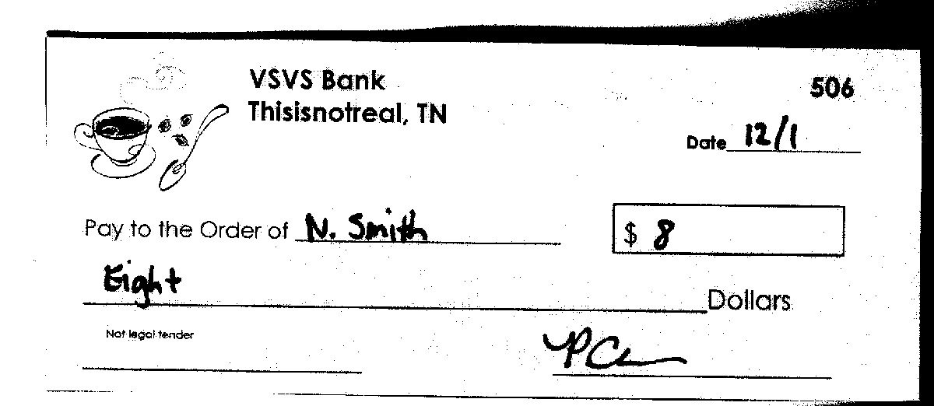

7. Using the PC pen from the Chromatography kit, take HALF of the checks and add “00” in the box with the dollar sign and add “hundred” to the “dollars” line. See below for example.

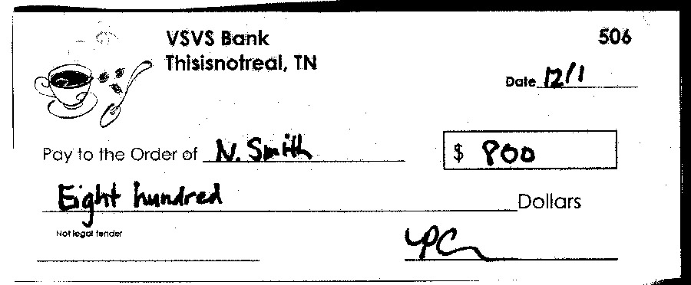

8. Separate the “altered” checks from the “control” checks into their respective bags.
CATCHING COUNTERFEITERS
COMPARISON SHEET

 | Real 5-dollar bill | Fake 5-dollar bill
Is there a fluorescent strip? What do you observe about it?
Is there a watermark? What do you see?
How do the printed lines look?

Counterfeit-detecting pen test

When you make a mark on each one-dollar bill using the counterfeit-detecting pen, what color is the mark? (Circle your answer)

Real one-dollar bill: Light brown mark Dark black mark

Fake one-dollar bill: Light brown mark Dark black mark

CATCHING COUNTERFEITERS
ANSWER SHEET
 | Real 5-dollar bill | Fake 5-dollar bill
Is there a fluorescent strip? What do you observe about it? | YES  It fluoresces blue and has USA written on it. | NO
Is there a watermark? What do you see? | YES  It is a picture of President Lincoln. | NO
How do the printed lines look? | Sharp  (answers will vary) | Fuzzy  (answers will vary)

Counterfeit-detecting pen test

When you make a mark on each one-dollar bill using the counterfeit-detecting pen, what color is the mark? (Circle your answer)

Real one-dollar bill: Light brown mark Dark black mark

Fake one-dollar bill: Light brown mark Dark black mark

