VANDERBILT STUDENT VOLUNTEERS FOR SCIENCE
http://studentorgs.vanderbilt.edu/vsvs

Electromagnetism
(4th/6th grade version)
Fall 2012

GOAL: For students to observe properties of an electromagnet and build their own.

LESSON OUTLINE
- What is an electromagnet? Students observe properties of the electromagnet and
Compare them to the bar magnet
- Magnetic Fields Students observe magnetic field of electromagnet and
compare it to that of the bar magnet
- Magnet Magic Use properties of magnets to perform “magic”
- Building Electromagnet Students use a screw and wire to build their own
electromagnet and test it.
MATERIALS
Note: Be sure you have all of the materials before you leave the lab
15 electromagnetism kits each containing:
1 circuit grid
1 electromagnet
1 bar magnet
1 press switch
1 black jumper wire
1 red jumper wire
1 AA battery holder
3 AA batteries
1 mini bag containing:
1 iron core rod
1 thin rod
3 paper clips, 1 with string attached
15 electromagnet kits containing:
1 Small Plastic bag containing:
2 D Batteries
1 Small Plastic bag containing:
10 Paper Clips
2 D Battery Holders
1 Grooved screw
2 Alligator Clips
1 Piece of Wire
1 bag with several loose staples, extra batteries, extra paper clips
32 observation Sheets
- What is an electromagnet?
Ask students if they know what an electromagnet is and accept answers. Explain that an electromagnet is a magnet that works only when an electric current passes through it (when it is connected to a battery).
Experiment:
- Divide students into groups of 3 and give each group one electromagnetism kit.
- Have students connect battery holder, switch, and electromagnet using black and red jumper wires and insert iron core rod into the center of the electromagnet.
- With the switch pressed, have students hold a paper clip up to the electromagnet to see that the electromagnet attracts the paper clip.
- Release the switch and try again. Ask students why the electromagnet no longer attracts the paper clip.
- Now replace the electromagnet with the bar magnet (held vertically) and repeat.
- Repeat using any other suitable magnetic objects in the room in place of the paper clip.
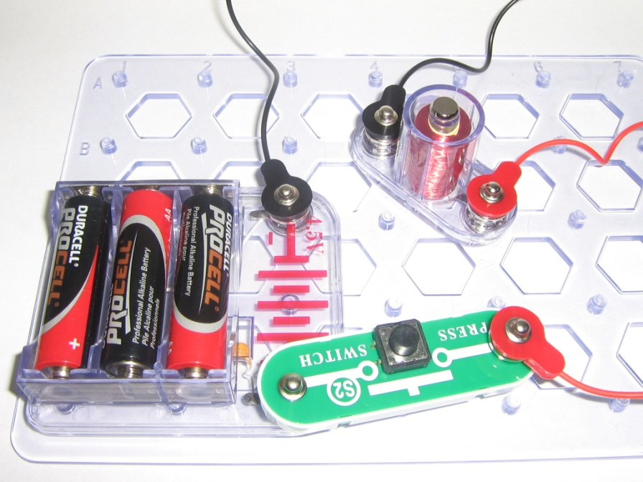
Explanation:
Explain to students that all objects are made up of atoms, which have protons and electrons. These protons and electrons are usually found in equal number in an atom so that the atom has no charge.
Sometimes, however, electrons can move to one side of the atom. A magnet is a material where all the electrons are aligned to one side. This means that one side of the atom is positively charged while the other side – with all the electrons - is negatively charged. The object overall still has no charge. This means that if you break a magnet in half, you’ll end up with 2 complete magnets, each with a positive side and a negative side.
An electromagnet works in a similar way. The electromagnet produces a magnetic field by running electric current through a looping wire. The strength of the magnetic field depends on how much current is running through the wire and how many loops are in the wire.
- Magnetic Fields

Explain to students that the magnetic field is an area around a magnet where it can affect the electrons within other objects. Tell students we will use the following experiment to discover where the magnetic field is strongest.

Experiment:
- Have students loop two paper clips together.
- While holding one paper clip, hold the bar magnet vertically and allow the other paper clip to dangle near the end of the bar magnet. Watch how the magnet causes the paper clip to “point” toward the end of the magnet. The paper clip shows the magnetic field.
- Move dangling paper clip to hang near the sides of the magnet. Ask students if the magnet has the same effect as it did near the ends of the magnet. Possible observations:
  - Paper clip is not as strongly attracted to the sides
  - Paper clip always points toward ends of magnet
  - Paper clip must be held closer to the sides of the magnet in order to be attracted to it
  - Etc.
- Repeat experiment with the electromagnet (switch pressed). The same observations should still apply.
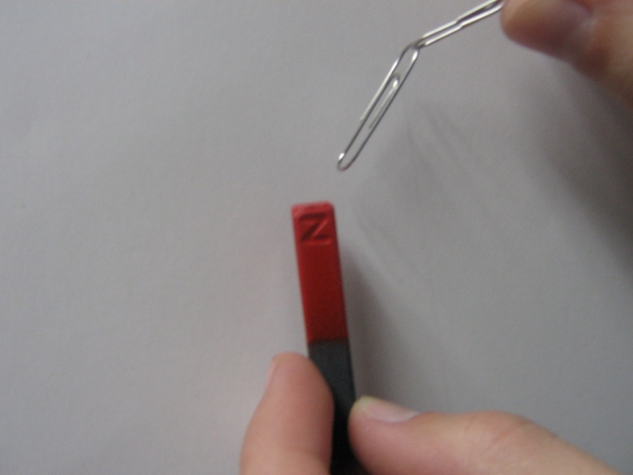
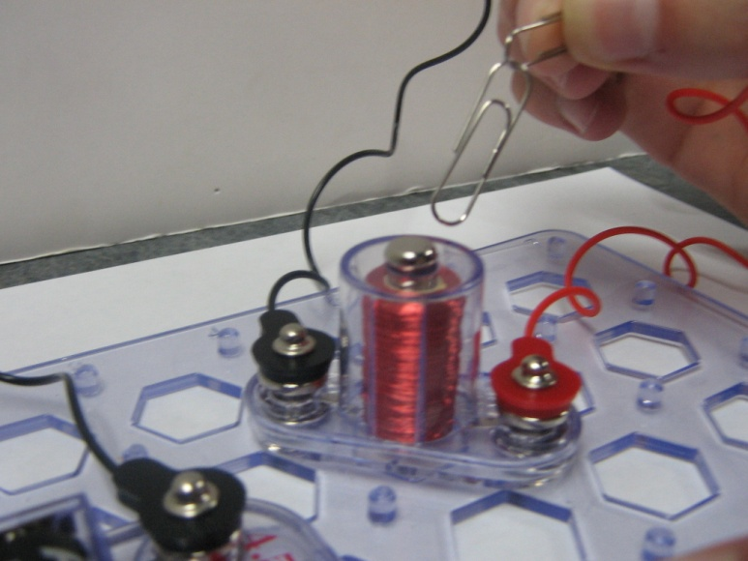
Explanation:
Ask students to where the magnetic field is strongest on the bar magnet, and where it is strongest on the electromagnet. Explain that the magnetic field is strongest at the ends of both magnets.
- Magnet Magic
Experiment 1- Electromagnet Tower
Tell students to:
- Snap one end of the switch to the battery holder.
- Snap one end of a red wire on the UNDERSIDE of the switch, and then snap the other end of the red wire to the TOP SIDE of the switch.
- On top of the red wire, snap one end of the electromagnet
- Attach both ends of black wire (one on top of the other) to the top of the battery holder on the opposite side from the switch. Snap the electromagnet to the top of the black wire. Help students with this setup as needed.
- Remove the iron core rod from the electromagnet and drop the thin rod into the hole. Then press the switch. The thin rod should be sucked up into the electromagnet. Press and release the switch to make the thin rod “bounce”.
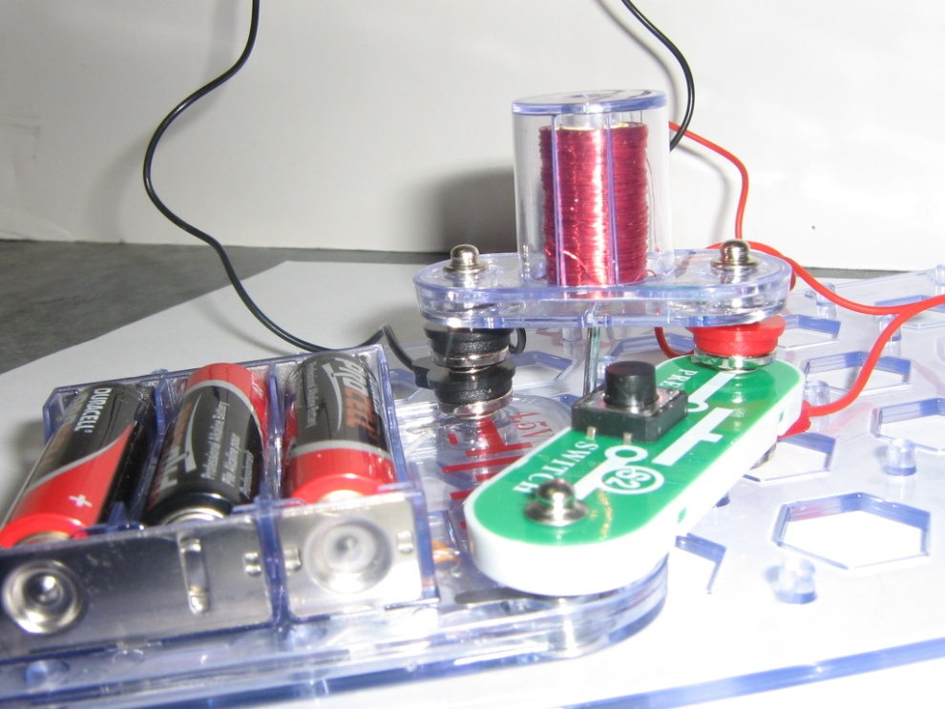
Experiment 2-Floating Paperclip
Tell students to:
- Tie string to one paper clip (if not previously attached).
- Hold string down on the table while using the bar magnet held just slightly away from the paper clip to lift the paper clip off the table without touching it. (this may take practice) and move it around in mid air.

- Make your own electromagnet
Instructions:
Tell students to:
- First, test the screw to make sure it is not magnetized by attempting to pick up the paperclip with the screw. If the screw does pick up the paper clip, have the students carefully bang it on the table until it becomes demagnetized and no longer picks up the paper clip.
- Have students make the circuit by:
  - Putting both D batteries into the battery holders.
  - Then, wrap the wire tightly around the screw as many times as possible using the grooves.
  - Snap one of the alligator clips onto one of the clips located on the side of the 1st battery holder and clip the other side onto the switch.
  - Take the other alligator clip and clip it onto the other side of the switch. Clip the remaining clip onto the wire on the area with the metal exposed.
  - With the side of the wire that is unclipped take the wire and put it in between the end clip on the 2nd battery holder.
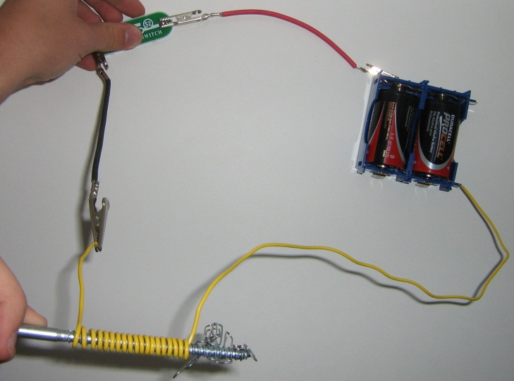

- Press and hold the switch to magnetize the screw.
- Use the tip of the screw to lift the paper clip off the table.
***Note: Warn students not to hold switch too long as the battery holder can become very hot***
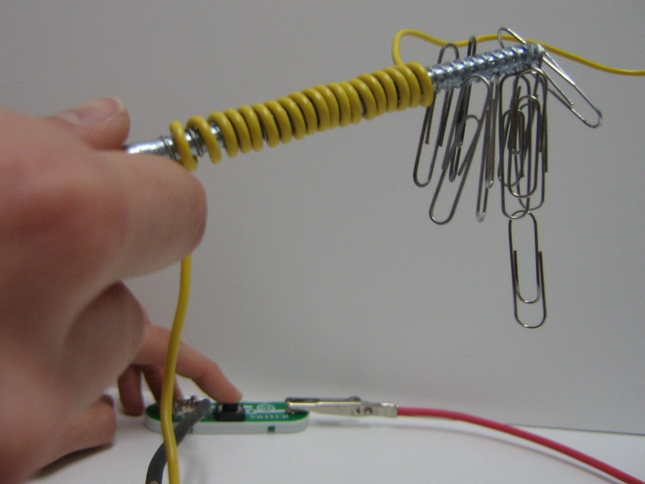

Explanation:
Tell students to examine the electromagnet from the kit and see that it is a wire coiled many times. The screw in our electromagnet works the same way as the iron core rod in the kit electromagnet. Our electromagnet, like the one that comes with the kit, requires electric current to be magnetic. Ask students why they think our magnet is so much weaker than the electromagnet in the kit. Our magnet has many fewer coils than the magnet in the kit. More coils make a stronger magnet.

