**VANDERBILT STUDENT VOLUNTEERS FOR SCIENCE**

[**http://studentorgs.vanderbilt.edu/vsvs**](http://studentorgs.vanderbilt.edu/vsvs)

**Wall Roller Coasters**

**Fall 2015 VINSE/TN-SCORE**

**GOALS:** To show how gravitational potential energy and kinetic energy are demonstrated in a wall roller coaster.

**LESSON OUTLINE**

**I. Introduction - Energy Definitions**

Definitions of kinetic and potential energy are discussed with the students.

**II. Demonstrations: Potential Energy/Kinetic Energy Conversions In Example Roller Coaster**

.Review of the changes between kinetic and potential energy in the example roller coaster

**III. Activity: Wall Roller Coaster**

Students build their roller coaster.

**IV. Roller Coaster Worksheet**

Students draw their roller coaster and graph the relative levels of potential and kinetic energy in each part of their roller coaster.

**MATERIALS**

10 Wall roller coaster boxes

5 Packages tack

I. Introduction

Ask students: What is energy?

Include the following information in the discussion:

* Scientists define **energy** as the **ability to do work** and cause a change.
  + Some examples include a change in position, speed, direction, state, or temperature.
  + The work done may be simply using a force to move an object.

Ask students: What is kinetic energy? What is Potential Energy?

1. **Kinetic energy**- Energy due to motion of the object
2. **Potential energy-** Energy stored because of an object’s position

High potential energy, low kinetic energy

High kinetic energy, low potential energy

Ask students to give some examples of kinetic energy.

* Some example may include: a swinging hammer, a wrecking ball, a moving car, anything that is moving

Ask students to give some examples of potential energy.

* Some examples may include: a stretched rubber band, an archer’s taut bow, a wound-up watch spring, a boulder at the top of a hill (gravitational potential), water in a lake at the top of a mountain (gravitational potential), food (chemical potential), a battery in a parked car (chemical potential)

**Background information for VSVS volunteers**: The Law of Conservation of Energy states that: Energy can be neither created nor destroyed by ordinary means. Energy can only be converted from one form to another.

There are five **forms** of energy: mechanical, heat, chemical, electromagnetic, and nuclear.

There are two **states** of energy: kinetic and potential. All five forms of energy can be classified into either one of these states of energy (kinetic or potential).

**How Does a Roller Coaster Work?**

Be sure to share the following information with the students.

* What you may not realize as you're cruising down the track at 60 miles an hours is that the roller coaster has no engine.
* The ride often begins as a chain and motor (or other mechanical device) exerts a force on the train of cars to lift the train to the top of a very tall hill.
* Once the cars are lifted to the top of the hill, gravity takes over and the remainder of the ride is an experience of the physics of energy transformation.
* The **conversion** of **potential energy** to **kinetic energy** is what drives the roller coaster, and all of the kinetic energy you need for the ride is present once the coaster ascends the first hill.

1. **Demonstrations:** 
   1. [Roller coaster graphic representation](http://www.solpass.org/5s/images/roller.gif)
   2. **Roller Coaster Potential/Kinetic Energy Example**

Tell students to look at their handout and follow the bar graphs that illustrate changes in Potential Energy and Kinetic Energy as the marble rolls down the roller coaster.



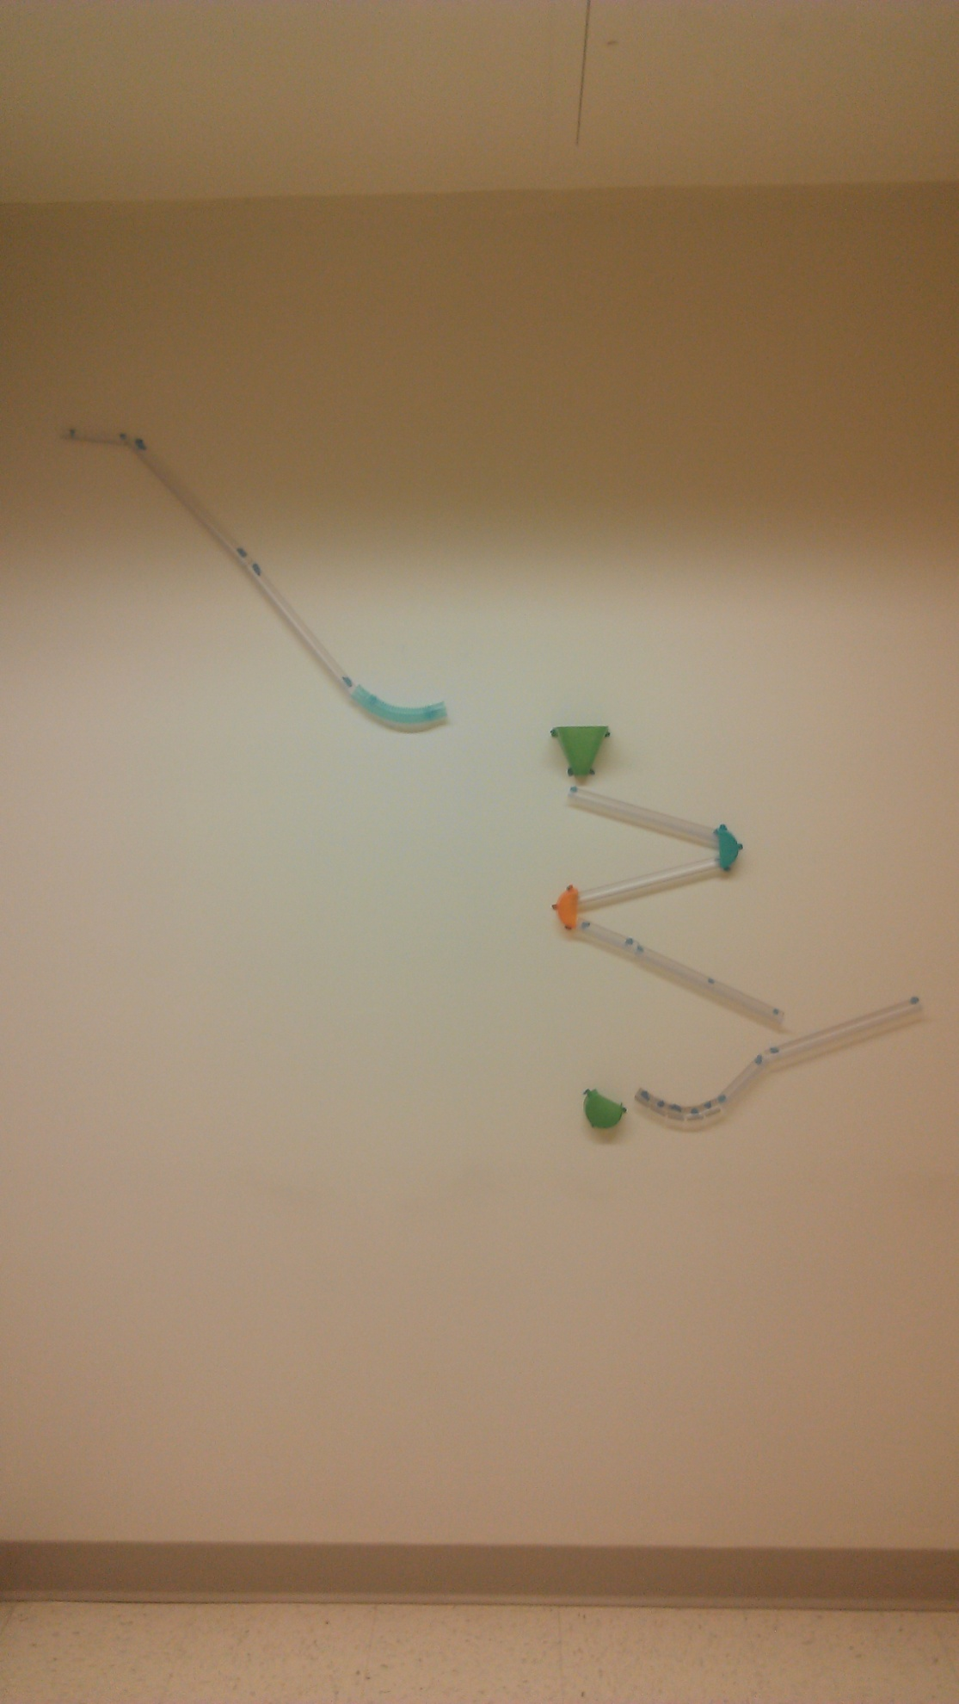

2 3

4

5 6

7

**Position 1**:

Potential energy high and kinetic energy is zero.

Potential energy is converted to kinetic energy as the ball rolls down the hill.

**Position 2:**

Potential energy decreases, kinetic energy increases

**Position 3:** Potential energy increases as ball goes up, kinetic energy decreases

**Position 4:** Some Potential energy lost as it is converted to kinetic energy as ball drops down to position 4

**Position 5:** Kinetic energy increases, as ball rolls down

**Position 6:** Kinetic Energy converted to Potential Energy as ball rolls up ramp towards #6.

**Position 7:** Potential energy low, kinetic energy high as ball reaches the bottom.

1. Roller Coaster Activity

Hand out roller coaster supplies to each group of students and allow them to build their own wall roller coaster.

Tips: If the marble is flying off the coaster, parts of the coaster may be coming loose from the wall.

Use a rubber band to hold pipes in place when bending them.

1. Roller Coaster Worksheet

Have students draw a diagram of their roller coaster and draw bar graphs of the potential and kinetic energy at 5 positions of the coaster.

**Roller Coasters Handout**

1





2 3

4

5 6

7

**Position 1**:

Potential energy high and kinetic energy is zero.

Potential energy is converted to kinetic energy as the ball rolls down the hill.

**Position 2:**

Potential energy decreases, kinetic energy increases

**Position 3:** Potential energy increases as ball goes up, kinetic energy decreases

**Position 4:** Some Potential energy lost as it is converted to kinetic energy as ball drops down to position 4

**Position 5:** Kinetic energy increases, as ball rolls down

**Position 6:** Kinetic Energy converted to Potential Energy as ball rolls up ramp towards #6.

**Position 7:** Potential energy low, kinetic energy high as ball reaches the bottom.

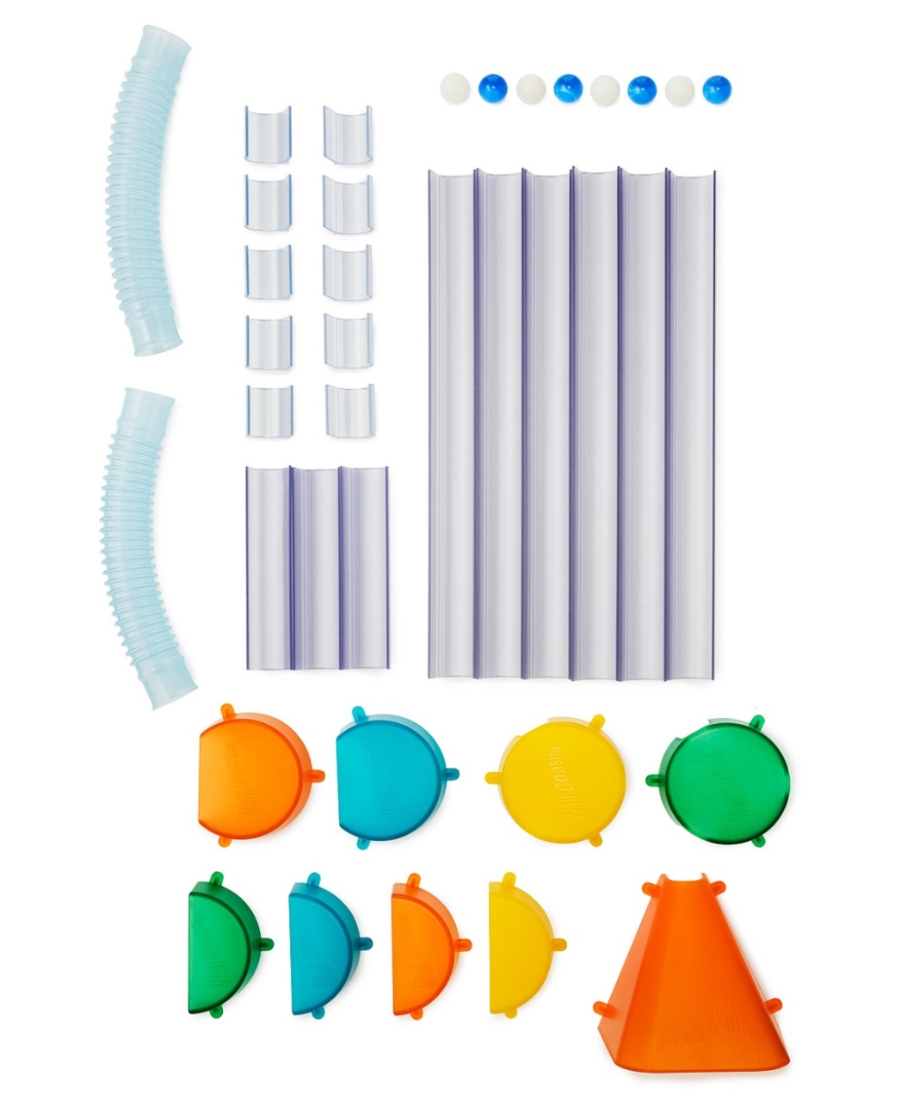

Make sure all materials are n box before and after the experiment is done.

* 2 – Three quarter Change Ups
* 4 – Half Circle Zig Zags
* 1 – Extra Large Catcher
* 2 – Three Hole Crazy Circles
* 6 – 10 Inch Coaster Tracks
* 3 – 4 Inch Coaster Tracks
* 10 – 1 Inch Coaster Tracks
* 2 – 6 Inch Coaster Tubes
* 2 – Coaster Bands
* 1 – Package of Reusable Non-marking Coaster Tack
* 4 Lightweight Crystal Marbles

**Roller Coasters Observation Sheet**

Draw your roller coaster below: Number 5 positions on your roller coaster and make bar graphs for the percentage (%) of kinetic and potential energy at each point. Remember that the total energy (PE plus KE) is always 100%.

Beside each graph, explain why the percentage of Potential Energy and Kinetic Energy has changed.

.

**Roller Coasters Observation Sheet #2**