VANDERBILT STUDENT VOLUNTEERS FOR SCIENCE
http://studentorgs.vanderbilt.edu/vsvs
Elements, Compounds, and Mixtures
Fall 2013

Goal: To help students understand the differences between elements, compounds, and mixtures.
Fits Tn State curriculum:
SPI 0807.9.3 Classify common substances as elements compounds or mixtures based on their symbols or formulas

Lesson Outline:
I. Introduction. One VSVS team member should discuss the concept of elements, compounds and mixtures while the other members set up the stations.
II. Classifying Unknowns. Students will go to each station and classify each unknown as an element, compound, or mixture from the information on the card. VSVS members will need to circulate the classroom to ensure that the transition from station to station goes smoothly. Review the answers with the students.
III. Discussion of Properties and Uses Listed on the Back of the Cards (Optional)
IV. Pennies Experiment
Students read about the penny on the back of card #23. Then they put pennies in three different solutions and observe which one cleans a dull penny the fastest.
V. Oxidation of Iron Experiment
Students learn about oxidation, combination reactions, and rusting by observing the reaction of iron filings and iron filings with hydrogen peroxide.
VI. List Of Common Chemicals (Appendix 1) (Optional)
Leave with teacher.

Materials for Elements, Compounds, and Mixtures
32 vials of unknowns
32 cards
16 periodic tables
1 set of Styrofoam ball models:
several balls representing elements that are same size and same color
balls connected to represent ammonia
a mixture of balls representing ammonia and water molecules
32 Observation Sheets

Station set up:
- The other VSVS team members should set up the lesson while one member goes through the Introduction.
- There are 32 vials of unknowns.
- Place the vials into 8 groups of 4. (1-4 (station 1), 5-8 (station 2), 9-12 (station 3), 13-16 (station 4), 17-20 (station 5), 21-24 (station 6), 25-28 (station 7), 29-32 (station 8).
- Place the corresponding cards (also numbered) with their vial.

Note: If it is undesirable to have students moving around the class, the VSVS volunteers can bring the stations to each group.

- Introduction
Pass out the periodic tables to pairs of students.

A. Ask students: What is an element? Ask them to give an example of an element.
Elements are substances that cannot be broken down further by ordinary chemical means.
Ask students how it is possible to tell if something is an element?
- We can tell something is an element by looking at the chemical formula. There should only be one symbol from the periodic table. Use the periodic table to point out the symbols for elements.
- Show students the model of an element. Point out that all of the balls are the same color and size, each ball represents an atom.

B. Ask students: What is a compound? Ask them to give an example of a compound.
A compound is made of two or more elements that are chemically joined (bonded). Use water as an example of a compound if students do not offer anything.

Ask students how it is possible to tell if something is a compound?
- A compound will have two or more chemical symbols. The formula for a compound will show the ratio of atoms.
- Write the chemical formula for ammonia on the board (NH₃); this means that there are three hydrogen atoms for every one nitrogen atom.
  - Ask students to find Nitrogen (N) and Hydrogen (H) on the periodic table.
  - Show students the model of ammonia and the model of water. Note that there are balls of different sizes and colors connected to one another. The connection represents a chemical bond.

C. Ask students: What is a mixture? Ask them to give an example of a mixture.
A mixture is a combination of elements or compounds that are not joined chemically. Examples of mixtures include salt water, brass, sand.
- Tell students that there are two types of mixtures – those where the parts of the mixture can be seen, such as muddy water, and those where the parts of the mixture can’t be seen, such as a salt solution. Although we normally think of solutions as liquids, such as salt solution, solutions can be mixtures of solids, liquids, and gases and any combination of these. An example of a solution of a gas in a liquid is air dissolved in water.

Metal alloys are solid mixtures of two or more metals. For example, brass is a mixture of copper and zinc. Keep in mind that all mixtures, whether you can see the parts in the mixture or not, are not chemically joined, and the parts can be separated by physical means. This is important, because many students confuse this concept and think that alloys like steel are compounds, but they are mixtures.

- Place the model for NH₃ and the model for H₂O in the same bag. Explain to students that this is a mixture. There are two compounds in the bag that are not chemically connected to one another.

D. Review of Classification of Matter
Emphasize:
- Elements, compounds, and mixtures can exist as solids, liquids, or gases.
- Mixtures can be separated by physical means. For example salt water solution can be separated by boiling off the water, leaving the solid salt.
- Elements and compounds are pure substances. Elements combine chemically to form compounds, and compounds can only be separated into elements by chemical means.

II. Classifying Unknowns
Note: Have the teacher assist the team in splitting the class into 8 groups.

- Tell students that they are going to use their knowledge of elements, compounds, and mixtures to classify substances as an element, compound, or mixture.
- Number each group 1 – 8. These should correspond with the station numbers that have been set up by the other volunteers during the introduction.
- Instruct the students to find the station number that matches their group number.
- Explain that each vial has a number on it. Each vial has a card with some information on it to help the students determine if the substance in the vial is an element, compound, or mixture. Emphasize that it is important that the number on the card match the number on the vial. Students are not allowed to uncap the vials.
- Have the students progress through the stations in a clockwise manner until they have finished every vial. Tell them to make sure they fill out their observation sheet.
- VSVS team members should facilitate the rotations to make sure everything moves smoothly. It will probably be best to have all the students move at one time.
- Go through the answer sheet with the students. The mixtures will probably be the most difficult for the students. Make sure to point out that solutions of compounds in water are mixtures.

III. Discussion of Properties and Uses Listed on the Back of the Cards (Optional)

IV. Pennies Experiment
Goal: Students will test ways of removing the copper oxide coating to make the penny shiny again.
Fits Tennessee science standards SPI 0807.9.8

Materials for a class of 30 students
90 dull pennies (3 dull pennies per pair– you will need to provide your own set for each classroom)
15 2oz cups labeled vinegar (1 per pair)
15 2oz cups labeled salt water (1 per pair)
15 2oz cups labeled vinegar plus salt (1 per pair)
30 plastic spoons
15 paper towels
8 100 mL bottles vinegar (pairs will share)
8 jars salt(pairs will share)
8 100 mL bottles water (pairs will share)
30 Observation Sheets

A. Introduction
Tell students to read about the penny before doing this experiment. This is the same information on the back of card # 23.

Until 1982, the composition of U.S. pennies was 95% copper and 5% zinc. By that time the value of copper had increased to the point where the penny was worth more than one cent. Since zinc is less expensive than copper, the composition of the penny was changed in 1982 to 97.5% zinc with a 2.5% coating of copper. However, a penny now costs 2 cents to produce so attention is again focused on how to produce pennies cheaper, or even the possibility of eliminating the use of pennies For example, Canada has withdrawn the Canadian penny from circulation.

Since 1982, Jarden Zinc Products, located in Greenville, Tennessee, has supplied the penny blanks – the zinc metal discs that become pennies after being coated with copper. Since the outside coating of the penny is copper, the penny looks like copper metal and has the properties of copper metal.

A new shiny penny gets dull looking after a few years. This is caused by a coating of copper oxide.
2Cu+O₂-->2CuO
Students will test ways of removing the copper oxide coating to make the penny shiny again.

B. Experimental Procedure
Tell students to:
- Fill the first cup half-full with vinegar.
- Fill the second cup about half-full with vinegar, add about ½ spoon of salt and stir.
- Fill the third cup half-full with water add about ½ spoon of salt and stir.
- Place the cups on the appropriate circle below.

Vinegar
Vinegar + salt
Water +
salt
1
2
333

- Place a dull penny in each cup and observe for three minutes.
- Remove each penny, one at a time, rub with paper towel, then rinse with water before putting the penny on a paper towel.
- Write your observations below.

Observations
Write what you observed when you removed the penny from the solution. Was there any residue left on the paper towel when you rubbed the penny? If so, include the color of the residue in your observations.

- Penny in cup of vinegar and salt solution ____________________________________________________

- Penny in salt solution ____________________________________________________________________

- Penny in vinegar ________________________________________________________________________

Which solution did the best job of cleaning the penny?
_____________________________________________________________________________

Why do you think this solution did the best job of cleaning the penny?
_____________________________________________________________________________

C. Discussion
The students will find that the vinegar plus salt solution will clean the penny while the other two solutions will not have much effect. They may or may not see any brown/black residue of the copper oxide when they rub the penny with a paper towel.
Explanation: The chemistry of what’s happening in the vinegar/salt solution is complicated, the short answer is to consider sodium chloride is a catalyst that speeds up the reaction between vinegar and copper.

BACKGROUND NOTE: When sodium chloride dissolves in water, the sodium ions and chloride ions are free to move around. As a result, electron transfer can occur easily. Vinegar is a 5% solution of acetic acid, which is a weak acid and slowly dissolves the copper oxide coating to give Cu²⁺ ions and oxide ions. The chloride ions in solution do not bond strongly to Cu²⁺ ions, but do bond strongly to Cu⁺¹ ions. In vinegar solution, the Cu²⁺ ions react with Cu atoms on the surface of the penny to give Cu⁺¹ ions. Although this reaction is very slow in vinegar, the chloride ions in the vinegar/salt solution bond to the Cu⁺¹ ions to form [CuCl₂]⁻¹. Therefore, the sodium chloride can be regarded as a catalyst because it speeds up the reaction of vinegar with copper oxide on the surface of the penny. Salt solution doesn’t work by itself because acid is needed to produce Cu²⁺ ions in solution.

OBSERVATION SHEET NAME __________________________

Information about pennies:
Until 1982, the composition of U.S. pennies was 95% copper and 5% zinc. By that time the value of copper had increased to the point where the penny was worth more than one cent. Since zinc is less expensive than copper, the composition of the penny was changed in 1982 to 97.5% zinc with a 2.5% coating of copper. However, a penny now costs 2 cents to produce so attention is again focused on how to produce pennies cheaper, or even the possibility of eliminating the use of pennies For example, Canada has withdrawn the Canadian penny from circulation.

Since 1982, Jarden Zinc Products, located in Greenville, Tennessee, has supplied the penny blanks – the zinc metal discs that become pennies after being coated with copper. Since the outside coating of the penny is copper, the penny looks like copper metal and has the properties of copper metal.

Procedure:
- Fill the first cup half-full with vinegar.
- Fill the second cup about half-full with vinegar, add about ½ spoon of salt and stir.
- Fill the third cup half-full with water add about ½ spoon of salt and stir.
- Place the cups on the appropriate circle below.
Vinegar
Vinegar + salt
Water +
salt
1
2
43

- Place a dull penny in each cup and observe for three minutes.
- Remove each penny, one at a time, rub with paper towel, then rinse with water before putting the penny on a paper towel.
- Write your observations below.

Observations
Write what you observed when you removed the penny from the solution. Was there any residue left on the paper towel when you rubbed the penny? If so, include the color of the residue in your observations.

- Penny in cup of vinegar and salt solution ____________________________________________________

- Penny in salt solution ____________________________________________________________________

- Penny in vinegar ________________________________________________________________________

Which solution did the best job of cleaning the penny?
_____________________________________________________________________________

Why do you think this solution did the best job of cleaning the penny?
_____________________________________________________________________________

V. Oxidation of Iron Experiment
Goal: To have students observe rusting of iron in a 15 minute time period. Students will observe that the reaction is an oxidation reaction and that it can be classified as a combination reaction. Evidence that a chemical reaction has taken place is observed.
Fits Tennessee science standards SPI 0807.9.8
Lesson Outline:
- Introduction. Oxidation, Combination reaction, and Rusting are defined.
B. Experiment 1. Students place iron filings on top of a piece of cotton and add hydrogen peroxide and salt to them. Rusting of the filings is noticeable in 5 minutes.
C. Experiment 2. Students add hydrogen peroxide and salt to iron filings in a plastic bag. The temperature of the solution is recorded at the beginning and after 10 minutes. The solution turns orange and a gas is given off. Students look at the equation for oxidation of iron.
Materials in Lesson Kit:
16 plastic bags containing:
1 1oz cup
1 cotton ball
1 container iron filings
1 salt container
1 mini spoon
1 plastic container with:
16 dropper bottles hydrogen peroxide
16 10 oz cups
16 sandwich bags
16 thermometers
32 Instruction sheets
32 Observation sheets
1 trash bag

A. Introduction
Ask students if they know what oxidation is? What are some things that oxidize?
Oxidation usually occurs when an element or compound combines with oxygen.
Cut fruits oxidize – apples turn brown after they have been cut and left exposed to the air.
Copper oxidizes and becomes a dull color (new pennies are shiny; older ones are dull).
Silver becomes “tarnished” and black when it oxidizes.
Iron is oxidizing when it rusts and turns a reddish color.

Tell students we are going to investigate the oxidation of iron, commonly called rusting.
The type of reaction we are observing is called a combination reaction.
A Combination Reaction is a reaction where two or more reactants are chemically bonded together to produce a single product.
Rust is the common name for a very common compound, iron oxide.
Rusting is a very slow process which takes place over several weeks or months.

Ask students if they have ever seen iron rust in a few seconds? Probably not!
Tell the students they are going to put some chemicals together that will cause rusting in just a few minutes.

B. Experiment 1– Rusting of Iron Filings - Oxidation
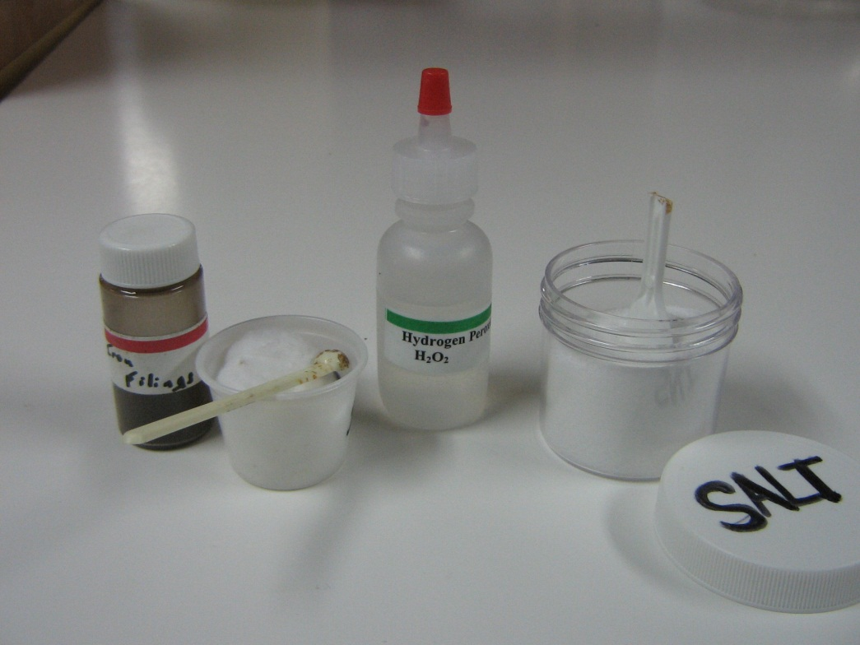
Materials
16 plastic bags containing:
1 1oz cup
1 cotton ball
1 container iron filings
1 salt container
1 mini spoon
1 plastic container with:
16 dropper bottles hydrogen peroxide

Distribute a set of materials to each pair.

Tell students to:
1. Put a cotton ball into the 1oz cup and to sprinkle iron filings on the cotton.
2. Sprinkle a small scoop of salt on top and add a squirt of peroxide to the cotton.
3. Set aside the cup and that they will observe it after they have started the next experiment.

The iron in the hydrogen peroxide and salt will start rusting and an obvious orange color will form within 2 minutes. The salt is a catalyst.

C. Experiment 2 – Iron Filings Oxidation – an Exothermic Reaction
Materials
Distribute the following to each pair:
1 10 oz cup
1 sandwich bag containing iron filings
1 2oz container of hydrogen peroxide
1 thermometer
1 container salt and spoon – students already have it
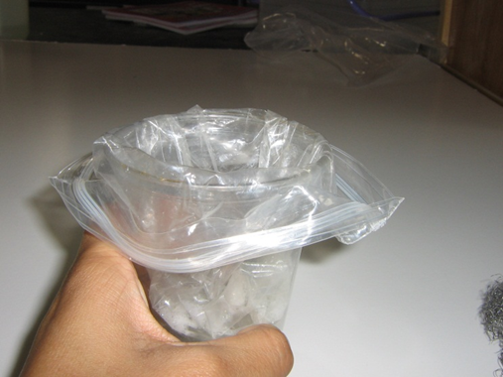
Tell students to:
1. Put the sandwich bag into the cup so that it resembles a garbage can liner.
2. Put a mini spoonful of iron filings into the plastic bag. Add a spoonful of salt and all the hydrogen peroxide into the plastic bag.
3. Feel the bag and note that it has the same temperature as their hands.
4. Put the thermometer into the liquid in the bag and measure the temperature. (It will be at room temperature.)
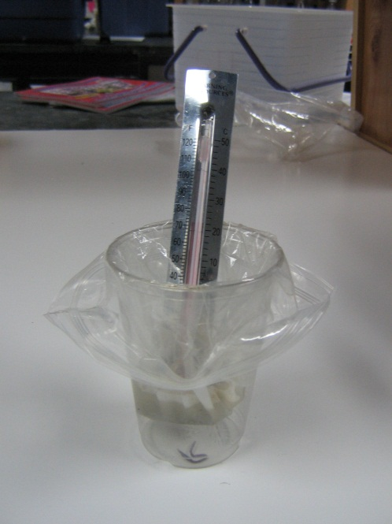
5. After 1 minute tell students to measure the temperature again and record their observations.
Observations will include:
Solution is becoming orange colored.
Solution is bubbling (producing a gas).
Temperature will probably not show any increase yet
6. Set the cup and bag aside for 10 minutes, at which time students will make more observations.
7. Tell students to go back and look at the iron filings in their 1 oz cup.
There should be a distinct orange color on the cotton.

Ask students to hypothesize which iron oxide has been formed? (Based on the color of the product). Students will need to see the 2 iron oxide vials again.

Discuss the type of reaction that is occurring.
a. Tell students to look at the equation on their observation sheet.
4Fe + 3O₂ → 2Fe₂O₃
- Ask students why it is classified as a combination reaction? Two elements or compounds are combining. Why is it an oxidation reaction? An element (iron)or compound is combining with oxygen.
Background Information for VSVS members:
The oxygen comes from the decomposition of hydrogen peroxide.
Equations: 2H₂O₂ → 2H₂O + O₂
4Fe + 3O₂ → 2Fe₂O₃
Salt is a catalyst (it is an electrolyte that helps remove electrons from the metal).

8. Ask the students if they know some chemical properties of iron.
Some information that may be included:
- Iron is a common metal found around the house.
- The chemical symbol of iron is Fe.
- One of the chemical properties of iron is its ability to combine with oxygen.
- Rusting of iron is chemically known as oxidation.
- Rust is the common name for iron oxide.
- Rusting is a chemical change that is not easily reversed.
- Rusting is usually very slow but can be sped up.
- Iron filings rust rapidly. (The surface area of iron filings is much greater than that of a piece of iron – this leads to an increase in the rate of the
oxidation reaction.)
9. Return to the plastic bag with iron filings, hydrogen peroxide and salt.
Tell students to measure the temperature of the liquid and to make final observations.
Students should observe an increase of 10-20 degrees C.
10. Ask students what evidence there is for a chemical reaction taking place?
A change in color (rust is reddish) is evidence of a chemical change.
A new substance is formed.
Gas (bubbles) is being given off (from the decomposition of hydrogen peroxide.)
There is a temperature change.
11. Ask the students if the reaction is exothermic or endothermic?
The temperature of the iron filings plus hydrogen peroxide plus salt mixture increases, so the reaction is exothermic. Rusting is exothermic. It usually happens so slowly that it is not noticed.

Disposal: Seal plastic bags and put in trash can at school. If this is not possible, put into larger plastic bag, seal and return to VSVS lab.
Try NOT to get 10 oz cups contaminated with iron oxide liquid – it stains.

Instruction and Observation Sheet Name ____________________________________

Experiment 1 – Rusting of Iron Filings
1. Put a cotton ball into a 1oz cup and sprinkle it with iron filings.
2. Sprinkle a small scoop of salt on top and add a squirt of hydrogen peroxide.
3. Set aside so you can observe after you have started the next experiment.

Experiment 2 – Rusting of Iron Filings in Plastic Bag
1. Put a plastic bag into cup so that it resembles a garbage can liner.
2. Add 2 scoops iron filings a spoonful of salt and all the hydrogen peroxide to the plastic bag.
3. Feel the bag and note that it has the same temperature.
4. Put the thermometer into the liquid in the bag and measure the temperature.
5. After 1 minute, measure the temperature again and record observations.
___________________________________________________________________________

6. Set the cup and bag aside for 10 minutes

7. Look at the iron filings in you 1 oz cup. Record observations.
________________________________________________________________________

Discuss the type of reaction that is occurring.
- Write down the name of the iron oxide that has formed (base your hypothesis on the information on cards 12-15).
Look at the equation for rusting:
4Fe + 3O₂ → 2Fe₂O₃
Iron + oxygen Iron Oxide

Why it is classified as a combination reaction? Why is it an oxidation reaction?
__________________________________________________________________________

- Return to the plastic bag with iron filings, peroxide and salt and measure the temperature of the liquid and make final observations.
___________________________________________________________________________

10. What evidence indicates a chemical reaction is taking place?
_________________________________________________________________________

11. Is the reaction is exothermic or endothermic?

VI. LIST OF COMMON CHEMICALS
Discuss some of the chemicals on this list as time permits.
Common Name | Chemical Name | Chemical Formula | Source
alum | aluminum potassium sulfate | AlK(SO₄)₂∙12H₂O | drug store, Flinn Scientific
aluminum foil | aluminum | Al | grocery store
ammonia, household, 5%soln | ammonia | NH₃ | grocery store
ammonium nitrate | ammonium nitrate | NH₄NO₃ | farm co-op, farm supply, garden supply
baking soda | sodium bicarbonate | NaHCO₃ | grocery store
bleach, 5% soln (clorox) | sodium hypochlorite | NaClO | grocery store
borax | sodium borate | Na₂B₄O₇∙ 10H₂O | grocery store (detergent aisle)
boric acid (roach killer) | boric acid | H₃BO₃ | drug store, hardware store
calcium chloride | anhydrous calcium chloride | CaCl₂ | farm co-op, farm supply
chalk | calcium carbonate | CaCO₃ | school supply
charcoal | carbon | C | hardware store or pet store
copper sulfate | copper (II) sulfate | CuSO₄∙5H₂O | hardware store
dextrose | glucose | C₆H₁₂O₆ | drug store
dry ice | solid carbon dioxide | CO₂ | grocery store
epsom salt | magnesium sulfate | MgSO₄∙ 7H₂O | drug store or grocery store
flowers of sulfur | sulfur | S | hardware store, garden supply, farm co-op
glycerin | glycerol | C₃H₅(OH)₃ | drug store
graphite (pencil lead) | carbon | C | school supply
gypsum | calcium sulfate | CaSO₄ | building supply
helium | helium | He | party store
hydrogen peroxide, 3% soln | hydrogen peroxide (soln) | H₂O₂ | grocery store
hypo | sodium thiosulfate | Na₂S₂O₃∙ 5H₂O | photo store
iron | iron | Fe | steel wool (alloy with iron), hardware store
lighter fluid | butane | C₄H₁₀ | grocery store
limestone | calcium carbonate | CaCO₃ | garden store, home supply
lite salt | potassium chloride | KCl | grocery store
lye | sodium hydroxide | NaOH | hardware store, grocery store
marble chips | calcium carbonate | CaCO₃ | garden store, home supply
milk of magnesia (soln) | magnesium hydroxide (soln) | Mg(OH)₂ | grocery store, drug store
muriatic acid | hydrochloric acid (conc) | HCl | hardware store (Be safe -strong acid)
rubbing alcohol (70% soln) | isopropyl alcohol (soln) | C₃H₇OH | grocery store
sal ammoniac | ammonium chloride | NH₄Cl | hardware store
saltpeter | potassium nitrate | KNO₃ | drug store
slaked lime | calcium hydroxide | Ca(OH)₂ | hardware store
smelling salt | ammonium carbonate | (NH₄)₂CO₃ | drug store
table salt | sodium chloride | NaCl | grocery store
table sugar | sucrose | C₁₂H₂₂O₁₁ | grocery store
tincture of iodine | iodine (alcohol solution) | I₂ | drug store
trisodium phosphate | sodium phosphate | Na₃PO₄ | home supply, paint store
vinegar | acetic acid (5% solution) | CH₃COOH | grocery store
washing soda | sodium carbonate | Na₂CO₃ | grocery store (detergent aisle)

Common Chemicals
Elements Mixtures and Compounds Observation Sheet Name ______________________________
 | Name of substance | Symbol  or  formula | Color | Phase  (check one) |  |  | Type  (check one) |  |  | If a Compound,
 |  |  |  | S | L | G | E | M | C | Number of elements present | Number of Atoms present
1. | Copper | Cu
2. | Copper Oxide | CuO
3. | Copper Sulfate | CuSO₄
4. | Sodium Bicarbonate (Baking Soda) | NaHCO₃
5. | Tin | Sn
6. | Sodium Chloride (Salt) | NaCl
7. | Iodized Salt | 99.097% NaCl with 0.003% KI
8. | Soil
9. | Aluminum | Al
10. | Magnesium | Mg
11. | Magnesium Sulfate (Epsom Salts) | MgSO₄
12. | Iron | Fe
13. | Iron oxide (rust, Hematite) | Fe₃O₄
14. | Iron oxide (Magnetite) | Fe₂O₃
15. | Steel | Fe alloyed with C, and other metals
16. | Carbon | C
17. | Calcium Carbonate | CaCO₃
18. | Marble | CaCO₃ + other minerals
19. | Aqueous Ammonia | 5% NH₃ in H₂O
20. | Vinegar (aqueous acetic acid) | 5% CH₃COOH in H₂O
21. | Sand | SiO₂, CaCO₃, + other rocks
22. | Zinc | Zn
23. | Penny | 2.5% Cu, 97% Zn
24. | Sucrose (sugar) | C₁₂H₂₂O₁₁
25. | Cobalt | Co
26. | Cobalt Chloride | CoCl₂
27. | Nickel | Ni
28. | Nickel Chloride | NiCl₂
29. | Cream of Tartar | KHC₄H₄O₆
30. | Sulfur | S
31. | Water | H₂O
32. | Air | N₂, O₂, and small amounts of other gases
Key: G = Gas, S = Solid, L = Liquid, E = Element, C = Compound, M = Mixture

Observation Sheet Answers
 | Name of substance | Symbol  or  formula | Color | Phase  (check one) |  |  | Type  (check one) |  |  | If a Compound
 |  |  |  | S | L | G | E | M | C | Number of elements present | Number of Atoms present
1. | Copper | Cu | Orange | X |  |  | X |  |  | 1 | 1
2. | Copper Oxide | CuO | Black | X |  |  |  |  | X | 2 | 2
3. | Copper Sulfate | CuSO₄ | Blue | X |  |  |  |  | X | 3 | 6
4. | Sodium Bicarbonate (Baking Soda) | NaHCO₃ | White | X |  |  |  |  | X | 4 | 6
5. | Tin | Sn | Silver | X |  |  | X |  |  | 1 | 1
6. | Sodium Chloride (Salt) | NaCl | White | X |  |  |  |  | X | 2 | 2
7. | Iodized Salt | 99.097% NaCl with 0.003% KI | White | X |  |  |  | X |  | 4 | ?
8. | Soil | ? | ? |  |  |  |  | X |  | ? | ?
9. | Aluminum | Al | Silver | X |  |  | X |  |  | 1 | 1
10. | Magnesium | Mg | Silver/black | X |  |  | X |  |  | 1 | 1
11. | Magnesium Sulfate (Epsom Salts) | MgSO₄ | White | X |  |  |  |  | X | 3 | 6
12. | Iron | Fe | Brown/  Black | X |  |  | X |  |  | 1 | 1
13. | Iron oxide (rust, hematite) | Fe₂O₃ | Orange | X |  |  |  |  | X | 2 | 5
14. | Iron oxide (Magnetite) | Fe₃O₄ | Black | X |  |  |  |  | X | 2 | 7
15. | Steel | Fe alloyed with C, and other metals | Silver/black | X |  |  |  | X |  | ? | ?
16. | Carbon | C | Black | X |  |  | X |  |  | 1 | 1
17. | Calcium Carbonate | CaCO₃ | White | X |  |  |  |  | X | 3 | 5
18. | Marble | CaCO₃ + other minerals | White | X |  |  |  | X |  | ? | ?
19. | Aqueous Ammonia | 5% NH₃ in H₂O | Clear |  | X |  |  | X |  | 3 | ?
20. | Vinegar (aqueous acetic acid) | 5% CH₃COOH in H₂O | Clear |  | X |  |  | X |  | 3 | ?
21. | Sand | SiO₂, CaCO₃, + other rocks | Beige | X |  |  |  | X |  | ? | ?
22. | Zinc | Zn | Silver | X |  |  | X |  |  | 1 | 1
23. | Penny | 2.5% Cu, 97% Zn | Orange | X |  |  |  | X |  | 2 | ?
24. | Sucrose (Sugar) | C₁₂H₂₂O₁₁ | White | X |  |  |  |  | X | 3 | 45
25. | Cobalt | Co | Gray | X |  |  | X |  |  | 1 | 1
26. | Cobalt Chloride | CoCl₂ | Maroon | X |  |  |  |  | X | 2 | 3
27. | Nickel | Ni | Silver | X |  |  | X |  |  | 1 | 1
28. | Nickel Chloride | NiCl₂ | Green | X |  |  |  |  | X | 2 | 3
29. | Cream of Tartar | KHC₄H₄O₆ | White | X |  |  |  |  | X | 4 | 16
30. | Sulfur | S | Yellow | X |  |  | X |  |  | 1 | 1
31. | Water | H₂O | Clear |  | X |  |  |  | X | 2 | 3
32. | Air | N₂, O₂, and other gases | None |  |  | X |  | X |  | ? | ?
Key: G = Gas, S = Solid, L = Liquid, E = Element, C = Compound, M = Mixture

