**VANDERBILT STUDENT VOLUNTEERS FOR SCIENCE**

**http://studentorgs.vanderbilt.edu/vsvs**

# Fossils

**Fall 2012**

### Goal: To introduce students to the geological time scale, the fossil record, index fossils, and the uses of fossils.

Fits Tennessee standards GLE **0807.5.6**

**I. Geologic Time**

1. Introduction
2. Time Scale Model
3. Timeline Mats

**II. Fossils**

1. What are Fossils?
2. Types of Fossils
3. Working with Real Fossils

**III. Usefulness of Fossils**

1. Dating with Index Fossils
2. Paleoenvironments
3. Evolution

**Materials:**

1 cylinder containing the larger string timeline

16 laminated timeline mats

16 bags containing 1 piece of Play-Doh

1 bivalve shell

1 clothespin

16 fossil boxes

16 Handout #1 copies

32 observation sheets

Write on the board: **Eon – Hadean, Archean, Proterozoic, Phanerozoic**

**Era**

**Period**

**BYBP = billion years before present**

**MYBP = million years before present**

**I. Geologic Time**

**A. Introduction**

* Q. Does anybody know how old the earth is?
  + *4.6 billion years old, or 4600 million years old. Write the number out in full on the board so they understand how much time this is (4600,000,000).*
* The **geologic time scale** covers earth’s entire history – today we will study this and fossils.
* It is divided into **eons**, which are further divided into **eras.**
  + Eons and eras are not of equal length, but are based on events/organisms in certain time periods (eons) and when major extinctions happened (eras).
* 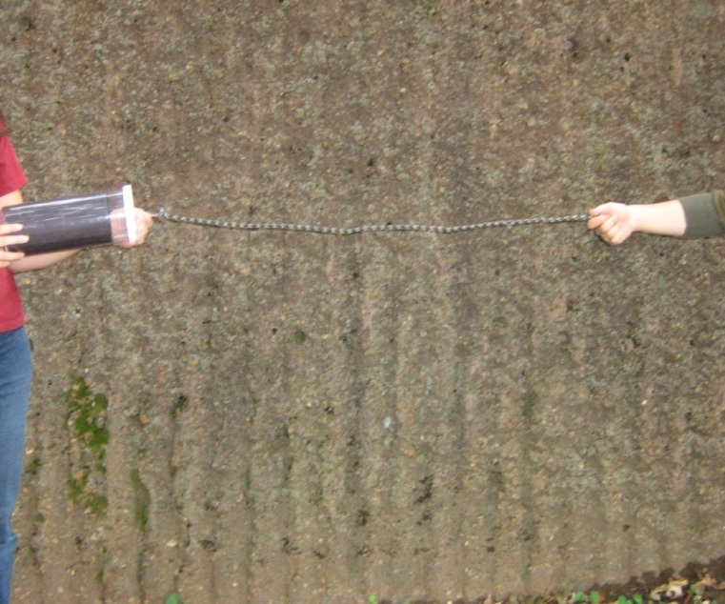Q. Tell the students to think about how much of the earth’s history humans have been around for, but tell them we will come back to this later. (*For about 1.5 million years.*)

**B. Time Scale Model**

* Hand out the Fossils Observation Sheet (1 per student). Draw the same table on the Observation Sheet on the board and fill it out as you go through the timescale. (A filled-out version of the table is shown below.)
* Since this lesson is a short mini lesson, have students answer these questions as a class. VSVS members can write the correct answer on the board. Tell students to copy down the time ranges and major events/dominant organisms/fossils/rocks information.

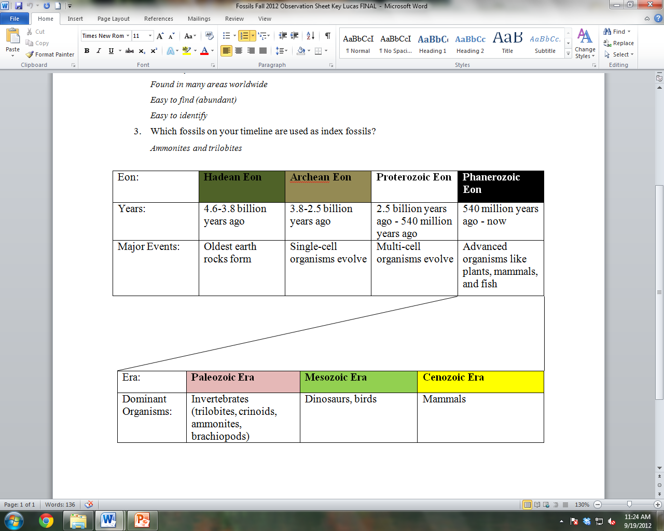

* Hold up the time scale model (the cylinder) with just a small piece of string pulled out so that all students can see it. Tell students:
* The string represents the timeline of earth’s history.
* The string covers the complete geologic time scale over a time of 4.6 billion years.
* The string is divided into the 4 eons, and the last eon is divided into eras.
* Note – the string is 19 feet long, so make sure you have enough room to “spread”.
  1. One VSVS member or student volunteer will hold the string and another will hold the container and walk to the right while removing each eon and stopping when a knot is reached.
  2. A VSVS member will describe each eon to the students, while another writes names of eons and eras on the board as they are introduced.
  3. The string must be kept taught in a straight line so that the students get the concept of the length of time taken for each eon.

1. Pull the first (camouflage-colored) section of the string out, and stop as soon as you get to the first knot (between color changes).

* ***Tell students:***
  1. This first section represents the **Hadean Eon** lasting from 4.6-3.8 billion years ago (write time ranges of eons on board).
  2. **Major event**: No organisms living during this eon, but the earliest known rocks were formed.
  3. The oldest earth rock is dated at 4.03 billion years old and was found in the Canadian Rockies. The only rocks found that are older come from meteorites and the moon.1.
  4. Q. How do we know the rocks are this old? *Scientists use radiometric dating with radioactive isotopes (elements like uranium) in the rocks to figure out their age.*

1. Pull the second (tan) segment of the string until the second knot is reached.
   1. This represents the **Archean Eon** lasting from 3.8-2.5 billion years ago.
   2. **Major event**: During this eon, the first single-celled organism evolved.
   3. Fossils of these are found in Australia and are aged at 3.77 billion years old.
2. Pull the third (white) segment of string until the third knot is reached.
   1. This represents the **Proterozoic Eon** lasting from 2.5 billion years ago - 540 million years ago.
   2. **Major event**: Multi-celled organisms evolved during this eon.
   3. The earliest multi-celled fossil is from Michigan and is dated at 2.2 billion years old.
3. Display the black end of the string.
   1. This last section represents the **Phanerozoic Eon** lasting from 540 million years ago - now.
   2. **Major event**: Life evolves from multi-celled organisms to plants, fish and animals as we know them today.
   3. Q. Have you been thinking about how long humans have existed?

*Humans only existed in the very last knot of the rope. (See the dangling skeleton!) This is an extremely short time in the history of the earth.*

This eon is subdivided into 3 smaller time intervals called **eras.** These eras are color coded with colored string twisted around the black cord.

**C. Timeline Mats**

* While the rope timeline is still stretched out, a VSVS member should pass out the timeline mats (one per pair of students). Focus students’ attention on the black (Phanerozoic Eon) section of the rope. Explain to them that this portion of the rope corresponds to the placemat timeline in front of them.
* Briefly explain the layout of the timeline mat:
  + The center rectangle is the time scale of the Phanerozoic Eon in millions of years before present with 0 being present day (denoted by the stick figure at the end).
  + The different colors (pink, green and yellow) show the different **eras.**
  + The thick black lines represent mass extinctions from catastrophic events.
  + The tan rectangles on the top and bottom of the time scale correspond to the life spans of the organisms in the rectangles.
  + The pictures are the fossils of the organisms that the rectangle represents (on the left) and images of what the organisms would have looked like (on the right).
* Eras are characterized by unique advanced life forms and end with mass extinctions.
  + Q. What is meant by extinction? (*The last remaining members of a species have died out.)*
* Identify the **pink section** of the time scale as the **Paleozoic Era**. During this era:
  + Invertebrates such as trilobites, brachiopods, crinoids, and ammonites flourished in this era. Direct students to the images on the timeline to see what trilobites, ammonites, crinoids & brachiopods look like.
    - Q. Does anyone know what makes an animal an invertebrate?

*The lack of a backbone; animals are vertebrates like us if they have a backbone.*

* + Early fish develop (direct attention to placemat for sharks).
  + Early land plants develop (direct attention to placemat for early ferns).
  + Early reptiles developed.
  + The biggest mass extinction occurred at the end of this era – 90% of all species became extinct. (Emphasize the magnitude of this extinction to students – tell them to imagine 90% of all animals on earth right now dying out.)
* Identify the **green section** of the time scale as the **Mesozoic Era**:
  + This is known as the Age of Reptiles, since many major reptile groups were dominant life forms.
  + Dinosaurs, birds, small mammals, flowering plants, and flies flourished.
  + Another mass extinction occurred at end of this era – 50% of all species became extinct, including dinosaurs.
  + Q. Does anyone know the current theory as to why the dinosaurs went extinct?
    - *Many scientists agree that it was likely due to the impact of a large meteorite near Mexico.*
* Identify the **yellow section** of the time scale as the **Cenozoic Era**:
  + Cenozoic means “recent life” – it continues up until today.
  + This is the Age of Mammals.
  + Some mammals are already extinct (woolly mammoth, saber-toothed cats), but another mass extinction hasn’t occurred yet.
  + Point to the last knot on the string and tell the students that this represents the time that man has lived on earth.
  + Don’t collect timeline mats, as they will be used later in the lesson.

**II. Fossils**

**A. What are Fossils?**

* Q. What is the definition of the word “fossil”?
  + *It is a preserved piece of ancient life. It may look like the original life form, or it may be a piece of evidence that a creature lived. It takes millions of years to form.*
  + Stress that in most cases, a fossil is not the actual flesh and bone (or stem/leaf) of the organism. Fossilized organisms look like the original form, but the parts have been replaced with rocks or minerals that took the shape of the organism’s remains.
* Q. Which parts of animals are preserved as fossils? Hint: many fossils are teeth, bones, or shells – how are these different from other parts of the body?
  + *Hard parts of animals’ bodies have the ability to be preserved as fossils. Soft parts of their bodies are almost never preserved as fossil because they decompose too quickly.*

**Question 1: What parts of an organism can turn into a fossil?**

*Hard parts like teeth, bones, or shells*

**B. Types of Fossils**

* There are 2 main types of fossils:
  + **Trace fossils** include tracks, burrows, or dung from animals – any evidence that the animal lived that isn’t an actual part of the animal’s body. They form because an empty animal burrow or track can be preserved.
  + **Body fossils** are the mineralized hard remains of an organism or an imprint left from the remains. In these fossils, we should see actual features of the living organisms.
* **Activity: Play-Doh fossils**
  + VSVS members should pass out a bag containing 2 pieces of Play-Doh, one bivalve (clam) shell and one clothespin per pair.
  + Tell the students to each take a hunk of Play-Doh
  + Demonstrate putting Play-Doh inside of the bivalve shell and taking it out to make a model of it, and making an imprint of the shell’s ridges in the Play-Doh - this is an example of a body fossil because we can see actual features of the organism.
  + Demonstrate making a print in the Play-Doh with the clothespin. Tell the students to pretend that the clothespin is the leg of a dinosaur and that this imprint is its footprint – this is a trace fossil.
  + VSVS members should collect the materials when students are finished.
* The oldest fossil found is dated at 2.2 billion years old – but we know that the earth is close to 4.6 billion years old, so we don’t have fossils spanning earth’s entire history.

**C. Looking at Real Fossils**

**DO NOT PASS OUT THE FOSSIL BOXES UNTIL YOU HAVE DONE THE FOLLOWING**: Open each fossil box and count the number of fossils. There must be 6 in each. These fossils are expensive and the boxes must be returned with all 6 fossils.

* 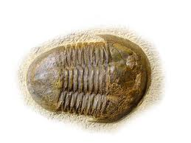Tell the students that we will now look at real fossils of past organisms.
  + Hand out the boxes of fossils (1 box per pair).
  + Tell students to identify each fossil and put it in the correct place on the timeline, using the pictures as a guide.
  + 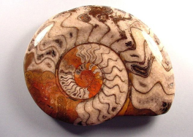Some images are at the right for your reference (top = trilobite, middle = ammonite, bottom = crinoid stem).
  + Walk around helping students as needed, and interact with the students to see what questions or thoughts they have about the fossils.
* 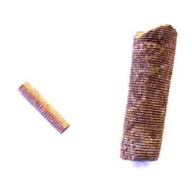After students are finished putting the fossils in their correct locations, tell them to return all of their fossils to the box and to leave the lid off.
  + Go to each group and count the fossils (make sure they are all different and are actually the fossils).
  + If the set is complete, put the lid on the box and place it in the kit.
  + If any fossils are missing and students say they do not know where they are, tell the teacher immediately and have him or her help you find the missing fossils.

**DO NOT CONTINUE UNTIL ALL FOSSILS ARE ACCOUNTED FOR.**

**III. Usefulness of Fossils**

* Q. Why are fossils useful?
  + *Answers will vary, but they should focus on fossils telling us how earth has changed over time. Besides the answers below that we will go over, they might say something about figuring out what organisms ate in the past or where organisms migrated from.*
* Tell students that fossils are useful for:
  + Finding the age of rocks.
  + Learning what type of environment once existed in a region.
  + Showing evidence that species evolve over time.

**A. Dating with Index Fossils**

* Tell students that fossils can be used to determine the age of rock layers - these are called **index fossils**.
  + Not all fossils are index fossils.
  + Fossils are chosen to be index fossils if they:
    - Lived only a short time.
    - Are found in many areas worldwide.
    - Are easy to find (abundant).
    - Are easy to identify.

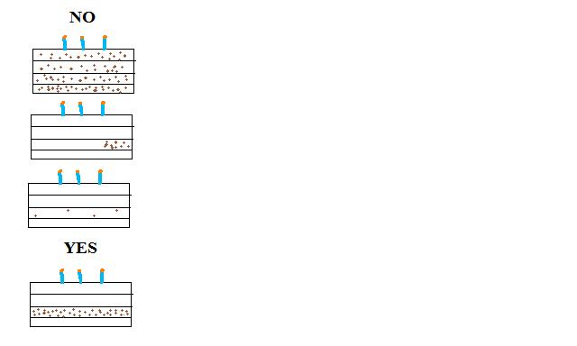

* Perspective: The layer cake
  + Draw a four-layer cake on the board – include candles. (See picture on this page.)
  + You aren’t very hungry and only want to eat the third layer of the cake, which has your favorite food, chocolate chips.
  + To make sure you know that you are eating the right layer:
    - The chocolate chips have to be only in this layer – if they were in all of the layers you wouldn’t know which one was the right layer.
    - The chocolate chips have to be found all throughout the cake, not just in one small area.
    - There has to be lots of chocolate chips in this layer so that they are easy to find.
    - The chocolate chips have to look like chocolate chips.
  + We use the same method to determine which fossils are good index fossils.

**Question 2: What are the four requirements for being an index fossil?**

*Lived only a short time, found in many areas worldwide, easy to find (abundant), and easy to identify*

* Students should now look at the three fossils within the column on Handout #1 (shown on the next page) and predict which fossils are index fossils. Make sure they understand that MYA means “millions of years ago,” and that the black bars represent the length of time fossils of this type formed.
  + The timeline on Handout #1 is reproduced below.
  + Hint – look for where the “chocolate chips” (i.e. the fossils) are only in one layer of the “cake” (i.e. the timescale).

|  |  |  |  |  |  |
| --- | --- | --- | --- | --- | --- |
| Today | Ammonite | | | | |
| 50 MYA |  | Ammonites  100 – 65 MYA | | | |
| 100 MYA |  |  | | | |
|  | | |  |
| 150  MYA |  | brachiopod | | | |
| 200 MYA | Brachiopods  510 MYA – Today |  | | | |
| 250 MYA |  |  | | | |
|  | | | |
| 300 MYA |  |  | | | |
| 350 MYA |  |  | | | |
| 400 MYA |  |  | | | |
| 450 MYA |  | trilobite | | | |
| 500 MYA |  |  | | | |
|  | Trilobites  540 – 490 MYA |  | | |
| 550 MYA |  |  |  |  | |
|  | |  |  | |
|  | | | | |
| 4.6 BYA |  | | | | |
|

* Q. Ask students which fossils are index fossils and which are not. For the ones that are index fossils, what time period are they useful for dating the rocks from?
  + Brachiopods are not index fossils because they are in almost every layer of the “cake” (timeline).
  + Ammonites and trilobites are index fossils because they are in just one layer of the “cake” (timeline). Trilobites can be used to date rocks 540 – 490 million years old. Ammonites can be used to date rocks 100 – 65 million years old.

**Question 3: Which fossils on your timeline are used as index fossils?** *Ammonites and trilobites*

**B. Paleoenvironments**

* Q. Ask students if they have ever found a fossil around home or anywhere in Nashville?
  + *If they say yes, ask them what type; ideally they will have found something that looks like a seashell.*
  + Rocks in Nashville have many fossils of brachiopods (clam-like animals), crinoids, and corals that are 400 million years old.
  + 400 million years ago, when these fossils were formed, what was the environment like? Hint – where do clams, crinoids, and corals live today?
    - *Underwater in shallow oceans.*
  + Fossils don’t move from where an organism lived, so what does this say about Tennessee’s location 400 million years ago?
    - *Underwater in a shallow ocean!*
* In Antarctica, dozens of fossil tree stumps have been discovered. Antarctica is covered mostly by ice today and no trees.
  + Q. What must be true about Antarctica’s past climate?
    - *It was much warmer and supported large plant life like trees.*

**C. Evolution**

* Note – if a student asks about creationism during this segment, say that that is a subject for the teacher to discuss and that you instead will finish talking about the uses of fossils, one of which is evidential support for evolution.
* 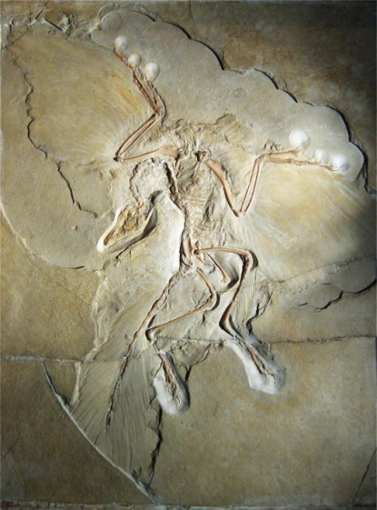One VSVS member should pass out Handout #1 (one per pair) to students as another team member starts this explanation.
* Q. What animals living today are dinosaurs most closely related to?
  + *They will likely answer with some sort of reptile. Graciously say that no, this is not the case, and to hold on for an explanation.*

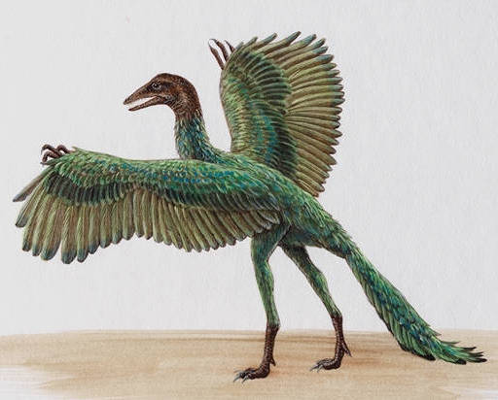

* Tell students to look at the picture of a fossilized *Archaeopteryx*, a type of ancient dinosaur (Handout #1, pictures to the right).
  + Q. Ask the students to talk with their partner about what groups of animals living today this creature most looks like. Hint – look at its arms and the way they are spread out, almost as though it was “flapping” them.
    - *The fossil has bird-like characteristics (wings) as well as those of dinosaurs.*

This is the *Archeaopteryx* (ARE-kee-OP-ter-rix), a transitional fossil between dinosaurs and birds. It has characteristics of dinosaurs like sharp teeth and a dinosaur-like head, but it contained many feathers which were modified scales (and still are on modern birds). Above is an artist’s reconstruction drawing based on several fossil specimens.

* This is evidence that the few dinosaurs that survived the mass

extinction evolved into birds, not reptiles. So birds are

actually the closest ancestors of the dinosaurs, not reptiles!

* Tell students that the picture on Handout #1 next to the fossil

is what scientists think the *Archaeopteryx* looked like while

living. Note the wings!

* Answer any further questions students have about any topics that were covered in the lesson.

Lesson written by: Pat Tellinghuisen, Coordinator of VSVS, Vanderbilt University

Courtney Luckabaugh, Lab Manager of VSVS, Vanderbilt University

Edited by: Kyle Broach, VSVS Training Committee, Vanderbilt University

Lucas Loffredo, VSVS Training Committee, Vanderbilt University

We gratefully acknowledge the assistance of Dr. Molly Miller, Professor of Earth & Environmental Sciences, Vanderbilt University.

Reference:Chernicoff, S., & Whitney, D. (2007). *Geology: An Introduction to Physical Geology.* Upper Saddle River, New Jersey: Pearson.