**VANDERBILT STUDENT VOLUNTEERS FOR SCIENCE**

[**http://studentorgs.vanderbilt.edu/vsvs**](http://studentorgs.vanderbilt.edu/vsvs)

**NEWTON’S SECOND LAW**

**Rubber-band Propelled Caps**

**Vinse TN-SCORE Fall 2014**

**Goal:** To investigate a relationship between the input force and the acceleration of a mass. This relationship is described by Sir Issac Newton’s Second Law of Motion, known by its equation: **F= ma**

**Materials (10 groups):**

10 Block Launchers (wooden block with four nails)

1 ball yarn– students cut their own lengths (or fishing line)

10 1oz cups with 5 gm mass added

10 1oz cups with 10 gm mass added

10 1oz cups with 20 gm mass added

10 plastic bags containing 3 Identical Rubber Bands

10 Tape measures

10 pairs Scissors

1 bag containing extra rubber bands

**Background:**

Write the following equations on the board and tell the students that they are the mathematical relationship of Newton’s Second Law of Motion:

*Force = Mass * Acceleration F=M*A A =*

In the experiment that the students are going to do, the mass is initially at rest, so the initial velocity is zero. Similarly, the initial distance and time are zero.

Put these equations on the board and tell the students that these relate time and distance together.

Velocity (final) = distance / time, V= D/t

Acceleration = velocity (final)/time, A=V/t

Then the acceleration is directly proportional to the distance travelled.

The lesson consists of two different trials:

In the first trial, the input force will be held constant by using one rubber band to launch the cups and changing the masses incrementally (5, 10, and 20 grams).

In the second trial, the mass of the container will be held constant as the input force is varied by using one, two, and three rubber bands to launch the cup.

The focus of the two trials is to observe what happens to (acceleration and) distance traveled when either the input force increases or when the mass increases.

**Make a Prediction**

Have the students use the equation:

Input Force = (Mass of object) x (Acceleration of object), F= ma

to predict what they think will happen in the experiment in terms of the variables.

When the input force INCREASES and the mass is held CONSTANT, the distance the mass travels will (*increase)*.

When the mass INCREASES and the input force is held CONSTANT, the distance each mass travels will *(increase)* from smallest mass to largest mass.

**Visual Demonstration (Optional)**

If there is a chair with wheels in the class, bring it to the front of the room. Ask a smaller student to sit in the chair and have another student push it with a somewhat constant force. Now, have a larger/taller student or two students sit in the chair and have the same student as before push the chair again with the added mass. Discuss the results with the class using terms from the prediction.

**Setup**

**NEW: In VSVS trials, we got better results when the board was put on a table rather than on the floor. Place the board at the edge of the table and measure the position on the floor where the cup first lands. Do not count any added distance the cup may roll.**

1. Stretch the rubber band(s) across the first and second nails.

2. Pull the rubber band(s) back behind the third nail, and TIGHTLY tie the string into place, preferably keeping the knot behind the fourth nail so it does not impede the cutting process. If you do this step correctly, there will only be ONE KNOT!

3. Carefully place the rubber band(s) in front of the third nail.

4. Put the plastic cup so that it is touching the rubber band(s), and centered in the middle.

NOTE: Try to keep multiple rubber bands stacked evenly over one another for accurate fire power. Also, try to center the rubber bands to strike the middle of the projectile block upon firing.

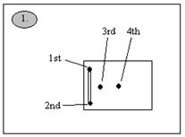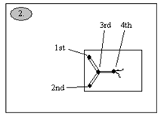 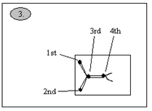

**Procedure (Part 1)**

1. Stretch one rubber band across the first and second nails, and complete the setup.

2. Place the cup containing the 5gm mass and put it against the rubber band.

3. Use scissors to cut the string between the third and fourth nails.

4. Measure the distance the cup traveled.

5. Record your data into the table below.

6. Repeat steps 2-5 using the cups containing the 10gm and 20gm masses,

|  |  |  |  |
| --- | --- | --- | --- |
| Trial | 5g Distance (cm) | 10g Distance (cm) | 20g Distance (cm) |
| 1 |  |  |  |
| 2 |  |  |  |
| 3 |  |  |  |
| Average |  |  |  |

**Procedure (Part 2) – use the 10 gm mass for all trials.**

1. Stretch one rubber band across the first and second nails, and complete the setup.

2. Place the cup containing the 10 gm mass against the rubber band.

3. Use scissors to cut the string between the third and fourth nails.

4. Measure the distance the cup traveled.

5. Record your data into the table below.

6. Repeat steps 2-5 using two rubber bands, then three rubber bands.

|  |  |  |  |
| --- | --- | --- | --- |
| Trial | 1 RB Distance (cm) | 2 RB Distance (cm) | 3 RB Distance (cm) |
| 1 |  |  |  |
| 2 |  |  |  |
| 3 |  |  |  |
| Average |  |  |  |

**Graph it!**

Use the data from the tables to complete the graphs. For distance, use the averages.

Draw a best-fit line for your points after they are plotted.



Here are two sample graphs for this experiment recorded in the lab.



**Questions**

Look at the graphs. What can you infer about the relationship between increasing input force with constant mass? About increasing mass with constant input force?

BONUS: Newton’s First Law of Motion states that an object in motion will remain in motion until another force acts upon it. Your projectile is the object in motion. What force acts on the cup to stop it?

**Conclusions**

From the linearity of the graphs, students will see that as the mass increases and the input force (1 rubber band) is held constant, the distance traveled by the cup + mass will decrease.

As the input force increases (# rubber bands) and mass is held constant, then the distance the cup travels increases as well.

In this experiment, acceleration can be directly correlated with distance travelled.

Mass and input force both affect the distance the cup is able to travel.

The bonus question regarding Newton’s First Law of Motion refers to **friction.**

Friction is the force that slows or stops objects from being in motion.

Lesson written by: Jason Wong, Vanderbilt University Undergraduate student, 2012

Frank Merendino, NSF Undergraduate Teaching Fellow, 2004

Jeff Bary, NSF Graduate Teaching Fellow, 2003

**Rubber Band Projectile Worksheet**

**Part 1. Keeping the Force (One Rubber Band) Constant and Changing the Mass.**

**Data Table for Part 1.**

|  |  |  |  |
| --- | --- | --- | --- |
| Trial | 5g  Distance (cm) | 10g  Distance (cm) | 20g  Distance (cm) |
| 1 |  |  |  |
| 2 |  |  |  |
| 3 |  |  |  |
| Average |  |  |  |

Use the averaged data from the tables to complete the graphs.

Draw a best-fit line for your points after they are plotted.

**Part 1: Distance vs. Mass (for 1 RB)**

0

10

20

30

40

50

60

0

5

10

15

20

25

30

**Mass (g)**

**Distance (cm)**

Look at your graph. What can you infer about the relationship between increasing mass with constant input force? ________________________________________________________________________________________________________________________________________________

**Part 2. Changing the Input Force**

**Data Table for Part 2**

|  |  |  |  |
| --- | --- | --- | --- |
| Trial | 1 RB  Distance (cm) | 2 RBs  Distance (cm) | 3 RBs  Distance (cm) |
| 1 |  |  |  |
| 2 |  |  |  |
| 3 |  |  |  |
| Average |  |  |  |

Use the averaged data from the tables to complete the graphs.

Draw a best-fit line for your points after they are plotted.

**Part 2: Distance vs. Input Force**

0

50

100

150

200

250

0

0.5

1

1.5

2

2.5

3

3.5

**Input Force (# RBs)**

**Distance (cm)**

**Questions**

Look at your graphs.

What can you infer about the relationship between increasing input force with constant mass?

________________________________________________________________________

How is distance a factor in Newton’s Second Law of Motion? What happened to acceleration in each part of the experiment? ________________________________________________________________________________________________________________________________________________

**Instruction Sheet Newton’s Second Law**

**(Rubber-band Propelled Caps)**

**Background:**

Force = Mass * Acceleration

Note: the mass is initially at rest, so the initial velocity is zero. Similarly, the initial distance and time are zero.

Since Acceleration = velocity (final)/time, A=V/t and Velocity (final) = distance / time, V= D/t

Then the acceleration is directly proportional to the distance travelled.

**Make a Prediction**

Use the equation, F= ma to predict what you think will happen in the experiment in terms of the variables.

eg, when the input force INCREASES and the mass is held CONSTANT, the distance the mass travels will ?

when the mass INCREASES and the input force is held CONSTANT, the distance each mass travels will *(?)* from smallest mass to largest mass.

**Setup**

1. Stretch the rubber band(s) across the first and second nails.

2. Pull **both parts** of the rubber band(s) back behind the third nail, and loop the string around both parts of the rubber band and tie the string behind the 4th nail. Keep the knot behind the fourth nail so it does not impede the cutting process.

3. Carefully place the rubber band(s) in front of the third nail. The string pieces sit on either of the nail.

4. Put the plastic cup so that it is touching the rubber band(s), and centered in the middle.

NOTE: Try to keep multiple rubber bands stacked evenly over one another for accurate fire power. Also, try to center the rubber bands to strike the middle of the projectile

block upon firing.

**Procedure (Part 1)**

1. Stretch one rubber band across the first and second nails, and complete the setup.
2. Place the cup containing the 5gm mass and put it against the rubber band, in front of the 3rd nail.

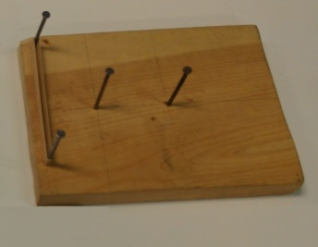

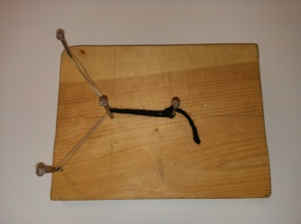

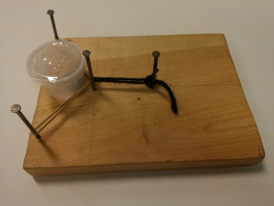

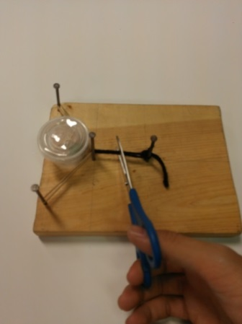

1. Use scissors to cut the string between the third and fourth nails.
2. Measure the distance the cup traveled.
3. Record your data into the table below.
4. Repeat steps 2-5 using the cups containing the 10gm and 20gm masses,

**Procedure (Part 2) – use the 10 gm mass for all trials.**

1. Stretch one rubber band across the first and second nails, and complete the setup.

2. Place the cup containing the 10 gm mass against the rubber band.

3. Use scissors to cut the string between the third and fourth nails.

4. Measure the distance the cup traveled.

5. Record your data into the table below.

6. Repeat steps 2-5 using two rubber bands, then three rubber bands.

**Graph it!**

Use the data from the tables to complete the graphs. For distance, use the averaged data.

Draw a best-fit line for your points after they are plotted.