VANDERBILT STUDENT VOLUNTEERS FOR SCIENCE
http://studentorgs.vanderbilt.edu/vsvs
Carbon Dioxide Properties
Elementary Grade
2013

Goal: To introduce students to various properties of CO₂ .
Fits Tennessee standards

LESSON OUTLINE
I. Introduction
Give students some background information about Carbon Dioxide
II. Comparing Dry Ice to H₂O Ice – Divide Students into 8 Groups.
Students observe a piece of Dry Ice and a piece of H₂O ice that have been placed in separate ziploc bags. The ziploc bag containing Dry Ice inflates from CO₂ gas given off when Dry Ice sublimes. Dry Ice doesn’t leave behind a liquid when it melts because it sublimes.
III. CO₂ as a Fire Extinguisher - Demonstration
Use the CO₂ gas given off from Dry Ice to extinguish a candle.
IV. Chemical Reaction to Produce CO₂, Demonstration
Students mix vinegar and baking soda and observe the production of CO₂ gas.
VI. CO₂ Foam
This activity is done in pairs. Students mix baking soda, gelatin, and alum, and then add vinegar. This forms a foam because the gelatin and alum form a solid matrix for the CO₂ gas released when vinegar reacts with baking soda.
VIII. Review

Materials:
1 trash bag for used cups
1 Bag containing:
1 small tea candle
1 box of matches
1 aluminum pan (small)
- styrofoam cup containing dry ice
- styrofoam cup containing regular ice
1 pairs gloves for VSVS members
30 plates
2 quart ziploc bags
1 quart-sized container of cabbage juice extract
30 6oz squat clear plastic cups (to be 1/3 filled with cabbage juice water)
16 3.5 oz cups marked to 50 mL line (vinegar added)
30 straws
1 medium (quart) bottle of vinegar
16 16 oz. clear plastic cups
1 container of baking soda (10 heaping spoonfuls are needed)
1 container of alum (10 heaping spoonfuls are needed)
1 container of gelatin (10 heaping spoonfuls are needed)
18 plastic spoons (3 to measure alum, baking soda, gelatin; 16 for pairs to use as stirrers)
32 Observation Sheets
1 Answer Sheet for VSVS Team (in page protector)
Preparation for this lesson:
1. One VSVS volunteer will fill the 6oz cups 1/3 full with red cabbage juice (1 per student).
2. Another volunteer will need to pour about 50 mL vinegar into 13 3.5 oz. cups (to the line marked on the cup) (1 per pair). Set these cups aside until time for the CO₂ Foam experiment in Part V and VI.
Divide the students into pairs.
While one team member starts the introduction, another should write the following vocabulary words on the board: dry ice, carbon dioxide, solid, liquid, gas, sublime, physical change, chemical change
Whenever possible, refer to vocabulary words throughout the lesson and during review.

Draw the thermometer diagram on the board
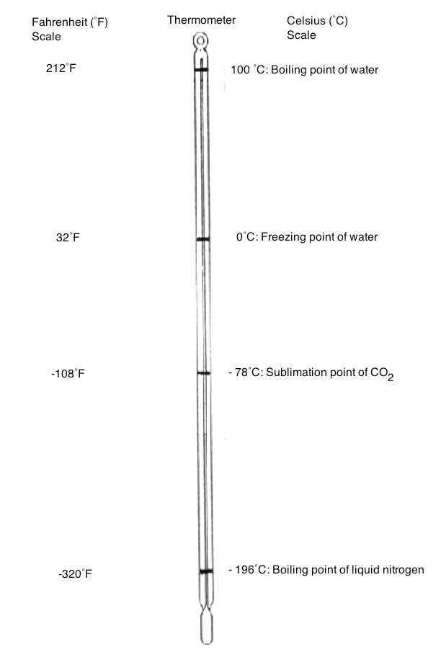

I. Introduction
Background on CO₂
Note: In this lesson use the words carbon dioxide and the term CO₂ interchangeably so the students will become familiar with both.
- Write CO₂ on the board and ask students: What is CO₂? carbon dioxide
- Ask students: What do the C and the O stand for? C stands for carbon and O stands for oxygen
- Ask students: What does the ₂ stand for? "2" means 2 O’s for every 1 C

- Ask students: What do you know about CO₂?
Share the following information if it is not mentioned in the discussion:
  - Humans inhale oxygen and exhale CO₂.
  - Plants use CO₂ to carry out the process of photosynthesis. The photosynthesis reactions of plants convert carbon dioxide to oxygen.
  - CO₂ is solid at –108° F or –78° C.
  - CO₂ is a gas at room temperature.
  - CO₂ dissolves in water and is what gives fizz to carbonated drinks.

- Ask students: What is dry ice?
Share the following information if it is not mentioned in the discussion:
  - Dry ice is solid CO₂.
  - Dry ice is called "dry” because it changes directly from a solid to a gas (sublimes) without passing through the liquid phase.
  - Dry ice is very cold – much colder than water ice. Refer to the thermometer diagram on the board and show the students where the freezing point of water and dry ice are.
  - It is used as a refrigerant to keep ice cream cold in display cases where ice cream cones and dishes are sold.
Safety Note: Students should not hold pieces of dry ice. The temperature of dry ice is -78° C, and students could get frostbite burns if their skin is in contact with dry ice for more than a few seconds.

II. Comparing Dry Ice to H₂O Ice: Observing Melting and Sublimation Demonstration
Materials
1 plate
4 pieces of dry ice
4 small piece of H₂O ice
2 quart sized ziploc bags
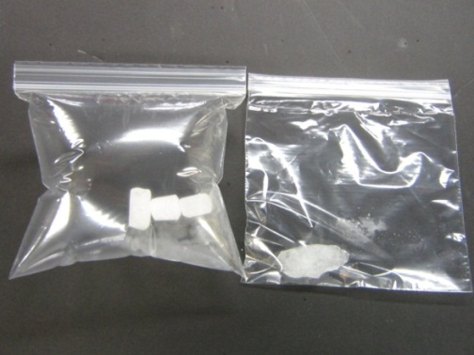
- Using gloves, a VSVS volunteer should place the pieces of dry ice in the ziploc bag and close the ziploc fastener.
- Also, place pieces of H₂O ice (use spoons) in the other ziploc bag and close the ziploc fastener.
- Hold the bags up in the air so that all students can see them.
- Ask the students to describe the appearance of the two types of ice.
- Ask students to observe both pieces of ice in the ziploc bags for a few minutes.
- Have students describe what happens and record observations on the Observation Chart.

Observation: The dry ice ziploc bag will inflate whereas the water ice bag does not.
Explanation: Room temperature is around 20°C. Dry ice sublimes at -78°C so CO₂ gas is filling the bag.
Ask students: is this a chemical or physical change? Physical
Ask students to note the (absence of) color of the CO₂ gas – the gas is not visible.

Open the ziploc bags and carefully empty the pieces of dry ice and ice onto the plate. Set aside to look at later in the lesson.

Other observations that students might make:
“Smoke” comes off the dry ice.
Explanation: This is caused by tiny ice particles that form because the cold carbon dioxide gas coming off dry ice cools the water vapor in the air around the dry ice , causing it to first condense into tiny droplets and then to form tiny particles of ice. Emphasize that students are NOT seeing CO₂ gas (it is colorless).

Later when the two pieces have disappeared, the students will notice a puddle where the H₂O ice was and there will be no puddle where the dry ice was.
Explanation: Students should recall that dry ice sublimes (becomes a gas without passing through the liquid phase), thus it does not leave a puddle. Regular ice leaves a puddle because solid ice turns to a liquid at temperatures above 0°C.
Ask students if these are physical or chemical changes? Physical changes
Background for VSVS students only: Dry ice actually does have a liquid state which can be observed at room temperature and 5 atmospheres of pressure.

III. Demonstration: CO₂ as a Fire Extinguisher
Materials:
1 aluminum pan
1 tea candle
1 box of matches
1 styrofoam cup of Dry Ice
1 aluminum pan (small)

- Place a small candle on a safe surface (aluminum pan) and light the candle. You may need to place a chair on a table so the candle will be visible to students.
- Ask students to predict what will happen when CO₂ from the Dry Ice reaches the candle. Accept logical responses and ask students to give reasons for their predictions.
- Hold the container of Dry Ice near the candle. Open the container of Dry Ice.
- Let the CO₂ from the Dry Ice float onto the candle to extinguish it. You may need to tilt the container so the CO₂ will float down to the candle.
- Ask students: Why did the flame go out? CO₂ is a good fire extinguisher because CO₂ is heavier than air. The CO₂ deprives the candle of the O₂ needed to keep it burning. This causes the flame to be extinguished.
- Have students record observations on their observation chart.

IV. Carbon dioxide makes water more acidic
Materials for 25 students
  - 500 container red cabbage juice solution is this enough?
- clear 6 oz. plastic cups containing red cabbage juice
25 straws
25 plates

Show students a cup of the purple cabbage juice and tell them that it will change color depending on how acid it is. Tell students that the purple liquid is made from cabbage juice. Since it comes from a science lab, it must not be drunk (the cups may be “dirty”, the cabbage juice was not prepared in a clean kitchen). Tell students that they can prepare the red cabbage juice at home by boiling leaves of red cabbage and keeping the liquid.
Show students the color chart and point out the color of neutral cabbage juice. Put a piece of dry ice in the demo cup and have students observe what happens.

Tell students they are going to make the cabbage juice change color with their own breath.
Ask students if they know what gas they breathe out (exhale)? Carbon dioxide
Show students how to put the straw into the cup of cabbage juice so that the straw goes all the way to the bottom of the cup.
Tell students to blow into the straw until the indicator solution changes color.

Tell students to look at the pH chart and ask
Does blowing into the indicator solution change its pH?
Yes, the color changes, so there must be a change in pH, too.
Does the solution become a little more acidic or a little more basic?
The color change shows that the solution is a little more acidic.

Tell students that a chemical reaction occurs between the molecules of CO₂ and the molecules of H₂O to create a very small amount of an acid called carbonic acid (H₂CO₃).

VI. CO₂ Foam – if time permits
Materials
8 16 oz. plastic cups
8 3.5 oz. plastic cups of vinegar
8 plastic spoons
8 plates
1 container of alum (with a spoon)
1 container of gelatin (with a spoon)
1 container of baking soda (with a spoon)

Demonstration: Chemical Reaction to form CO₂
Materials
1 plate 1 spoon
1 16 oz. clear plastic cup 1 container of baking soda
1 bottle of vinegar 1 3.5 oz cup containing 50 mL vinegar

- Place a 16 oz. clear plastic cup on a plate.
- Put a spoonful of baking soda (NaHCO₃) in the cup.
- Ask students to predict what will happen when you add vinegar to the baking soda (Most students have done this before and will know that bubbles will form.)
- Add 50 mL of vinegar.
- Ask students: What is the gas that is formed? CO₂ gas is formed

Explanation: An acid reacts with baking soda to give carbon dioxide gas. Vinegar is an acid (5% solution of acetic acid in water).
Ask students if this is a physical or chemical change? Chemical – new substances are formed.

Activity (done in pairs).

- Give each pair a plate, 1 16 oz. plastic cup, and a spoon.
- Have students place the cup on the plate.
- Three VSVS volunteers should take the containers of dry ingredients (alum, gelatin, and baking soda) around to each group and put one level spoonful of each of the three solid ingredients into each group’s cup.
- Tell students to stir the solid ingredients when they have received all three.
- Give each group a 3.5 oz. cup of vinegar (filled to the 50 mL mark by a volunteer before the lesson began)
- Have one student in each group add the vinegar slowly and have the group observe what happens.
- Have students record their observations on their observation sheet.
- Have a student share a description of what happened.
- Ask students: Which substances react to produce the carbon dioxide gas? vinegar and baking soda

Explanation:
This foam lasts a long time because the gelatin and alum add body to the foam. The gelatin and the alum trap the carbon dioxide bubbles to give a solid foam. The carbon dioxide gas is the gas in this foam. This gas was produced by combining the vinegar and baking soda.
Students may be curious about the alum and gelatin. Alum is used in making pickles and gelatin is in Jello.
This type of foam is used to put out fires and to foam down runways for emergency airplane landings. Regular fire extinguishers are labeled carbon dioxide and contain carbon dioxide gas under pressure. The foam made in this experiment contains carbon dioxide suspended in the gelatin/alum.

Used chemicals can be disposed by pouring them down the sink. If there is no sink in the classroom, put all cups in the plastic trash bag and return everything to the lab for cleaning and re-use.

Lesson written by Pat Tellinghuisen, Director of VSVS, Vanderbilt University
Dr. Melvin Joesten, Emeritus Professor, Chemistry Department, Vanderbilt University

Parts of lesson adapted from www.middleschoolchemistry.com/lessonplans/chapter6/lesson10

Properties of CO₂ - Observation Sheet
Name________________________________________________________________
Make observations for the different activities and write “yes” or “no” if the changes are physical or chemical.

Lesson Activity | Observations | Physical  Change | Chemical  Change
III. CO₂ as a Fire Extinguisher
a) What changes occur when the candle is burning?
b)What changes occur when CO₂ gas is “poured “ over flame?
V. Vinegar with Baking Soda
What happens?
VI. CO₂ Foam
What changes occur when vinegar is added to the alum, gelatin and baking soda mixture in the cup?

Properties of CO₂ - Answer Sheet
Names________________________________________________________________

Lesson Activity | Observations | Physical  Change | Chemical  Change
III. CO₂ as a Fire Extinguisher  a) What changes occur when the candle is burning? | Wax melts  Burning candle wick and melting wax burn to give CO₂ gas and H₂O vapor | yes  no | no  yes
b) What changes occur when CO₂ gas is “poured” over flame? | CO₂ is heavier than air and does not support combustion, so it put out the flame. | yes | no
V. Vinegar with Baking Soda  What happens? | Acid in vinegar reacts with baking soda (sodium bicarbonate) | no | yes
VI. CO₂ Foam  What changes occur when vinegar is added to the alum, gelatin and baking soda mixture in the cup? | Vinegar reacts with the baking soda to produce carbon dioxide gas.  (For VSVS members only: Alum and gelatin do not react but form a foam by trapping the carbon dioxide gas bubbles.) | no | yes

