VANDERBILT STUDENT VOLUNTEERS FOR SCIENCE

http://studentorgs.vanderbilt.edu/vsvs

PULLEYS

**Fall 2013**

**Goal:** To understand how pulleys can be used to lift objects; to understand the mechanical advantage of different pulley systems.

Fits Tn State Standards: GLE 0707.11.1 Identify six types of simple machines

GLE 0707.11.2: Apply the equation for work in experiments with simple machines to determine the amount of force needed to do work

Lesson Outline:

1. Introduction

Discuss the six classes of simple machines.

1. Tug of War Demonstration
2. Using the Spring Balance

Have students practice using the spring balance with the 200-gram mass.

1. Single Fixed Pulley

Measure the force needed to lift a mass with a single fixed pulley. Students follow diagrams as VSVS volunteer demonstrates. Discuss results, including mechanical advantage and the system's usefulness.

1. Single Movable Pulley

Measure the force needed to lift a mass with a single movable pulley. Students follow diagrams as VSVS volunteer demonstrates. Discuss results, including mechanical advantage and the system's usefulness.

1. Single Fixed Pulley with Single Movable Pulley

Measure the force needed to lift a mass with a single fixed pulley and a single movable pulley system. Students follow diagrams as VSVS volunteer demonstrates. Discuss the results and the reason for using this pulley system.

1. Double Fixed Pulley with Single Movable Pulley

Measure the force needed to lift a mass with a double fixed pulley and single movable pulley system. Students follow diagrams as VSVS volunteer demonstrates. Make sure the system is used correctly. Discuss results, including mechanical advantage and the system's usefulness.

1. Review

Review mechanical advantage and the data entries on the observation sheet. Connect the different experiments with the goals of the lesson.

1. Optional Pulley Activities

Demonstrate the double fixed pulley with the double movable pulley and the triple fixed pulley combined with the double movable pulley.

Materials:

**8** pulley stands with a short string attached to ring A and a long string attached to ring C

(Each of these strings has a paper clip on the loose end.)

**2** pieces of PVC pipe

**1** rope

**1** pair of gloves

**8** large ziploc bags containing:

1 200g spring balance

1 200g mass

2 single pulleys

1 double pulley

1 short string with paper clips on both ends (wound around a straw)

1 long string with paper clips on both ends (wound around a straw)

**1** ziploc bag containing:

1 triple pulley

1 long string with paper clips on both ends (wound around a straw)

Students need their own calculators

**30** pulley data sheets

**15** sets of Pulley System Diagrams (in sheet protectors and on a ring) - one set for VSVS volunteers

**30** optional activity worksheets

**Management Notes:**

The class should be divided into **8 groups of 3-4** students. Have the teacher assist in organizing the students into groups or request that the teacher group the students prior to your arrival.

**All VSVS volunteers need to know how to do this experiment. Study the diagrams carefully as you are reading through the lesson.**

Student groups will need close supervision during these activities. The materials may be difficult for some students to manipulate and some groups may have difficulty following the diagrams and instructions for each pulley system**.**

**VSVS members should each supervise one or two groups of students to ensure that the groups are following instructions and using materials properly to achieve appropriate results.**

### I. Introduction

* Ask students to name the six classes of simple machines. *Inclined plane, wedge, screw, lever wheel and axle/pulley*
* Ask students why we use machines?  *to make work easier*

Write the definitions of work on the board:

* work = force x distance W = Fd
* **Work** is only done when the **force** exerted on an object is done over a **distance.**
* **The Law of Conservation of Energy** states that energy cannot be created or destroyed.
  + So the work done by a machine cannot be greater than the work done on the machine.
    - work input = work output
    - OR, input force x distance = output force x distance
    - So when the distance is increased, the input force decreases.
  + Machines do NOT decrease the amount of **work** you have to do, but change the way a **force** is applied.
  + They make work easier by allowing a force to be applied over a greater distance or by changing the direction of the input force.

Example: It takes just as much **work** to lift a box up 1 meter, as it does to drag it up a ramp that is raised to 1 meter in height.

But in the case of the ramp, the **distance** the box is moved is longer, and so the **force** needed is less.

* Ask students to tell what they know about pulleys.

Include the following in the discussion:

* Pulleys are simple machines that are used in different ways to lift objects.
* A string, rope, belt or chain passing around a wheel is the simplest pulley.
* Pulleys can change the direction of a force and can make it easier to lift heavy objects.
  + A **single** pulley can either change the direction of a force or can make it easier to lift heavy objects. A **single** pulley cannot do both at the same time, whereas combinations of pulleys can.
  + A **fixed** pulley is attached to a support and does not move. (Show fixed pulley)
  + A **movable** pulley is attached to the object and moves along with the object.
* Ask students to name some examples or uses of pulleys. *Flagpole, hoisting sails, traction of broken bones of hospital patients, mini-blinds on windows, stage curtains, pulling cable cars, cranes, and others*

### II. Tug of War: Demonstration

## Materials:

2 PVC pipes

1 Rope

1 Pair of Gloves

* Arrange the PVC pipes as shown in the diagram. Tie the rope to one pipe and wind it around the pipes several times.
* Pick one of the smaller students to pull the rope. **The student MUST use the gloves to prevent rope burns.**
* Two VSVS members or teachers each hold one of the PVC pipes and pull in opposite directions, trying to separate the pipes. At the same time the student volunteer, standing alongside one of the VSVS members or teacher, grips the free end of the rope with both hands, and pulls on the rope in an attempt to draw the pipes closer together. (The student is easily able to prevent the VSVS members or teachers from pulling the pipes apart.)
* Unwind the rope until it is only around the pipes once. Then ask the student volunteer to try again. (This time the student volunteer will not be able to prevent the VSVS members or teachers from separating the pipes.)
* Try winding the rope around the PVC pipes, one wind at a time, to demonstrate how it becomes easier for the student volunteer with each wind of the rope.
* Ask students why the student volunteer was able to prevent the pipes from separating the first time and not the second time.
  + Point out that this is a pulley system – rope is used instead of string and pipes are used instead of pulley sheaves.
  + Tell students that **the mechanical advantage** is increased or decreased by changing the number of turns of the rope around the PVC pipe (pulley). Students will learn more about mechanical advantage as the lesson progresses.



### III. Using the Spring Balance

* Distribute to each group: 1 pulley stand, 1 large ziploc bag containing pulleys and strings, pulley data sheets (1 per student), and 2 sets of diagrams of pulley systems. The extra sets of diagrams and calculator are for the instructors.
* Have students place the pulley stands near the edge of the table, **lettered side facing the edge.**
* Have students unpack the group’s bag and lay out the materials with the pulleys together, the 200g mass sitting with recessed end down and hook up, two strings (one long and one short, wrapped around straws), and one spring balance.

**Note:** A VSVS volunteer should hold up the components to make sure students understand the different types of pulleys - single pulley, double pulley. The mass needs to sit flat on the recessed end with the hook up.

Have students examine the spring balance.

1. Have students arrange the handle so it hangs properly (some handles may have slipped).
2. Instruct students to hold the spring balance by the handle**.**
3. Notice that the spring balance goes from 0 to 250g and 0-2.5 Newtons.
4. **Tell students that they will be recording measurements in Newtons.**
5. The zero needs to be checked and possible adjusted.
6. Show students how to adjust the zero by gently twisting the plastic screw on the top of the scale until the blue plastic disc inside the tube and the zero marking are aligned. Tell students that the plastic disc should always start out even with the 0 mark.
7. Tell students that they must "zero the balance" each time they measure.
8. Check to make sure student groups do this correctly. Some students may need help in reading the increments of the scale on the spring balance.

**Weighing with the Spring Balance**

1. Have students hold the spring balance by the top metal ring.
2. Practice measuring the force needed to lift the 200g mass by hooking the spring balance to the hook on the mass and carefully raising the spring balance until the mass is hanging freely (about one inch or 2.5 cm off the table). Keep arm still to get a good reading. Every student should have an opportunity to use the spring balance to do this.
3. Record the reading in the **Output force** column on the pulley data sheet. (If student readings are a little less than 2N, ask them to round up to 2N for this column.) Tell students that this is the **Output Force** for all the experiments, and to fill in all the lines in column 1.
4. Readings by different group members should be very close to 2N. If the readings are not close to 2N, the group should recheck the zero and repeat the exercise. It is important to keep your arm still to get an accurate measurement; otherwise the tab will go below 2.
5. Explain that gravity is the force pulling on the spring scale. If you were to remove the mass and pull down on the spring scale, your muscles would be providing the force.

**IV.** Single Fixed Pulley: Measuring the force required to lift a mass with a single fixed pulley.

Note: VSVS volunteers should demonstrate all procedures in Parts I and II so the students will understand what to do. One person should call out instructions for each activity while others monitor the groups to ensure that students are following the diagrams and directions for all experiments.

Make sure that the students take turns manipulating the materials. The students who are manipulating the materials should face the side of the pulley system that has the letters A, B, and C above the rings.

## Materials:

1 Single pulley

1 Short string (wound around straw)

* Make sure that the students have placed the pulley stand near the edge of the table with the lettered side facing the students who will be stringing the pulley.
* Have students follow the diagram for the **Single Fixed Pulley** as a teacher gives the following instructions.

|  |  |
| --- | --- |
| Pulley pictures 001  1. Place a single pulley on the middle ring (B) of the stand. Place the 200g mass on top of the #1 written on the base of the stand. | Pulley pictures 002  2. Take the short loose string off the straw. Thread the string over the top of the pulley and gently pull down on the strings (grasp one in each hand just above the paperclips) to keep the string in the groove of the pulley. |
| Pulley pictures 002 new  3. Hook the **left** paper clip to the mass. Keep tension on the string on the right by pulling down gently. | C:\Users\VSVS\Dropbox\Training\Leandra\pulleys 1.jpg  4. Take the spring balance, check the zero, and **hold the balance upside down.** Hook the spring balance onto the **right** paper clip. (Be sure the string is still in the groove of the pulley.) Pull the spring balance down gently until the mass lifts off the platform. Lift about 1” (2-3 cm). Keep the tension on the balance, and take a reading from the balance. |

Tell the students to:

* MAKE SURE THE SPRING BALANCE IS PULLED DOWN TOWARDS THE FLOOR, NOT HORIZONTALLY.
* Take the spring balance reading just as the mass moves off the platform, making sure there is still tension on the string.
* Record the reading in the **“Input Force**” column (column 2) on the Single Fixed Pulley row of the Pulley Data Sheet. (The reading should be 2N, or very close.)
* Groups report the reading to the VSVS volunteer at the board. (8 readings will be noted.)

**Calculations and Discussion of the Single Fixed Pulley**

A.  **Calculating the Average Balance Reading – this step can be skipped if wanted.**

Refer to the eight readings (one from each group) on the board.

* Ask students: How do you calculate an average of the numbers listed on the board?
  + If students do not know, explain that an average is calculated by adding up the individual balance readings (8 readings in most cases) and dividing the total by the number of readings (8 in most cases).
* Give the groups a few minutes to calculate the average balance reading, using a calculator.
* Then call on each group for their average and write it on the board.
* If there is any disagreement, point out the correct value and ask each group to record it on their data sheet in the **Averaged Input force** column (column 3) on the "Single Fixed" row of the Pulley Data Sheet.

# **Mechanical Advantage**

# Ask students if they can explain the term **mechanical advantage**.

* If students do not know about mechanical advantage, tell them that:
  + the mechanical advantage of a machine is the number of times the machine multiplies the input force
  + mechanical advantage tells you how much effort the user saves by using a machine. The more times a machine multiplies the input force, the easier it is to do the job. After all, machines are only helpful if they make our work easier to do.
  + But there is a tradeoff for less input force; the force is exerted over a greater distance.
  + For example, a mechanical advantage of 2 multiplies an input force twice which means that you only exert half the force required to get the job done without the machine; a mechanical advantage of 3 multiplies your input force three times which means you only exert one third of the effort to do the job…..
  + Explain to the students that the mechanical advantage is shown by a number that represents the amount of reduction in force required to lift a given mass.
* The greater the mechanical advantage of a machine, the smaller the amount of force we need to accomplish a task. A good mechanical advantage is greater than 1.

**C. Calculating the Mechanical Advantage**

* Explain to students how to calculate the mechanical advantage.

The mechanical advantage can be found by using the following equation (put on board):

Mechanical advantage (MA) = Output force (in Newtons)

Input force (in Newtons)

* Demonstrate this calculation by writing this example on the board:
  + In the experiment just done with the single fixed pulley, the output force is 2N(ewtons).
  + The input force is the force the student uses to lift the mass with the pulley, and in this case it is the same, 2 N.
  + The MA = 2N/2N = 1
* Explain to students that a mechanical advantage of 1 means that we use the same force to move the mass with the pulley **and** without the pulley.
  + **We do not receive a mechanical advantage when we use a single fixed pulley or when the mechanical advantage is 1.**
* Ask students: Why would you use a single fixed pulley if there is no mechanical advantage?
  + It allows you to change the **direction** in which the input force is applied. For example: Running a flag up a flagpole uses a single fixed pulley at the top of the flagpole. You pull the rope down to make the flag go up. So the distance you pull is the same as the distance the flag moves.
  + The pulley makes the job easier by taking an object to a place that would be otherwise hard to reach.
* Ask students: How many sections of string were supporting the mass? *only 1; the other section was being pulled in the opposite direction and does not count as a supporting string*. It merely changed the direction.
* For advanced students:
  + Tell students that you can tell how much a pulley system will reduce the output force by counting the sections of the string that support the load.
  + However, you do not always count the piece of string you are pulling on. You only count that piece of string when the force exerted is in the same direction that the load (mass) is moved.
  + Since you pulled **down** on the string in this experiment and the mass moved **up**, you do not count this last section of the string.
  + The number of sections of string actually lifting the mass in this experiment would be 1. (Have students look at the diagram on their observation sheet to help them understand this.
* Tell the students to dismantle the setup from section IV. Take off the pulley and the short loose string. Wind the string around the straw and put it back in the ziploc bag.

### V. Single Moveable Pulley

Materials

1 Single pulley

1 Short string attached to the pulley stand at “A”

Have students follow the diagram for the **Single Movable Pulley**.

Demonstrate the following procedure to make sure students understand what they are going to do. After the demonstration, have students follow the procedure.

* Unwind the short string already attached to the pulley stand at “A”.
* Make sure that the students have placed the pulley stand near the edge of the table with the lettered side facing the students who will be stringing the pulley.

**Warning:** The movable pulley might twist around if the student is not holding it properly. Before they take a balance reading, students should make sure that neither the pulley nor the string is twisted.

|  |  |
| --- | --- |
| Pulley pictures 004 new  1. Place the mass on top of the #1 on the base of the stand. Hold the hook above the wheel on the single pulley and hook its bottom hook to the mass.  One student should continue to hold the pulley through diagram #3. | Pulley pictures 017  2 Thread the short string attached at “A” through the bottom of the pulley (from left to right), and slip it in the groove of the pulley.  Grasp the paper clip and hold it up toward the top of the stand. Make sure that the string is in the groove of the pulley. |
| C:\Users\VSVS\Dropbox\Training\Leandra\pulleys 2.jpg | 3. Hold the balance upright and check the zero.  Attach the spring balance to the paper clip that is being held up in the air.  Let go of the pulley.  Slowly raise the balance until the mass is about 1” (2-3 cm) above the base of the stand.  MAKE SURE THE STRING IS PULLED UP, NOT OUT.  Take a reading from the balance. |

Tell the students to:

* Record the reading in the Group Balance Reading column on the "Single Movable” row of the Pulley Data Sheet. (This reading should be approximately 1.2N.)
* Each group should report its reading to the VSVS volunteer who will write the 8 readings on the board.
* Refer to the 8 readings (one from each group) on the board.If anyreading is 1.2+/_ .15, ask that group to take another reading.
* Rewind the short string around the bar near “A”.

**Calculations and Discussion for the Single Moveable Pulley:**

1. Write the 8 balance readings on the board.
2. Guide the groups as they calculate both the average class reading and the mechanical advantage. Each group should record the answers on the data sheet.
3. Write the 8 values calculated for mechanical advantage on the board.
   1. Values for a mechanical advantage of 1.8-1.9 should be 2.0 because the mass of the movable pulley contributes to the reading. Tell students to round the answer to the nearest whole number.
4. Ask students what it means if there is a mechanical advantage of 2.
   1. A movable pulley multiplies the input force by 2. Therefore, you only have to exert half the force to do the same work. You must, however, exert that force for a greater distance. You pull twice as far, but you do not have to pull as hard.
5. Ask students to look at the diagram or the setup and count the sections of string that are supporting the mass in this experiment.
   1. This time you count the input force string because it is being pulled in the same direction that the mass is moving - the input force string is going up and the mass is also going up.
6. Ask students if they notice any connection between the mechanical advantage and the numbers of sections of string that support the mass.
   1. They appear to be the same.
      1. 1 section of string bearing the mass = Mechanical Advantage of 1;
      2. 1 section of string bearing the mass plus 1 section redirecting the force, MA = 1
      3. 2 sections of string bearing the mass = Mechanical Advantage of 2.

### VI. Single Fixed Pulley Plus Single Moveable Pulley

## Materials:

2 Single pulleys

1 Long string attached to the pulley stand at “C”

* Guide student groups through the following procedure. Instruct students to follow the diagram for a **Single Fixed Pulley plus Single Movable Pulley** as you give instructions.
* Ask students to look at the last diagram for the Single Fixed Pulley with Single Movable Pulley and predict the mechanical advantage of this pulley system.
* Accept logical answers and ask students why they made that prediction. Have groups write their predictions in the margin outside the proper section of the data sheet.
* Do not tell students the correct answer at this time. Tell them to compare the prediction with the answer at the end of this experiment.
* The correct prediction is 2. Some students may predict 3 if they are confused about counting the input force string. The input force string does not count this time because it is being pulled in the opposite direction of the movement of the mass. See the observation sheet.
* Unwind the long string at “C”.

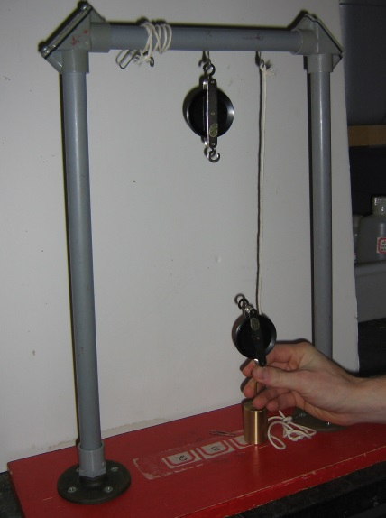

1. Place the mass on the #2 stand on the base of the stand. Hook a single pulley to ring B on the stand. Grasp one of the hooks of the other single pulley and attach it to the mass. (One student should continue to hold it through Diagram #3.)

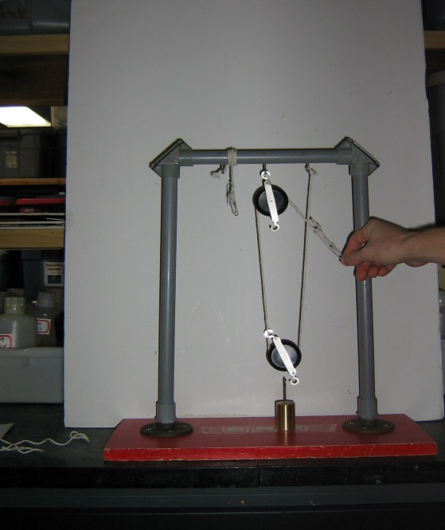

2. Take the long string attached to ring C on the stand and thread the string through the bottom of the lower pulley (right to left) and over the top of the fixed upper pulley (thread from left to right). Grasp the end of the paper clip and gently pull down so the string remains taut.

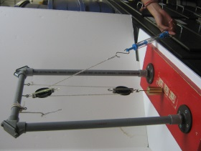

3. Let go of the pulley and make sure the strings are still in the grooves of the pulleys. Zero the spring balance. Hold the spring balance upside down and attach it to the paper clip at the end of the string. Gently pull down until the mass is about 1" (2-3 cm) above the base of the pulley. Take a reading from the spring balance.

* Groups should record the reading balance in the input force column of the data sheet. (The reading should be approximately 1N-1.1N.)
* Report the reading to the VSVS member at the board.

**Calculations and Discussion of Single Fixed Pulley with Single Moveable Pulley**

1. Write the 8 balance readings on the board.
2. Guide the groups as they calculate both the average class reading and the mechanical advantage and record them on the data sheet. (Circulate to assist groups with this process.)
3. Write the 8 values calculated for mechanical advantage on the board. (Values for mechanical advantage should range from 1.6-2.0 because the mass of the movable pulley contributes to the reading.) Ask students to round to the nearest whole number (2).
4. Ask students how these results compare with the first two experiments. (The single fixed pulley had a mechanical advantage of 1 in the first experiment. The single movable pulley had a mechanical advantage of 2 in the second experiment. Using both pulleys in this experiment you have a mechanical advantage of 2. This is the same advantage as the single movable pulley alone.)
5. Ask: Why would you use a single movable pulley and a single fixed pulley if the mechanical advantage is the same as just using the single movable pulley?
   1. Movable pulleys cannot change the direction of the input force. A fixed pulley can change the direction.
   2. A greater mechanical advantage can be obtained by combining fixed and movable pulleys into one pulley system. As more pulleys are used, more sections of string are attached to the system and each section helps support the object. Therefore, less force is required to move the object and this increases the mechanical advantage.
6. Ask students to look at the last diagram or the setup and count the sections of string that are supporting the mass in this experiment. Remind them to count the input force string (the section they are pulling on) only if that piece of string is being pulled in the same direction that the mass is moving.
7. This time you do not count the input force string because it is being pulled in the opposite direction that the mass is moving - the input force string is going down and the mass is going up.
8. Dismantle the setup from Section VI. Wind the long string around the bar near ring C.

### VII. Double Fixed Pulley with Single Moveable Pulley

## Materials:

1 Double pulley

1 Single pulley

1 Long string with paper clips on both ends (wound on a straw)

Ask students to look at diagram 4 for the **Double Fixed Pulley with a Single Fixed Movable Pulley** and make a prediction about the mechanical advantage they will find using this pulley system. Accept predictions and ask why they made that prediction.

Instruct students to use the **long** string (the one wrapped around the straw) and follow the diagrams to arrive at a balance reading for this pulley system.

Unwind the long string from the straw.

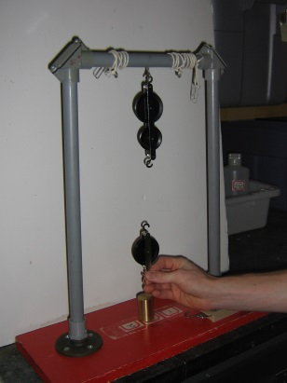

1. Place the mass on the #3 on the base of the pulley stand. Hook the double pulley to ring B on the stand. Hold the top hook of the single pulley and attach the bottom hook to the mass. One student should continue to hold the pulley through diagram #3.

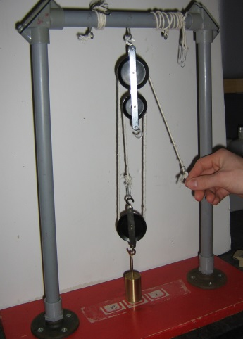

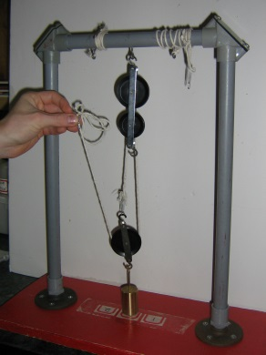

2. Take the long string (from the straw) and attach it to the hook at the top of the single pulley. Thread the string over the lower wheel on the double pulley (from left to right), then down under the single pulley (from right to left)

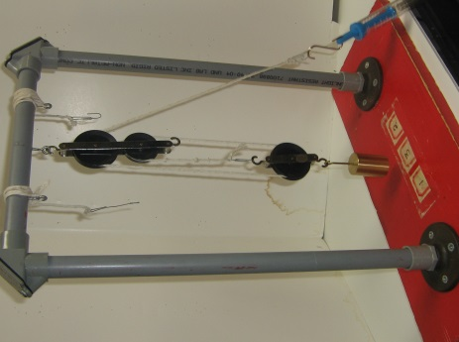

3. Thread the string over the top of the upper wheel on the double pulley (from left to right). Grasp the end of the paper clip and gently pull down so that the string remains taut.

4. Let go the pulley and make sure the strings are still in the grooves of the pulleys. Zero the spring balance. Hold the spring balance upside down and attach it to the paper clip at the end of the string. Gently pull down until the mass is about 1" (2-3 cm) above the base of the pulley. Take a reading from the spring balance.

* Record the reading in the Balance Reading column in the "Double Fixed with the Single Movable" row of the data sheet.
* Tell groups to record the balance reading on the data chart and report the results to the teacher at the board. (The balance reading should be approximately .65 - .70N).

**Calculations and Discussion of Double Fixed Pulley and Single Moveable Pulley**

1. Write the 8 balance readings on the board.
2. Guide the groups as they calculate both the average class reading and the mechanical advantage and record them on the data sheet.
3. Write the 8 values calculated for mechanical advantage on the board. (Values for the mechanical advantage should be approximately 3.)
4. Ask students why they think the mechanical advantage increased. *Adding the extra pulley and using more sections of string helped reduce the input force and increase the mechanical advantage.*
5. Ask students to look at the last diagram on the setup and count the sections of string that are supporting the mass in this experiment. Remind them to count the input force string (the section they are pulling on) if that piece of string is being pulled in the same direction that the mass is moving.
6. This time you do not count the input force string because it is being pulled in the opposite direction from the way the mass is moving - the input force string is going down and the mass is going up.

### VIII. Results

* Discuss mechanical advantage and its relationship to the number of sections of string supporting the mass.
* Mechanical advantage is equal to the number of sections of string supporting the mass in a pulley system.
* Explain to students, "you can't get something for nothing."
* Increasing the mechanical advantage requires that the force be moved through a longer distance. This lesson shows this characteristic by using long and short strings.
* Students should observe that the large mechanical advantage requires movement through a greater distance (use of the long string). In order to use less input force, you must pull the string through a greater distance.

### Optional Activity

* Use the optional activity sheet and the triple pulley if there is time.
* Pass out the Pulley Optional Activity Sheet.
* Have students observe the diagrams and do the calculations
* Discuss the results.

Lesson written by Pat Tellinghuisen, Coordinator of VSVS, Vanderbilt University

Susan Clendenen, Teacher Consultant, Vanderbilt University

Dr. Melvin Joesten, Chemistry Department, Vanderbilt University

**Pulley Data Sheet**

Answer Key

|  |  |  |  |  |  |  |
| --- | --- | --- | --- | --- | --- | --- |
| **PULLEY SYSTEM** | **Output force** | **Input force**  **(Your group’s reading)** | **Average**  **Input Force**  **Reading** | **Allows**  **Change**  **Of**  **Direction** | **Sections**  **Of String**  **Holding**  **mass** | **Mechanical**  **Advantage** |
| Single Fixed | **2N** | **2N** | **2N** | **yes** | **1** | **1** |
| Single Movable | **2N** | **1.2N** | **1.2N** | **no** | **2** | **2 - i.e., twice as easy** |
| Single Fixed with  Single Movable | **2N** | **1N** | **1N** | **yes** | **2** | **2** |
| Double Fixed with  Single Movable | **2N** | **.65N** | **.65N** | **yes** | **3** | **3 - i.e., three times as easy** |

**Pulley Data Sheet**

**Name____________________________**

**Single fixed Single Moveable**

**Input**

**Force =1N**

**Input Input x**

**Mass**

**Mass**

**Mass**

**Force=2N Force=1N**

**Output Force =1 Output Force = 2N Output Force = 2N**

**Mechanical Advantage = 1 Mechanical Advantage = 2 Mechanical Advantage = 2**

|  |  |  |  |  |  |  |
| --- | --- | --- | --- | --- | --- | --- |
| **PULLEY SYSTEM** | **Output Force** | **Input Force (Your group’s reading)** | **Average**  **Input force** | **Allows**  **Change**  **Of**  **Direction** | **Mechanical**  **Advantage** | **Sections**  **Of String**  **Holding**  **mass** |
| Single Fixed | **2N** |  |  |  |  |  |
| Single Movable | **2N** |  |  |  |  |  |
| Single Fixed with Single Movable | **2N** |  |  |  |  |  |
| Double Fixed with Single Movable | **2N** |  |  |  |  |  |

**Instruction Sheet**

**SINGLE FIXED PULLEY**

**Make sure the pulley stand is placed near the edge of the table with the lettered side facing the students stringing the pulley.**

**Materials**

**short loose string (take off the straw)**

**single pulley**

1.Place a single pulley on the middle ring (B) of the stand. Place the weight on the #1

written on the base of the stand.

2. Take the short loose string off the straw. Thread the string over the top of the pulley and gently pull down on the strings (grasp one in each hand just above the paperclips) to keep the string in the groove of the pulley.

3. Hook the **left** paper clip to the weight. Let go of the string on the left, but keep tension on the string on the right by pulling down gently.

4. Take the spring balance, check the zero, and **hold the balance upside down.** Hook the spring balance onto the **right** paper clip. (Be sure the spring is still in the groove of the pulley.) Pull the spring balance down gently until the weight lifts off the platform. Lift about 1” (2-3 cm). Keep the tension on the balance, and take a reading from the balance.

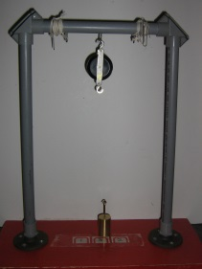

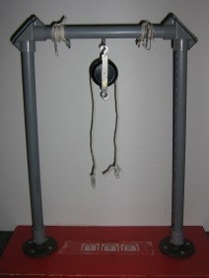

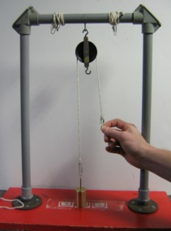

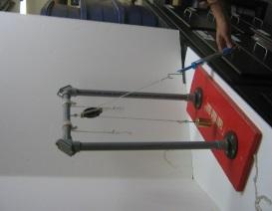

**MAKE SURE THE STRING IS PULLED DOWN, NOT HORIZONTALLY OUT.**

Take the balance reading just as the weight moves off the platform, making sure there is still tension on the string.

* Record the reading in the **“Input Force**” column (column 2) on the Single Fixed Pulley row of the Pulley Data Sheet. (The reading should be 2N, or very close.)
* Groups report the reading to the VSVS volunteer at the board. (8 readings will be noted.)

**SINGLE MOVABLE PULLEY**

**Make sure the pulley stand is near the edge of the table with the lettered side facing the students who will be stringing the pulley.**

**Materials**

**single pulley**

**short string attached to the pulley stand at “A”.**

* Unwind the short string already attached to ring A on the pulley stand.
* **Warning:** On movable pulleys, the pulley might twist around you are not holding it properly. Before they take a balance reading, make sure that neither the pulley nor the string is twisted.

1. Place the weight on the #1 on the base of the stand. Hold the hook above the wheel on the single pulley and hook its bottom hook to the weight. One student should continue to hold the pulley through diagram #3.
2. Thread the short string attached at "A” through the bottom of the pulley (from left to right), and slip it in the groove of the pulley. Grasp the paper clip and hold it up toward the top of the stand. Make sure that the string is in the groove of the pulley.

3. Hold the balance upright and check the zero. Attach the spring balance to the paper clip that is being held up in the air.

Let go of the pulley.

Slowly raise the balance until the weight is about 1” (2 -3 cm) above the base of the stand.

Take a reading from the balance.

MAKE SURE THE STRING IS PULLED UP, NOT HORIZONTALLY OUT.

* Record the reading in the **“Input Force**” column .
* Report the Balance Reading to the VSVS volunteer at the board.
* Rewind the short string around the bar near “A”

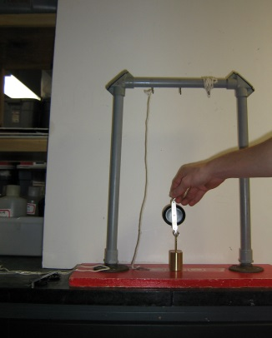

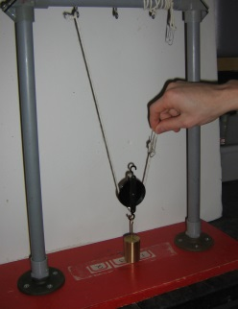

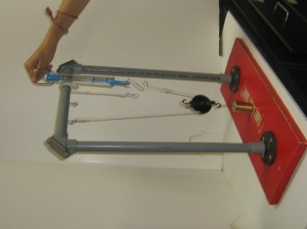

**SINGLE FIXED PULLEY PLUS SINGLE MOVABLE PULLEY**

**Materials**

1. **single pulley**

**1 long string attached to ring C**

* Unwind the long string near “C”.

1. Place the weight on the #2 on the base of the stand. Hook a single pulley to ring B on the stand. Grasp one of the hooks of the other single pulley and attach it to the weight. (One student should continue to hold it through Diagram #3.)
2. Take the long string attached to ring C on the stand and thread the string through the bottom of the lower pulley (right to left) and over the top of the fixed upper pulley (thread from left to right). Grasp the end of the paper clip and pull down gently so the string remains taut.
3. Let go of the pulley and make sure the strings are still in the grooves of the pulleys.

Zero the spring balance. Hold the spring balance upside down and attach it to the paper clip at the end of the string.

Gently pull down until the weight is about 1 inch (2-3 cm) above the base of the pulley.

Take a reading from the spring balance.

* Record the reading in the **“Input Force**” column.
* Report the reading to the VSVS volunteers at the board.

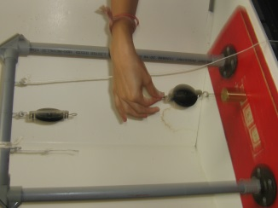

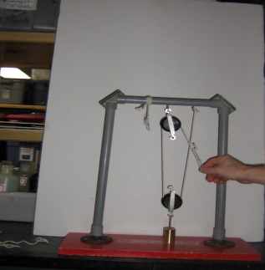

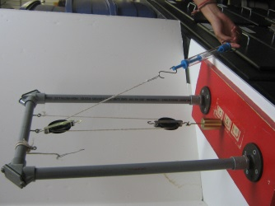

**DOUBLE FIXED PULLEY PLUS SINGLE MOVABLE PULLEY**

**Materials**

**1 double pulley and 1 single pulley**

**long string with paper clips on both ends (wound on a straw)**

* Look at the diagram for the **Double Fixed Pulley with a Single Fixed Movable Pulley** and make a prediction about the mechanical advantage you will find using this pulley system.
* Use the **long** string (the one wrapped around the straw) and follow the diagrams to arrive at a balance reading for this pulley system.
* Record the reading in the Balance Reading column in the "Double Fixed with the Single Movable" row of the data sheet.

1. Place the weight on the #3 on the base of the pulley stand. Hook the double pulley to ring B on the stand. Hold the top hook of the single pulley and attach the bottom hook to the weight. One student should continue to hold the pulley through diagram #3.

2. Take the long string (from the straw) and attach it to the hook at the top of the single pulley. Thread the string over the lower wheel on the double pulley (from left to right), then down under the single pulley (from right to left).

3. Thread the string over the top of the upper wheel on the double pulley (from left to right). Grasp the end of the paper clip and gently pull down so that the string remains taut.

4. Let go the pulley and make sure the strings are still in the grooves of the pulleys. Zero the spring balance. Hold the spring balance upside down and attach it to the paper clip at the end of the string. Gently pull down until the weight is about 1" (2-3 cm) above the base of the pulley. Take a reading from the spring balance.

Record the reading in the **“Input Force**” column

