VANDERBILT STUDENT VOLUNTEERS FOR SCIENCE
http://studentorgs.vanderbilt.edu/vsvs
Rainbows and Color
Elementary school, Spring 2013

Goal:
Standards:

Materials (for 25 students)
13 CD’s (1 per pair)
25 Rainbow glasses
1 commercial color wheel
30 Color Wheel sheets in sheet protectors
9 white Styrofoam plates
- paper towels
9 sets of 3 dropper bottles labeled and filled with red, blue and yellow water
13 mixing palettes
1 bag of toothpicks

- Introduction
Give each student a handout.

- Introducing Rainbows
Ask students: How many of you have seen a rainbow?
What did it look like?
When did you see it?
How many colors did you see?
Can you name any of the colors?

Have you seen a rainbow in other places (not in the sky)?
Answers may include a rainbow, a garden sprinkler, light shining through a prism, or on an oil film.
Tell students to look at the “rainbow” on their handout.

R O Y G B V
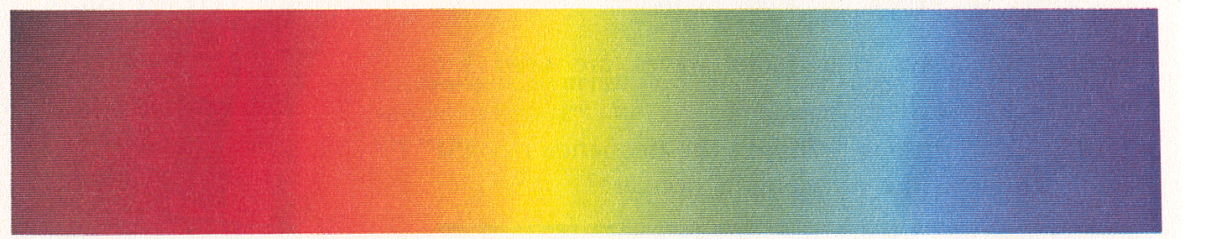

White light contains all of the colors in the visible portion of the electromagnetic spectrum. The visible portion is only a small part of the entire spectrum.

Stress how the colors are always in the same order in a rainbow. (red-orange-yellow-green-blue-and purple).
These 6 colors give color to everything around us.

Ask students: when you look at a light bulb you only see white light. Do you think there might be other colors there?

- Looking at Rainbows through Diffraction Gratings and CD’s

Pass out a CD to each pair of students.
Make sure the students observe the “rainbows” on the shiny side.
Point out that light can be broken into its colors even if there is no rain. Tell them that the CD has many tiny little grooves that bend the light and split it into the six colors.

Hand out a pair of rainbow glasses to each student.
Tell the students that these glasses have a special clear film that scientists call diffraction grating film. The diffraction grating has the same effect as a prism in that it separates white light into a spectrum of colors.
However, the order of the colors is opposite from that seen in a spectrum made by a prism.

CAUTION: Do not look directly at the sun with the glasses.

A VSVS volunteer should show students how to hold the “rainbow glasses”.
Hold the glasses by the cardboard only.
Do not touch the clear film in the cardboard holder.
Hold the glasses close to (but not touching) the eye and look at any lights or windows in the room.
Several rainbows should appear.
Tell students to do this with their glasses.

Explanation for VSVS members only:
- Diffraction grating slides consist of many equally spaced parallel grooves -- typically about 1500 lines per centimeter.
- Each space between two grooves acts as a slit through which light can pass.
- The light bends around the edges of the grooves.
- When illuminated with white light, the diffraction grating has the same effect as a prism in that it separates white light into a spectrum of colors.
- However, the order of the colors is opposite from that seen in a spectrum made by a prism.
- CDs have many parallel grooves so the CD acts as a diffraction grating.
- The different colors in white light are bent different amounts, so a full spectrum of color can be seen when light is shone onto a CD.

- Color Wheels
- Demonstration - Color Wheels

Tell students that you are going to show them how the colors of the rainbow can be put back together again to make white light.
Show them the color wheel and point out all the colors.
Spin it slowly and have the students realize that they can still see the individual colors.
Now spin it rapidly. When the disk spins rapidly, your eyes cannot distinguish the separate segments, and so the colors appear to merge into gray or close to white. If perfectly pure colors were used in the correct balance, the disk would appear white. In fact, this is almost impossible.

- Activity – Making a color wheel
Give each group of 3 students:
1 set of dropper bottles containing the 3 prime colors
1 plate

Tell the students to place the Color Wheel sheet on their desk and place the three dropper bottles on their plate.
Tell students they are going to make their own color wheel by mixing the 3 prime colors in exact proportions.

Show students how to use the Color Wheel chart:
- On the sheet protector containing the color wheel charts, students will put 1 drop (or 1 blob) of red in all the dots that are red. Tell students NOT to take the color wheel chart out of the sheet protector, and to place the colored water on the sheet protector.
- Then add the blue drops, followed by the yellow.
- When all students have completed all dots, show them how to mix the 4 dots in each circle. They can mix the dots with their fingers. Once again, mixing of the color dots should take place on top of the sheet protector.
- Ask them to name the colors they have made.
Students can record their color wheel by laying a paper towel over the circle and blotting up the colors.
Students can repeat this activity if they want, and “drag” the colors into the center of the circle to make new colors.

Mixing colors in a palette (Optional- if time permits)
Tell students to use the colors in the dropper bottles to make colors of their choice. Tell them to use the information from their color wheel experiment to make different shades of green or purple or orange in their mixing palette.
How could they make black?

How is this different from all the colors of the rainbow making white light?
The colors in the waters are called pigments.

