VANDERBILT STUDENT VOLUNTEERS FOR SCIENCE
http://studentorgs.vanderbilt.edu/vsvs
Types of Chemical Reactions
Fall 2013

Goal: To show students types of chemical reactions.
Fits TN SPI 0807.9.10

I. Introduction

Students review the difference between a chemical reaction and a physical reaction.
2. Single Replacement Reaction
Students do reactions with 3 metals (Al, Zn and Fe) and copper chloride solution and observe precipitation.
3. Double Replacement Reaction
Students add sodium phosphate to copper chloride and observe a precipitate and color change
in solution.
4. Decomposition Reaction – Electrolysis of Water
Students use a 9V battery and nickel electrodes to decompose water. Universal indicator is used to observe the pH changes at the electrodes.

Materials
16 dropper bottles 0.1 M CuCl₂
16 dropper bottles 0.1M Na₃PO₄
16 strips aluminum (cut from pie plates)
16 paper clips (medium)
16 steel nails
1 dropper bottle Universal indicator
16 jars with distilled water
1 plastic container with 16 6-well plates and covers
1 demonstration Ziploc bag containing
1 9-volt battery with wire leads
1 set of nickel electrodes mounted in Styrofoam
1 plastic container with 16 sets of nickel electrodes mounted in Styrofoam
16 Ziploc bags containing the following items:
1 9-volt battery with wire leads
1 small container of sodium sulfate
1 small plastic scoop
1 toothpick
- hand magnifying lens
- plastic container with 17 2oz. jars of distilled water
- Binder containing
16 Instruction sheets
30 Observation sheets
Training Presentation
1 jar containing silver nitrate solution
1 piece of copper wire coiled to the jar.
1 roll of paper towels

While one team member starts the introduction, another should write the following vocabulary words on the board: Physical change, Chemical change, Combination reaction, Single Replacement Reaction, Double Replacement Reaction, Decomposition, Combustion
Whenever possible, refer to vocabulary words throughout the lesson and during review.

I. Introduction
A. Discuss Physical and Chemical Changes.
Ask students: What is the difference between a physical change and a chemical change?
Be sure to include the following information in the discussion:
- A physical change does not change the chemical properties of a substance.
  - No new substance is formed during a physical change.
- A chemical change does change the chemical properties of a substance.
  - One or more new substances are formed in a chemical change.

Ask students: How can you tell when a chemical change has occurred?
Share the following information:
Evidence of a chemical change might be a color change, a gas given off, the formation of a precipitate or temperature change

Tell the students that chemical reactions can be classified into 5 types:
1. Single Replacement.
2. Double Replacement.
3. Decomposition.
4. Combination.
5. Combustion (this is a special case of Combination reaction).

B. Safety
- Remind students to put on their safety goggles and to keep them on until the end of the lesson. VSVS volunteers should put on their safety goggles and keep them on until the students are finished.
- Emphasize to students how important it is for them to follow directions.
- If anyone gets any of the chemicals on their skin or in their eyes, they should flush immediately with water. Although the solutions are dilute, they could still cause eye damage.
- Dropper bottles are easy to use. Apply slow, gentle pressure.

Organize students into pairs and distribute the following materials to each pair of students:
Materials (per pair of students)
2 safety goggles
1 6-well plate
2 Instruction Sheets
2 Types of Chemical Reactions Lab Observation Sheets
2 pencils (Students should use their own pencils.)

C. Review Combination Reaction
Remind students that the 1st lesson was on Rusting, which is an example of a Combination Reaction. The iron combined with oxygen to form rust (iron oxide). Tell them since they have already studied it, this lesson will focus on the other types of chemical reactions.
2. Single Replacement Reaction

Demonstration
Show students the jar containing silver nitrate solution (AgNO₃)
Tell the students that the solution contains silver ions and nitrate ions.
Place the piece of copper wire into the jar.
Tell the students that you will show them the jar again at the end of the lesson.

Tell students that:
- Common paper clips are made of galvanized steel wire. This means the steel wire is coated with zinc. Reactions with the paper clip are therefore reactions of zinc, Zn.
- The nails are steel and so the reaction is with iron, Fe
- The aluminum strip is from a pie pan is made of aluminum metal, Al.
- The solution is copper chloride (CuCl₂). It contains copper (Cu²⁺) ions and chloride ions (Cl⁻).

Give each pair the following materials:
1 dropper bottle 0.1 M CuCl₂
1 dropper bottle 0.1 M Na₃PO₄
1 strip aluminum
1 paper clip
1 steel nail

Tell students to use wells 1, 2 and 3:
1. Fill wells 1, 2 and 3 with copper (II) chloride half-way.
2. Place one end of the aluminum strip (Al) into the solution in well 1 and let it sit there.
3. Bend a paper clip (zinc coated, Zn) so that it forms an L-shape and place it into the
solution in well 2.
4. Put 1 end of the nail (iron, Fe) into the solution in well 3.
5. Observe for 5 minutes.
6. Record results.
A dark reddish-brown precipitate of copper metal deposits on the metals dipped
in the solution.
The copper color appears almost immediately on the nail.
A black coating appears on the paper clip immediately and slowly (5 minutes)
turns a copper color.
The aluminum strip slowly gets a few dots of black coating on it and after 10
minutes has a reddish-brown copper coating.
Tell students that the green-blue color from the copper chloride solution eventually becomes colorless.
Why? There will no longer be copper chloride in the solution because all the copper has been displaced.
Tell students to look at the equations for these reactions on their observation sheet.
2Al (s) + 3CuCl₂ (aq)→ 2AlCl₃(aq) + 3Cu (s)
2Fe (s) + 3CuCl₂ (aq)→ 2FeCl₃(aq) + 3Cu (s)
2Zn (s) + 2CuCl₂ (aq)→ 2ZnCl₂(aq) + 2Cu (s)
Silver green-blue colorless reddish

Ask students: Why is this reaction classified as a single replacement type?
One substance replaces one other substance.
The aluminum, iron and zinc metals replace the copper in the solution.
Ask students: What evidence do they have for a chemical reaction?
Precipitate (copper solid on the metal).
Color change in solution (they may not see this during the class period).
Side Notes for VSVS members only: Aluminum foil will not react quickly with 1 M hydrochloric acid because it is coated with aluminum oxide If a piece of aluminum foil is placed in 1 M hydrochloric acid, after about one hour, a vigorous reaction starts because the hydrochloric acid has removed the oxide coating and begins to react with the Al. The products are hydrogen and aluminum (III) chloride. The aluminum foil reacts quickly with the 0.1 M CuCl₂ solution because the CuCl₂ acts as a catalyst to remove the aluminum oxide coating.

3. Double Replacement Reaction
Tell students to use well 4:
1. Squirt enough 0.1M copper (II) chloride solution so that the well is about ¼ filled.
2. Squirt the clear 0.1M sodium phosphate solution so that the well is now about half
filled.
3. Observe the reaction and record the results.
A pale blue precipitate forms (copper phosphate), and the mixture becomes a clear solution (sodium chloride).

Tell students to look at the equation on their observation sheet.
2Na₃PO₄ (aq) + 3CuCl₂ (aq)→ Cu₃(PO₄)₂ (s) + 6NaCl (aq)
colorless blue-green turquoise colorless

Ask students: Why is this reaction classified as a double replacement type?
The copper and sodium replace each other (swap places).

Ask students: What evidence they have for a chemical reaction?
Precipitate (copper phosphate is the turquoise solid).
Color change (blue-green and clear solutions become clear solution only).

4. Decomposition Reaction – Electrolysis of Water
Ask students if they know the formula for water?
H₂O. Write the formula the board. Explain that this formula shows that water is made
up of two parts hydrogen and one part oxygen.

Ask students if they know what will happen if an electrical current is passed through water?
The water decomposes into 2 gases, oxygen and hydrogen. Write the formula for these gases on the board – O₂ and H₂.
Tell students that they are going to use electrical current from a 9-volt battery to decompose water.

A. Demonstration Distilled Water Experiment
Materials
1 Demonstration ziploc bag containing
1 9-volt battery with wire leads
1 set of nickel electrodes mounted in Styrofoam
1 jar with distilled water
1 dropper bottle universal indicator

Do the following demonstration before you pass out materials:
- Take the 9-volt battery, wire leads, and the set of nickel electrodes from the demonstration bag.
- From the plastic container, take one jar of distilled water.
- Follow the diagram below and show the students how to hook up the set of nickel electrodes to each wire by attaching the alligator clip to the short end of the electrode. Explain that the nickel is an electrode because nickel conducts electricity.
- Show them how the electrodes are placed in the jar. Emphasize to students that the nickel electrodes and their mount should be handled with care. Refer them to the picture on the instruction sheet (also given below) for the correct hookup and placement of the nickel electrodes. Note that the alligator clips are connected to the short end of the nickel electrodes.
- Place the electrodes connected to the 9-volt battery in the jar containing distilled water so that the electrodes are in the water.
- Walk around the class and ask students if they can see any bubbles forming around the end of the electrodes in the water. Students should observe that nothing happens.
- Tell students that distilled water does not conduct electricity, so the electricity generated from the battery could not travel through the water to decompose it. Tell students they will need to add a salt to the distilled water.

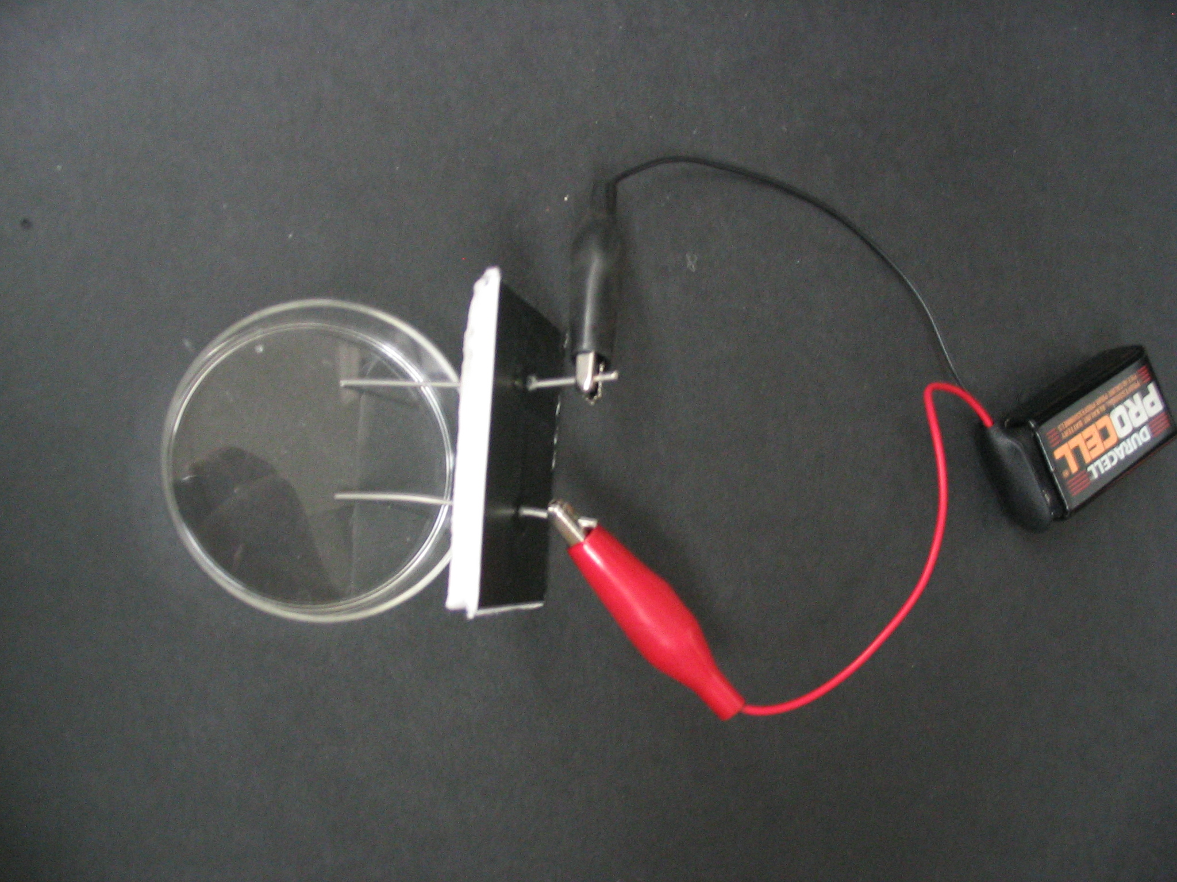
Give each pair the following materials:
1 set of nickel electrodes mounted in Styrofoam
1 ziploc bag containing the following items:
1 9-volt battery with wire leads
1 small container of sodium sulfate
1 small plastic scoop
1 toothpick
1 hand magnifying lens
1 2oz. jar of distilled water

Tell students to:
- Use the small plastic scoop to add the sodium sulfate to the jar of distilled water.
- Stir the water and sodium sulfate with the toothpick.
- Place the electrodes into the jar.
- Look through the side of the jar to see if any bubbles are forming around the end of the electrodes in the water. Use the hand lens to better see the bubbles. If necessary, tell the students to tilt the electrode set-up so they can see the bubbles on the surface of the water.
- Record observations on their observation sheet.
Note: Students should observe tiny gas bubbles at both electrodes.
One electrode should have twice as many bubbles as the other. This is the negative electrode (the black wire). The students may have difficulty seeing this because this is where the hydrogen bubbles are emitted. Hydrogen bubbles are smaller than the oxygen bubbles.

- Remove the electrode set up from the water. A VSVS member will go around and add enough drops of universal indicator to give a medium green solution. (Observations will not be possible if the solution is too dark.)
- Place the electrodes back into the jar and water
- A purple color will develop at one electrode (the cathode) and a yellow to red color will develop at the other (anode).
- Tell students that the universal indicator is detecting changes in the acidity of the water.
The water starts with a pH of neutral and is green colored.
Its pH becomes acidic at the anode where oxygen is given off and hydrogen ions
remain. The Universal Indicator turns red in acid.
The water’s pH becomes basic at the cathode where hydrogen is given off and hydroxide ions remain. The Universal Indicator turns purple in basic solutions.

- Tell students to look at the equation on their observation sheet.
2 H₂O(l) → 2 H₂(g) + O₂(g)
The number of hydrogen molecules produced is twice the number of oxygen molecules.
- Ask students to notice which electrode (black connection or red connection) has the most bubbles. Answer: Black connection.

Ask the students the following questions:
- What kind of bubbles are forming in the jar? Hydrogen and Oxygen gas
- Which electrodes had the most bubbles? The electrode connected to the black (negative) alligator clip. It may be difficult to notice the ratio is 2:1.
- Based on the formula for water, which bubbles are being produced in larger amounts: hydrogen or oxygen?
The formula for water shows that water has twice as many hydrogen atoms as oxygen atoms. There are more bubbles around one electrode. Those are the hydrogen bubbles.

Ask students: What is the evidence for a chemical reaction taking place?
Gas bubbles are given off.
For VSVS Information only:
In the water at the negatively charged cathode, a reduction reaction takes place, with electrons (e⁻) from the cathode being given to hydrogen cations to form hydrogen gas
Cathode (reduction): 4H₂O(l) + 4e⁻ → 2H₂(g) + 4OH⁻(aq)

At the positively charged anode, an oxidation reaction occurs, generating oxygen gas and giving electrons to the cathode to complete the circuit:
Anode (oxidation): 2 H₂O(l) → O₂(g) + 4 H⁺(aq) + 4e⁻

Overall reaction: 2 H₂O(l) → 2 H₂(g) + O₂(g)
The number of hydrogen molecules produced is thus twice the number of oxygen molecules.
Clean – up:
Collect the nickel electrode sets; place them back in their plastic container.
Collect the jars and make sure the lids are screwed on tightly. Return them to their plastic container.
Have students put the other materials in their bag.
VSVS volunteers should collect the bags of materials and place them back in
the kit box.

Lesson written by: Pat Tellinghuisen, VSVS Program Director, Vanderbilt University
Dr. Mel Joesten, Professor Emeritus, Vanderbilt University
Types of Chemical Reactions – Observation Sheet
Name __________________________________

Combination Reaction
- What is an example of a combination reaction? ___________________________

Single Replacement Reaction
Answer these questions about the copper wire & silver nitrate solution demo when it is revisited at the end of the lesson.
- What happened to the copper wire? _________________________________________________________________
- What changes were visible in the solution? ______________________________
Record observations from wells 1, 2, & 3 below.
- What are your observations for well 1 (aluminum & copper chloride)?
____________________________________________________________________________________________________________________________________
- What are your observations for well 2 (zinc & copper chloride)?
____________________________________________________________________________________________________________________________________
- What are your observations for well 3 (iron & copper chloride)?
____________________________________________________________________________________________________________________________________
The equations for these reactions are:
2Al (s) + 3CuCl₂ (aq)→ 2AlCl₃(aq) + 3Cu (s)
2Fe (s) + 3CuCl₂ (aq)→ 2FeCl₃(aq) + 3Cu (s)
2Zn (s) + 2CuCl₂ (aq)→ 2ZnCl₂(aq) + 2Cu (s)
Silver green-blue colorless reddish
- Why is this reaction classified as a single replacement type?
__________________________________________________________________
- What evidence do you see that tells you a chemical reaction occurred?
__________________________________________________________________
Double Replacement Reaction
- What are your observations during the reaction that occurred in well 4 (copper chloride & sodium phosphate)? ________________________________________ ____________________________________________________________________________________________________________________________________
The equation for this reaction is:
2Na₃PO₄ (aq) + 3CuCl₂ (aq)→ Cu₃(PO₄)₂ (s) + 6NaCl (aq)
colorless blue-green turquoise colorless

- Why is this reaction classified as a double replacement type?
__________________________________________________________________
- What evidence do you see that tells you a chemical reaction occurred?
__________________________________________________________________

Decomposition Reaction (electrolysis of water)
- What are your observations when the electrodes are placed in the water containing sodium sulfate? ____________________________________________________
__________________________________________________________________
- What new observations can you make when the universal indicator is added?
____________________________________________________________________________________________________________________________________

The equation for this reaction is:
2 H₂O(l) → 2 H₂(g) + O₂(g)

- What kind of bubbles are forming in the jar? _____________________________
- Which electrodes had the most bubbles? ________________________________
- Based on the formula for water, which bubbles are being produced in larger amounts: hydrogen or oxygen? _______________________
- What evidence do you see that tells you a chemical reaction occurred?
__________________________________________________________________

Types of Chemical Reactions – Answer Sheet
Combination Reaction
- What is an example of a combination reaction? Rusting

Single Replacement Reaction
Answer these questions about the copper wire & silver nitrate solution demo when it is revisited at the end of the lesson.
- What happened to the copper wire? Silver solid forms on the surface of it.
- What changes were visible in the solution? The color changes from clear to blue.
Record observations from wells 1, 2, & 3 below.
- What are your observations for well 1 (aluminum & copper chloride)?
The aluminum metal slowly gets a few dots of black coating on it and after
10 minutes has a reddish-brown copper coating.
- What are your observations for well 2 (zinc & copper chloride)?
A black coating appears on the paper clip immediately and slowly (5
minutes) turns a copper color.
- What are your observations for well 3 (iron & copper chloride)?
A dark reddish-brown precipitate of copper metal deposits on the metals
dipped in the solution. The copper color appears almost immediately on the nail.

The equations for these reactions are:
2Al (s) + 3CuCl₂ (aq)→ 2AlCl₃(aq) + 3Cu (s)
2Fe (s) + 3CuCl₂ (aq)→ 2FeCl₃(aq) + 3Cu (s)
2Zn (s) + 2CuCl₂ (aq)→ 2ZnCl₂(aq) + 2Cu (s)
Silver green-blue colorless reddish
- Why is this reaction classified as a single replacement type?
One substance replaces one other substance.
The aluminum, iron and zinc metals replace the copper in the solution.
- What evidence do you see that tells you a chemical reaction occurred?
Precipitate (copper onto the metal).
Color change in solution (they may not see this during the class period).
Double Replacement Reaction
- What are your observations during the reaction that occurred in well 4 (copper chloride & sodium phosphate)? A pale blue precipitate forms (copper phosphate) with a clear solution (sodium chloride).

The equation for this reaction is:
2Na₃PO₄ (aq) + 3CuCl₂ (aq)→ Cu₃(PO₄)₂ (s) + 6NaCl (aq)
colorless blue-green turquoise colorless

- Why is this reaction classified as a double replacement type?
The copper and sodium replace each other (swap places).
- What evidence do you see that tells you a chemical reaction occurred?
Precipitate (copper phosphate is the turquoise solid).
Color change (blue-green and clear solutions become clear solution only).

Decomposition Reaction (electrolysis of water)
- What are your observations when the electrodes are placed in the water containing sodium sulfate? Students should observe tiny bubbles of gas at both electrodes.
One electrode should have twice as many bubbles as the other. This is the negative electrode (the black wire). The students may have difficulty seeing this because this is where the hydrogen bubbles are emitted. Hydrogen bubbles are smaller than the oxygen bubbles.

- What new observations can you make when the universal indicator is added?
The water starts with a pH of neutral and is green colored. Its pH becomes acidic at the anode where oxygen is given off and hydrogen ions remain. The Universal Indicator turns red in acid. Its pH becomes basic at the cathode where hydrogen is given off and hydroxide ions remain. The Universal Indicator turns purple in basic solutions.

The equation for this reaction is:
2 H₂O(l) → 2 H₂(g) + O₂(g)
- What kind of bubbles are forming in the jar? Hydrogen and Oxygen gas
- Which electrodes had the most bubbles? The electrode connected to the black (negative) alligator clip. It may be difficult to notice the ratio is 2:1.
- Based on the formula for water, which bubbles are being produced in larger amounts: hydrogen or oxygen? The formula for water shows that water has twice as many hydrogen atoms as oxygen atoms. There are more bubbles around one electrode. Those are the hydrogen bubbles.
- What evidence do you see that tells you a chemical reaction occurred?
Gas bubbles given off.
Types of Chemical Reactions – Instruction Sheet

Single Replacement Reactions
Use wells 1, 2 and 3:
1. Fill wells 1, 2 and 3 with copper (II) chloride (blue solution) HALF-WAY.
2. Place one end of the aluminum strip (Al) into the solution in well 1.
3. Bend a paper clip (zinc coated, Zn) so that the wire forms an L-shape and place it into
the solution in well 2.
4. Put 1 end of the nail (iron, Fe) into the solution in the 3rd well
5. Observe for 5 minutes.
6. Record results.

Double Replacement Reaction
Use well 4:
1. Squirt enough 0.1 M copper (II) chloride solution so that the well is about ¼ filled.
2. Squirt the clear 0.1 M sodium phosphate solution so that the well is now about half
filled.
3. Observe the reaction and record the results.

Decomposition Reaction (electrolysis of water)

- Use the small plastic scoop to add the sodium sulfate to the jar of distilled water.
- Stir the water and sodium sulfate with the toothpick.
- Connect the electrodes & place them into the jar as shown in the image on the right. →
- Look through the side of the jar to see if any bubbles are forming around the end of the electrodes in the water. Use the hand lens to look at the bubbles. If necessary, tilt the electrode set-up so you can see the
bubbles on the surface of the water.
5. Record observations on your observation sheet.
6. Remove the electrodes from the water. VSVS members will come and add enough drops of Universal Indicator to give a medium green solution.
- Replace the electrodes into the jar.
- Record observations on your observation sheet.

