Water Pollutants and Purification
Fall 2015

GOALS
To have students construct a water filter in order to understand the complexity of cleaning polluted waters.
To help students develop an understanding of the complex economics regarding water cleanup and the differences in available resources among different countries.

Materials
15 water Treatment diagrams
8 jars containing 4 filter sections
16 filter supports
8 large beakers
8 containers alum
Dirt
8 spoons
32 clear cups (for collecting filtered water)
64 1 oz cups for keeping a small amount of the original polluted water testing starch pollution
20 soda pop bottles – cut off
20 bags cotton balls
20 bags Gravel
20 bags
sand

Divide students into pairs. Give each pair a handout of the water pollution chart

I. Introduction
Ask the students if they know where their drinking water comes from? The Cumberland river.
Would you drink water straight from the Cumberland? Hopefully the answer is “no”.
How it is made safe to drink?
Nashvillians are fortunate because we don't have to worry about the quality of our drinking water. We have the means to clean and provide water to the city. You can get a clean glass of water whenever you need it.
However, many people in the world don't have this luxury. Their town or village might not have a well nearby and a family member might need to walk for miles to get the daily requirement of water.
Or if there is water nearby, it might be contaminated.
Large cities such as Nashville have a large wastewater treatment plant.
What is the difference between clean water and polluted water?
Polluted water is water that is not suitable for drinking, washing, irrigation, or industrial uses. Ask students if they know what substances can pollute water?
Answers might include natural substances such as decaying leaves, animal wastes, dirt and sand. Human activity is the main cause of water pollution, including manmade fertilizers and pesticides, gasoline, toxic chemicals of all types, even unused medicines that people have flushed down the toilet.

A diagram depicting possible sources of pollution is on their observation sheet
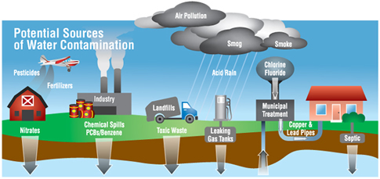

II. Cleaning Water.

Before you get your from your faucet in your home, it is pumped to a water treatment plant to be cleaned and treated.
Look at the diagram of the wastewater treatment process.
Very briefly point out the different stages of water purification (they will be talked about as you go through the experiments), and tell students they will be using some of these stages in their experiments.
Highlight: 1. coagulation and sedimentation chambers
2. Filtration
3. Post Chlorination.
We will be simulating these processes.
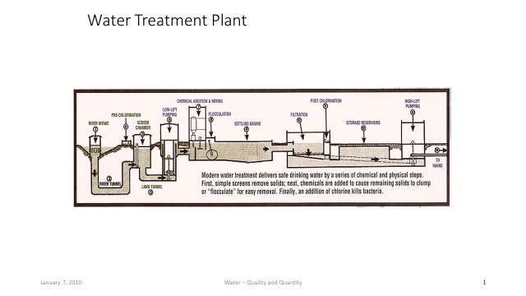
Give each pair:
200 mLs of contaminated water (water plus starch solution) in a 600 mL beaker.
Add a spoon of dirt to the water in the beaker.
Tell students this water has been contaminated with chemicals as well as dirt.
1 oz cup
1 jar alum
1 spoon
1 jar containing 4 filter sections
4 clear beaker for collecting decanted water
4 clear cup for collecting filtered water
2 filter support contraptions
2 test tubes (for measuring 10 mL of decanted water)

Important: Before proceeding any further, tell students half fill one of the 1 oz cups with the polluted water. It will be used to give baseline tests.
Steps 1 and 2 – Coagulation and Sedimentation.
Tell students to:
- Make observations of the sample, such as the color or turbidity of the water. Write the observations on their Observation Sheet. Ask them if they would want to drink this water?
- Add one mounded spoonful of alum to that beaker, and stir gently with a teaspoon. The chemical alum is added to make the solid particles such as dirt and other particles stick together (coagulate) into larger clumps that are heavy enough to sink (sedimentation) to the bottom.
- Let the solution settle for five minutes. Tell students this process is called coagulation and sedimentation.
- While students are waiting, tell them to look at the individual filters, Point out the different filters:
  - course gravel
  - sand
  - cotton filter
  - activated charcoal
- Tell students they will use all 4 filters separately to determine what each filter removes from the contaminated water.
- After 5 minutes of allowing the alum to do its work, carefully pour (decant) only the clear liquid on the top, into the smaller clear plastic beaker. Leave the settled dirt (the sediment) behind in the larger beaker.
- Tell students to make observations about the clarity/color of the decanted water. Would you want to drink it yet?
Step 3 – Filtration and Testing for the Chemical Pollutant

  - Set the first filter (gravel) into the holder and place the holder on top of the collecting cup.
  - Measure 10 mL of the contaminated decanted water into the vial and pour it into the filter containing the gravel. Set the first filter section on top of the clear jar, and pour the treated water into it. Collect the water in the jar.
  - Repeat with all filter sections. For the charcoal and sand sections you’ll have to add the water a little at a time. Be careful not to spill contaminated water over the top.
  - Look at the collected samples and compare the clarity and color of the filtered water with the unfiltered water and record your results. Would you want to drink it yet?
  - Tell students that even though the water from the charcoal filter looks clear, it may have chemical contaminants. They will now test for that possibility.
  - Tell students that the chemical contaminant used was starch. If the chemical passed through the filter, it can be detected by adding a drop of iodine. If starch turns blue/black when a drop of iodine is added, then the water is still contaminated.
  - Tell students to add a drop of iodine to the unfiltered contaminated water in the collection cup. Compare the darkness of the blue/black color. Did any filter do a better job than others?
Comparison and Conclusion
After all pairs have filtered their sample and recorded observations, have one member from each team present their findings.
Ask the following questions to each pair and have them respond.:
Did anything change after filtering the sample?
Was any filter effective in removing the chemical pollutant?
Which filter material gave the best results.
Pat’s results:
 | Color after iodine added
Untreated Dirty Water | black
Water filtered through Charcoal | Light Blue black
Water filtered through Sand | Dark blue/black
Water filtered through Gravel | Dark blue/black
Water filtered through cotton | Light Blue black

Step 4 - Disinfection
Water that has been filtered and looks clean may still contain invisible particles of chemicals or bacteria that can make you sick.
Deaths from polluted water happen more often in 3rd world countries, but can also happen in the US.

A small amount of chlorine is added or some other disinfection method is used to kill any bacteria or microorganisms that may be in the water. Water treatment plants must add enough chlorine to kill any bacteria plus a bit more to fight any germs that might be in the pipes that carry the water to your home. This is why you can sometimes smell chlorine in the water from your faucets.

Water purification with disinfectant - Demonstration
- Tell the students you are going to add a chemical that will destroy the chemical contaminant in their filtered samples. Add a few squirts of the Na_{s2}S₂O₃ (Sodium thiosulfate) until the solution is clear. Explain that this is a simulated experiment only.
III. Putting the Filtering Cups in a Stack
Tell students that the filtering cups can be connected in a column. Ask students what order would be the best? Start with the first filter. The ideal order would be:
Gravel
Sand
Cotton filter
Activated charcoal plus cotton filter

If there is enough time, have the students put the filter sections in a column and have them filter another 10 mL of contaminated water.

IV. Making their Own Filter
Give each student a cut-off soda pop bottle. The bottom opening will be covered with a cloth filter.
Tell students to use the materials provided to construct their own filter bottle.
1 bag of gravel
1 bag of sand
1 bag of cotton balls
Remind them that they cannot drink any contaminated water even after it has been filtered.
Students can test their filters with dirty water, or take them home to test

