Water Color Transport

Introduction to Engineering Design Process:
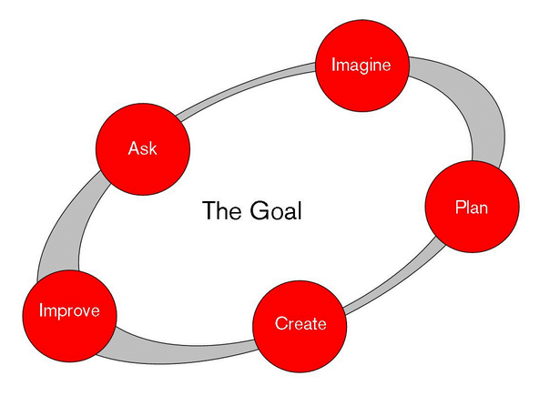
While having a guide is useful for novices who are learning about engineering, it is important to note that practicing engineers do not adhere to a rigid step-by-step interpretation of the process. Rather there are as many variations of the model as there are engineers. The Engineering Design Process is cyclical and can begin at any step, or move back and forth between steps numerous times. In real life, engineers often work on just one or two steps and then pass along their work to another team.

Moving through the Engineering Design Process might involve asking the following questions or making the following decisions:
ASK
- What is the problem?
- What have others done?
- What are the constraints?
IMAGINE
- What are some solutions?
- Brainstorm ideas.
- Choose the best one.
PLAN
- Draw a diagram.
- Make lists of materials you will need.
CREATE
- Follow your plan and create it.
- Test it out!
IMPROVE
- Talk about what works, what doesn't, and what could work better.
- Modify your design to make it better.
- Test it out!
After you improve your design once, you may want to begin the Engineering Design Process all over again to refine your technology. Or you may want to focus on one step. The Engineering Design Process can be used again and again!

Engineering Design Process found at:
http://www.mos.org/eie/engineering_design.php
Materials:
- PVC Pipes
- 6 Elbow Joints
- 7 T-Joints
- 3/4” vinyl tubing
- 10 Y-valves
- 5/8” X 3/4” Nylon Female Hose Barb Swivel
- 1 Utility-Pump
- 3/8 in. 9.6-Volt Cordless Drill
- 4 – ½ Gallon containers
- 8 16 oz. containers
- Zip-ties
- Yellow, Blue, and Red Food Coloring

Objectives:
The object of this activity is to be able to transport any color or any combination of colors from the 4-1/2 gallon containers to any of the 8-16 oz. containers. To begin fill the 4 - ½ gallon containers with water and put Blue food coloring in the first container, Yellow food coloring in the second, and Red food coloring in the third. The remaining ½ gallon container will be left alone as clear.
Criteria to be met:
- Be able to pump water from any 4- ½ Gallon containers to any one of the 8- 16 oz. containers
- The 4- ½ Gallon containers have to be 12 inches off the ground
- Everything else (valves, tubing, pump) has to be suspended at least 6 inches off the ground
- No Water Leaks!!
Have a group discussion with the class going through the engineering process and help them come up with a design for the water distribution system. Start off with deciding on how many Y valves are needed. Draw a diagram. If you haven’t done so already split the students into 4 equal groups. Now have the students make the distribution system using the Y-Valves, the nylon female hose barb, and ¾” vinyl tubing.
Note: Make sure when connecting the pump you have the flow going in the right direction.

The next step is to come up with the frame work to meet the criteria given, using PVC pipes and T-joints and elbow joints. The PVC pipes have already been cut to their desired lengths. Give the students 5 minutes in their groups to come up with a sketch of the frame work required to hold the 4- ½ Gallon containers, Y-Valves, and Drill Pump. Then have a class discussion and pass out the images of the designed frame work that they will be building.

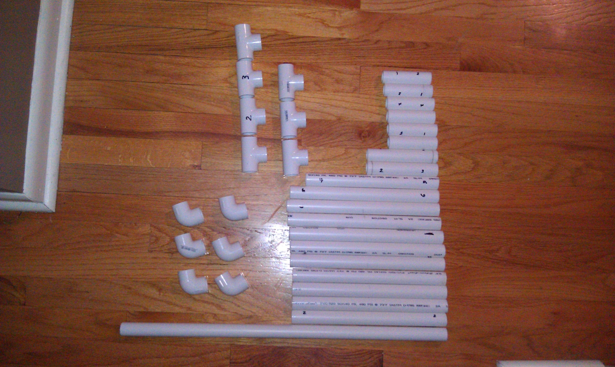

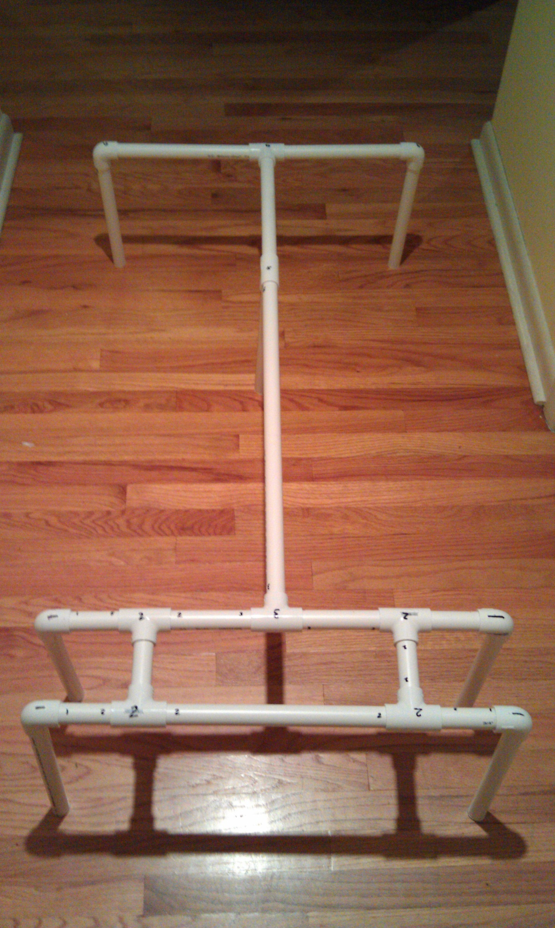
The students have 20 minutes to build the PVC frame, and secure the water distribution system they made using zip-ties onto the frame.

Once the whole system is built and set it is time to run some tests. The proctor will call out a random color to be pumped to a specific 16 oz container and the 4 groups will be competing against each other to fill their cup with the right color.
Note: When calling out the colors you don’t have to call out the three prime colors, you can call out a combination like purple, green, or orange in cup number 5.

