VANDERBILT STUDENT VOLUNTEERS FOR SCIENCE
http://studentorgs.vanderbilt.edu/vsvs
Why Is An Apple Red?
Fall 2012
Goal:
Standards:

Lesson adapted from Gems

1Plastic model of the eye
26 Eye handouts
16 color blindness charts
13 sets of red and green filters
13 red lasers
1 green laser
13 handouts #1 and #2
25 color coded pictures
12 Sets of magic markers (shared by pairs)
25 half sheets of paper
8 bags containing various other filters
8 Graphs of absorption for above filters

- Introduction - What causes the color of an object?

Materials
1 Plastic model of the eye
26 Eye handouts
Ask students to tell you some sources of light.
A light bulb, a flashlight, the sun, flames from a fire
Tell students that light from these sources travel directly to the eye.

We see most objects because light bounces off them and then travels to our eyes. This is called reflection.
Ask students if they can name some objects that reflect ALL of the light that reaches them.
A mirror, calm water, shiny aluminum pan

Most objects only let some colors of light bounce off of them.
When white light hits an object, some wavelengths are absorbed by the object, and other wavelengths are reflected or transmitted. The eye sees only wavelengths that are not absorbed.
For example, a piece of blue paper appears blue because only the blue wavelengths are reflected back to your eye, and all the other wavelengths in white light are absorbed.

Hold up the plastic model of the eye, pass out handouts, and explain the following parts. Have the class follow along on their handouts.

External eye muscles - Show the kids the eye muscles marked in red on the outside of the model. Explain that the eye has voluntary muscles like any other muscle in the body that are used to move the eye around. This is how you look from side to side and up and down.

Cornea - The clear structure with a roman numeral I on it is the cornea. The clear area in the center of the outer eye is the cornea. This protects the iris and other internal structures.

Inner, brown sphere

Iris - Take apart the white sphere. The structure labeled with a 3 is the iris. The iris is the muscle that controls the size of the pupil (and therefore how much light enters the eye); this is the colored part of the eye. The iris alters the diameter of the pupil to adjust for varying light conditions.

Pupil - The hole in the middle of the blue iris is the pupil. The pupil is the hole where light enters the eye. It is the small, black circle in the center of your eye. The pupil can change size depending on how much light is present (large for dim conditions when the retina needs to let lots of light in to see and small for bright conditions when the retina doesn’t need as much light and could be damaged by overexposure)
Lens - Take the brown sphere apart and show the kids the lens, labeled with the number 15. Explain that this special shape of the lens is what causes light to focus properly. The shape of the lens can be changed by the eye muscles depending on whether you are looking at something nearby or far away. You can see these muscles in red on the inside of the brown sphere. If the lens and the cornea aren’t shaped quite right you will need to wear glasses. DON’T LOOSE THE LENS!!

FYI - Nearsighted means you can only see things that are nearby and far away things are
blurry, doctors call this myopia. Farsighted means that you can only see things that are far away and near things are blurry, doctors call this hyperopia. An astigmatism is a different problem where the light doesn’t focus correctly due to improper shape causing vision to be blurred.

Vitreous humor - The clear plastic sphere labeled with a 16 inside the brown sphere. The vitreous humor is a clear jelly substance that holds the shape of the eye (i.e. the eyeball).

Retina - The retina is inside of the brown sphere and labeled with the number 9 (looks a bit like a g). The retina is the back part of the eye where there are special cells called rods and cones that sense light and send signals to the brain via nerves.

Rods - Special cells on the retina that are sensitive to light. Rods detect if there is or is
not light (black or white)
Cones - Special cells also on the retina that are sensitive to colored light. There are 3
types of cones, those that respond to red, green, and blue light. Cones require more light
to work so they don’t function as well at night - this is why you tend to see things in black and white at night
Blind Spot - several of the demonstrations in this lesson demonstrate the blind spot. This is the point where the optic nerve leaves the back of the retina. It is labeled on the inside of the brown sphere with the number 14.

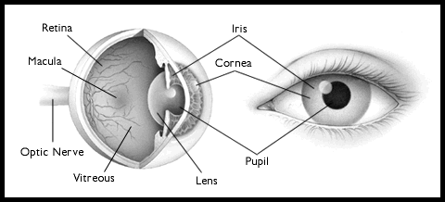

Color Blindness
Materials
16 color blindness charts

• Give the students the colored "29” square to help them understand how doctors detect if
someone is color-blind.

Individuals are said to be color-blind when a single group of cone cells is missing from the retina. The most common type of this form of color blindness is red-green color blindness, where the cones most receptive to both red light and green light are missing from the eye. Thus, the individual cannot distinguish between red and green. Color blindness of this kind is an inherited condition, with males affected much more frequently than females. There are also individuals with all three cone types, and all three photo-pigments, but one of the photo-pigments differs from normal, thereby affecting color vision. There are a number of other more rare conditions that affect color vision.
Tell students to hold a red filter up to one eye and look through it at the chart. They should see that the “29” is missing.

II. Experiment – Shining Lasers Through Filters
Tell students that in this experiment we will use lasers that operate at single wavelengths, either red (about 700nm) or green (about 500nm) light. Remind students that white light has all wavelengths in the visible light region of the electromagnetic spectrum.

Tell students that the lasers are to be used only as directed and not pointed towards any other part of the room, or person.
Show students how they will hold the laser and point down through a filter.
Pass out a red and green filter and a red laser to each pair of students.
Have one student hold the red filter horizontally and another shine the red laser from above, pointing down towards the desk or floor.
Have the students verify that the red laser light passes through the red filter (they will see a red dot on the floor or desk).

Have the students repeat with the green filter.
What happens?
The red filter appears red because it transmits only red wavelengths, and absorbs all others, (including green wavelengths). Therefore, the red laser light passes through this filter, but the green laser light does not.

Ask students: What do you think will happen if a green laser is shone through the green filter? And the red filter?
Show students that the green laser light passes through the green filter, but not through the red filter.
Safety Note: The green lasers are expensive and very bright. Please do not allow the students to play with the lasers!

One VSVS member should go to each group and shine the green laser onto the green and red filters.

The green filter appears green because it transmits only green wavelengths and absorbs all others, including red wavelengths. Therefore the green laser light passes through, but the red laser light does not.

Collect all lasers - make sure that all lasers have been returned by counting them!

III. Experiment – Looking Through Color Filters.
Pass out Handout #1, with the colored blocks.
- Tell students to look at the red-colored block.
- Ask them to explain why they see red? Red is the only color reflected back to their eyes. All other colors are absorbed.
- Now view the block through the green filters.
- Ask them to explain what they see? The red color will appear white or very light colored through the red filter and dark thru the green filter.
- Tell the students to look at the line of color blocks through the red and green filters and to tell you
  - what colors appear dark and light through the red filter?
  - what colors appear dark and light through the green filter?

- Tell students to look at the word “help” on the Handout #1. Can they predict what word they will see through a red filter, and through the green filter? Test their hypothesis.

IV. Creating Color Filter Codes

Tell students to look at Handout #2 on the flip side. Tell them to look at the words through the red filter.
Tell them they can now try to make their own secret color code. They can color the codes provided, or create their own.

If they create their own, tell them to:
- Choose the colors that will show up dark when looked through the red filter.
  - Red filter – choose blue, green or purple.
- Draw an object or a word with the chosen colors. Make it simple.
- Use the other color markers to make a mosaic pattern or extra lettering over the writing to camouflage or disguise it. Draw many shapes around your object/word and color them with pens that will be white or pale when looked through your filter.

- Test their codes.

V. Optional Activity to do at end (after making the secret codes) – you will need to use lasers again for this.
If time permits, have the students choose another color of filter (blue, aqua, yellow, or pink). Ask the students to predict if the light will be absorbed by the filter. Have them repeat the above experiment with their new filter. Was their prediction correct? The differently colored filters will not block the laser entirely, however, students should notice that the laser light dims when passing through some of the filters (the filter is absorbing some, but not all, of the laser light).

VI. Other Resources
A Fun Optics Lesson about Light and Color. optics.nasa.gov/docs/Make_Secret_messages.doc
Materials suggested from this lesson - white paper, highlighter or pastel magic markers, at least three colors such as red/pink, green or blue, and yellow, transparent plastic color filters or cellophane wrap in colors similar to the markers

More, on the Web…
http://micro.magnet.fsu.edu/primer/java/scienceopticsu/primarycolors/colorfilters/index.html

The NASA educator's guide Optics contains activities for grades K-12 in Science and Math. It has color and light activities using lenses, prisms, kaleidoscopes, periscopes, and this lesson on hidden messages. See it at: http://spacelink.nasa.gov/products/Optics

Handout #1

Handout #2

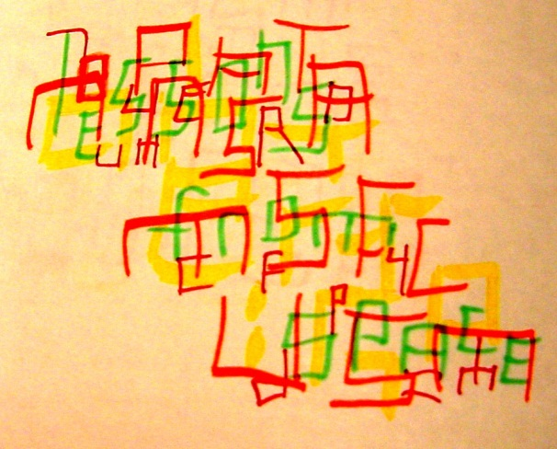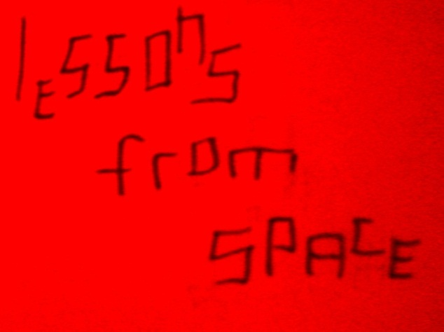

the unfiltered message with all colors…. shows the green ink dark with a red filter
optics.nasa.gov/docs/Make_Secret_messages.doc

