Create Your Job Search Communications Portfolio
updated 3-9-2020

Prepare What Will Be Heard

- Preferred Function | Industry | Geography “FIG” Statement What do you want to do next? What qualifies you to do this? Also answers the questions, Tell me about yourself? or Walk me through your resume. Worksheet attached.

- Exit Statement Why do you want to leave your company? Why did you leave your company? Worksheet attached.

- SOAR stories – accomplishment stories in SOAR format (Situation, Obstacle, Action, and Result). Worksheet attached will help you develop 8-10 stories tied to competencies and what you like and do best.

Prepare What Will Be Seen

- Resume https://blogs.owen.vanderbilt.edu/alumni/tools/resume-and-references/
Scroll down to the bottom of the screen.

- Email Signature Line: Name, Email address, Cell Number, LinkedIn profile url AFTER you have customized the url. (Here’s how to customize your LinkedIn url: https://www.linkedin.com/help/linkedin/answer/87

- Cover Letter Template https://blogs.owen.vanderbilt.edu/alumni/tools/cover-letters-and-correspondence/

- Reference List https://blogs.owen.vanderbilt.edu/alumni/wp-content/uploads/sites/3/2014/09/References-Worksheet-Sample.doc

- Business Card (http://www.vistaprint.com, local office supply store or print shop). Simple is better – Name, Function, contact information, customized LinkedIn url; no pictures, symbols.

- Learn to use LinkedIn and Create Your Profile; Utilize this FREE resource:

LinkedIn: The Missing Manual by The LinkedIn Guys

Everyone knows that effective networking is the difference between landing a job and landing a great job. And that mastering LinkedIn is a significant component to effective networking.

But having worked at LinkedIn, we also know the site isn't always the most intuitive. Which is why we've built out a complete, step-by-step online course to mastering LinkedIn - from turning your profile into a recruiter magnet to engaging fellow alumni and connections around the world to help you get your foot in the door.

Think of it as the manual you wish LinkedIn came with - all visually demonstrated, all updated for the latest version of the website. And it's waiting for you here as an exclusive free resource for Owen alumni (normally $99):

- Go to our course site: https://courses.breakinto.tech/courses/linkedin?th__ug=b9c72942&th__c=vandy
- Click the Enroll button
- And create an account

That's it! You now have access to the world's only guide to LinkedIn created by former LinkedIn employees. Which means you now have what you need to land not just any job, but the job that's best for you.

- Create a Target Company List
Utilize this Owen paid-for resource called The 2-Hour Job Search by Steve Dalton.

Register here:

Go to: http://mba2hourjobsearch.com/registration/. Select Vanderbilt from the school dropdown list. Once you complete the registration form, you will receive a unique login password by email. You can then go to the login tab to access the resources.

Get Out and Network

- Learn the Basics of Networking https://blogs.owen.vanderbilt.edu/alumni/strategies/networking/; http://www.highlyeffectivejobsearch.com/images/Job_Srch_Net_Guide.pdf

- Owen Alumni in your city, target company or function. Use the LinkedIn Find Owen Alumni feature. Also check out VUConnect.

- Professional Association Meetings https://www.directoryofassociations.com/
- Hobby and Shared Interest Groups; Neighborhood Gatherings
- Job Search Accountability Group
- Identify Groups and People in Your Area www.job-hunt.org
Prioritizing Your Career Options
Function, Industry, Geography (F-1-G)

Once you have identified your skills, abilities and interests, it is time to begin formulating your career and job search goals.

One way to create career and job search goals is to think about your options in three categories: Function, Industry, Geography. In order to narrow your focus, you need to identify at least two of the three categories. As you narrow your focus by identifying two of the three categories, keep in mind the larger economic landscape to ensure that you are setting realistic goals.

Function
Business functions may include corporate finance, investment banking, operations, marketing, general management, human resources, information technology and consulting. There are many MBA-level jobs available within each function. Start by narrowing your interests to a specific function, then focus on the various jobs available within each function. If you have interests in more than one function, you will need to prioritize them.

Industry
This category may be the easiest with which to start because you may already feel strongly about a specific industry. Determine if industry or function is more important to you. If working in the pharmaceutical industry is more important than whether you work in marketing, business development, business planning or general management, then you have successfully narrowed your first category.

Geography
This can be one of the most difficult categories to determine for a couple of reasons. Too broad? While it is important to be flexible, if you are focused on the entire United States or on the globe you cannot devote enough time to make the necessary impact. If you don’t have a specific city in mind, pick two or three and target them in a ranked order. If you don’t get traction in a specific city, then move on to the next city. Too specific? The alternate pitfall is limiting yourself to only one city or focusing on a city that doesn’t have a base of jobs in the specific industry or functional area in which you are interested—for example, being focused on Nashville if you are interested in the consumer products industry.

Sample F-I-G Template

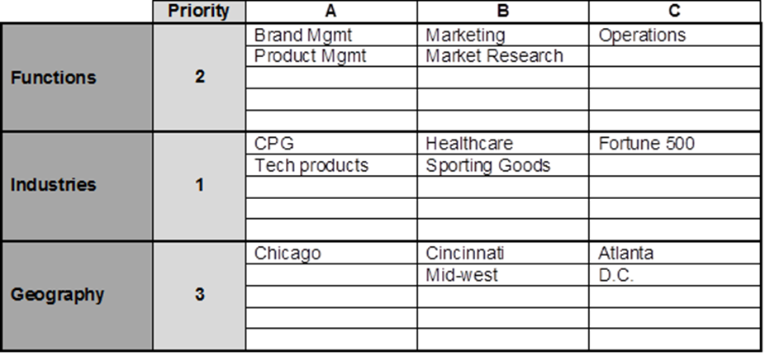

Develop Your Exit Statement

Your Exit Statement answers the question, “Why are you looking for a job?”

A vital part of your communications strategy is the “Exit Statement”. This is the opportunity to answer, “Why are you leaving XYZ Company?” or “Why are you in the job market?” Keep your statement very short and simple. You will not want to discuss personality conflicts, disagreement with management or speak negatively about the company. Below are some acceptable reasons for leaving your present position:

Career growth: You can easily say that you are looking for a change in role and wanted more growth, or even that your position was getting stagnant. This might be an acceptable reason for quitting your job, but this by no means gives you leeway to criticize your job.

Your career path: One reason is basic dissatisfaction with your career. Remember that it is not about the particular company or the department, but your career on the whole. This reason would hold true if you have a rich career profile and are currently applying for a job in a new profession.

Looking for challenges: One of the most common and simple reasons is that your job was at a standstill and you wished to seek newer avenues and greater challenges.

Restructuring: Another common reason is company restructuring. When a company restructures, it can lay off a number of employees. Therefore, even if you have not been directly told to go, nobody would blame you if you are looking for avenues because your colleagues or some other department has been laid off.

Relocation: More often than not, relocation could be a reason that a seeker is looking for another job.

Enhanced Education: Another reason that can be provided is enhancement of abilities and education. If you have recently acquired a degree and have decided to utilize your education to enhance your professional profile, this would be a good reason to give for this question.

Remember that you cannot lie about the reason why you quit your job. In this era of references and cross references, finding out the real reason why you quit your job is as simple as making a telephone call.

As you are preparing your Exit Statement, think about mentioning something positive about your experience – the training, variety of opportunities, what you learned, etc.

Finally, you want to focus on the positive and the future. “I am looking for an opportunity in _______ and am excited to explore a variety of options.”

Write your Exit Statement here.

_____________________________________________________________________________________________

_____________________________________________________________________________________________

_____________________________________________________________________________________________

_____________________________________________________________________________________________

_____________________________________________________________________________________________

_____________________________________________________________________________________________

_____________________________________________________________________________________________

Develop a List of Accomplishments

By Writing SOAR Stories

Read through the following questions and check those that apply to you. Beside each item, write a key word that will remind you of that accomplishment.

Accomplishment Key Word

Identify and solve a problem for your department, boss or the company? ____________
What were the results?

Design or implement a process or procedure to make a job ____________
more efficient, easier or more accurate?

Save the company money or time? How much? ____________
What positive impact did the savings have on the company?

Did you increase productivity or reduce downtime? By how much? ____________
How did the savings affect the bottom line?

Consistently meet or exceed goals or objectives? ____________

Did you effectively manage systems or people? ____________
What were the results of your efforts?

Did you work between departments? How were you able to
make things run more efficiently? ____________

Train a group or individual? ____________

Maintain a strong work record (performance, attendance, safety)? ____________

Did you receive any awards, bonuses or promotions? ____________

Did you participate in decision making or planning? ____________
What contributions did you make to the team? Results?

Did you improve the efficiency of people or operations? ____________
What were the savings?

Were you responsible for reducing staff or trimming an operation? ____________
How were you able to do this efficiently?

Were you involved in a start-up, shutdown or reorg? ____________
What challenges did you face? Successes?

Receive a strong compliment from someone in a more senior position? ____________

Did you produce reports or data that enabled management to ____________
make more informed decisions?

Receive a strong compliment from someone in a more senior position? ____________

Soar Stories – The Key to a Strong Resume, Success in Networking and
Answering Behavioral Questions

Your resume will stand out, your networking will succeed, and interviews will be easier if you take time to think through and develop your SOAR stories. You want to know your skills so that you can transfer skills into other functional areas or industries. You will need to use specific examples of your skills and accomplishments. Refer to your Key Words from the previous page and describe several work-related accomplishments using the SOAR technique.

I. Accomplishment:

- Situation: Describe the situation.

- Objective or Obstacle: Describe the objective to be achieved or an obstacle you faced in the situation above.

- Actions: Describe the actions that you took.

- Results: Describe the results you obtained and the benefits to your company.

II. Skills, Strengths and Traits:

List the skills, strengths and traits used in your story.

III. Resume Accomplishment Bullet:

Turn your accomplishment into a resume bullet which is a shortened version of the SOAR story:

- Start with an action verb (List of action verbs attached.)
- Name the situation
- Briefly describe actions
- Quantify results

IV. Interview Preparation

This SOAR story could answer a variety of questions that begin with “tell me about a time you…”

Repeat these stories for as many accomplishments as possible. It is recommended that you have 6 to 12 SOAR stories.

