TACMRS 218

- home
- Speakers
- Agenda
- Registration
- Transportation
& lodging
- TACMRS
- DFLL

Between humanity and divinity

in literature, art, religion and culture
The 12th Annual International Conference of Taiwan Association of Classic, Medieval and Renaissance Studies
National Chi Nan University (NCNU), Puli, Nantou, Taiwan
19-20, October, 2018

Welcome to the website of TACMRS 2018,
Between Humanity and Divinity: In Literature, Art, Religion and Culture, an interdisciplinary conference organised by the Department of Foreign Languages and Literature and the Centre of Language Teaching and Research at National Chi Nan University. Our university is situated in a mountainous area and close to the famous tourist attraction Sun Moon Lake. Please do enjoy intellectual dialogues with peers in the pastoral beauty our campus has to offer.

Latest News
No. | Date | Title
1 | 2018-09-28 | The pick-up point for the free shuttle bus ride to our campus is at Exit 6, Taichung THSR Station.
2 | 2018-09-21 | The deadline to register for TACMRS 2018 is extended until October 10th.
3 | 2018-09-20 | Please be informed that free accommodation is only reserved for presenters and board members on October 19th (Friday), as previously announced on the Transporation and Lodging page. For those who need a room for the night of 18th, please contact us directly. We as host university will book a room for you at a price of NT1,600 per night, and the payment can be made at the on-campus hotel. For the night of 20th, the on-campus hotel rooms are already fully booked and not available to any guests.
4 | 2018-09-20 | Please be informed that we do not provide transportation reimbursement for presenters this year.
5 | 2018-09-06 | Reception will take place outside Room 116, Humanities Building. For opening/closing ceremony, keynote speech and Panel A, please go to Room 116. For Panel B, please go to Humanities Cafe. For Panel C, please go to Conference Hall. All venues will be at Humanities Building.
6 | 2018-09-01 | Certificate of Participation for the conference will be provided. Six hours will be certified for the first day, and seven hours for the second day.

Agenda
- Day 1
- Day 2

Day 1 (October 19th)
Time | Schedule
09:00-10:40 | Registration
 | bus leaves Taichung THSR station at 9:20
10:40-10:50 | Opening Ceremony
10:50-11:50 | Keynote Speech by William Franke
11:50-13:10 | Lunch Break
13:10-14:20 | First Session (3 Panels)
14:20-14:50 | Tea Break
14:50-16:00 | Second Session (3 Panels)
16:00-18:00 | Trip to Sun Moon Lake
18:30-20:30 | Banquet

Contact Us

- tacmrs2018@gmail.com
- 主辦單位：台灣西洋古典、中世紀暨文藝復興學會 / 國立暨南國際大學
- 承辦單位：國立暨南國際大學外國語文學系暨語文教學研究中心
- 協辦單位：國立暨南國際大學國際處
- 贊助單位：
- 1. 科技部
- 2. 台灣西洋古典、中世紀暨文藝復興學會
- 3. 國立暨南國際大學國際處
- 4. 教育部（高教深耕計畫）
- 5. 國立暨南國際大學語文教學研究中心
- 6. 國立暨南國際大學外國語文學系

TACMRS 218

- home
- Speakers
- Agenda
- Registration
- Transportation
& lodging
- TACMRS
- DFLL

About Speakers
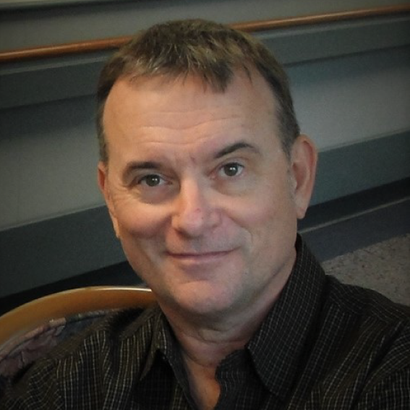

Professor Lowell Gallagher
Lowell Gallagher is professor of English at UCLA, where he teaches courses in Renaissance literature, critical theory, and queer and feminist approaches to biblical studies. He is author of Medusa’s Gaze: Casuistry and Conscience in the Renaissance (Stanford UP), Sodomscapes: Hospitality in the Flesh (Fordham UP), and editor or co-editor of several essay collections, including Redrawing the Map of Early Modern English Catholicism (Univ. of Toronto P), Catholic Figures, Queer Narratives, with Frederick S. Roden and Patrician Juliana Smith (Palgrave Macmillan) and Knowing Shakespeare: Senses, Embodiment, and Cognition, with Shankar Raman (Palgrave Macmillan). Gallagher’s current research examines the long history of Catholic speculative fiction, from Counter Reformation-era romances to 20th-century Catholic theological and aesthetic insights into the sacramental character of posthuman ethics. Professor Gallagher has been a member of the Modern Language Association Shakespeare Division Executive Committee, has served on the Advisory Board of Shakespeare, journal of the British Shakespeare Association, and the MLA Spenser Society Executive Committee, and he currently serves on the Advisory Board of Exemplaria: Medieval, Early Modern, Theory.
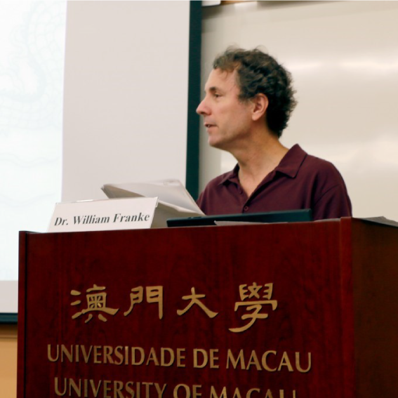

Professor William Franke
William Franke is a philosopher of the humanities and professor of comparative literature at Vanderbilt University. He has also been professor of philosophy at the University of Macao (2013-2016); Fulbright-University of Salzburg Distinguished Chair in Intercultural Theology and the Study of Religion; and Alexander von Humboldt-Stiftung research fellow. His books have been published by the university presses of Chicago, Stanford, Notre Dame, Northwestern, Ohio State, and the State University of New York. Franke’s most recent critical theory book is A Theology of Literature: The Bible as Revelation in the Tradition of the Humanities (2017). It follows up on books tracing prophetic poetry from Homer and Vergil to Dante (The Revelation of Imagination, 2015) and then forward in history from Dante through Chaucer, Milton, and Blake to more recent modern classics (Secular Scriptures: Modern Theological Poetics in the Wake of Dante, 2016). In addition to his work on prophetic poetry, Franke has developed what he calls A Philosophy of the Unsayable (2014) reconstructing the apophatic tradition of discourse in On What Cannot Be Said (2007, 2 vols.). His Apophatic Paths from Europe to China: Regions Without Borders (2018) pursues this project as an intercultural philosophy, taking it to sources in Oriental thought.
- 主辦單位：台灣西洋古典、中世紀暨文藝復興學會 / 國立暨南國際大學
- 承辦單位：國立暨南國際大學外國語文學系暨語文教學研究中心
- 協辦單位：國立暨南國際大學國際處
- 贊助單位：
- 1. 科技部
- 2. 台灣西洋古典、中世紀暨文藝復興學會
- 3. 國立暨南國際大學國際處
- 4. 教育部（高教深耕計畫）
- 5. 國立暨南國際大學語文教學研究中心
- 6. 國立暨南國際大學外國語文學系

