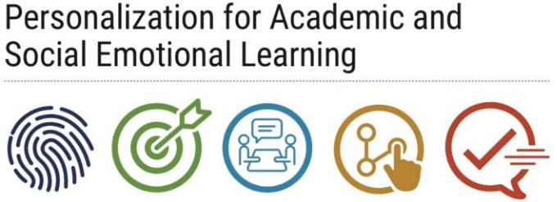
Rapid Check Ins
Data Collection

Overview:
- As educators conduct rapid check-ins with students, they need a way to document important information learned during these interactions.
Purpose:
- The first form is a tool for teachers to collect student data surrounding academics, behavior, and other relevant information that may indicate their overall well-being.
- The second form is an organizational tool for counselors to collect student data which may be relevant to their social-emotional welfare.
- These data may then be shared at educator team meetings and/or used to develop a solution to address any student issues or problems.
Implementation:
- Ongoing collection and use of student data
Details:
- School personnel may distribute the following forms and record data using a paper format or electronically by integrating the template into a system such as BASIS, FileMaker Pro, Google Drive, etc.
Connections to Other Components:
- Teachers may use the first form to record the details that emerge from their rapid check-ins with students.
- Counselors may use the second form to record data that surfaces through their interactions with students.
- These data may then be cross-compared to develop a composite picture of the whole student(s) and their needs, as well as used during future rapid check-ins or other interactions.
- These findings may additionally be shared at educator team meetings to develop a plan for addressing any student issues that arise.
Materials:
- Teacher Rapid Check-Ins Data Form
- Counselor Rapid Check-Ins Data Form

Teacher Rapid Check-Ins Data Form

Class Period & Teacher’s Name: ___________________________________

Name | Grade Level | PASL ID |  | Date | Course Grades | In-Class Behavior | Notes

Counselor Rapid Check-Ins Data Form

Student Name | PASL ID | Grade | Date | Reason for Guidance | Notes
 |  | Level

