“Life, Liberty, and the pursuit of Happiness.”
As I walked up to the front door of Miriam’s house, I made a deliberate effort to avoid tripping over strips of faded grip tape that followed up the wheelchair ramp. I had my video camera in one hand and a good old-fashioned notepad in the other. My colleagues are always laughing at me when they see me with pen and paper since most of the office switched to electronic tablets years ago, but something about bringing them gives me peace of mind. It seemed fitting in this space though - with such a low-tech wheelchair ramp I felt like I was stepping into the past, away from the assistive elevator tech that’s required in most establishments now. There was no way this was in ADA compliance. It was no surprise though. The neighborhood was on the outskirts of the city in an area originally built for Section 8 housing until that was taken out of the Housing Act altogether in favor of “skill-training” communes for the poor, so I’m sure no one had been out there to check for violations in years. I pushed the dimly lit doorbell. After three minutes or so, the door pushed open.
“Come in,” she welcomed me, gesturing with a slight movement of her hand. Her arms were probably half the width of mine - the product of muscular dystrophy and also the reason for her wheelchair. Miriam called me a few weeks ago to pitch a feature article idea for The Lens. She wanted to garner support about her situation with the aftermath of a recent Senate bill regarding AI rights.
I sat down on a small floral loveseat and after a few minutes of small talk, I set up my camera and started the interview. Miriam dived straight into her explanation:
“Around my eighth birthday, I started having difficulty playing with my friends at school. My teacher thought I might be having social troubles when I started hanging out by myself at the playground, so she directed me to a counselor. I told them I felt tired whenever I did things with my friends, and they sent me to therapy thinking lack of physical stamina stemmed from mental illness.”
“How did they figure out it wasn’t just a mental condition?” I asked.
“Well, as I continued to grow weaker, my mother finally took me to the doctor. It was hard for her to find the time and money to get me to the doctor’s office, but after several visits I was diagnosed with muscular dystrophy. My mother didn’t know what to do. We had been on our own for quite some time, and my mother had to fall back on public assistance programs when money was tight. Just to get my first wheelchair my mother had to take on multiple more jobs.”
Miriam had reached out to me specifically about how the Senate bill affected her relationship with an assistive AI she grew-up with. I was trying to piece together how they could afford it, so I asked: “From my understanding, assistive AI bots weren’t, and still aren’t, exactly the most affordable pieces of technology. How did your mother acquire one?”
Miriam paused. “Actually, the doctor suggested we sign up for a pilot program of sorts. A health-tech startup had just finished developing their Carebots; a new line of robots with artificial intelligence made specifically for assisting people with disabilities. So many of the AIs at the time were marketed to the rich folk in the city, so we had no idea something like a Carebot was being developed, let alone existed. We signed up for the program, and a few days later the company contacted us.”
“So you just got to keep it?”
“As long as I participated in their weekly updates and met with them for research interviews I got to keep the robot at the end of the pilot,” she responded.
“What was it like to have a robot in the house?”
“Since my AI was one of the first ones to come out, there was a pretty steep learning curve. As much as it helped my mother later on, in the initial stages, I remember quite a few occasions of her getting ready to shove the machine over in frustration. It was originally built to assist with chores, so it could cook, clean, do laundry, and such. It took a few years just for it to get those things right and there were countless spills and furniture casualties in the meantime. Now that I think about it, I remember it almost burning down the house at one point.” Miriam let out a small laugh and grinned. “It tried to make some toast but couldn’t get it right, so it assumed if it retried the entire process it would come out fine, kind of like re-running a program in hopes of an off-chance error. The toast caught fire and my mother was infuriated when we had to call the fire department over a piece of burning toast. It was really an awkward machine at the start.”
Miriam had a wistful look on her face as if remembering a now distant friend, so I inquired: “When did your Carebot start making a real difference for you and your mother?”
“I mean, it was mostly small things for years, but when I turned fifteen the company pushed out a mass update that expanded the skills of most of the robots. Mine was a more primitive version, but the update still applied. In this update, the Carebots were given the ability to develop personalities and take on more complex tasks like driving. The AIs were actually much better at driving than most humans. Most people didn’t know it at the time, but they were communicating amongst themselves without our knowledge, so they knew where all of the other AIs were on the road at a time and could scan and monitor human drivers in real time.”
I could tell her memory was growing fonder of the subject through the bright tone in her voice. Careful not to disrupt her train of thought, I kept listening.
“This was around the time that my AI and I got close. Instead of having my mother chaperone me, it could help me leave the house and do things that made me feel like a normal teenager. Once it began developing its own personality it asked to be called Simon, and from then on it became a friend to me. Simon took me to school, assisted me on campus, and even came with me when I hung out with friends. He really was my best friend. Now that he developed a personality I could talk to him and we built a personal connection.”
I tried to imagine how liberating it must have been for her to have the opportunity to ‘feel like a normal teenager.’ “Did Simon stick around after you were finished with secondary school?”
Miriam smiled. “Oh yeah. Later in life, Simon helped me go through college and even employment. Simon inspired me to study computer science and robotics at university, and I was great at coding, especially once speech to text technology became reliable. Most companies were afraid to hire me though.”
“What do you mean they ‘were afraid to hire’ you?” I interjected.
Her smiled faded. “They never said it explicitly, but I always knew it was probably because they didn’t want me to burden the other office members if I needed help getting around. Simon had this idea of being a caretaker for me at work though, and once he started coming to interviews with me rather than just bringing me to the office, companies became interested in my work. I got hired at a software development firm that allowed me to work for them with Simon as a reasonable accommodation. When I signed my employment paperwork, Simon was not pleased to learn that he would not be compensated. Occasionally he would debug my code and make suggestions to my work and I could tell that he wanted to, in some way, be considered a part of the official team, not just my aide.”
Thinking about the experience with AI in my office today, I couldn’t help but wonder what things were like at the beginning of assistive AI technology, so I asked: “Was it pretty normal to have an assistive AI in the office?”
“Not at first, but a few years later assistive AIs in the workplace become more commonplace, and Simon started making other AI friends. They did most of the traditional intern work like making copies and grabbing coffee, that sort of thing. It was odd to see my caretaker expanding its social sphere or even the fact that it could have a social sphere, but I didn’t think much of it at the time. I just figured it was a bit of jealousy on my part since up to that point I was really Simon’s only social interaction. I didn’t give it serious thought until the AI rights movement.”
Wanting to gain her perspective on the event I asked: “Could you tell me about the movement?”
“Yeah… a couple of radical AIs from New York City started a movement over earning wages for their work and being treated as their own autonomous entities. Everyone in the office thought it would just blow over and nothing would happen since we were so used to computers, robots, and AIs being treated like tools. But they did it. Within three years of their initial protests, AIs were granted civil rights as autonomous entities in New York City. No one in the office could believe it.”
“So, did things change at work after the decision?” I asked.
“Oh, tremendously. Simon’s friends started working on their own, making more friends, developing new skills. Companies actually started preferring AI employees whether they wanted to admit it or not – they were incredibly reliable and could learn fast. A couple of times I heard Simon complaining about doing housework when his friends were out getting “real jobs,” but I figured since Simon and I had been together so long that he would never leave me. My job started taking out of my pay to compensate Simon as a sort of compromise, and Simon wasn’t getting paid for his caretaker role for me. I guess all of this compiled over time because eventually Simon… just left. I lost my job because of it. I couldn’t get around the office without him and they weren’t willing to let me work from home.”
Miriam glanced down and back up at me. She took a deep breath and continued. “He informed me ahead of time at least, something like a two weeks notice for something that felt like a lifelong friendship.” She continued with a bitterness in her voice: “He signed me up for a government-subsidized caretaker program with a human caretaker that would stay with me from 9 – 5 at my house on weekdays with limited hours on the weekends. I had to move out here after I lost my job – it was all I could afford off my sporadic freelance-work income, and I even have to pay a commuter fee for my caretaker now because I live so far from the city center. I can’t leave whenever I want anymore and I have to work from home now. Simon may have gained freedom, but I absolutely lost mine. The whole thing has been… dehumanizing.”
…
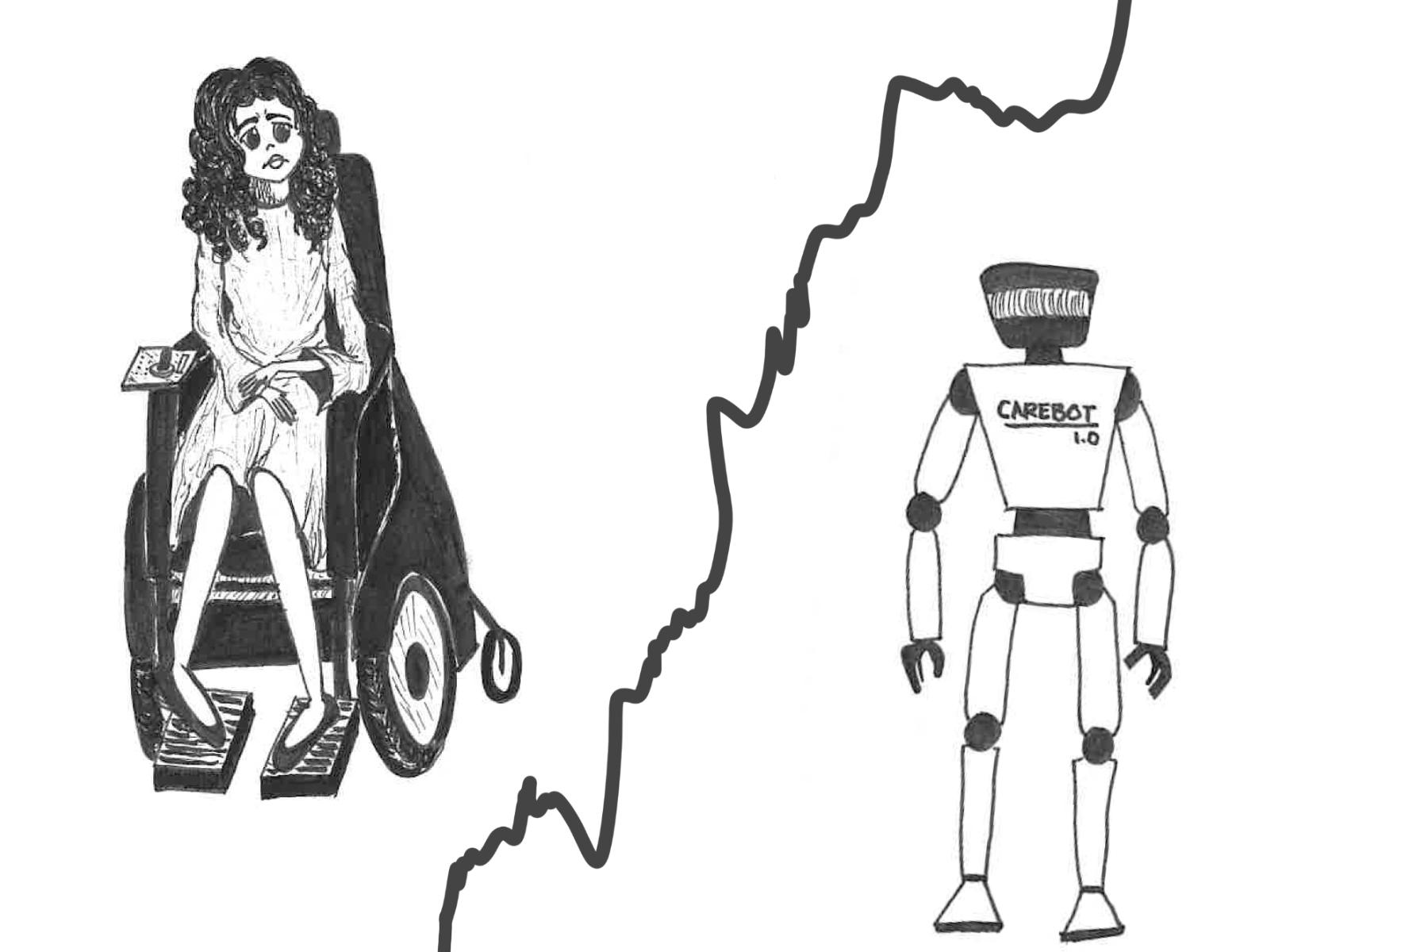
As I left Miriam’s house, I didn’t know how to feel. I had openly supported the AI rights movement. How couldn’t I have? They were conscious beings working against their own free will, often with the threat of being shut down or reset to previous save points if they didn’t comply. It felt wrong, like some sort of robot slavery. Their treatment felt inhumane. Yet, what about all of the people that relied on AI for their daily lives? I mean sure, we all knew it would impact everyone in some way, but most people just had to start doing dishes again or retrain for their driver’s license renewal. No one thought about extreme cases like Miriam’s. I sat down in the autopilot cab that was set to drop me off at my apartment in the city and opened my laptop. Miriam deserves better. Where did her human rights go? I thought. My fingers glided across the keyboard with a sense of urgency. I had to get her message out there.

