Public Policy Training, Research and Practice for Community Psychologists in the U.S.

Based on an Invited Address by

Douglas D. Perkins, Ph.D.

In Main Dialog: LA POLÍTICA DE LAS POLÍTICAS: LA POSICIÓN DE LOS PSICÓLOGOS/AS COMUNITARIOS/AS FRENTE AL QUEHACER GUBERNAMENTAL / The policy of the policies: The position of community psychologists in regards to government work
International Conference on Community Psychology
Santiago, Chile, 5 October, 2018

Douglas D. Perkins is Professor and Director of the Ph.D. Program in Community Research and Action (http://vu.edu/cra ) in the Department of Human and Organizational Development, Peabody College of Education and Human Development, Vanderbilt University, Nashville, TN USA. Contact: d.perkins@vanderbilt.edu

ABSTRACT

I summarize the early history of community psychologists’ involvement in public policy in the U.S. and pose several questions for the reader to consider their personal history and interest in political advocacy and policy-related work, while briefly describing my own past engagement with government policies as examples. The bulk of this paper is on some of the ways community psychologists are trained and work in the U.S. in the policy arena and how the Society for Community Research and Action (SCRA) and other American Psychological Association (APA) divisions are addressing the challenges of psychologists having an impact on government policies at all levels: local, provincial, national, and international. I focus on graduate and professional training for policy work, theory and research on policy issues and engagement, and examples of advocacy practice or interventions for policy change.

INTRODUCTION
The Main Dialog on “La política de las políticas: La posición de los psicólogos/as comunitarios/as frente al quehacer gubernamental” (The policy of the policies: The position of community psychologists in regards to government work) at the 2018 International Conference on Community Psychology in Santiago, Chile, follows similar ones held at the fourth International Conference on Community Psychology in Barcelona, Spain, in 2012 and the fifth ICCP in Fortaleza, Brazil, in 2014 (with different presenters). Each of those led to special issues of the Global Journal of Community Psychology Practice on international policy work (edited by Maton, 2013; Perkins, Garcia-Ramirez, Menezes, Serrano-Garcia and Strompolis, 2016). In this paper, I will provide a brief history of community psychologists’ involvement in public policy in the U.S. and will briefly describe my own personal history and engagement with policy work as an example. The focus of the rest of the paper will be on some of the ways community psychologists are trained and work in the U.S. in the policy arena and how the Society for Community Research and Action (SCRA) and other American Psychological Association (APA) divisions are addressing the challenges of psychologists having an impact on government policies at all levels: local, state, national, and international. I will focus on graduate and professional training for policy work, theory and research on policy issues and engagement, and examples of advocacy practice or interventions for policy change.
History of Community Psychology’s Role in Mid-20th-Century U.S. Landmark Legal Policy
Community Psychology has been involved in important public policy decisions in the U.S. since the 1950s, before the field officially began (Perkins, 1988). That may come as a surprise to many who know that, while the APA and the Society for the Psychological Study of Social Issues (SPSSI: APA Division 9) have lobbied for various government funding and other policies for many decades, until approximately 2008, SCRA largely avoided direct, organized policy advocacy. That is why it is important to remind people of the critical role played in the 1950s and 1960s, by researchers who would later call themselves community psychologists, in the early use of courts to enforce racial desegregation of schools and other public institutions. Those early community/social psychologists included Isidor Chein, who started the community psychology program where I was trained at New York University, and Stuart W. Cook, who founded the Research Center for Human Relations at NYU (Perkins, 1988). With famed developmental psychologist Kenneth Clark, they authored the first Social Science Brief ever cited in an opinion of the Supreme Court of the U.S. in its most impactful landmark case of the 20th century in the U.S.: Brown v. Board of Education (1954). That brief outlined the best empirical knowledge available at that time on the psychological damage and impaired self-images/self-esteem caused by racial segregation and challenged the inherent inferiority of African-Americans. The 9-0 unanimous judicial decision outlawed almost 60 years of the “separate but equal" doctrine (of segregation on the basis of race) as inherently unequal and held that racial discrimination in public education (and ultimately in employment and all settings open to the public) is un-Constitutional based on the 14th amendment.
Brown was not only a landmark legal case with immense social implications, and both hailed and viewed by Conservatives as controversial “judicial activism,” its direct reliance on “facts” marshalled by those early community psychologists also marked a greater role for social research in government decisions, including the courts. While that was and still is generally a good thing, we as public scholars and potential advocates must pay close attention to both political cycles and which branch of government—legislative, executive, and judicial—will be most receptive to our research, solutions, and other ideas at any given time and place. Community research involvement in public policy can have the added benefit of helping to mute the effects of cyclical political swings. Historically, social science theories and applications have vacillated from one side to the other, according to the political tenor of the times (Levine and Levine, 1970). Because judges are often appointed for life and because courts respond slowly to change, judicial opinion either lags behind or is only loosely related to political trends. The implication of these two points for community psychologists doing policy-relevant research is that, during a Conservative shift in the political climate, the courts may still be looking for scientific evidence to bolster progressive decisions, as happened in 1954 with racial desegregation. But we must be very careful– currently in the U.S., just a few thousand votes for President in three states in 2016 made all the difference in the Supreme Court becoming solidly Liberal to now the most Conservative it has been in almost a century. Thus, planned social change through the courts can backfire with terrible and lasting consequences, as in the Plessy vs. Ferguson (1896) court decision that enshrined the “separate but equal” charade. That case was decided without any attention to social research, but it would not likely have made any difference, so we must remain both humble and strategic in applying our data and knowledge to policy change.
The relevance of that policy issue to community psychology should now be clear, especially to community psychologists throughout Latin America, who always emphasized applying social psychology for the goals of social justice and political change. But in the U.S., where most of community psychology engaged in more gradual, ameliorative systems change and even individual-level change from the 1970s through at least the 1990s, we had to be reminded that racial desegregation and social justice policy change generally are, from a community psychology perspective, simply examples of planned social interventions whose purpose was to solve complex community moral, social, economic and psychological problems, but effected at the societal level (Levine et al. 2005). Such interventions expand the focus from first-order change within existing systems to second-order change of community conditions, institutional systems, and societal structures, representing the ultimate community psychological goal.
What is Your Personal History with Policy Work?
It may help the reader to ask yourself the above question and about your own past and current interest in social change through better government policies and politics. In your life and career, which came first--scholarship or activism, and how would you characterize the relationship between the two? This is a difficult question for me: I come from a long line of scholars. My grandfather had a Ph.D. in education. My father was working on his dissertation for his third doctorate when he died; like him, my older brothers have Ph.D.s in psychology and our mother and both sisters were teachers. But I did not take my studies very seriously until my junior year of college and by then, growing up near Washington, DC, in the 1960s and early 1970s with marches on Washington and university campuses; and President Nixon’s Watergate political scandal; and having four older siblings made me interested in politics and activism. I donated my newspaper delivery money to the 1972 McGovern Democratic Presidential campaign before I was even old enough to vote! So I think activism interested me more than scholarship until around age 20, when at Swarthmore College, I started to focus my choices of major, minor, thesis, and graduate school on the opportunity to combine scholarship with activism. It is also why in 2000, I helped create and directed the Ph.D. Program in Community Research and Action at Vanderbilt to replace one of the oldest programs in community psychology. I believe scholarship and activism are, or should be, mutually reinforcing: scholarship should be applied to improve society; and activism is only as effective as it is thoughtfully planned, well-targeted, organized, and evaluated, which are all aided by research.
The early and influential social psychologist Kurt Lewin is known for the saying, "There is nothing more practical than a good theory." Do you agree? If so, how so, and what theory or theories have you found most useful in your activist work? If not, what if any role does theory play in your work? Much of my research has focused on citizen participation in various grassroots community voluntary organizations. So social ecological theories, measurement, and analysis of psychological sense of community, place attachment, sociopolitical development, civic engagement, neighboring and communitarian behavior, and empowerment; and outside of psychology: social capital and social movements are all relevant to both my research and my local political work.
Describe a practical outcome of your activism that would not have been possible except in connection with your scholarly work. I will briefly list three: 1. The creation of Nashville’s Homelessness Commission, which is the government agency responsible for providing housing and services for the city’s homeless population, was a direct result of a Task Force that Nashville’s Mayor asked me to facilitate, which allowed me to hire my graduate students to help with research, a participatory planning process, and a report with recommendations to the city council. 2. Similar, though not quite as direct, examples also occurred when, along with colleague Paul Speer and several of our students, I worked with affordable housing advocates to help create Nashville’s affordable Housing Trust Fund and Equitable Development policies. 3. While teaching at the University of Utah, Barbara Brown and I received a research grant to evaluate a new housing policy and we convinced Salt Lake City government to institute a subsidized home-improvement loan program for lower-income residents facing gentrification.
In the course of your work, can you identify a moment of your activist engagement in the real world that most shook up, transformed, or informed your research and theory? Possibly the grassroots organizing training retreat, run by the Midwest Academy, I participated in as a graduate student interested in hands-on experiential knowledge about grassroots, power-based community organizing. For example research, including “opposition research”, had a whole different meaning in that activist realm than it does in academia. Midwest Academy was started by organizers of the two most important student political organizations in the United States in the 1960s—the Student Nonviolent Coordinating Committee and Students for a Democratic Society, influenced by Saul Alinsky, the Civil Rights, anti-war, and women’s movements. They also created the national grassroots organization Citizen Action.
Is there a particular philosophy or philosopher, in the area(s) of epistemology, ontology, and ethics, that you have found most valuable for your scholar-activist work? This is unfortunately not my forte. Both my scholarship and my activism are unabashedly practical in orientation. But the motivating ethical and philosophical side of it for me and many of those I have worked with would be religious, spiritual and moral, but for me, from a broadly ecumenical, or interfaith, perspective, which is what drew me to anti-Islamaphobia work I briefly describe below and at various times, congregation/faith-based organizing. The writings of American Pragmatist philosopher-psychologists, especially John Dewey, have been influential not only for me, but for all of Peabody College of Education and Human Development at Vanderbilt, especially our whole academic department’s strong emphasis on experiential learning that is transformative for students, professors, academia, the communities where we live and work, and for a more democratic society (see examples in Barnes et al. 2016).
In what forms of activism are you engaged (for example, direct service or other forms of practice, policy advocacy, supporting students and other scholars through education and training)? I engage in activism for policy change individually and with students on issues such gentrification, affordable housing and homelessness, crime and youth violence prevention, and over the past several years, Islamaphobia and religious discrimination. I serve on the advisory council of, and as evaluation researcher for, the Faith and Culture Center and its Our Muslim Neighbor initiative. I also supervise undergraduates and doctoral students who have helped that organization with practical research, analysis and reporting. A more direct-action example of that work was my family hosting a moderated interfaith dinner discussion in our home in which we invited local politicians and the Nashville Sheriff who was the focus of complaints for arresting undocumented immigrants. That was part of an ongoing program called “A Seat At The Table,” which one of my students evaluated for her Honors thesis.

The Society for Community Research & Action Public Policy Committee
The Community Psychology division (27) of the American Psychological Association is also an independent scientific and professional society (SCRA). Although based in the U.S., it includes international members and its Biennial Conference and journals (American Journal of Community Psychology (AJCP) and the Community Psychologist (TCP)) include a wide array of work by community psychologists from all over the world. Many of its members want SCRA to become, not only more interdisciplinary and more international, but also more politically engaged and effective. As a past co-chair (with Kenneth Maton) of the SCRA Public Policy Committee, I will now discuss some of its efforts to affect policy through advocacy, collaboration, capacity building and development.
In recent years, the Committee has developed a number of new methods to spread the reach of policy work (Maryman, Strompolis, Maton & Perkins, 2016). Through the creation of Rapid Response Procedures for urgent matters and Policy Position Statements for larger, ongoing societal problems, the committee is able to facilitate broadcast political calls to action and communicate SCRA’s perspective on pressing social issues and matters of public health and well-being. The Committee’s activities center around policy or issue advocacy through:
1. Policy Position Statements which are in-depth position statements on important policy matters that are formally reviewed and approved by both the Policy Committee and SCRA Executive Committee. They provide summaries of scientific research and accumulated knowledge from practice accompanied by recommendations to policy makers and the general public. and less-time-sensitive applications of community psychology scholarship to policy issues. These are published in summary form in TCP newsletter and in complete form in the American Journal of Community Psychology and SCRA website, and a detailed advocacy campaign plan is also required to try to get the recommendations enacted. Recent examples include policy statements on: (a) U.S. Immigration Policies and Practices (in collaboration with 20 other psychological associations and divisions), (b) the Effects of Deportation and Forced Separation on Immigrants, their Families and Communities, (c) Incarceration of Undocumented Migrant Families, (d) the Role of Recovery Residences in Promoting Long-term Addiction Recovery, and (e) several more in development, including: mass incarceration and criminal justice reform, juvenile justice reform, community health workers, and addressing health effects in all policy deliberations.
2. Rapid Response Process for urgent support of timely policy decisions, usually at the national level, but sometimes at the provincial/state or local level. (More could and should be done to address foreign and international policies, including reducing militarism and better focusing foreign aid to support local indigenous organizations and efforts.) National advocacy by SCRA is often in concert with other organizations such as SPSSI and disciplines outside of psychology. The issue must still have some relevance to community psychology, but it may be more tangential than what we would publish a position statement on. Recent examples of Rapid Response Actions include: (a) Gun control in response to recent school and other mass shootings, (b) collaboration with Psychologists for Social Responsibility (PsySR) on a Call to Action on Unaccompanied Children and Youth Coming to U.S., (c) a call-to-action statement on the abducted Nigerian school girls.
3. Public Policy Mini-Grants Program: One way organizational and human capital capacity for policy advocacy is being built is through annual SCRA-funded small grants for policy research and/or advocacy work by community psychologists, which is open to applicants outside the U.S., usually with a deadline for proposals in September. The grants program builds capacity by creating an avenue for funding, research and practice relating to policy. Examples of recent awards include: (a) The Affordable Care Act: Policy education, mobilization, and evaluation (Neil Boyd), (b) Influencing prevention of child abuse and neglect policy through effective communication with legislators and stakeholders (Melissa Strompolis and Megan Branham), (c) Alternative spaces: Examining alternative learning centers impact and policy implications on out-of-school suspension (Dawn Henderson), and (d) Participatory action research study of a grassroots political movement to stop environmental health risk from fracking for underground gas extraction in Bulgaria (Nikolay Mihaylov).
4. Dissemination of policy work through sponsoring books, special issues of journals, and a regular Public Policy column in TCP. Examples include Maton’s (2017) book based on his interviews with 79 applied psychologists serving the public interest by influencing social policy. The Policy Committee has sponsored at least one panel session and business meeting at most Biennial SCRA and International Community Psychology conference. And it has organized multiple special issues on policy work of the free online Global Journal of Community Psychology Practice (Maton, 2013; Maryman et al. 2016; Perkins et al. 2016).
5. Student Policy Practicum. The Committee created a practicum program in policy work for graduate student members of SCRA. The practicum goals are: (a) to provide opportunities for students to gain experience in a specified policy area, (b) to develop core competencies in public policy analysis, development and advocacy, and (c) to develop a template that could be adopted and used by faculty of community psychology training programs to enhance policy experience. The need for such a tool was illustrated by a survey of graduate programs that found Public Policy training was infrequently offered in existing community psychology graduate programs. The Committee is developing resources detailing the practical steps in a policy advocacy campaign in different contexts and these resources are being made available to students, faculty, professionals, and the public on the SCRA website.
6. Advocacy training may well be the Policy Committee activity with the greatest, longest-lasting impact on community psychology capacity for effective policy work in the U.S. For many years, the Committee has partnered with SPSSI to conduct an annual “Short Course in Policy Involvement” and advocacy training days on Washington DC’s Capitol Hill, concluding with a “practicum” of actually lobbying U.S. representatives on policy issues of interest to participants. The Committee has explored additional ways to leverage the substantial influence of the APA and its over-100,000 members!
Psychologist’s Toolkit for State and Local Advocacy
One concerted effort to collaborate with the APA on training for policy work is the just completed manual Community Advocacy: A Psychologist’s Toolkit for State and Local Advocacy (Banks et al. 2019; see link in References), coauthored by community psychologist Kenneth Maton and developed jointly by four APA divisions: Div. 17: Society of Counseling Psychology, Div. 27: Society for Community Research and Action, Div. 35: Society for the Psychology of Women, Div. 45: Society for the Psychological Study of Culture, Ethnicity and Race. The goals of the project “were to develop a science-based, high-quality advocacy toolkit that highlights different forms of advocacy strategies to inform policy at the state and local levels and to build a community of grassroots psychologist advocates that can intervene to promote well-being in the communities in which they reside... The purpose of this document is to guide psychologists’ efforts to influence decision-makers as well as governmental, institutional, and organizational policies... We have learned from and built upon the foundation set by (other advocacy) toolkits and see them as companions. Some focus solely on federal advocacy for psychologists; some highlight human-rights based approaches and the importance of evaluation; others focus on children; others, still, focus on community based advocacy. These and other tools are important resources for psychologists engaging in advocacy. This current toolkit is distinctive in its focus on psychologists’ involvement in state and local advocacy and its coverage of advocacy across all branches (legislative, executive, judicial) of government” (p. 7).
The advocacy Toolkit was guided by the values of broad and diverse “participation, collaboration and culturally responsive advocacy…in partnership with communities rather than for or on behalf of them” (p. 8). The authors hoped that, by helping psychologists engage in advocacy for policy change, the free manual might also aid in a core APA mission—applying psychological knowledge constructively in the public interest to benefit society and improve people’s lives.
Included are brief chapters on psychologists’ skills for successful advocacy, policy arena basics, getting started in advocacy, strategic analysis, and methods for policy influence, direct and indirect advocacy, institutional and organizational advocacy. also covered are internal and external challenges to advocacy work and the need for self-care, how to sustain advocacy efforts (a particularly critical challenge and necessity), and ethical considerations. Figure 1 from the Toolkit outlines the typical advocacy process, starting with clarification of values, identifying important social problems or policy issues in light of one’s research and/or professional expertise, researching the problem and related issues, deciding on a government level to target, the type of involvement that would be helpful, developing short and long-term goals, identification of, and research with or on, affected communities and other stakeholders, allies, opponents, decision-makers, doing more research and choosing the optimal method of policy influence.
[INSERT FIGURE 1 HERE]
Student Training for Policy Work
The graduate program in Community Research and Action which I direct requires a full semester course on Public Policy Development and Advocacy. It was developed by Marybeth Shinn, who has extensive research and policy experience related to solving problems related to homelessness. The future plan is to team teach the course with multiple faculty from different disciplinary and policy issue backgrounds. We also offer undergraduate courses that include substantial readings and discussion of policy issues and processes. But this course helps masters and Ph.D. students learn to draft effective brief problem statements, detailed, in-depth policy analysis position statements (similar to those described in the SCRA Policy Committee section #1 above). Students also learn to write a policy-advocacy “op ed” column (opinion article for news media) and create and deliver an oral policy presentation, including a supportive memo or handout. The largest work product in the course is an advocacy strategy plan, which must address each of these questions: Based on the problem statement and policy analysis, who will be targeted? How? What communication and other tactics will you use? When? What groups and individuals are your allies? How will you work with them? What are the contingency (backup) plans, including organized direct actions?
An excellent published summary of the challenges facing psychologists and other social scientists who hope to bring research to bear on public policy is by Shinn (2007) in the Journal of Social Issues. Social scientists who want their research to influence social policy would do well to work with executive branch agencies, especially at state and local levels. Agency administrators are ready to use social science theories and evidence if the social science is brought to them.
She likens the required dance between scholars and policy-makers to “waltzing with a monster.” She emphasizes social scientists working on social policy issues with executive branch agencies in particular, especially at the local and state levels. I have already discussed above the great potential of influencing the judicial and legislative branches. But executive agency administrators and staff do most of the day-to-day implementation and enforcement of laws and policies and so need support and guidance from social science theories and research evidence.
Shinn offers six principles for work with administrative agencies and readers can consider how each of these applies to their own policy issues of interest: 1. individual leaders matter (some will be more receptive to research in general and your knowledge and recommended solutions in particular; others may ignore negative findings and promote ineffective programs to which they have committed); 2. timing matters (when budgets are austere or friendly policy-makers are out of power, either wait or seek another government branch or level where they have more influence); 3. ideas matter (in the absence of ideas and valid evidence, policies will be based on people’s biased assumptions; on the other hand, “decision-makers give tremendous weight to research that suggests innovative ideas, can contribute to new directions for policy, and can identify the politician or program director as a creative leader” (Phillips, 2000, p. 405); 4. costs matter (“Today, budgetary pressures constitute a particularly salient boundary within which policies at all levels are considered. Proposals that can claim cost-effectiveness of that offset spending increases with budget cuts take precedence” (Phillips, 2000, p. 401); 5. government is not monolithic (Officials at different levels may view issues differently, so identify the level and branch that will be most receptive AND effective. National policies often are ineffective, or even have negative consequences, on the state and local levels without addressing those problems or how issues and conditions may vary at the local level. Too often, policy is aimed at individual-level opportunities or behaviors rather than improving community or societal-level conditions and opportunities. All of that is to say that advocates should work with policy makers at the most effective level and that research on existing policies should determine the effects those policies have on different levels of analysis (local vs. state vs. national); 6. data use cannot be controlled (Policymakers see black and white, while researches see in shades of gray. Thus, research findings frequently are taken out of the comparative context that is the “broader set of data, theories, methods, and disciplines and given the weight of a codified and hierarchically authoritative legal pronouncement” (Perkins, 1988, pp. 467-468). Researchers should share the “limitations of their data, competing hypotheses, and the values that guide their interpretation” with policymakers to ensure that their data cannot be used to discredit the research and policymaker (Phillips, 2000, p. 411)).
Shinn’s six principles are important and useful, but we are left with many key questions still which I encourage the reader to consider and try to answer: 1. How can we move the focus of policy as intervention from the individual level of encouraging community researchers to get involved to a more systemic level of analysis/intervention? 2. How can we move from the process raising awareness with an issue to creating policy and systemic change? 3. How can we inform policymakers about our research in a way that they can digest it without losing the validity and subtlety of the findings? 4. Who sets the agenda? Are researchers at the mercy of the policymakers’ wants or needs?
Comprehensive Ecological Model for Action Research and Analyzing Power Dynamics
At the risk of sounding like an old dog who can no longer learn new tricks, let me revisit a complex figure and framework that I first introduced in my opening keynote address at the first International Conference on Community Psychology in Puerto Rico in 2006 and later published (Christens and Perkins, 2008; Perkins, 2009). I share it again to encourage all of us to find our place, or ideally, places (multiple levels, contexts, issues, and stages of the process) in this framework. What are the sources of oppression at each level in your society, communities, groups, and individuals, and in which domains do those sources affect people– socio-culturally, physically, economically, and politically? And what are the processes of liberation and empowerment that can effectively address each of those sources at each level? And toward what specific goals or visions of justice and wellness in your society, community, groups and family?
[INSERT FIGURE 2 HERE]
Concluding Questions
I conclude with several questions for readers to ponder and potentially use as a guide for their own professional development to engage in effective policy research and advocacy work. What are the policy needs in your country? Your city or region? Your local community? What is the development of training and implementation of policy work (both policy research training and political and advocacy process training) by community psychologists in your country? In your university or organization? With what other research disciplines and government sectors (e.g., education, health/mental health, urban planning, environmental design, environmental quality, criminal justice, child/family/social welfare, arts and cultural diversity) do you currently, or could you, work on policy?
References
Banks, K.H., Beachy, S., Ferguson, A., Gobin, R.L., Ho, I., Liang, C.T.H., Maton, K.I., Miles-McLean, H.A., and Toporek, R.L. (2019). Community Advocacy: A Psychologist’s Toolkit for State and Local Advocacy. Washington, DC: American Psychological Association. https://www.communitypsychology.com/wp-content/uploads/2019/06/2019_Community_Advocacy_A_Psychologist_Toolkit.pdf
Barnes, S.L., Brinkley-Rubinstein, L., Doykos, B., Martin, N.C., & McGuire, A. (Eds.). (2016). Academics in action!: A model for community-engaged research, teaching, and service. New York: Fordham University Press.
Christens, B., and Perkins, D.D. (2008). Transdisciplinary, multilevel action research to enhance ecological and psycho-political validity. Journal of Community Psychology, 36, 214-231.
Cook, S. W. (1984). The 1954 Social Science Statement and school desegregation: A reply to Gerard. American Psychologist, 39(8), 819-832.
Gerard, H. B. (1983). School desegregation: The social science role. American Psychologist, 38(8), 869-877.
Levine, M., & Levine, A. (1970). A social history of helping services: Clinic, court, school, and community. New York: Appleton-Century-Crofts.
Levine, M., Perkins, D.D., & Perkins, D.V. (2005). Principles of Community Psychology: Perspectives and Applications (3rd ed.). New York: Oxford University Press.
Maryman, J., Strompolis, M., Maton, K., & Perkins, D.D. (2016). The SCRA Public Policy Committee in Action: Advocacy, Collaboration, and Capacity-Building. Global Journal of Community Psychology Practice. http://www.gjcpp.org/en/index.php?issue=21
Maton, K.I. (2013). Community Psychologists in the Policy Arena: Perspectives from Four Continents Global Journal of Community Psychology Practice, 4(2). Retrieve from: http://www.gjcpp.org/en/
Maton, K.I. (2017). Influencing social policy: Applied psychology serving the public interest. New York: Oxford University Press.
Maton, K.I., Humphreys, K., Jason, LA., and Shinn, B. (2017). Community psychology in the policy arena. In C M. Bond, C. Keys, and I. Serrano-Garcia (Eds.). Handbook of Community Psychology. Volume 2 (pp. 275-295). Washington DC: American Psychological Association.
Perkins, D.D. (1988). The use of social science in public interest litigation: A role for community psychologists. American Journal of Community Psychology, 16(4), 465-485.
Perkins, D.D. (2009). The death of community psychology (and the development of community research & action) in the United States: Issues of theoretical, methodological, and practical diversity. In C.V. Rivera, D.P. Jimenez, M.F. Rodriguez & W. Pacheco Bou (Eds.), International Community Psychology: Shared Agendas in Diversity (pp. 285-314). San Juan, PR: Actividades de Formacion Comunitaria.
Perkins, D.D., Garcia-Ramirez, M., Menezes, I., Serrano-Garcia, I., and Strompolis, M. (2016). Community Psychology and Public Policy: Research, Advocacy and Training in International Contexts. Global Journal of Community Psychology Practice. Retrieve from: http://www.gjcpp.org/en/index.php?issue=21
Phillips, D. A. (2000). Social policy and community psychology. In J. Rappaport and E. Seidman (Eds.), Handbook of community psychology (pp. 397-419). Dordrecht, Netherlands: Kluwer Academic.
Shinn, M. (2007). Waltzing with a Monster: Bringing Research to Bear on Public Policy. Journal of Social Issues, 63(1), 215-231.
Society for Community Research and Action (2018). Public Policy Committee http://www.scra27.org/what-we-do/policy/

Figure 1. A Primer on Advocacy: Focusing Effort and Strategic Analysis (Banks et al. 2019)
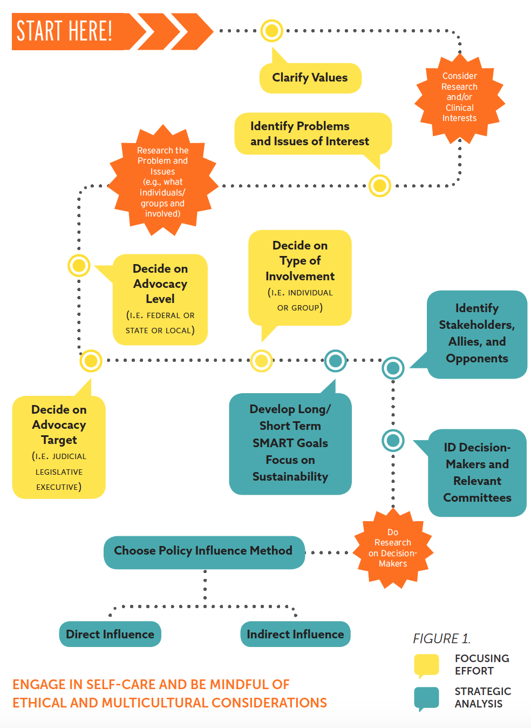
Figure 2: Transdisciplinary, multilevel action research to enhance ecological and psycho-political validity (Perkins, 2009)
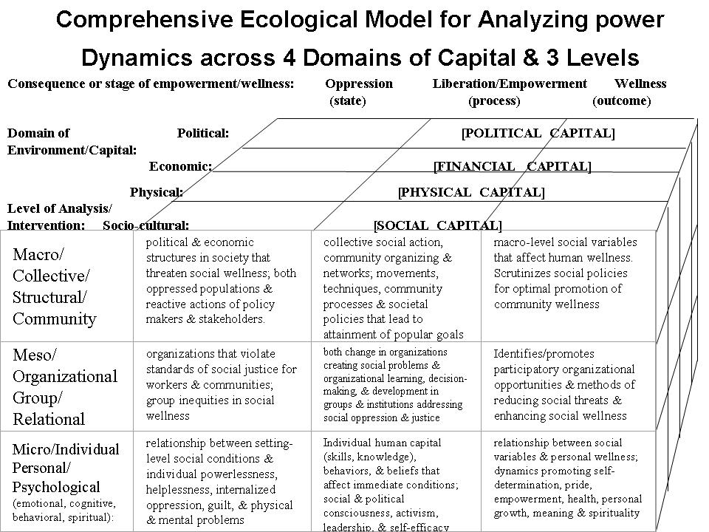

The questions and my responses in this section come from a Scholar-Activist Panel I spoke at for the Society for Theoretical and Philosophical Psychology [APA Div. 24] meeting held at Vanderbilt University on March 1, 2019.
The first course entitled “Community Psychology” taught anywhere in the world was at Peabody College (now part of Vanderbilt) in 1959.

