Skills I bring to a job:  - Fluent in English and Kurdish  - Good communication  - Office task experience  - Punctuality  - Reliability  - Polite  - Organizing materials  - Works well with others  - Flexible | 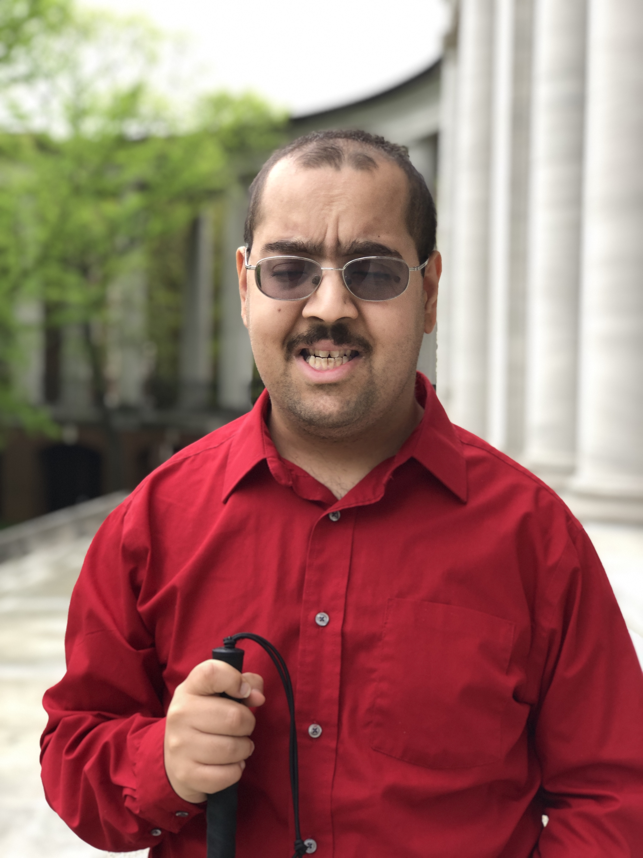  Words that best describe me:  Friendly, Caring, Diligent, Respectful | Valuable supports for me at work:  - Physical guidance upon request  - Support learning a new environment  - Describe job tasks  - Answer my work questions

