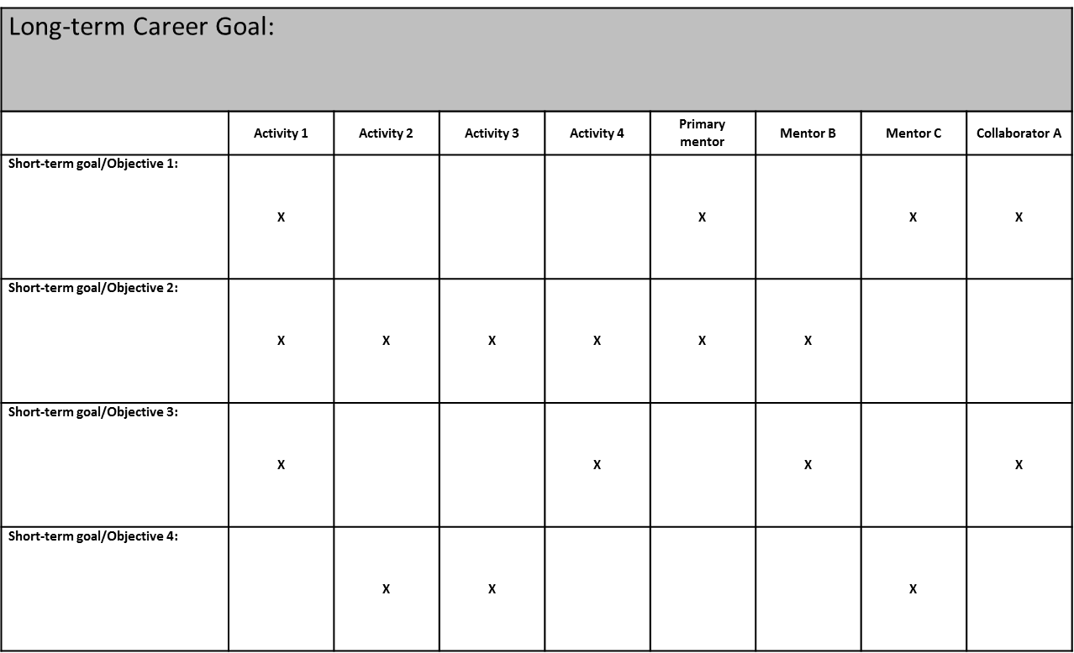
Matrix for showing relationship between/among Long-term Career goal, short-term goals/objectives, activities,
mentors, and collaborators v2

