Rita Yosief
Professor Greenfield
ITA 3803
9 May 2017
Ciao, Cefalú!

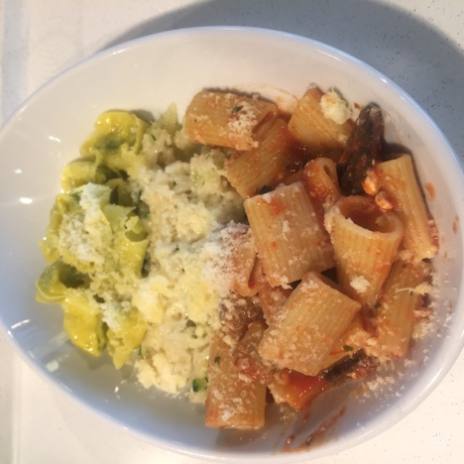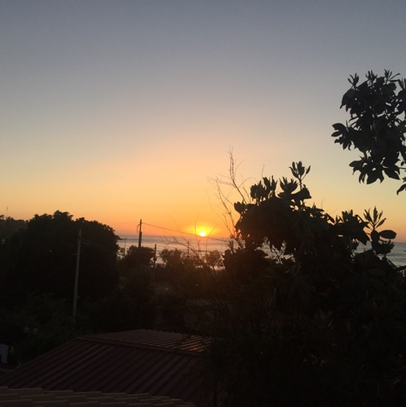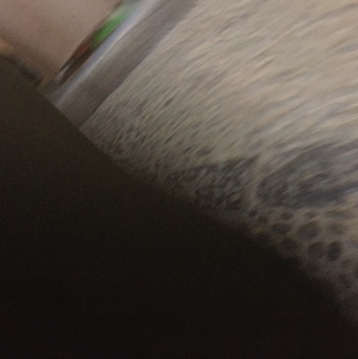

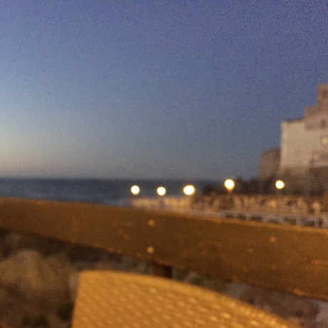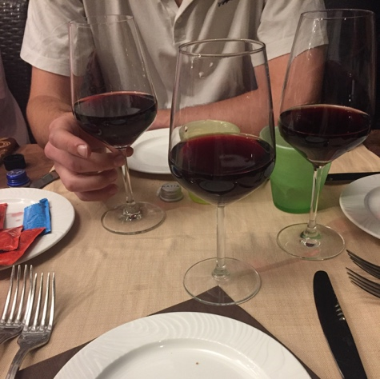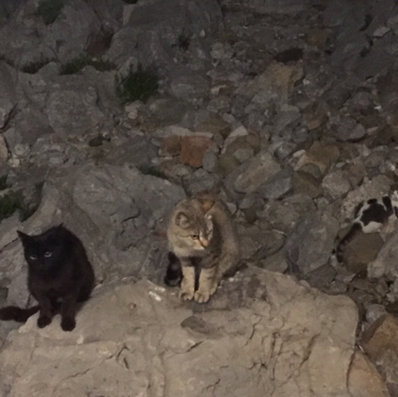

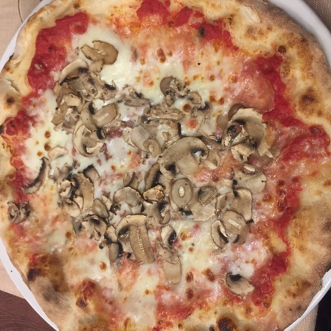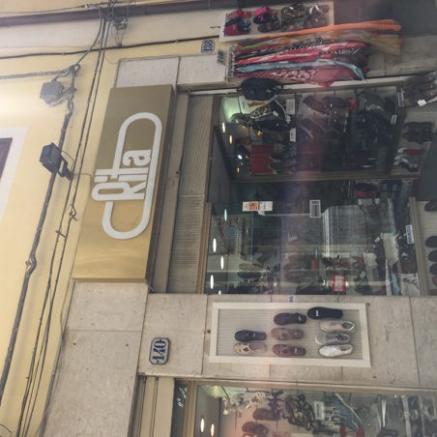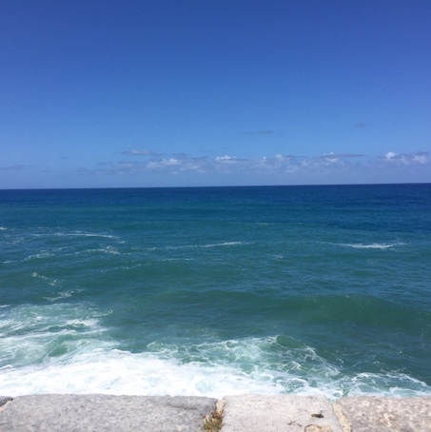

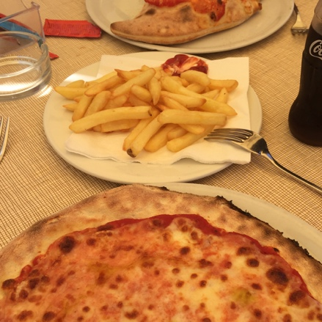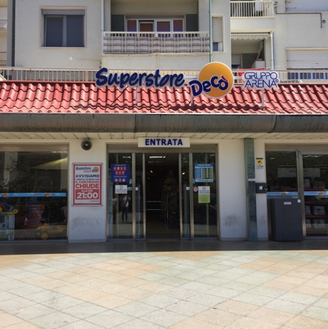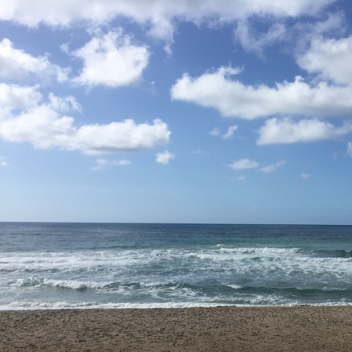

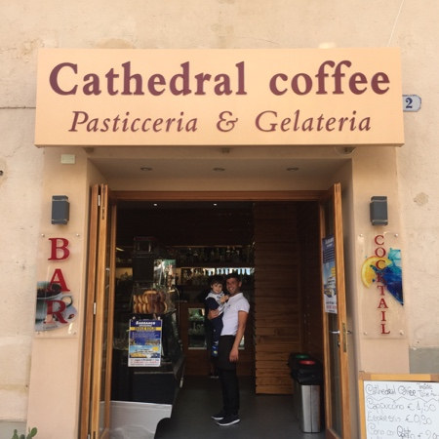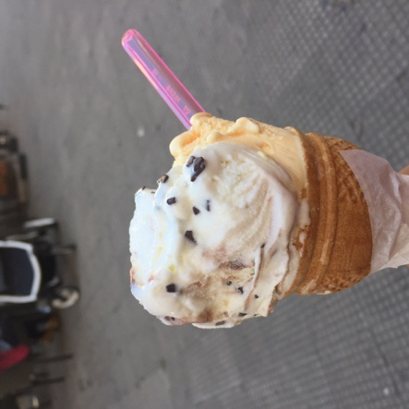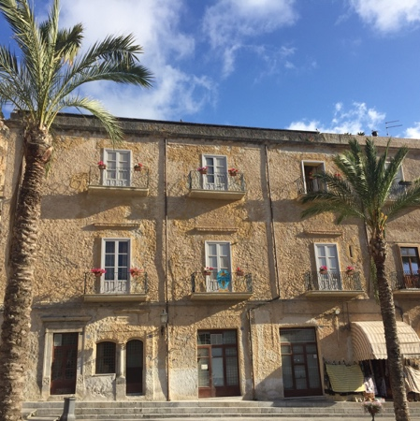

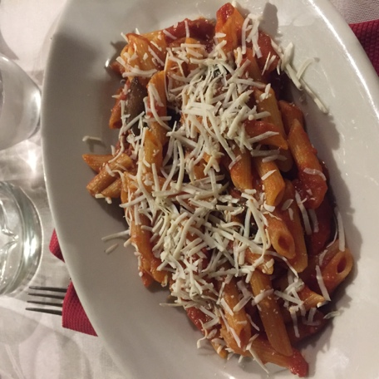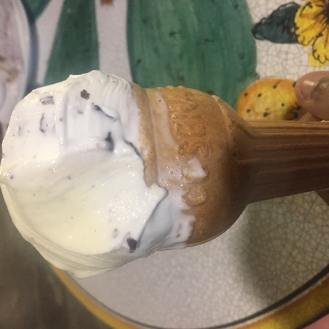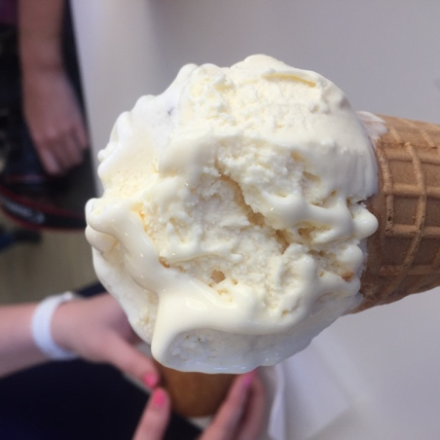

Pictures

- Rigatoni, risotto, and tortellini in FCO
- Sunset outside of our villa on Cefalù on the first evening
- Blurry picture of cobblestone streets in Cefalù
- Group dinner by the water
- Italian wine
- Stray cats on the rocks by our restaurant
- Margherita with mushroom
- Shoe store (with my name!)
- The ocean appears to be many colors of blue
- Another margherita and frites
- Grocery shop
- Beach
- Gelateria
- My first gelato (vanilla and straticella)
- We sat on the church steps and listened to an Italian singer (Italian songs, but American classics too!)
- Pasta for dinner
- Gelato no. 2 (straticella and vanilla)
- Gelato no. 3 (straticella and vanilla)

These first couple of days in Cefalù have been a simple nice. A life here appears to be one of leisure and simplicity. I came through the airport in Rome before flying to Palermo and riding the bus to Cefalù. And while I was quite impatient when we first got here, I am beginning to love the peaceful slowness of the days here. Just thinking back to the first dinner, I couldn’t understand how we stayed in the restaurant for just about 3 hours. I am so used to the go-go-go pace of life at school and even at home, so this was quite the difference for me. These have been the first differences I have noticed in Cefalù, but have begun to pay close attention to the subtle differences in everyday. Now, I want to tell you a story -- a gelato story.

Since we first came to Cefalù, or arrived in Rome even, I had been keen to have my first Italian gelato. I had prepared myself for this trip to Italy ever since I learned I would be going and read in a travelogue during my research that when in Italy, one must treat themselves to gelato everyday, at least once a day. I just couldn’t wait, so needless to say my first time having gelato was a happy one. I want to write a bit about that time. I walked with Cynthia to get gelato on our second day and we passed many gelaterias, but we wanted to pick the “right one” for our first time, so we wandered from our villa all the way to the cathedral and decided on Cathedral Coffee, a pastry and gelato shop just by the cathedral. Before entering the small gelateria, I took out my phone to take a picture of the cute little shop. Inside the shop, a man and his little son were ordering gelato and saw me concentrating my frame on the place. The man turned and smiled wide and had his son pose for me (Picture 13). I took many pictures of the moment, my heart warmed, and we walked inside. The man could certainly tell we were tourists and was kind with his eyes because of our language differences. He pointed to his favorite, straticella, before he left the store and I ordered the flavor, with what I thought would be a classic vanilla, on his recommendation. The gelato was glorious, it was, and with such a generous serving too. I did run into some trouble, when it came time to pay because I only had my cards with me and no euros. The cashier informed me that I should always carry euros, even if a small amount, because many places still do not take cards. I made a note to myself and thankfully, Cynthia had enough euros for the both of us. This occurrence made me think of a couple of things. Firstly, I thought of the little boy. I hadn’t seen any children in Cefalù before then. I know it had just been a couple of days, but I had expected to see more young families with children than I had by then. I then thought back to human geography and how the Italian population has been in decline, as less and less children are being born. I think there may even be more elders than there are young people in the country. And that made me think of the economy in Cefalù and more largely, Italy and why less and less couples are having children. The second thought I had was of paying in euros. It is a novelty for me to not pay with a card because even at home I don’t carry the currency. What more, I thought that because Cefalù has many tourists come through, that having euros with me wouldn’t be neessary. I ended up having the same problem in other restaurants and businesses after this first gelato time and so, I finally withdrew euros for payment. And then, this also made me think about the economy in Cefalù. I have only seen a little of Cefalù, but what I have seen is a service industry, so I wonder what else helps the economy here. And if the economy is mainly based on the service indusry, I would understand why there are little children here. A couple, for example, would both have to work jobs to care for themselves and their needs, so having a child could very much be considered a luxury here. These questions of population and economy, I will continue to seek answers for, especially as I begin to meet locals and those with a greater understanding of the history here. The first time I had gelato was not only a lovely time, but it also led me to ask questions about Cefalù, instead of being a passive tourist. I hope to be a curious student while here and this gelateria visit was just a first.

