Standard Operating Procedure
Vibromet I Vibratory Polisher

Department: | Earth and Environmental Sciences
Date SOP was written: | 1/17/2018
Date SOP was approved by PI/lab supervisor: | 1/17/2018
Principal Investigator: | Guil Gualda
Internal Lab Safety Coordinator/Lab Manager: | Richard Bradshaw
Lab Phone: | Click here to enter text.
Office Phone: | G. Gualda (615) 322-2976 (campus phone: 3-2976)  R. Bradshaw (615) 343-0839 (campus phone: 3-0839)
Emergency Contact: | G. Gualda (615)-988-8230 (cell)  R. Bradshaw (208) 260-2792 (cell)
Location(s) covered by this SOP: | SC 5730B

Personal Protective Equipment (PPE)

Eye/Hearing Protection:

Other Protection:
Pull long hair back
No loose clothing

NOTE: Reading this SOP does not give you permission to use this polisher, you MUST be trained by the Lab Manager on the proper use. This SOP is meant as a reminder of the procedure and safety information, not a comprehensive set of instructions.

This polisher is generally used as the final polishing step for samples where the polished surface needs to be free of defects, generally for EBSD analysis.

Important:
Be sure to clean your sample thoroughly before using this polisher to avoid contamination of the pad
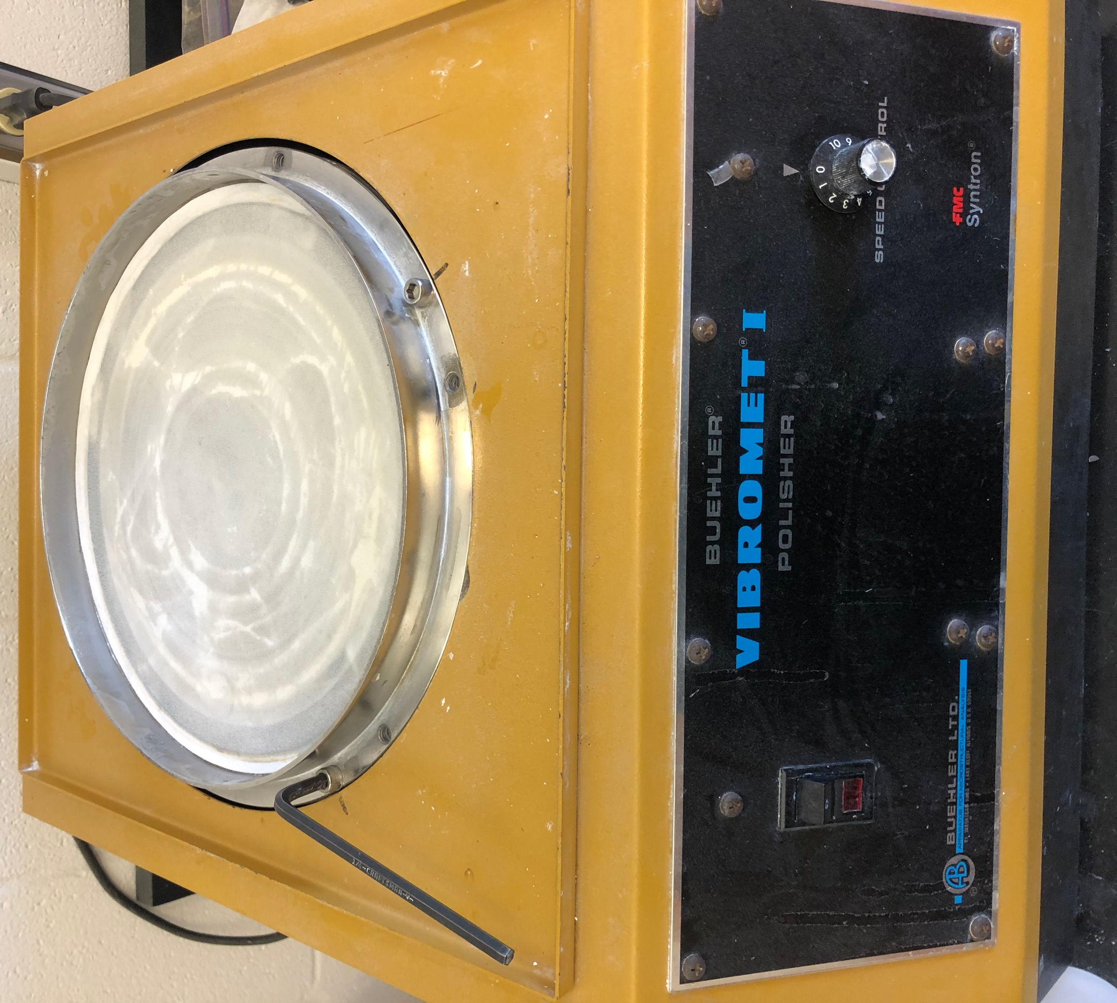
Procedure:

Preparation
- Make sure all the parts of the polisher are clean and dry
- Make sure your sample is clean
- Assemble the polisher
  - The drive plate, which has the polishing pad, needs to be placed on the machine and secured with the 4 bolts
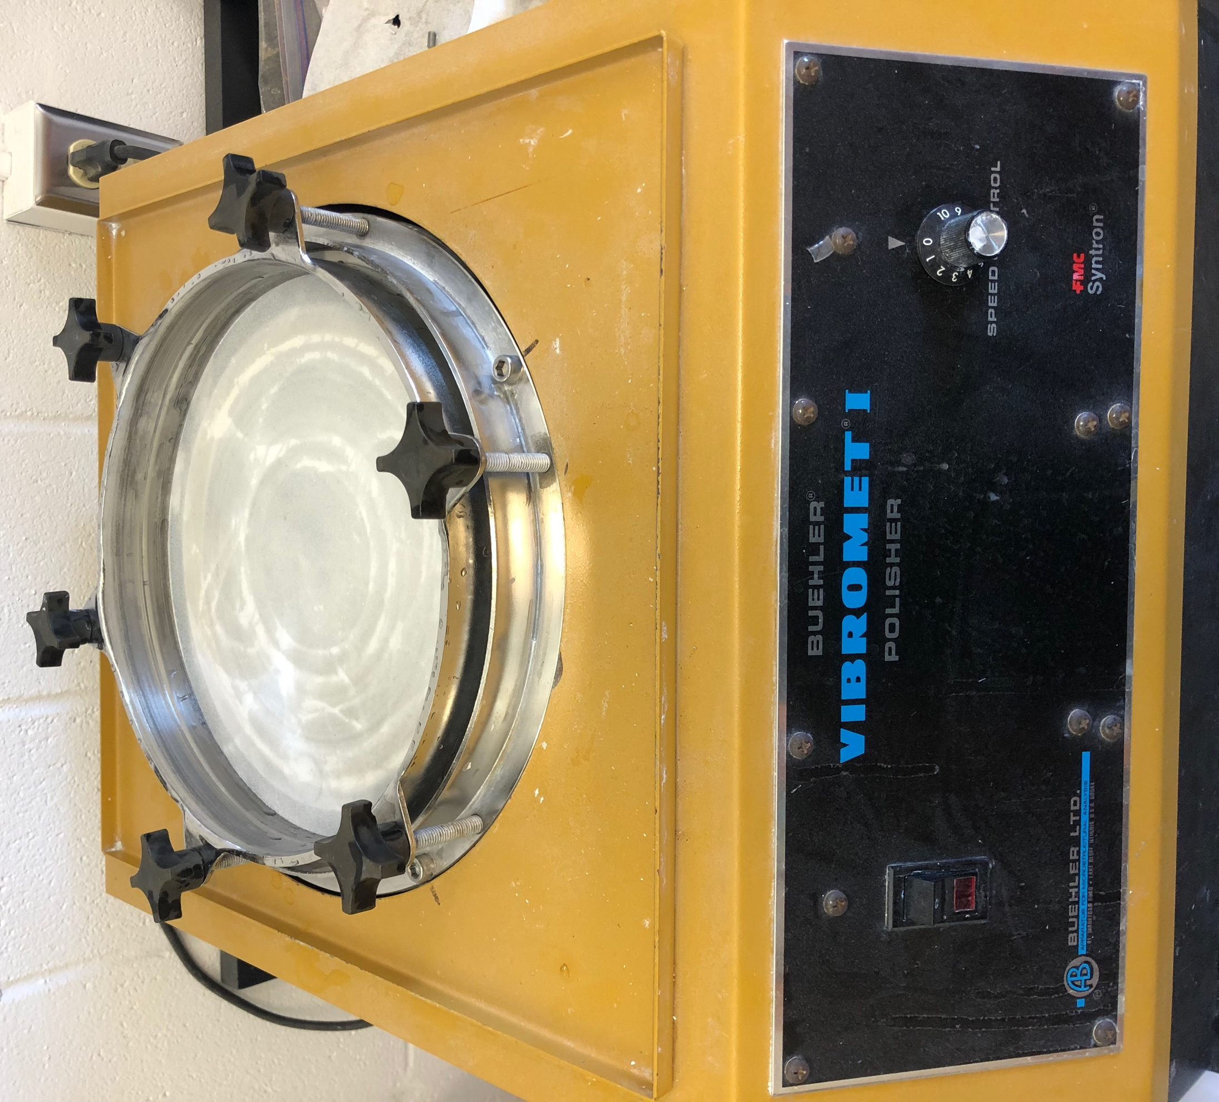
  - The clamping ring is then placed on top of the pad and secured to the drive plate with the 6 hand turned bolts
- Prepare your samples
  - For 1” round samples
    - place your mount face down in the appropriate slot on the loading fixture (The disk with 3 round indentations, located in the drawer below the polisher)
    - Place a sample holder on the loading fixture around your sample
    - Tighten the set screw in the sample holder using an allen wrench
  - For thin sections
    - There are 3 thin section holders in the drawer
    - Use double sided tape to secure your thin section to the sample holder
  - For some applications you might want to add weight to the sample holder
    - Screw a weight shaft into the threaded hole on the top of the sample holder
    - Slip the required weights on the shaft
    - Generally 0 to 1 weight is sufficient for this final polishing step
- Apply the polishing solution
  - Moisten the polishing cloth with DI water before applying the polishing solution
  - Apply enough polishing solution (Master Prep Polishing Suspension, 0.05 μm) so there will be complete coverage once it is redistributed
  - Use one of your samples to manually redistribute the polishing solution over the pad
- Start the polisher
  - Place the dust cover on top of the polisher
  - Switch the power switch to ON
  - Adjust the vibration amplitude using the speed control knob on the right until the samples make ~6 revolution per minute (#2 on the speed control dial is a good starting point)
- Polishing time
  - Generally, samples should be polished for >1 hour

Finishing up
- Remove your samples from the sample holders
- Remove the clamping ring and drive plate
- Thoroughly clean the following
  - Your samples
  - All sample holders used
  - The clamping ring and all 6 bolts
  - Lightly rinse the polishing pad and drive plate
  - Wipe down the dust cover, inside and out
- Leave everything out to dry
- Come back after everything is dry and place everything back on the polisher with the dust cover on to avoid dust contamination on the pad

