Standard Operating Procedure
Making Mounts

Department: | Earth and Environmental Sciences
Date SOP was written: | 1/17/2018
Date SOP was approved by PI/lab supervisor: | 1/17/2018
Principal Investigator: | Guil Gualda
Internal Lab Safety Coordinator/Lab Manager: | Richard Bradshaw
Lab Phone: | Click here to enter text.
Office Phone: | G. Gualda (615) 322-2976 (campus phone: 3-2976)  R. Bradshaw (615) 343-0839 (campus phone: 3-0839)
Emergency Contact: | G. Gualda (615)-988-8230 (cell)  R. Bradshaw (208) 260-2792 (cell)
Location(s) covered by this SOP: | SC 5703B

Personal Protective Equipment (PPE)

Eye/Hearing Protection:

Other Protection:
Pull long hair back
No loose clothing

Medical Emergency Dial (615) 322-2222 for Vanderbilt Police

Life Threatening Emergency, After Hours, Weekends and Holidays – Dial (615) 322-2222 for Vanderbilt Police or go to the nearest emergency room. Note: All serious injuries must be reported to Environmental Health and Safety (EH&S) within 8 hours.

Non-Life Threatening Emergency – Go to the Occupational Health Facility (OHF). After hours, go to the nearest emergency room. Note: All serious injuries must be reported to EH&S within 8 hours.

Please leave the sample preparation area cleaner than you found it!

Procedure:

Preparing your sample
- Prep each blue SampleKup you will need
  - Apply a thin layer of Vaseline on the inside of the cup and on the bottom insert—Anywhere the epoxy will touch should have Vaseline so you will be able to remove your sample later!
  - If you are making grain mounts and have your grains on two-sided tape, you can either
    - Place the tape on the bottom insert, making sure that the entire thing is covered. If some of it is not covered, apply Vaseline to it.
    - Place the double-sided tape on a large glass slide and press the top of the SampleKup firmly onto the tape around the grains (some epoxy will typically leak out the bottom of the cup with this method)
- Insert the bottom part of the SampleKup in the correct side, it should click into place (see figure below for correct orientation)
- Insert your sample into the SampleKup so it is centered (if not a grain mount)

Mixing the epoxy
- Place an empty mixing cup on the balance and zero it out
- The resin and hardener you need to mix is located in the metal cabinet marked Flammable next to the door
- Mix the resin and hardener in the ration of 25:3 resin:hardener by weight
  - Rule of thumb: 25 grams resin to 3 grams hardener should make ~3 mounts
  - The hardener is also more dense than the resin, so it doesn’t take very much
- Once you have both the resin and hardener poured into the mixing cup, mix them together with a stir stick
  - Mix them together slowly to avoid making bubbles
  - Thoroughly mix them for 2-3 minutes until you no longer see any streaks
  - Note: under-mixed epoxy will not set properly

Vacuum impregnating mounts
- Place each of your samples in the Cast N’ Vac chamber
- Place the cup with the epoxy mixture in the cup holder in the vacuum chamber
  - Double check that the SampleKups are at the appropriate distance from the cup
- Place the plastic dome on the vacuum chamber
- Place the vacuum gauge in the correct hole on the dome
- Turn on the vacuum pump
- Once the vacuum gauge reads 26” of mercury (560 Torr) turn the pump off
- Slowly rotate the casting knob (that rotates the mixing cup) to pour the epoxy into the mold
  - Fill the mold up enough to cover your sample and not more than half full
  - After pouring, do not immediately raise the cup to a vertical position. Keep it slightly tilted until the epoxy stops dripping
- Press the revolving table switch to move your next sample into position
- Pour epoxy into all of your samples
- Leave under vacuum to allow your samples to cure under vacuum for about 30 minutes
- Clean up everything you used to mix the epoxy
- Remove the dome off the vacuum chamber and remove your samples
- Remove the mixing cup and throw it away

Making grain mounts
- To avoid bubble formation around grains, we do not pour the epoxy on grain mounts under vacuum
- You can heat up the epoxy on the hotplate to reduce the viscosity
  - Use a beaker on the hotplate at ~50 °C
- Carefully pour the epoxy by letting it run down the stir stick to the side of the SampleKup so it slowly runs across the bottom over the grains
- Let the mounts cure overnight on the counter (not under vacuum)
  - It is a good idea to cover the SampleKups with a paper towel
- IMPORTANT: If you mix the epoxy in a beaker, place the beaker under a steady stream of hot water under the sink IMMEDIATELY after you pour the epoxy to rinse it out before it sets

Finishing up
- After the epoxy has set overnight, remove the bottom piece off the SampleKup and slide your sample out
  - This may require a lot of effort
- Clean and dry everything
- Put everything away
- Remember to clearly mark your samples
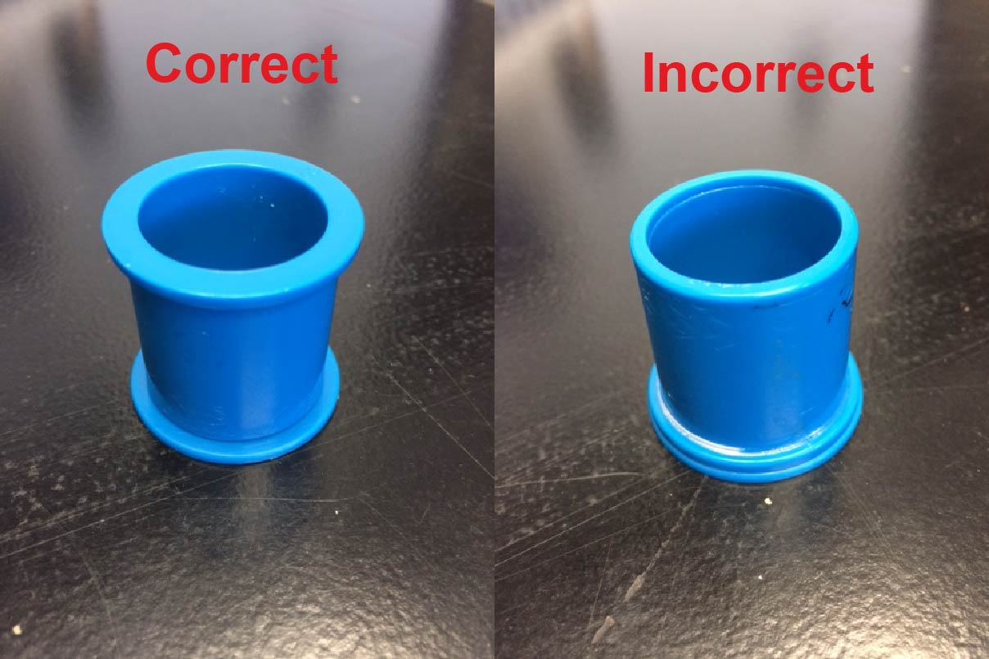

Documentation of Training (signature of all users is required)
- Prior to conducting any work, the PI or LM must provide training to his/her laboratory personnel specific to the hazards involved in working with this equipment, work area, and emergency procedures.
- The Principal Investigator must provide his/her laboratory personnel with a copy of this SOP.
- The Principal Investigator must ensure that their laboratory personnel have attended appropriate laboratory safety training and are current with any refresher training required.

I have read and understand the content of this SOP, and have completed the accompanying safety checklist:

Name | Signature | Date

