Standard Operating Procedure
IsoMet 1000 Precision Saw

Department: | Earth and Environmental Sciences
Date SOP was written: | 1/17/2018
Date SOP was approved by PI/lab supervisor: | 1/17/2018
Principal Investigator: | Guil Gualda
Internal Lab Safety Coordinator/Lab Manager: | Richard Bradshaw
Lab Phone: | Click here to enter text.
Office Phone: | G. Gualda (615) 322-2976 (campus phone: 3-2976)  R. Bradshaw (615) 343-0839 (campus phone: 3-0839)
Emergency Contact: | G. Gualda (615)-988-8230 (cell)  R. Bradshaw (208) 260-2792 (cell)
Location(s) covered by this SOP: | SC 5730B

Personal Protective Equipment (PPE):

Eye/Hearing Protection:

Other Protection:
Pull long hair back
No loose clothing

Medical Emergency Dial (615) 322-2222 for Vanderbilt Police

Life Threatening Emergency, After Hours, Weekends and Holidays – Dial (615) 322-2222 for Vanderbilt Police or go to the nearest emergency room. Note: All serious injuries must be reported to Environmental Health and Safety (EH&S) within 8 hours.

Non-Life Threatening Emergency – Go to the Occupational Health Facility (OHF). After hours, go to the nearest emergency room. Note: All serious injuries must be reported to EH&S within 8 hours.

NOTE: Reading this SOP does not give you permission to use this saw, you MUST be trained by the Lab Manager on the proper use. This SOP is meant as a reminder of the procedure and safety information, not a comprehensive set of instructions.

For this machine to retain its designation as a precision saw, all the parts must be kept clean and in good condition. Please be careful with the saw blade so that it won’t warp, resulting in uneven cuts for your and other’s samples. Never start the saw blade with a sample resting on it.

Procedure:

Preparing to cut
- Make sure all the parts you need are clean and in good working order before starting
- Find the appropriate chuck for your sample in the drawer beneath the saw and securely mount your sample
- Remove the sample tray to allow removal of the lubrication tank and/or installation of the blade
- Fill the lubrication tank with water, either by pulling the tank out and filling it in the tap, or by using a beaker to fill it up without taking it out
  - The water should be filled to a level that will immerse the bottom of the blade in about ¼ in. of water
- Install the blade
  - The blade is installed with two flanges and the end cap bushing
  - The order to slide these parts on the drive shaft is:
    - Flange, blade, flange, end cap bushing, thumbscrew (see figure below procedure)
  - The smooth sides of the flanges should face away from the blade
  - Hand tighten the thumbscrew
- Load your sample on the sample arm
  - Use the thumbscrew to attach the chuck holding your sample onto the arm
  - Move the sample arm to the left so it won’t hit the blade using the sample positioning knob on the left side of the machine
  - Lower the weight arm so it is horizontal and slide the load weight to the zero position
  - Slide the counter balance weight until a balance is achieved and tighten it
  - Slide the load weight to the desired load (~300 grams is a good starting point)
    - Less weight will result in a slower, but smoother cut
- Set the end of cut adjustment (black knob on top of the machine) so that your sample sits just below the top of the blade
  - This will turn the blade off once the cut is finished

Cutting your sample
- Raise the sample arm up until it locks into place
- Rotate the sample positioning knob to move the sample into place
  - You can lower and hold the sample arm so your sample is just above the blade to make this adjustment
  - Be careful not to hit the blade, which could damage your sample and the blade
- Move your sample so it touches the side of the blade and select “zero” button to set the position display to 0.
- Lift up the sample arm and move it over the desired distance for your cut
  - Remember the width of the blade is:
- Close the hood
- Turn the blade on by pressing the Saw button
  - Make sure the water level is high enough to lubricate the saw blade
  - You can increase or decrease the speed of the blade
    - Lower speeds will result in a slower, but smoother cut
- Slowly lower the sample arm down to start the cut
  - DO NOT start the blade while a sample is resting on it
- Once the cut is finished, the saw will automatically stop

Finishing up
- Remove all the parts used:
  - Remove your sample and chuck from the sample arm
  - Remove the sample tray
  - Remove the blade and flanges from the drive shaft
  - Remove the lubrication tank and dump out the water
- CLEAN and dry everything
  - Rinse off the blade and flanges and gently dry them with a paper towel
  - Rinse off the sample tray and lubrication tank
  - Rinse off and dry the sample chuck
  - Wipe down the hood and the inside surface of the machine
  - Wipe down any other surface that may have gotten wet on or around the saw
- Put everything away
  - Reinstall the lubrication tank
  - Put the flanges, end cap bushing, and thumbscrews on top of the machine (inside the hood)
  - Put the (clean and dry) blade away
  - Put the chuck back in the drawer
  - Keep the hood open so everything will finish drying

Dressing the blade
- The two reasons to dress a blade are:
  - If you are using a new blade (rare) it needs to be dressed before use
  - If you notice that the blade seems to be cutting slowly, you can dress the blade to increase the cutting efficiency
    - For what we generally cut, this rarely needs to be done
- Put a dressing stick in an appropriate chuck and install on the sample arm
- Make ~5 cuts for a new blade, or 2-3 for a used one
- Remove and clean the chuck
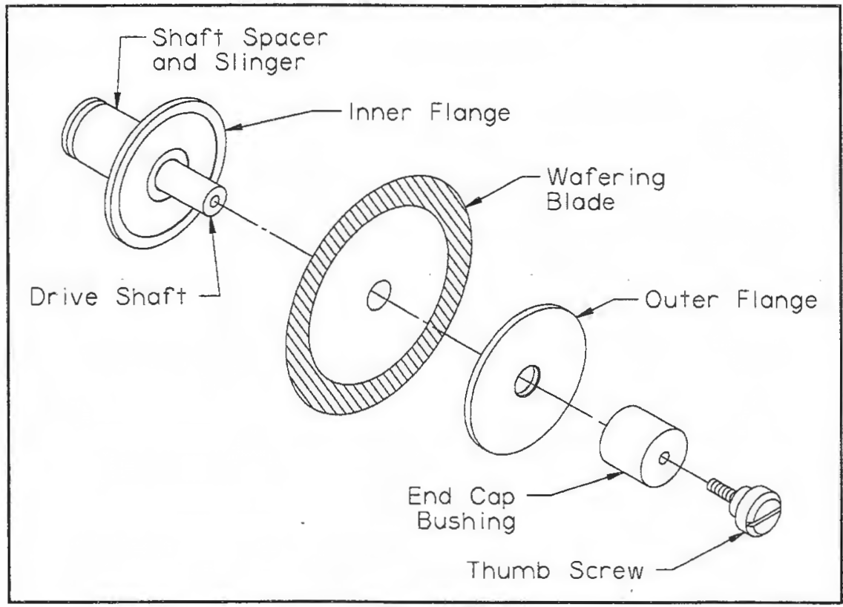

Documentation of Training (signature of all users is required)
- Prior to conducting any work, the PI or LM must provide training to his/her laboratory personnel specific to the hazards involved in working with this equipment, work area, and emergency procedures.
- The Principal Investigator must provide his/her laboratory personnel with a copy of this SOP.
- The Principal Investigator must ensure that their laboratory personnel have attended appropriate laboratory safety training and are current with any refresher training required.

I have read and understand the content of this SOP, and have completed the accompanying safety checklist:

Name | Signature | Date

