Standard Operating Procedure
Chipmunk Crusher

Department: | Earth and Environmental Sciences
Date SOP was written: | 9/19/2013
Date SOP was approved by PI/lab supervisor: | 9/19/2013
Principal Investigator: | Calvin Miller
Internal Lab Safety Coordinator/Lab Manager: | Richard Bradshaw
Lab Phone: | Click here to enter text.
Office Phone: | Miller: (615) 322-2232
Emergency Contact: | Miller: (615) 480-1077  Bradshaw (Office): (615) 343-0839  (Cell): (208) 260-2792`
Location(s) covered by this SOP: | SC1108A
 | (Building/Room Number)

Type of SOP: ☒ Process ☐Hazardous Chemical ☐ Hazardous Class
Purpose
The purpose of the Chipmunk Crusher is to reduce the size of small rock specimens. This machine can only accommodate specimens which have already been reduced to less than 2” x 3”.
Personal Protective Equipment (PPE)
Respirator Protection
Dust masks must be worn during any operation of the Chipmunk Crusher. If you use the last mask, make sure your PI knows so they can order more.
Overhead circulator must be turned on to properly clean the air in the room during the use of the machine.
Eye Protection
ANSI approved, tight-fitting safety glasses/goggles and/or face shield.

Body Protection
Remove any loose jewelry around your neck or any jewelry on your hands and wrists. Tightly secure long hair in ponytail.

Ear Protection
Ear protection in the form of ear muffs or ear plugs must be worn during operation.
Engineering Controls
The main breaker to this machine is located right above the switch. If this breaker trips contact the LM to assure nothing is wrong with the machine before continuing use.
Never run the machine without the belt guard securely fastened.

Medical Emergency

To contact the Vanderbilt University Police Department in an emergency:
- Call 911 from any campus phone.
- Call (615) 421-1911 from any other phone.
Protocol/Procedure
Report any problems or abnormalities with the equipment immediately to the PI or LM.

DO NOT USE WATER ON THE PLATES!!!

***NEVER leave the machine unattended while operating***
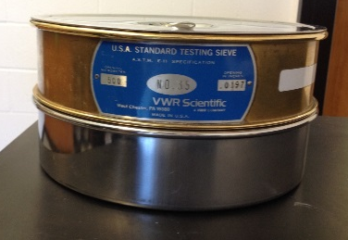
A. You will need:
- The 500µm sieve and pan. They are kept in 5703A.
- A Shop Vac. There should be one in 1108.
- Ziplock bags (gallon-size preferred).
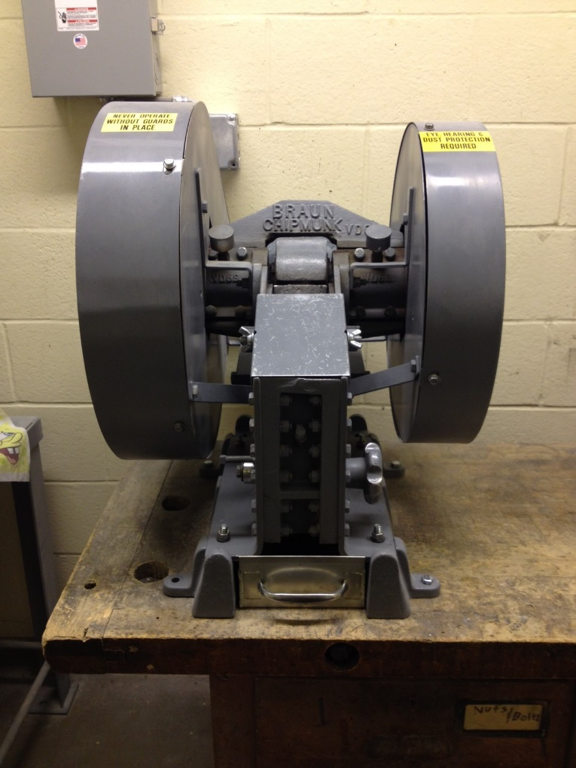
- A sample. Pieces need to be smaller than ~4x4x4 cm.
Sample in.
Power
Adjust jaw width
Sample out.
Figure 1: The sieves.

This is the crusher. Put rocks in the top, they get crushed and wind up in the tray at the bottom. The power switch is on the wall behind the crusher. The jaw width is adjusted with the large knob on the right side.

If you turn on the machine and it makes any terrible, squeaky, non-chipmunk-like noise, do not use! Notify PI or LM immediately.
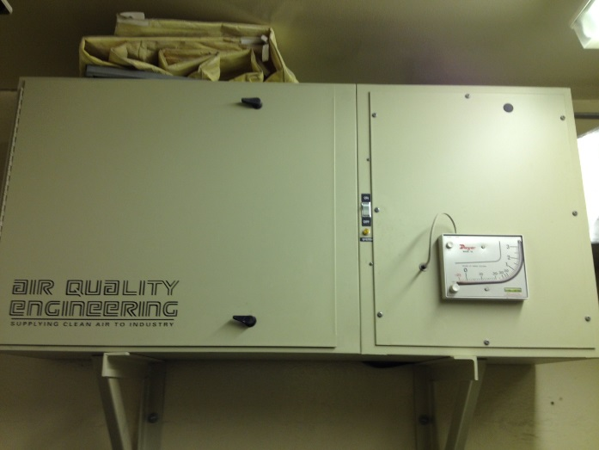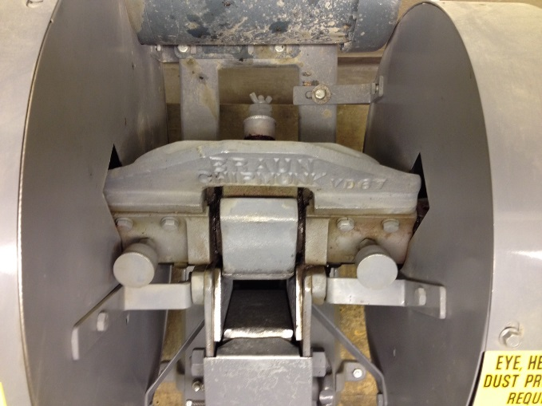
Figure 2: The ventilation system. The power button is circled. Figure 3: The crusher from above. Note the grease knobs.
B. Before doing anything with crusher:
- Make sure you have the appropriate PPE: hearing protection, eye protection, and a dust mask.
- Turn on the ventilation system.
- Close the door.
- Give the grease knobs ¼ turn clockwise each. There are 3 of them. If a knob is turned tight, it needs more grease. The grease and the spatula to dispense it are on the top shelf in the crushing room. Unscrew the knob and fill the interior with grease. Put some in the cap as well, then screw the knob back on. Be sure to clean the spatula and put back.

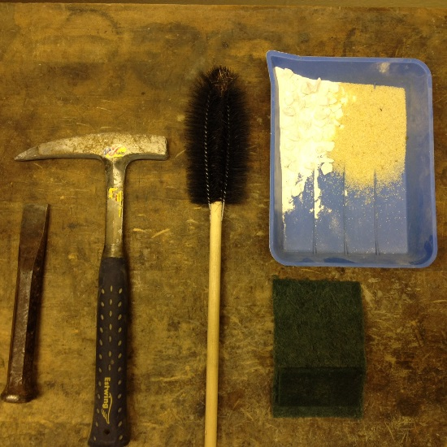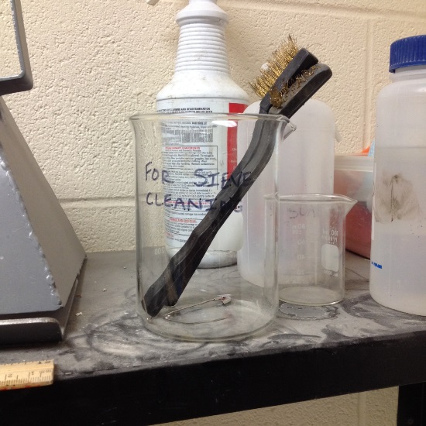
Figure 4. A) The tools you need, from left to right: Chisel, hammer, scrub brush, quartz sand and marble chips (top) and scouring pad (bottom). These should all be in the crushing room. B) The sieve cleaning tools, they live on the shelf to the right of the sink.

C. You are now ready to clean the crusher.
NOTE: The crusher must be cleaned before and after every use.

Cleaning Procedure: Crusher
- Use the ShopVac to vacuum inside, underneath, and around the crusher as much as possible.
- Remove the metal plate. Use the chisel and hammer to remove the crush plate inside.
- Use compressed air to blow away any grains in the crusher or on the parts you removed.
- Use the provided brushes and scouring pads to scrub the crusher and parts.
- Use compressed air to get rid of debris. Visually inspect around the edges of the plates in the crusher and use the butter knife to dislodge any pieces that are stuck.
- Use an ethanol-soaked paper towel to wipe down the crush plate, metal plate, tray, and interior and underneath of the crusher. Do the underneath of the crusher last because it is greasy.
- Replace all the parts.
- Run a mixture of quartz sand and marble chips through the crusher with the plates at the closest setting.
- Repeat steps 1-7.

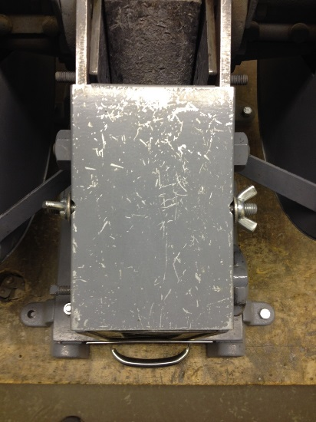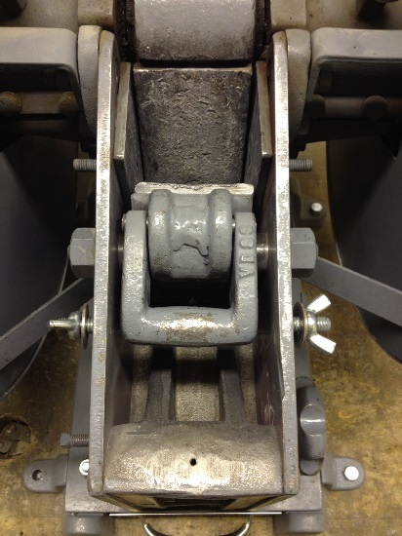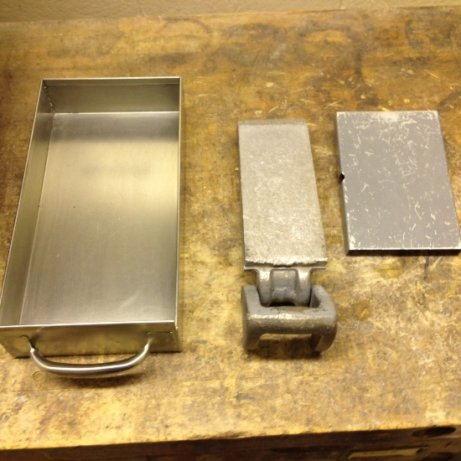
Figure 5: A) The metal plate. B) Use the hammer and chisel to lift the handle on the crush plate.
C) The sample tray, crush plate, and metal plate ready for cleaning.
Cleaning Procedure: Sieve
- Blow out the sieve and silver bottom with compressed air.
- Use the metal brush on the underside of the sieve to scrub out grains. The sieve tools are to the right of the sink.
- Remove any grains that are still stuck by poking them out with a safety pin. Always go from the underside—don’t force grains through the top or the sieve mesh will get larger.
- Wipe the inside and bottom of the sieve and the silver bottom with ethanol.

D. Once the crusher and sieves are clean, you are ready to start. You will crush your sample progressively from the widest jaw width to the smallest, unless your sample is in tiny (~1 cm³) pieces to start with.
- Put the jaws on the widest setting.
- Turn on the crusher. Slowly add your sample to the crusher, waiting for the material to clear before adding more. Do not put too much in the crusher at once! The jaws will get stuck and it’s a pain to fix.
- Keep an eye on the tray—when it’s about half full (or empty), dump the contents into the sieve and start shaking. When all the tiny material is sieved through, save the >500µm fraction in a bag.
- Repeat 2 and 3 until all your material is crushed and sieved.
- Adjust the jaws to about midway. This is maybe 10-15 turns of the knob.
- Repeat steps 2-4.
- Adjust the jaws so they are about as close together as they’ll go. Turn the knob all the way tight, then back it off half a turn. Verify the jaws are not contacting when power is on. This reducing the chances of the jaws clogging. It is especially important now to add sample slowly and wait for all the material to go through before adding more.
- Repeat steps 2-4.
- If you don’t have as much <500µm material as you’d like, run the large fraction through the crusher on the smallest setting again. Otherwise, you are done!
- Transfer your <500µm fraction to one bag and the >500µm fraction to another.
- If you crush multiple samples, turn the grease knobs ¼ turn every 4-5 samples.
_______________________________________________
E. Clean the crusher and sieves again according to directions in Part C with one small (optional) change—stop after Step 7 and move on to the sieves.
_______________________________________________
Before leaving the room, ensure that:
- The ventilation is off.
- There aren’t rock chips on the table.
- The floor around the crusher is swept.
- The garbage is emptied into the larger garbage in 1108 if full.
- The crusher is covered with either the large garbage bag or the plastic sheet.
- The sieves are on their way back to 5703 with you.
DO NOT USE WATER ON THE PLATES!!!

***NEVER leave the machine unattended while operating***

NOTE
Any deviation from this SOP requires approval from PI.
Documentation of Training (signature of all users is required)
- Prior to conducting any work with the Chipmunk Crusher, LM or designated personnel must provide training to his/her laboratory personnel specific to the hazards involved in working with this substance, and emergency procedures.

- The Principal Investigator must provide his/her laboratory personnel with a copy of this SOP.

- The Principal Investigator must ensure that their laboratory personnel have attended appropriate laboratory safety training and are current with any refresher training required.

I have read and understand the content of this SOP:
Name | Signature | Identification | Date

