

Building Learning Communities in Online Classrooms

**Lam Pham** working with  
**Dr. Xiu Cravens**, Associate Dean for International Affairs, Associate Professor of the Practice, Department of Leadership, Policy, and Organizations

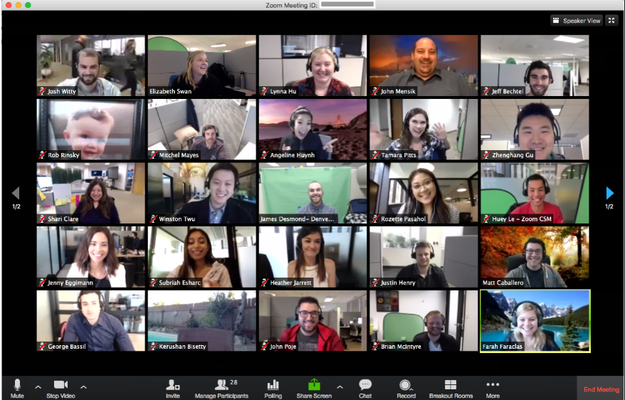

Robust Discussions:

Measured with Collaborative Interactions Rubric

Student Learning:

Measured with Rubric Score for Project Proposal

**Outcome Measures: Learning Experiences Survey Scales: Collaborative Learning, Cognitive Presence, Social Presence, Teaching Presence**

Student Engagement:

Measured with Student Perception Survey

Community of Inquiry Model

Student Learning:

Measured with Rubric Score for Project Proposal

**Data: Student Surveys and Interview**

**Problem: What are the tools that online students use to create and maintain classroom communities in the absence of co-presence?**

**Context: Vanderbilt Online Ed.D. Program; Research Design Course**

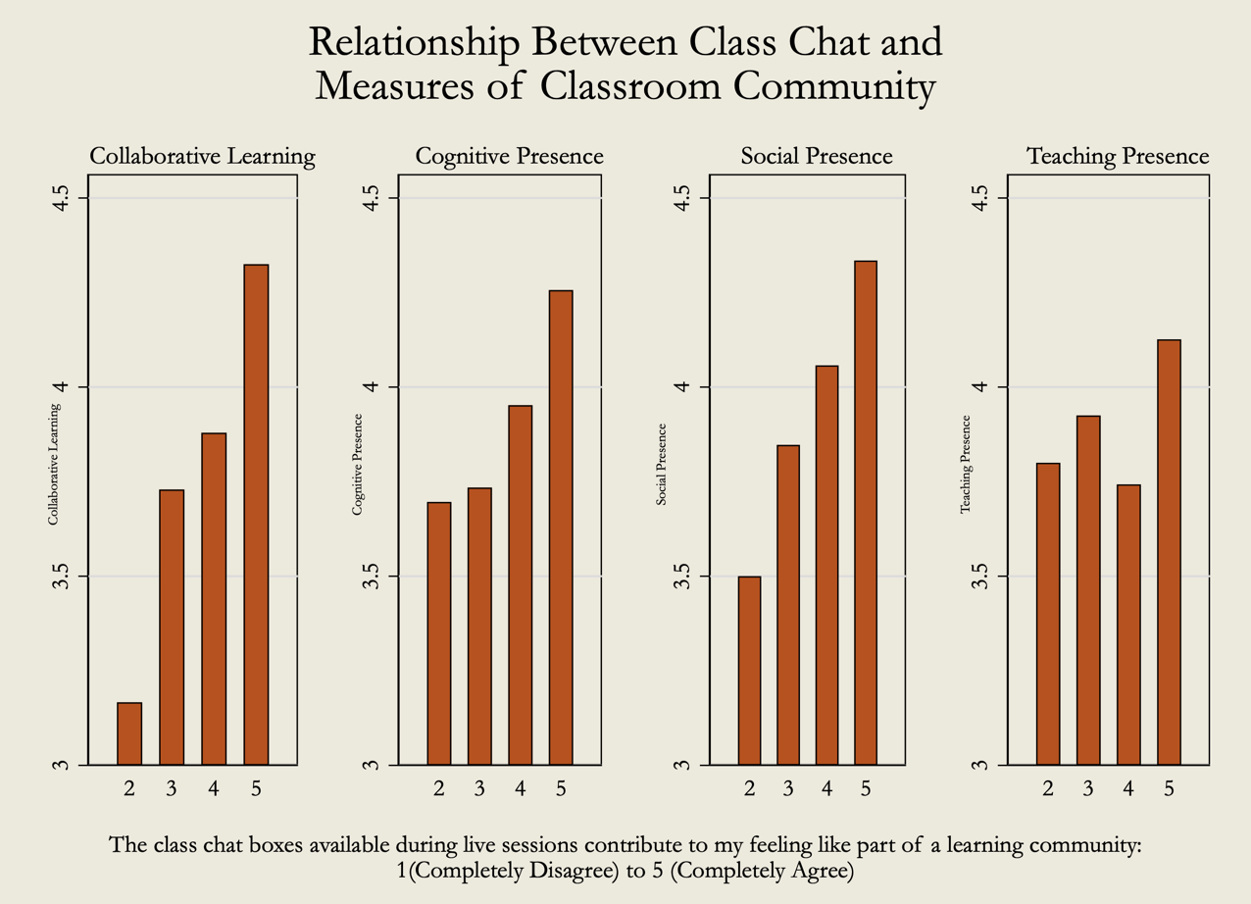

“If I was in a regular classroom setting, and somebody made a good point, I don't necessarily know that I would be able to indicate to them, "Hey, I totally agree with you on that…” You don't really stop. You can't stop the class to process. So, I do think that the digital realm provides a higher level of opportunities for collaboration or cross talk.”

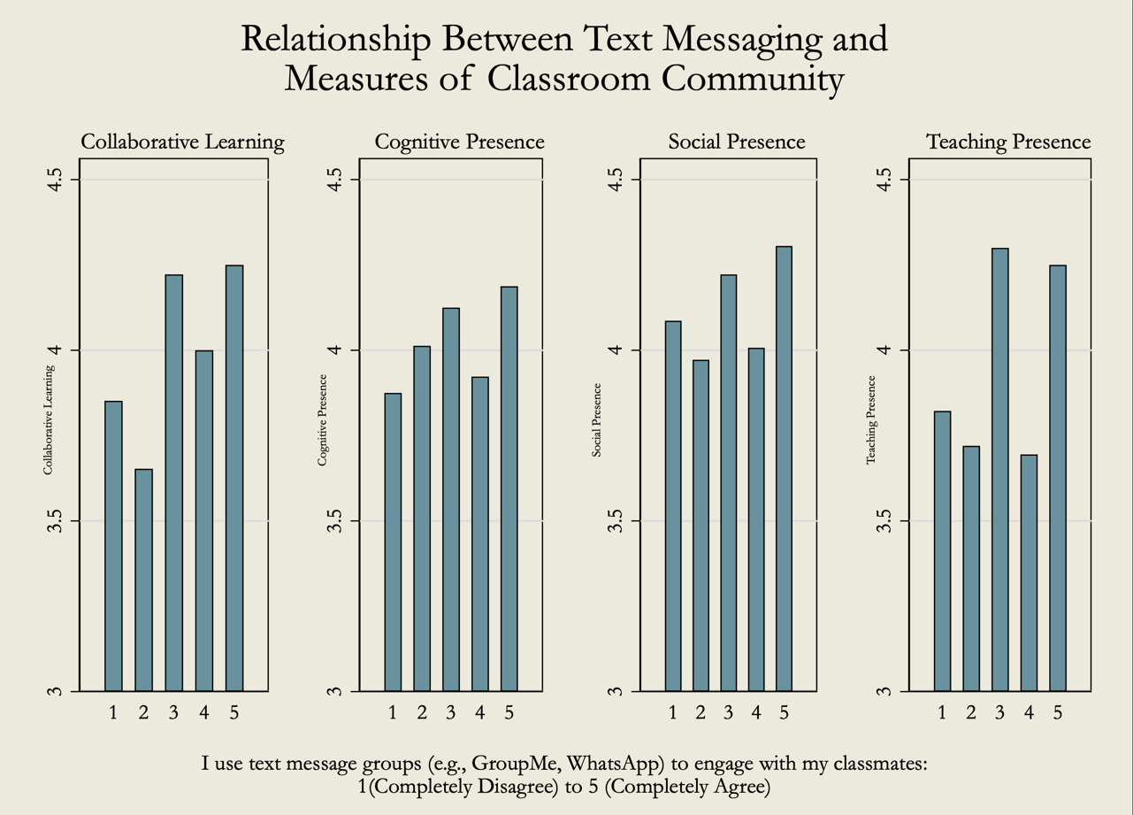

“I have been more comfortable chatting with other people, setting up text groups and having it be more supportive of each other, not necessarily about classwork but just these mini communities of us helping each other to things and we can go through whatever we're talking about in class.”

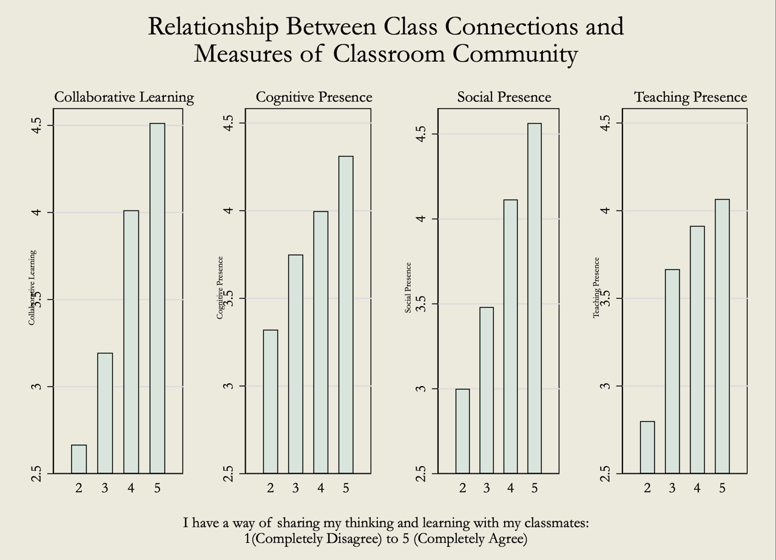

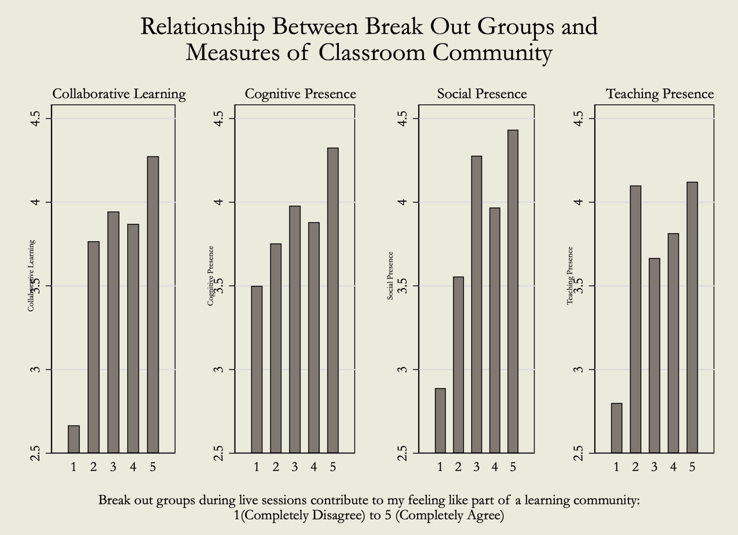

“I was lucky enough that my first course that the instructor had, that was one of her requisites was that everybody reach out and create a link. And that put me in touch with a peer in the program. And that kind of started that whole symbiotic interaction of like, ‘Okay, if you don't understand something, I'm going to call you and you're going to call me…’ So, it really created a little bit of a learning network that was a living organism outside of the classes.”

And I think that there's a level of comfort in our cohort now, whereas we know each other, we don't always have to agree. And so, the smaller groups do afford a higher volume of activity and back and forth exchange.